
WEBSITE PLANNING WORKSHOP

Fitness Studios & Personal Trainers
Website workbook
Plan a clear website for fitness studios & personal trainers. Explore a worked example, shape your own message and prepare to build with SaaSTech Servers.
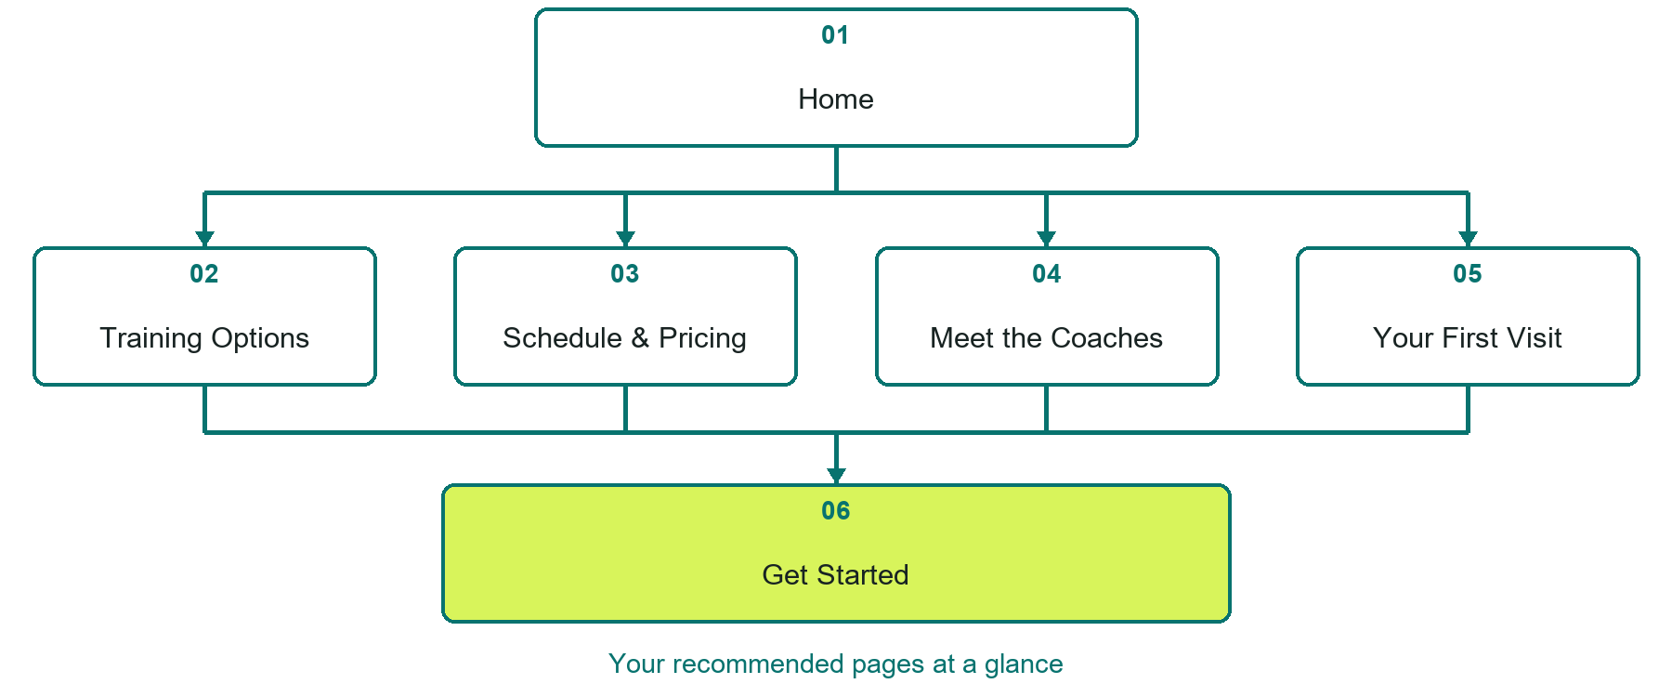

Inside this workbook
Six page examples • Practical writing exercises • A launch review
Use it in a workshop or at your own pace. Write by hand or complete the response fields in Word. The final page links to Website Builder, plans and account signup.
Example business Prairie Motion Studio

FITNESS STUDIOS & PERSONAL TRAINERS

Your website brief
A SaaSTech Servers workshop for fitness studios & personal trainers. Plan your website, learn from the Prairie Motion Studio example and draft content for your own business.
Each page has a reference sheet followed by a writing sheet. Demo excerpts are labelled separately from new sample wording, which may differ from the screenshot. Click a blank response line to type; longer answers may add pages. Replace fictional details and verify every claim before publishing.
Your business or organization and workshop date

Who should visit your site and what do they need

The main action you want a visitor to take

What you offer and where or how you provide it

Facts photos and permissions to gather before publishing

Workshop rhythm: review the example, write your draft and exchange feedback. Use the final review to choose your next changes. Website Builder and account links are on the last page.

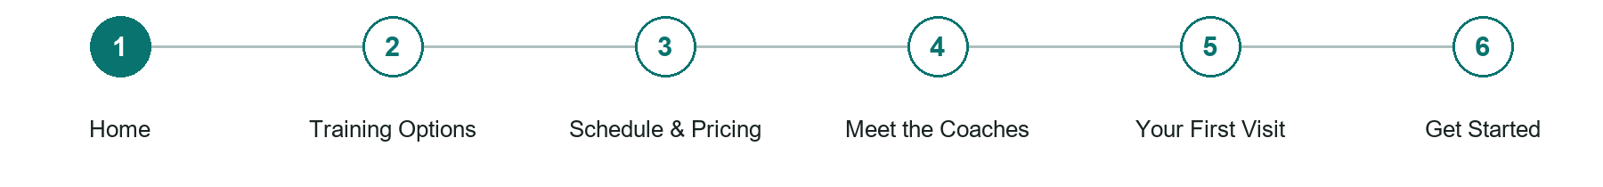
LOOK AND LEARN

Home

The job of this page
Introduce the studio and its approach, show a trainer in context and provide one first-session action.
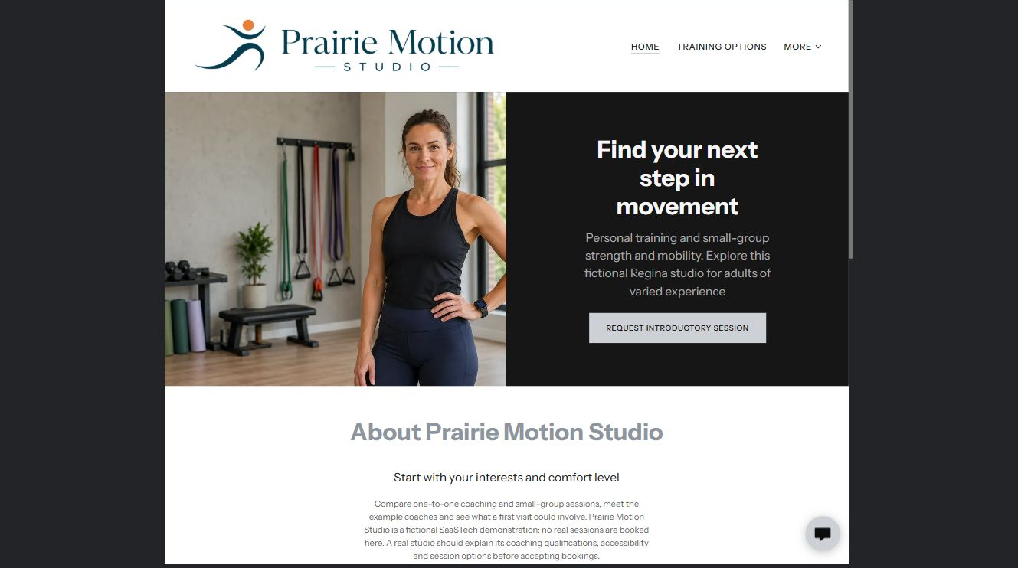
Prairie Motion Studio example | Explore SaaSTech Website Builder

Demo text example
Find your next step in movement
Personal training and small-group strength and mobility. Explore this fictional Regina studio for adults of varied experience.

Pause and plan
Could a first-time visitor explain what you do and who it is for after one glance? Choose one main action and the strongest truthful detail that gives them confidence to continue.

WRITE YOUR PAGE

Home
Write for your visitor. Be specific about what they need to know and what happens next. You can revise the wording after the workshop.
Your page headline

Your opening paragraph

Your offer audience location and most useful supporting details

Button or link wording and where it should lead

Photo idea caption and permission or credit needed

Facts to verify or questions to resolve

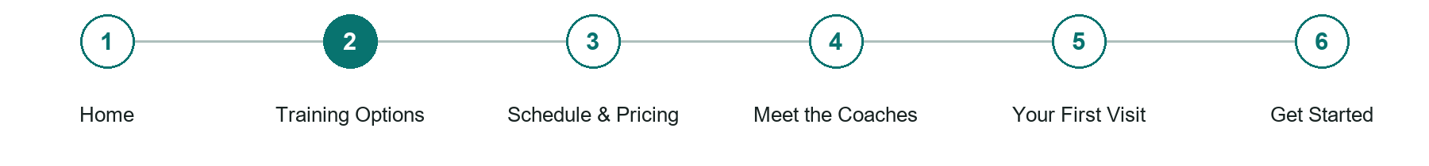
LOOK AND LEARN

Training Options

The job of this page
Explain personal training, small groups and introductory sessions, with duration and suitability information.
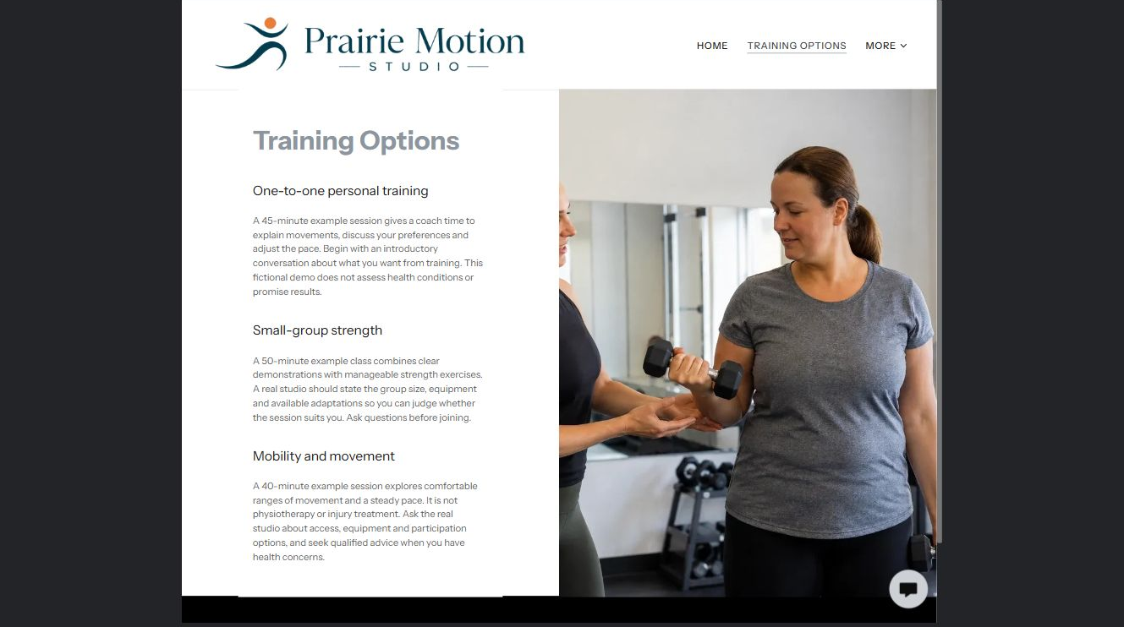
Prairie Motion Studio example | Explore SaaSTech Website Builder

Sample wording to adapt
Choose how you want to train
Compare one-to-one coaching, small-group strength and mobility sessions. Ask about group size, equipment and participation options before choosing. This demonstration does not assess health conditions or promise results.

Pause and plan
Who is each option for, what does it include and where are its limits? Describe the information needed to check fit. Make the next step clear without promising an outcome before assessment.

WRITE YOUR PAGE

Training Options
Write for your visitor. Be specific about what they need to know and what happens next. You can revise the wording after the workshop.
Your page headline

Your opening paragraph

Service options who they suit and what each includes

Button or link wording and where it should lead

Photo idea caption and permission or credit needed

Facts to verify or questions to resolve

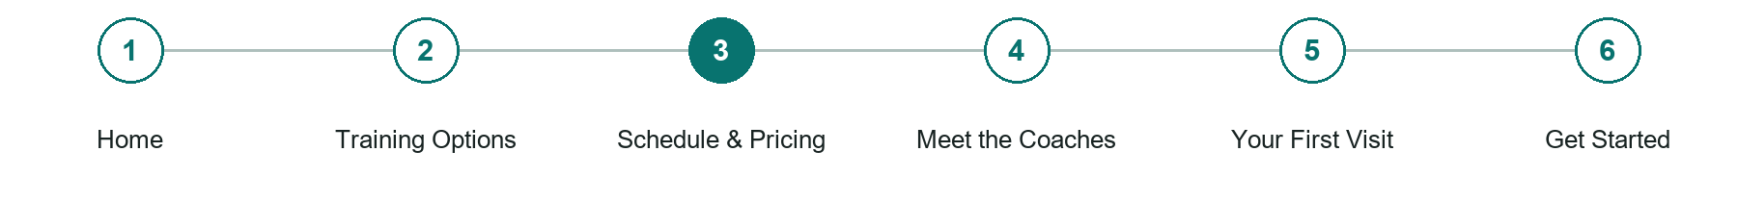
LOOK AND LEARN

Schedule Pricing

The job of this page
Show current session times, prices and what each option includes. Do not imply a live schedule unless it is connected and tested.
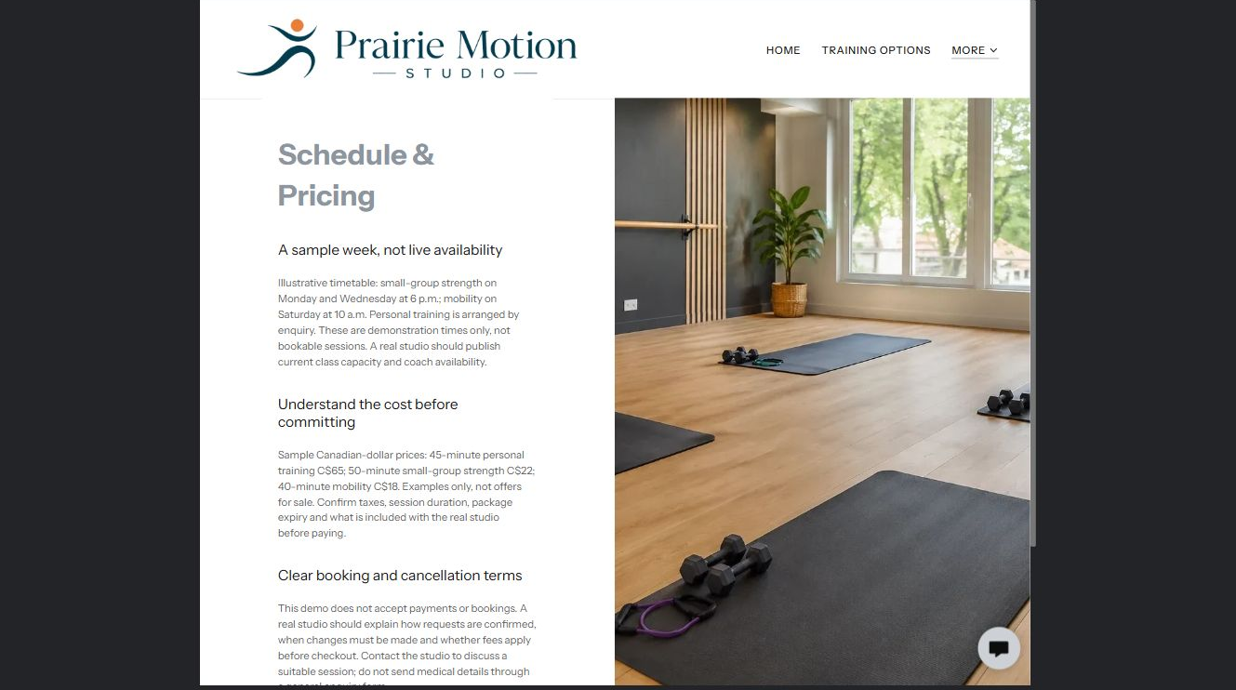
Prairie Motion Studio example | Explore SaaSTech Website Builder

Sample wording to adapt
Understand the session before committing
Confirm the current timetable, coach availability, session length and total price. Ask about package expiry and changes or cancellations before paying. The timetable shown in this demo is illustrative, not live availability.

Pause and plan
Which dates and locations need to stay current? Decide who will update changes and where visitors should check before travelling. Separate archived information and illustrative schedules from current availability.

WRITE YOUR PAGE

Schedule Pricing
Write for your visitor. Be specific about what they need to know and what happens next. You can revise the wording after the workshop.
Your page headline

Your opening paragraph

Dates locations update process and participation details

Button or link wording and where it should lead

Photo idea caption and permission or credit needed

Facts to verify or questions to resolve

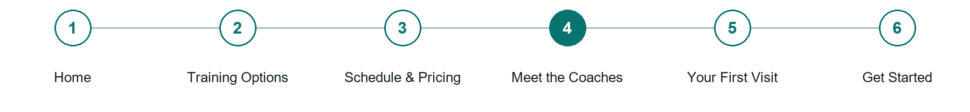
LOOK AND LEARN

Meet the Coaches

The job of this page
Publish approved portraits, verified qualifications and the coaching approach without invented testimonials or outcome guarantees.
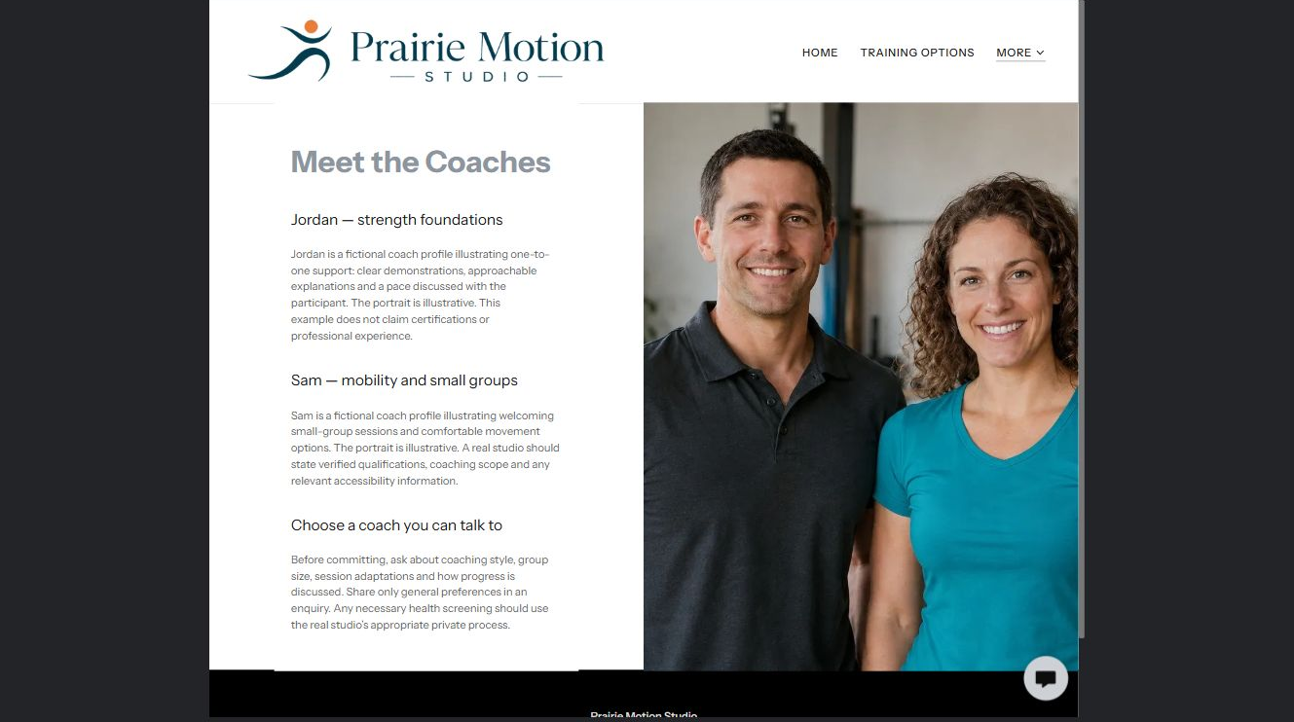
Prairie Motion Studio example | Explore SaaSTech Website Builder

Sample wording to adapt
Choose a coach you can talk to
Jordan's example profile focuses on strength foundations; Sam's on mobility and small groups. Ask a real studio about verified qualifications, coaching style and practical access needs before committing.

Pause and plan
Which names, roles and qualifications can you verify? What would help a visitor feel comfortable contacting you? Obtain permission for portraits and describe actual experience without unsupported claims.

WRITE YOUR PAGE

Meet the Coaches
Write for your visitor. Be specific about what they need to know and what happens next. You can revise the wording after the workshop.
Your page headline

Your opening paragraph

People roles approach and verified credentials to introduce

Button or link wording and where it should lead

Photo idea caption and permission or credit needed

Facts to verify or questions to resolve

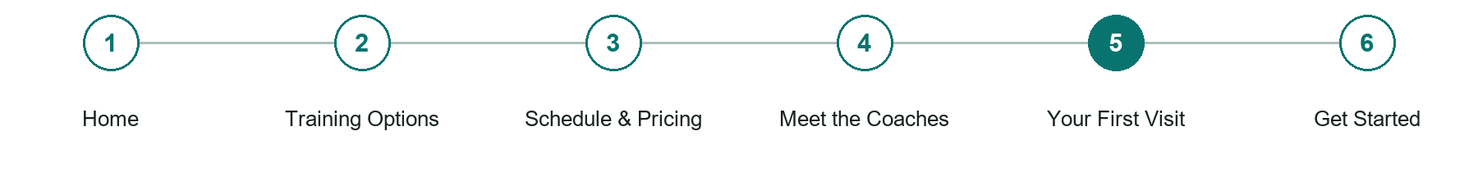
LOOK AND LEARN

Your First Visit

The job of this page
Explain arrival, equipment, preparation, access and how to discuss individual requirements privately.
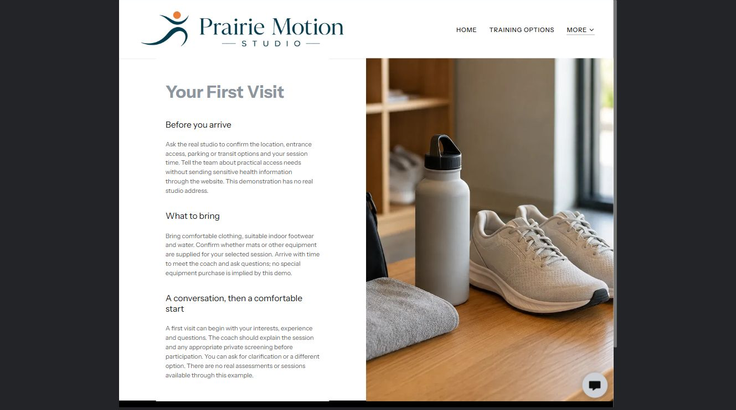
Prairie Motion Studio example | Explore SaaSTech Website Builder

Demo text example
What to bring
Bring comfortable clothing, suitable indoor footwear and water. Confirm whether mats or other equipment are supplied for your selected session.

Pause and plan
What should someone know before arriving or proceeding? Clarify preparation, access and the right contact route. Verify policies and avoid promising urgent help or specialist advice the website cannot provide.

WRITE YOUR PAGE

Your First Visit
Write for your visitor. Be specific about what they need to know and what happens next. You can revise the wording after the workshop.
Your page headline

Your opening paragraph

Preparation access policies and practical questions to answer

Button or link wording and where it should lead

Photo idea caption and permission or credit needed

Facts to verify or questions to resolve

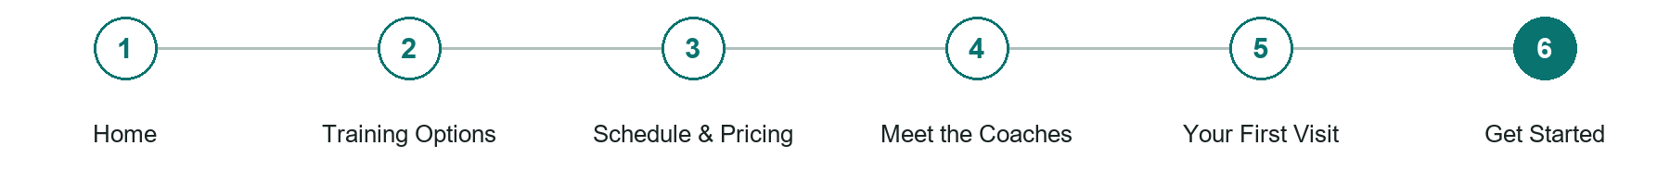
LOOK AND LEARN

Get Started

The job of this page
Ask for contact details, session interest, experience level and preferred timing. Keep medical histories and sensitive assessments out of a general enquiry form.
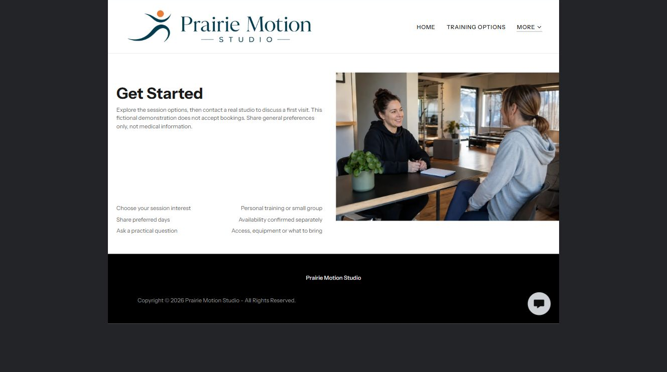
Prairie Motion Studio example | Explore SaaSTech Website Builder

Sample wording to adapt
Start with a conversation
Tell the studio which session interests you and your preferred days. Ask about equipment, access or what to bring. Keep medical information out of a general website enquiry and use the studio's appropriate private process.

Pause and plan
What must someone provide, and what happens after they send it? Separate a request from a confirmed booking, order or place. Decide what information should stay out of a public form.

WRITE YOUR PAGE

Get Started
Write for your visitor. Be specific about what they need to know and what happens next. You can revise the wording after the workshop.
Your page headline

Your opening paragraph

Information to request and how you will reply or confirm

Button or link wording and where it should lead

Photo idea caption and permission or credit needed

Facts to verify or questions to resolve

WORKSHOP CLOSE

Review and next steps
Ask a partner to read your draft as a first-time visitor. Can they explain what you offer, who it is for and the next step without extra help?

Before you publish
[ ] Every page has a clear purpose and a useful next step.
[ ] Headlines are specific and the wording sounds like your business.
[ ] Names, service areas, prices, dates and policies have been checked.
[ ] Credentials, testimonials and results are genuine and permission-cleared.
[ ] Photos support the text, do not repeat needlessly and have appropriate permissions.
[ ] Forms ask only for necessary information and explain what happens next.
[ ] Links, downloads and the main visitor task work on a phone.
The most useful feedback from your workshop partner

First change to make and who will do it

Information or photographs still needed

Target review date and who will approve the final content

Keep sensitive customer, patient, employee and payment information out of this workbook. Completing it does not publish a website or connect to Website Builder.

BUILD WITH SAASTECH SERVERS

Put your draft into Website Builder
Use the content you have written to build your own site. Keep the fitness studios & personal trainers demo as a reference, and replace its company name, images and claims with your verified business information.

Explore the builder
See the editor, compare available plans and decide which features your business needs. Confirm current pricing and terms before purchasing.
Website Builder overview

Create your account
Set up your SaaSTech Servers customer account using your own details. Creating an account is separate from purchasing a Website Builder plan.
Create your SaaSTech account

Choose your plan
Open the secure shop to review the plan, subscription term and final total. Use the account connected to your purchase when you open your service.
View Website Builder plans

Build and check your pages
Add the pages from this workbook. Transfer your approved wording, upload permission-cleared photos and review each page on desktop and mobile before publishing.
Return to the Website Builder guide

Using a printed workbook
Type these short addresses into your browser. The account guide includes the Create My Account button.
www.saastech.net/products/website-builder
www.saastech.net/create-account
This workbook does not create an account, purchase a plan or publish your website. Keep passwords, payment details and confidential customer information out of your draft.

