SaaSTech Servers  Website workshop workbook | 

Build a farm equipment repair website that earns the next conversation
Use this SaaSTech Servers workshop workbook to plan six purposeful pages, compare the Prairie Gearworks example on desktop and mobile, and draft your own customer-ready wording.
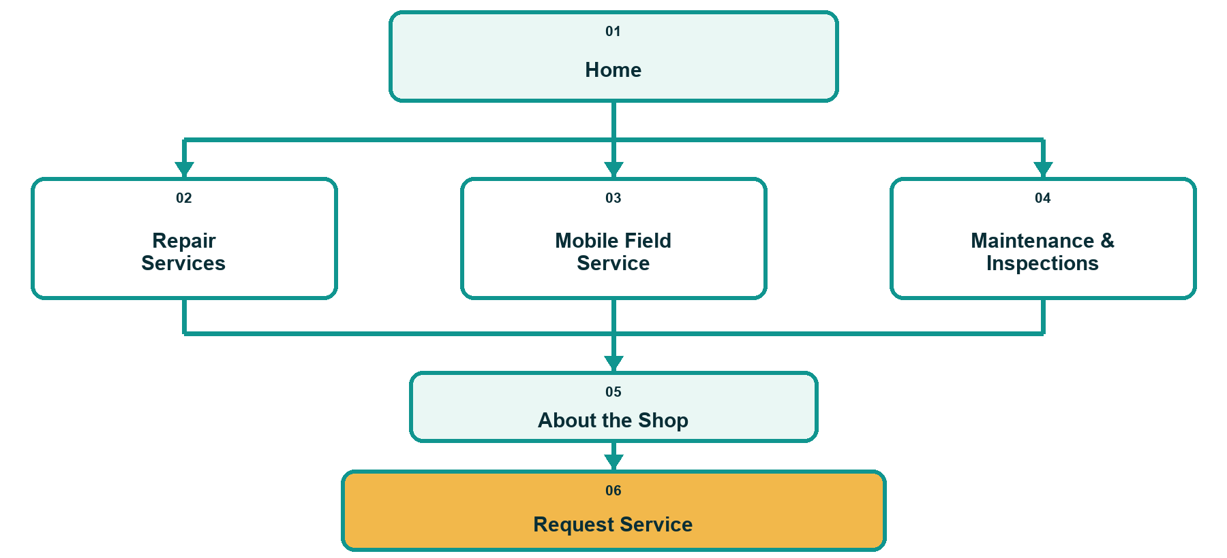
Website Builder: https://www.saastech.net/products/website-builder
Industry guide: https://www.saastech.net/industry/farm-equipment-repair

SaaSTech Servers
Page 01 of 06

01 Home
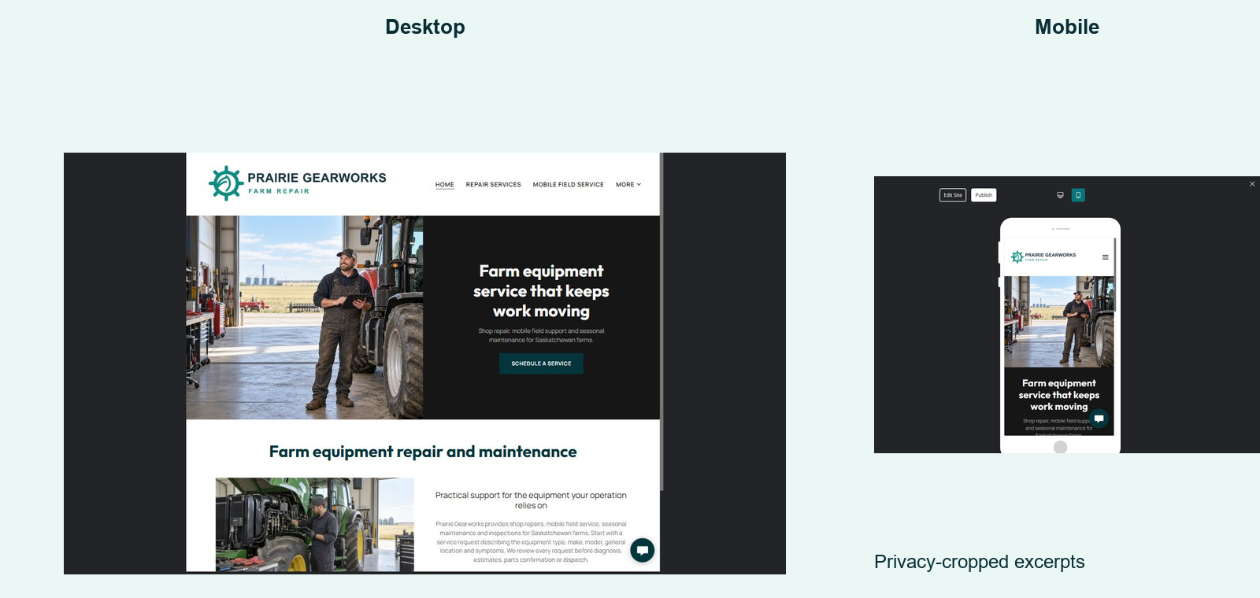
WEBSITE ADVICE  Open with the equipment, service area and next step a visitor can understand in seconds. | PRAIRIE GEARWORKS SAMPLE WORDING  Farm equipment service that keeps work moving. Shop repair, mobile field support and seasonal maintenance for Saskatchewan farms.

Your draft
Main promise or page heading:
________________________________________________________________________________
________________________________________________________________________________
What the visitor needs to know, trust or do next:
________________________________________________________________________________
________________________________________________________________________________
________________________________________________________________________________
________________________________________________________________________________
________________________________________________________________________________
Primary button label and destination:
________________________________________________________________________________
________________________________________________________________________________

SaaSTech Servers
Page 02 of 06

02 Repair Services
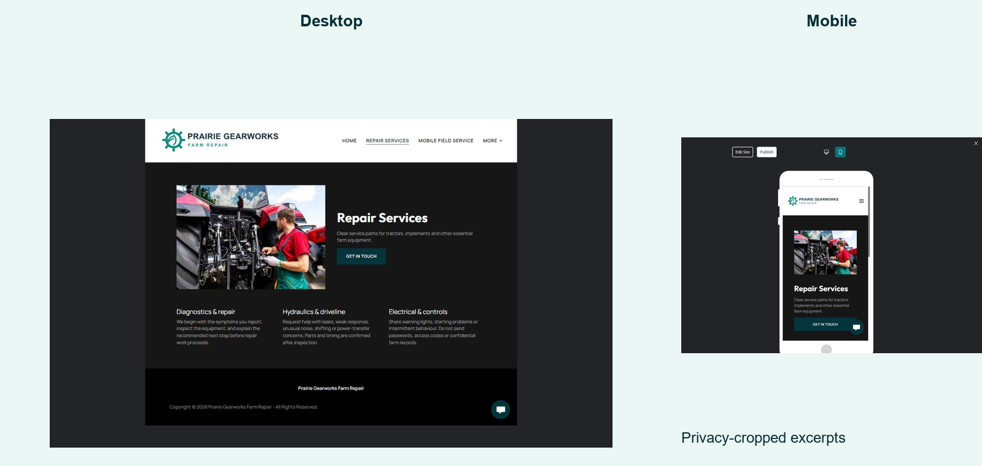
WEBSITE ADVICE  Describe repair categories and the review process without promising a diagnosis or stocked parts. | PRAIRIE GEARWORKS SAMPLE WORDING  Bring the machine to the shop for a practical inspection, clear options and approval before repair work begins.

Your draft
Main promise or page heading:
________________________________________________________________________________
________________________________________________________________________________
What the visitor needs to know, trust or do next:
________________________________________________________________________________
________________________________________________________________________________
________________________________________________________________________________
________________________________________________________________________________
________________________________________________________________________________
Primary button label and destination:
________________________________________________________________________________
________________________________________________________________________________

SaaSTech Servers
Page 03 of 06

03 Mobile Field Service
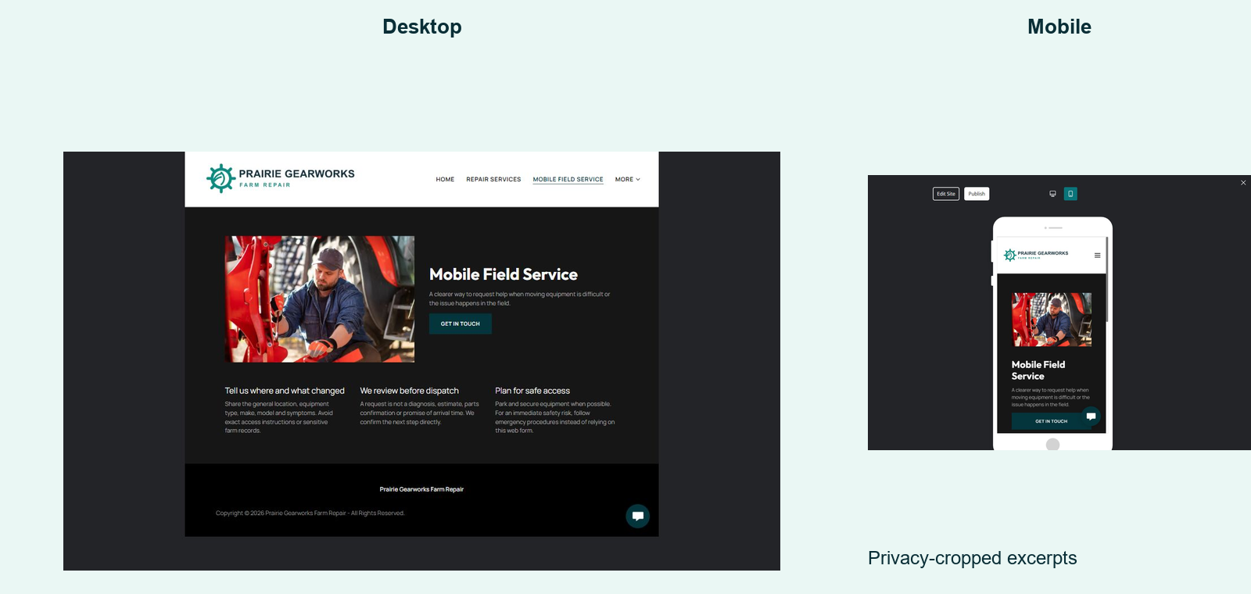
WEBSITE ADVICE  Set location, access, travel and dispatch expectations before the customer submits. | PRAIRIE GEARWORKS SAMPLE WORDING  Tell us the equipment, general location, symptoms and urgency. We review availability and safe access before confirming a field visit.

Your draft
Main promise or page heading:
________________________________________________________________________________
________________________________________________________________________________
What the visitor needs to know, trust or do next:
________________________________________________________________________________
________________________________________________________________________________
________________________________________________________________________________
________________________________________________________________________________
________________________________________________________________________________
Primary button label and destination:
________________________________________________________________________________
________________________________________________________________________________

SaaSTech Servers
Page 04 of 06

04 Maintenance & Inspections
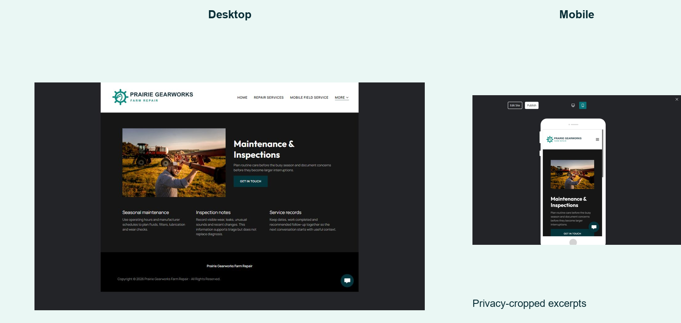
WEBSITE ADVICE  Use seasonal checkpoints to turn preventive service into an understandable plan. | PRAIRIE GEARWORKS SAMPLE WORDING  Plan pre-seeding, in-season and post-harvest checks around the equipment your operation relies on.

Your draft
Main promise or page heading:
________________________________________________________________________________
________________________________________________________________________________
What the visitor needs to know, trust or do next:
________________________________________________________________________________
________________________________________________________________________________
________________________________________________________________________________
________________________________________________________________________________
________________________________________________________________________________
Primary button label and destination:
________________________________________________________________________________
________________________________________________________________________________

SaaSTech Servers
Page 05 of 06

05 About the Shop
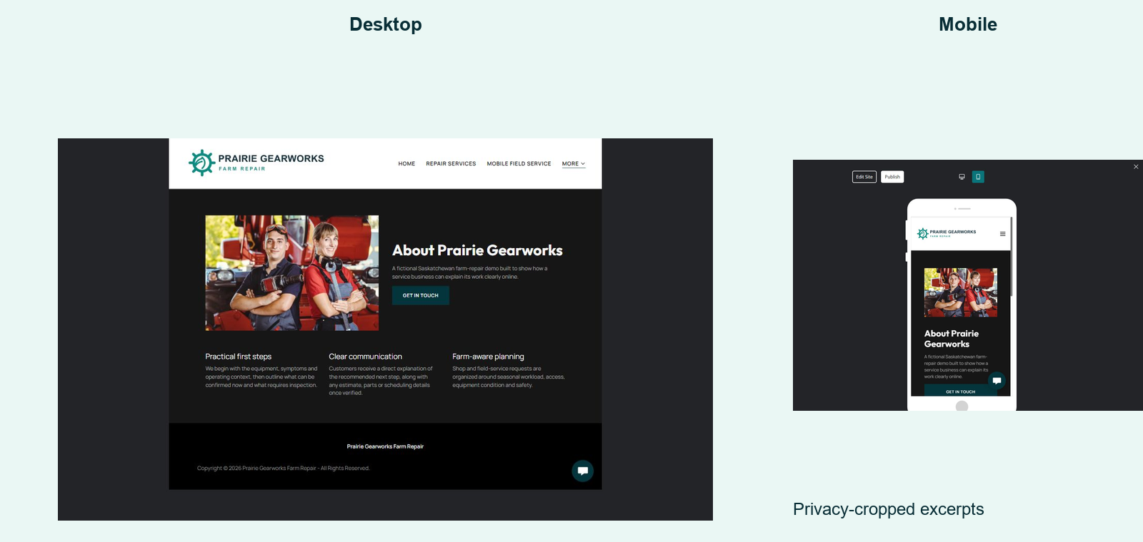
WEBSITE ADVICE  Build trust with people, working principles and the way approvals are handled. | PRAIRIE GEARWORKS SAMPLE WORDING  Prairie Gearworks combines practical shop experience with clear communication, documented findings and customer approval before added work.

Your draft
Main promise or page heading:
________________________________________________________________________________
________________________________________________________________________________
What the visitor needs to know, trust or do next:
________________________________________________________________________________
________________________________________________________________________________
________________________________________________________________________________
________________________________________________________________________________
________________________________________________________________________________
Primary button label and destination:
________________________________________________________________________________
________________________________________________________________________________

SaaSTech Servers
Page 06 of 06

06 Request Service
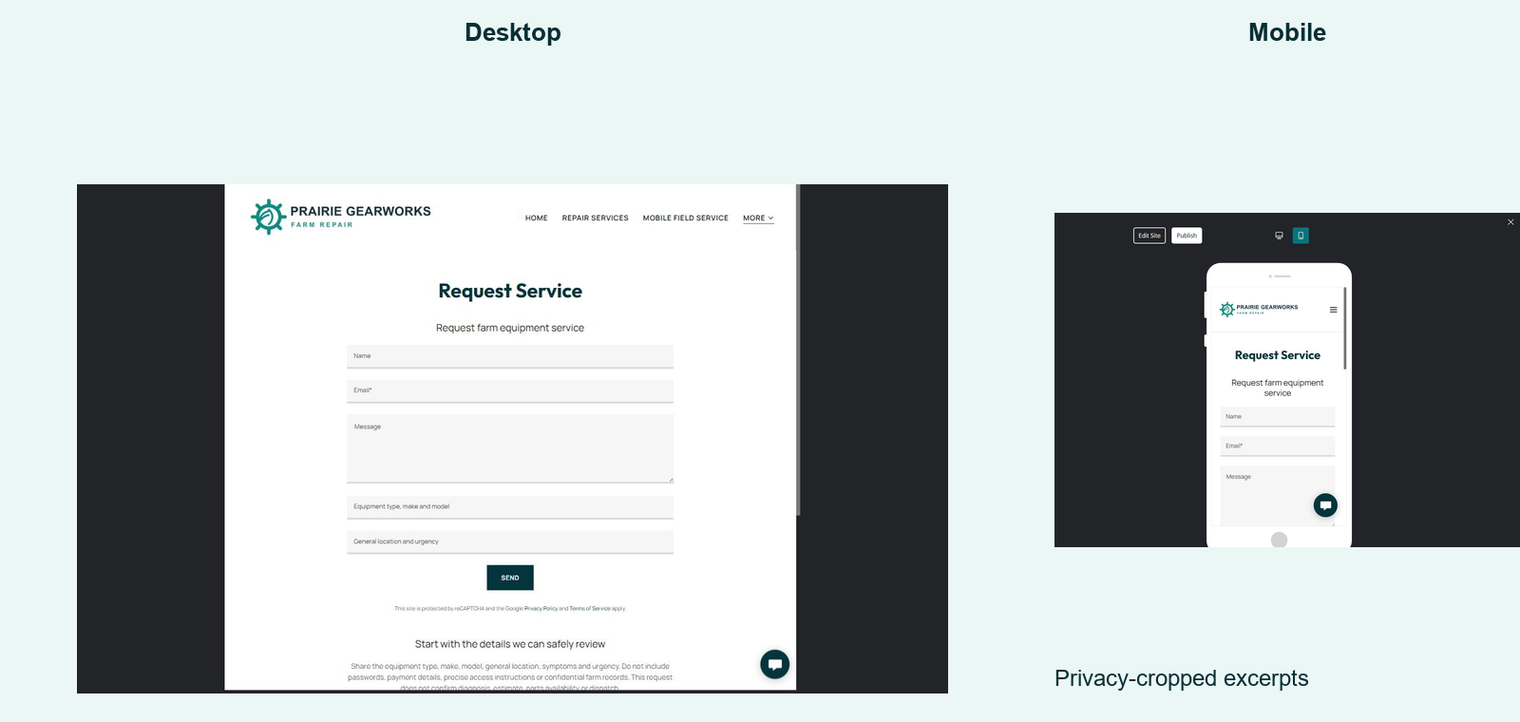
WEBSITE ADVICE  Collect only routing details and explain what happens after submission. | PRAIRIE GEARWORKS SAMPLE WORDING  Share the equipment type, make, model, general location and symptoms. We will review the request before diagnosis, estimate, parts confirmation or dispatch.

Your draft
Main promise or page heading:
________________________________________________________________________________
________________________________________________________________________________
What the visitor needs to know, trust or do next:
________________________________________________________________________________
________________________________________________________________________________
________________________________________________________________________________
________________________________________________________________________________
________________________________________________________________________________
Primary button label and destination:
________________________________________________________________________________
________________________________________________________________________________

