

Exhibitions, Fairs & Agricultural Societies
Website workbook
A practical workshop for a 6-page website. Study the example, plan the content and draft your own version in Word or on paper.
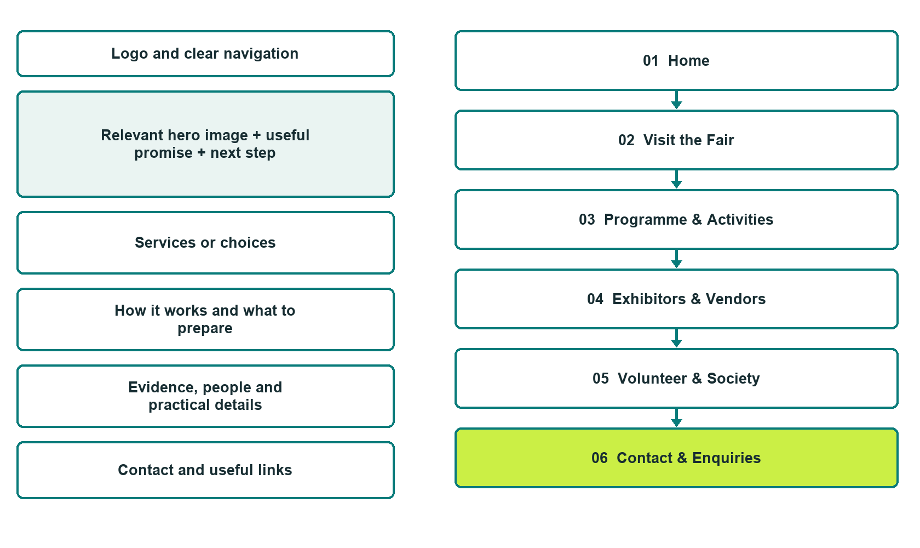

Plan → Draft → Build → Test
Demo-capture edition: actual Website Builder desktop previews and excerpts of the example wording. See each matching mobile preview in the industry page gallery. The example business and its AI-generated photographs are fictional.
Explore Website Builder and compare plans

Before you build
Your business supplies the facts. Prairie Gathering Exhibition Society is a fictional teaching example, not a live service.

□ Plan a visit or enquire about participating
□ Verified business identity and current contact information
□ Clear request and confirmation process
□ Choose original photographs and confirm permission to use them.
□ Keep private customer records out of public website forms.

Your audience and the action you want them to take

Facts to verify and people who must approve them
Create your SaaSTech account

01 Home
Give this page one clear job in the customer journey.
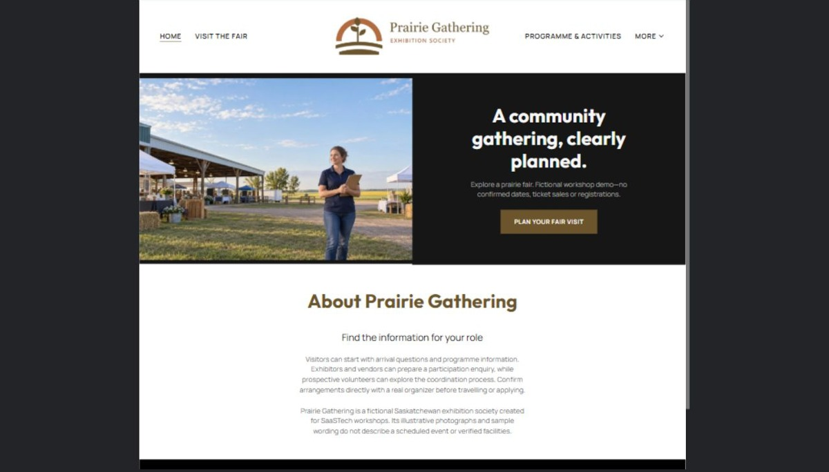
Actual desktop preview - unpublished fictional demonstration

Demo wording excerpt to adapt and verify
A community gathering, clearly planned.
Explore a prairie fair. Fictional workshop demo—no confirmed dates, ticket sales or registrations.
Visitors can start with arrival questions and programme information. Exhibitors and vendors can prepare a participation enquiry, while prospective volunteers can explore the coordination process. Confirm arrangements directly with a real organizer before travelling or applying.
Prairie Gathering is a fictional Saskatchewan exhibition society created for SaaSTech workshops. Its illustrative photographs and sample wording do not describe a scheduled event or verified facilities.
Suggested button: Plan your fair visit

Website advice
Separate visitor schedules and access information from exhibitor, vendor and volunteer enquiries. Keep dated event information controlled and clearly identify the current edition.

Your draft: Home
Write in the voice of your own business. Use facts you can verify, not promises copied from the example.

Headline and short introduction

Main content and details visitors need

Button wording and destination

Photo choice, permission and facts still to confirm
Partner check: can someone unfamiliar with the business find a useful next step?

02 Visit the Fair
Give this page one clear job in the customer journey.
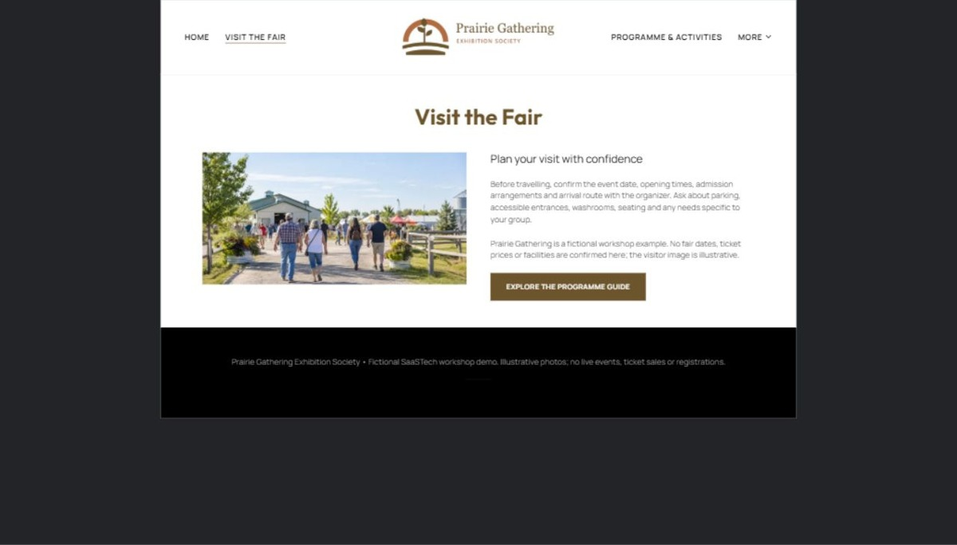
Actual desktop preview - unpublished fictional demonstration

Demo wording excerpt to adapt and verify
Plan your visit with confidence
Before travelling, confirm the event date, opening times, admission arrangements and arrival route with the organizer. Ask about parking, accessible entrances, washrooms, seating and any needs specific to your group.
Prairie Gathering is a fictional workshop example. No fair dates, ticket prices or facilities are confirmed here; the visitor image is illustrative.
Suggested button: Explore the programme guide

Website advice
Make the current edition, dates, admission, parking and visitor facilities easy to find. Never recycle last year’s details without review.

Your draft: Visit the Fair
Write in the voice of your own business. Use facts you can verify, not promises copied from the example.

Headline and short introduction

Main content and details visitors need

Button wording and destination

Photo choice, permission and facts still to confirm
Partner check: can someone unfamiliar with the business find a useful next step?

03 Programme & Activities
Give this page one clear job in the customer journey.
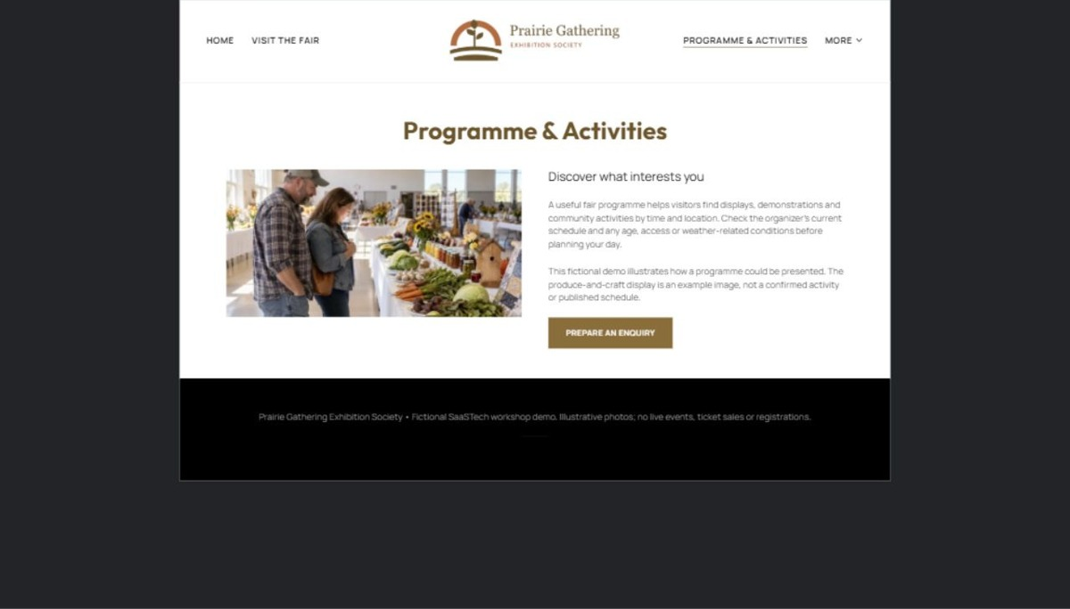
Actual desktop preview - unpublished fictional demonstration

Demo wording excerpt to adapt and verify
Discover what interests you
A useful fair programme helps visitors find displays, demonstrations and community activities by time and location. Check the organizer’s current schedule and any age, access or weather-related conditions before planning your day.
This fictional demo illustrates how a programme could be presented. The produce-and-craft display is an example image, not a confirmed activity or published schedule.
Suggested button: Prepare an enquiry

Website advice
Group verified activities into a readable schedule. Distinguish published times from draft programme ideas.

Your draft: Programme & Activities
Write in the voice of your own business. Use facts you can verify, not promises copied from the example.

Headline and short introduction

Main content and details visitors need

Button wording and destination

Photo choice, permission and facts still to confirm
Partner check: can someone unfamiliar with the business find a useful next step?

04 Exhibitors & Vendors
Give this page one clear job in the customer journey.
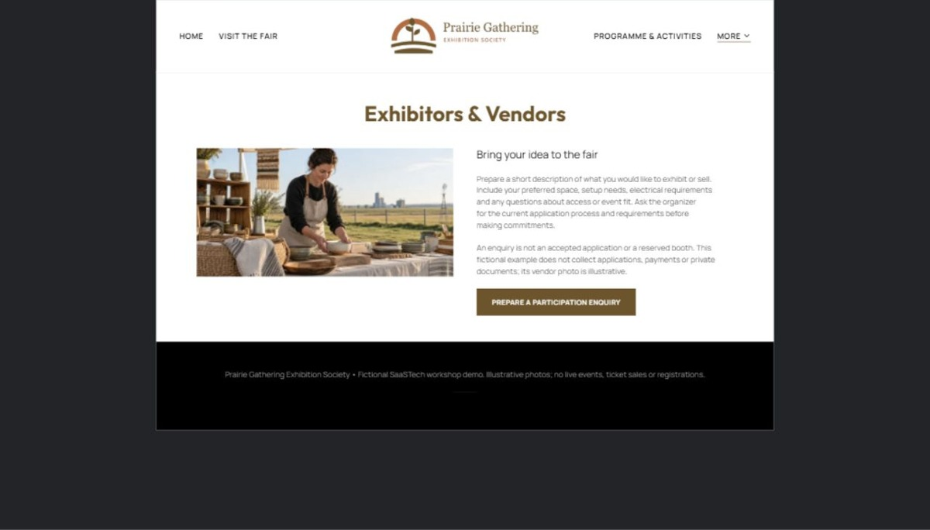
Actual desktop preview - unpublished fictional demonstration

Demo wording excerpt to adapt and verify
Bring your idea to the fair
Prepare a short description of what you would like to exhibit or sell. Include your preferred space, setup needs, electrical requirements and any questions about access or event fit. Ask the organizer for the current application process and requirements before making commitments.
An enquiry is not an accepted application or a reserved booth. This fictional example does not collect applications, payments or private documents; its vendor photo is illustrative.
Suggested button: Prepare a participation enquiry

Website advice
Explain the enquiry and application process, required information and approval steps. Publish only approved deadlines and terms.

Your draft: Exhibitors & Vendors
Write in the voice of your own business. Use facts you can verify, not promises copied from the example.

Headline and short introduction

Main content and details visitors need

Button wording and destination

Photo choice, permission and facts still to confirm
Partner check: can someone unfamiliar with the business find a useful next step?

05 Volunteer & Society
Give this page one clear job in the customer journey.
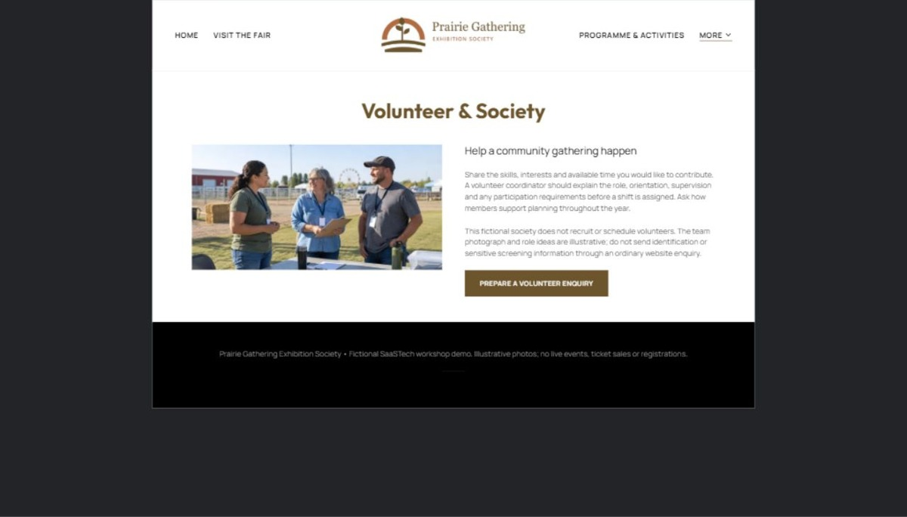
Actual desktop preview - unpublished fictional demonstration

Demo wording excerpt to adapt and verify
Help a community gathering happen
Share the skills, interests and available time you would like to contribute. A volunteer coordinator should explain the role, orientation, supervision and any participation requirements before a shift is assigned. Ask how members support planning throughout the year.
This fictional society does not recruit or schedule volunteers. The team photograph and role ideas are illustrative; do not send identification or sensitive screening information through an ordinary website enquiry.
Suggested button: Prepare a volunteer enquiry

Website advice
Introduce the society and roles available, with verified contacts and approved volunteer arrangements. Keep sensitive volunteer records private.

Your draft: Volunteer & Society
Write in the voice of your own business. Use facts you can verify, not promises copied from the example.

Headline and short introduction

Main content and details visitors need

Button wording and destination

Photo choice, permission and facts still to confirm
Partner check: can someone unfamiliar with the business find a useful next step?

06 Contact & Enquiries
Give this page one clear job in the customer journey.
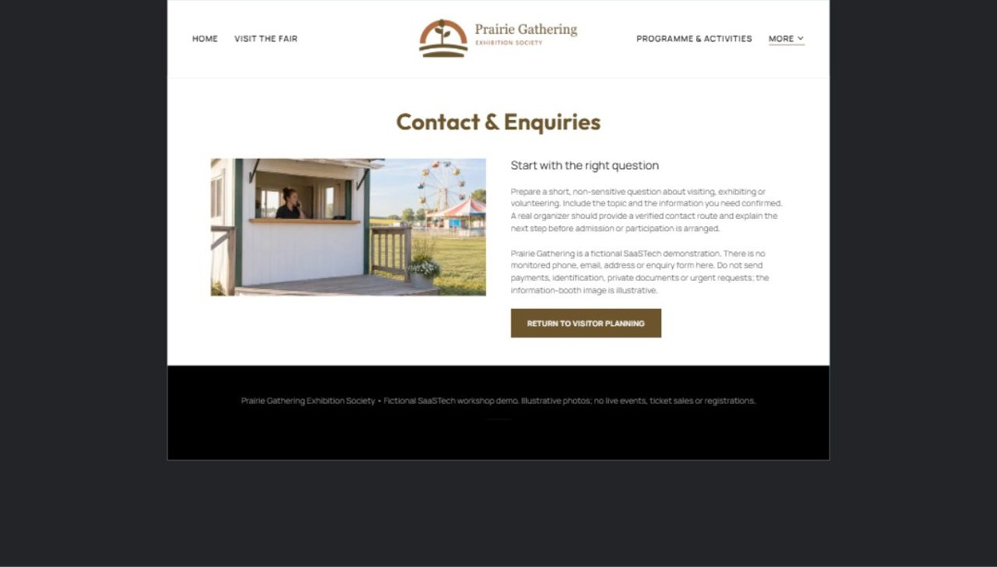
Actual desktop preview - unpublished fictional demonstration

Demo wording excerpt to adapt and verify
Start with the right question
Prepare a short, non-sensitive question about visiting, exhibiting or volunteering. Include the topic and the information you need confirmed. A real organizer should provide a verified contact route and explain the next step before admission or participation is arranged.
Prairie Gathering is a fictional SaaSTech demonstration. There is no monitored phone, email, address or enquiry form here. Do not send payments, identification, private documents or urgent requests; the information-booth image is illustrative.
Suggested button: Return to visitor planning

Website advice
Give the verified address, hours and correct contact path. Collect only the minimum information needed for a first response; make confirmation requirements clear.

Your draft: Contact & Enquiries
Write in the voice of your own business. Use facts you can verify, not promises copied from the example.

Headline and short introduction

Main content and details visitors need

Button wording and destination

Photo choice, permission and facts still to confirm
Partner check: can someone unfamiliar with the business find a useful next step?

Test before publishing
Review the whole journey on a desktop and phone. The industry page pairs each desktop capture with its mobile preview and provides the complete sample page copy.
□ Fictional event example only. Have the organizer verify schedules, entry rules, fees, accessibility and permissions before accepting registrations or publishing event claims.
□ Verify contact routes, hours, location and every offered service.
□ Remove invented prices, claims, testimonials and availability.
□ Keep sensitive records and payment details out of ordinary public forms.
□ Check all image permissions, downloads and page links on a phone.
□ Check every link, form destination, download and confirmation message.
□ Check logo contrast, hero framing, text sizes and image loading.
□ Save a named backup and assign a content-review date.

Changes to finish and person responsible

Approval and next review date
Website Builder plans and signup

