
WEBSITE PLANNING WORKSHOP

Event Planners & Entertainers
Website workbook
Plan a clear website for event planners & entertainers. Explore a worked example, shape your own message and prepare to build with SaaSTech Servers.
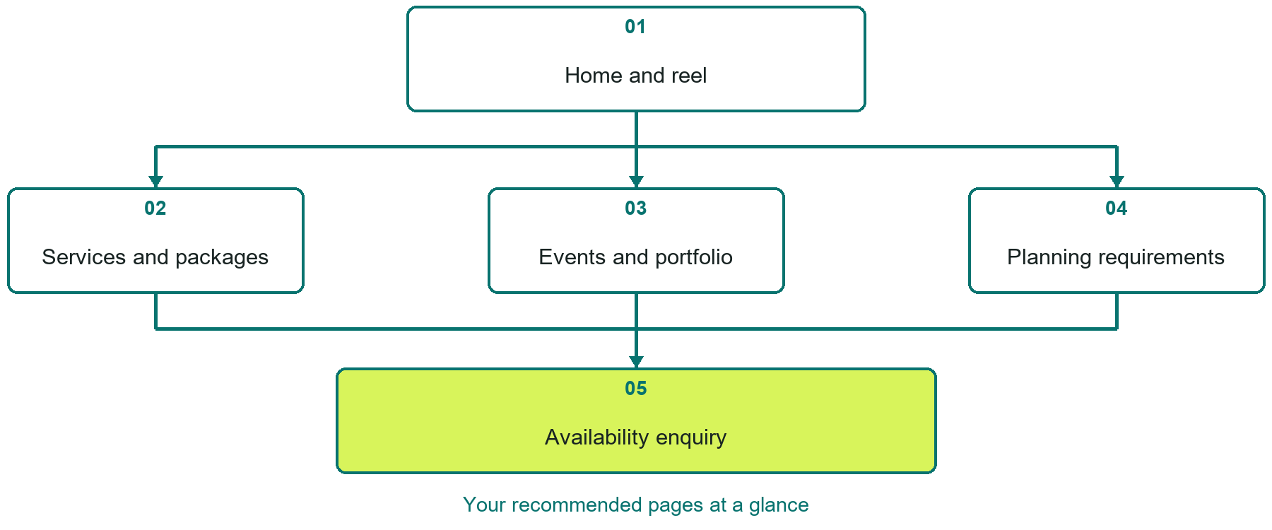

Inside this workbook
Five page examples • Practical writing exercises • A launch review
Use it in a workshop or at your own pace. Write by hand or complete the response fields in Word. The final page links to Website Builder, plans and account signup.
Example business Aurora Stage & Events

EVENT PLANNERS & ENTERTAINERS

Your website brief
A SaaSTech Servers workshop for event planners & entertainers. Plan your website, learn from the Aurora Stage & Events example and draft content for your own business.
Each page has a reference sheet followed by a writing sheet. Demo excerpts are labelled separately from new sample wording, which may differ from the screenshot. Click a blank response line to type; longer answers may add pages. Replace fictional details and verify every claim before publishing.
Your business or organization and workshop date

Who should visit your site and what do they need

The main action you want a visitor to take

What you offer and where or how you provide it

Facts photos and permissions to gather before publishing

Workshop rhythm: review the example, write your draft and exchange feedback. Use the final review to choose your next changes. Website Builder and account links are on the last page.

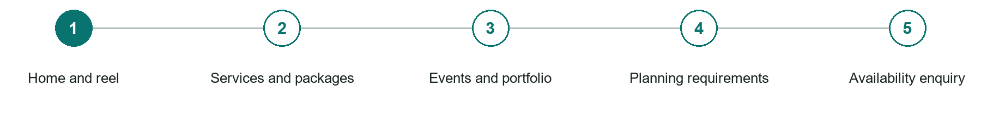
LOOK AND LEARN

Home and reel

The job of this page
Show the experience, service area, audience fit, and date-availability action without forcing a long video to load first.
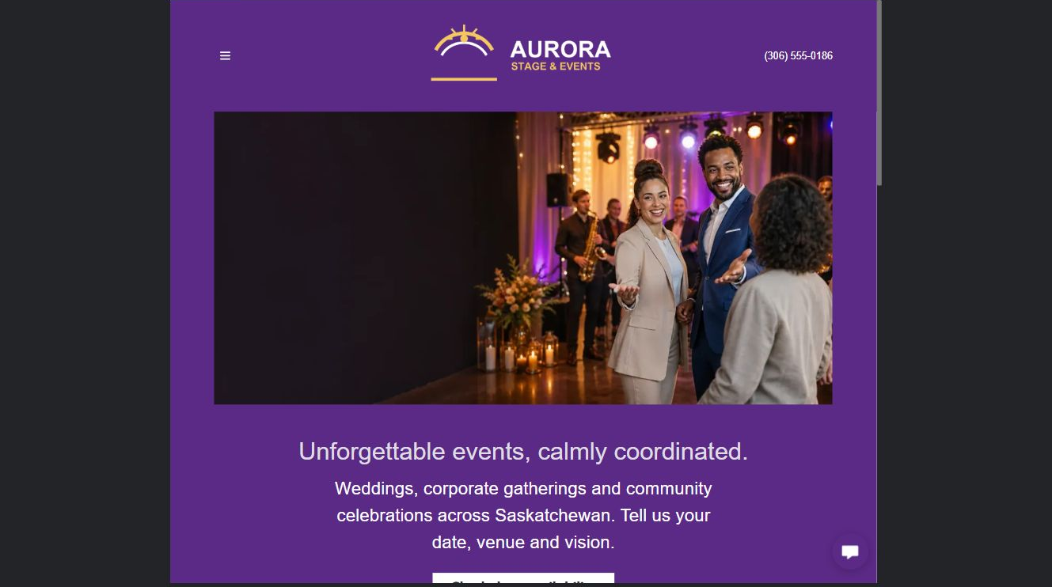
Aurora Stage & Events example | Explore SaaSTech Website Builder

Sample wording to adapt
Start planning the atmosphere for your event
Explore the performance and production examples, then tell us about your occasion. Scope, venue requirements and availability are discussed before a booking is agreed.

Pause and plan
Which examples best support this page? Explain the context, your contribution and the permissions or credits needed. Label illustrative work and distinguish it from genuine completed projects or customer results.

WRITE YOUR PAGE

Home and reel
Write for your visitor. Be specific about what they need to know and what happens next. You can revise the wording after the workshop.
Your page headline

Your opening paragraph

Examples captions context and evidence to include

Button or link wording and where it should lead

Photo idea caption and permission or credit needed

Facts to verify or questions to resolve

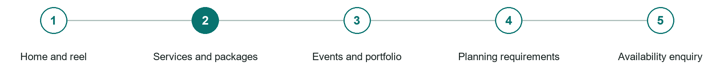
LOOK AND LEARN

Services and packages

The job of this page
Separate planning, performance, production, hosting, add-ons, and package guidance in buyer language.
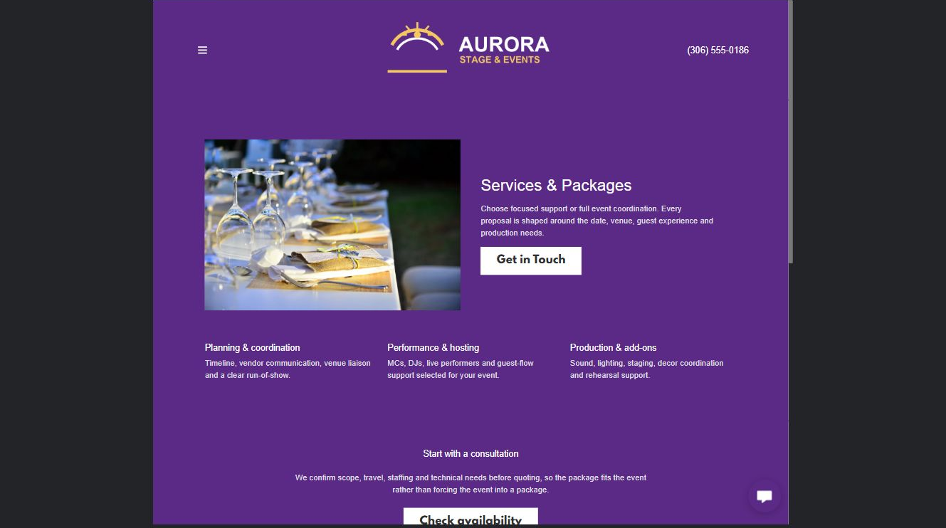
Aurora Stage & Events example | Explore SaaSTech Website Builder

Sample wording to adapt
Choose support for the event you are planning
Describe the audience, format and timing. We will clarify the service, equipment, staffing and exclusions before quoting. A package example is a starting point, not a confirmed offer.

Pause and plan
What is included and what needs separate confirmation? Make quantities, timing, exclusions and price conditions understandable. Avoid implying that an example price or image guarantees availability.

WRITE YOUR PAGE

Services and packages
Write for your visitor. Be specific about what they need to know and what happens next. You can revise the wording after the workshop.
Your page headline

Your opening paragraph

Options inclusions price conditions and availability details

Button or link wording and where it should lead

Photo idea caption and permission or credit needed

Facts to verify or questions to resolve

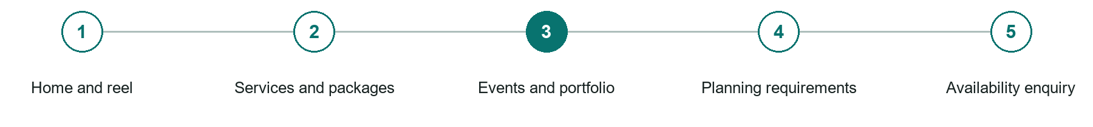
LOOK AND LEARN

Events and portfolio

The job of this page
Show relevant weddings, corporate events, festivals, private functions, or productions with permission and context.
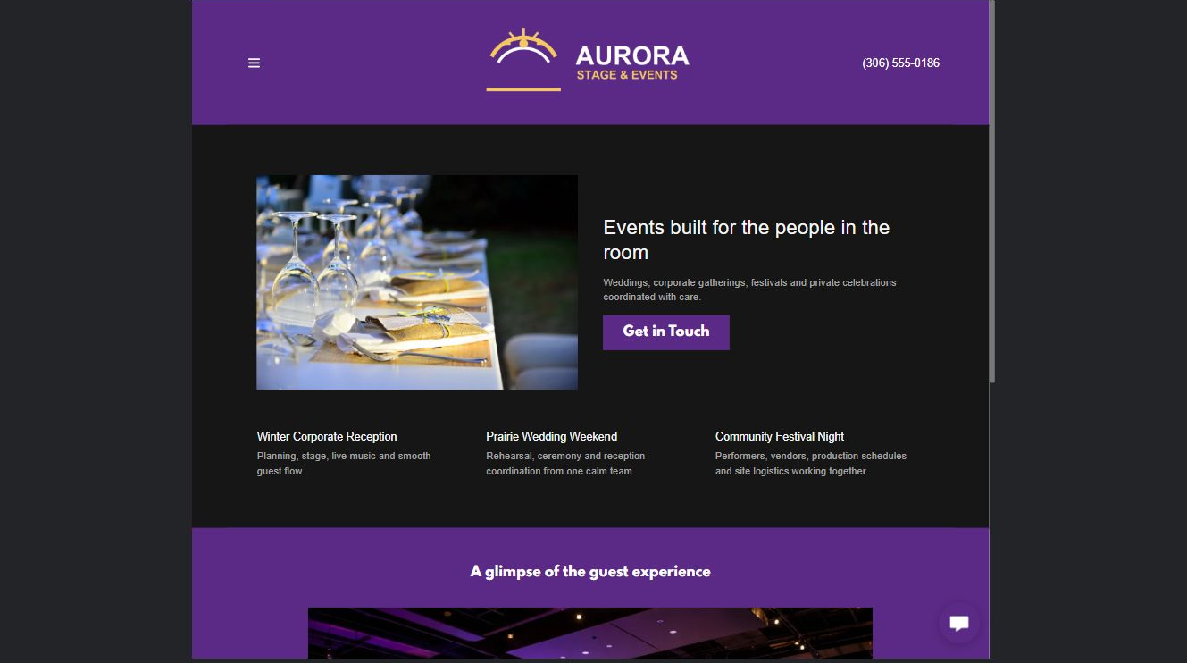
Aurora Stage & Events example | Explore SaaSTech Website Builder

Sample wording to adapt
See the event in context
Look at the venue, audience and work provided in each example. Published photographs need permission and useful captions. Illustrative scenes should not be presented as completed client events.

Pause and plan
Which examples best support this page? Explain the context, your contribution and the permissions or credits needed. Label illustrative work and distinguish it from genuine completed projects or customer results.

WRITE YOUR PAGE

Events and portfolio
Write for your visitor. Be specific about what they need to know and what happens next. You can revise the wording after the workshop.
Your page headline

Your opening paragraph

Examples captions context and evidence to include

Button or link wording and where it should lead

Photo idea caption and permission or credit needed

Facts to verify or questions to resolve

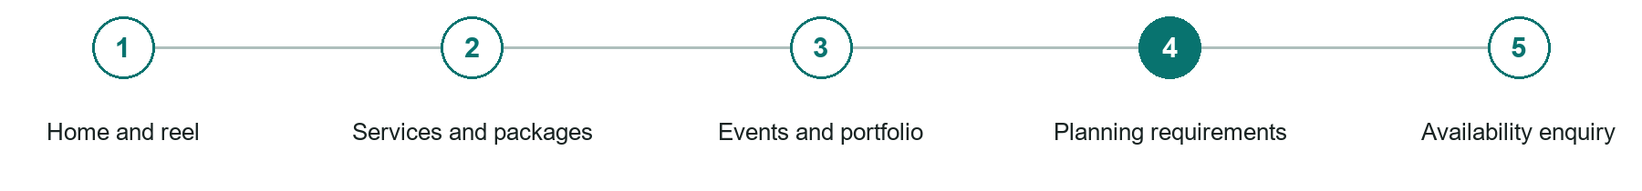
LOOK AND LEARN

Planning requirements

The job of this page
Explain travel, space, power, sound, setup, access, timing, deposits, cancellations, and venue coordination.
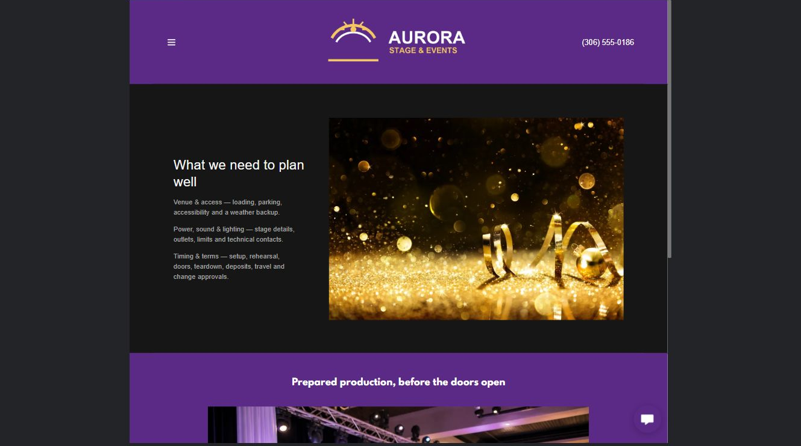
Aurora Stage & Events example | Explore SaaSTech Website Builder

Sample wording to adapt
Prepare the venue information
Share access, performance space, timing and available facilities. Discuss setup, sound limits and weather arrangements where relevant. Responsibilities should be confirmed with the venue before booking.

Pause and plan
What question brings a visitor to this page? List the details they need, the evidence you can provide and the next useful action. Remove content that does not help them decide or proceed.

WRITE YOUR PAGE

Planning requirements
Write for your visitor. Be specific about what they need to know and what happens next. You can revise the wording after the workshop.
Your page headline

Your opening paragraph

Key sections visitor questions and supporting details

Button or link wording and where it should lead

Photo idea caption and permission or credit needed

Facts to verify or questions to resolve

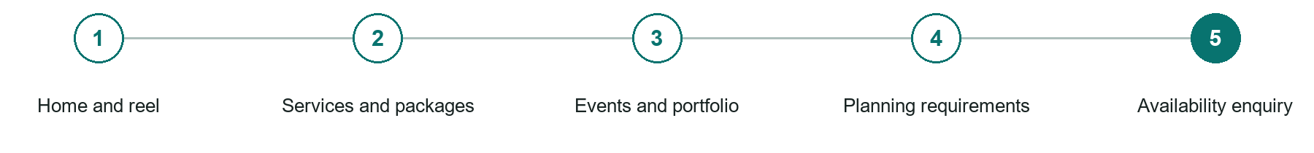
LOOK AND LEARN

Availability enquiry

The job of this page
Ask for date, venue, location, event type, audience size, timing, desired service, and contact details.
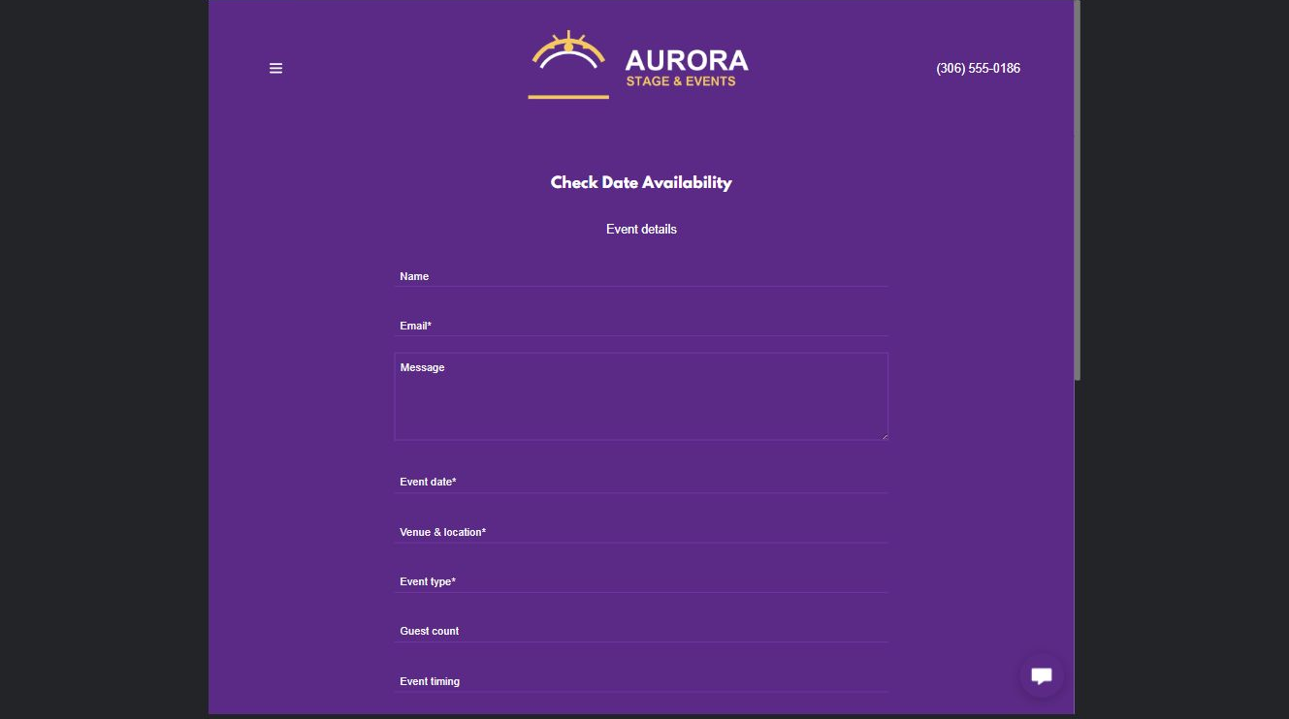
Aurora Stage & Events example | Explore SaaSTech Website Builder

Sample wording to adapt
Ask about your date
Include the occasion, date, venue, guest count and service interest. The team will review fit and availability. A request does not reserve performers or confirm an event package.

Pause and plan
What must someone provide, and what happens after they send it? Separate a request from a confirmed booking, order or place. Decide what information should stay out of a public form.

WRITE YOUR PAGE

Availability enquiry
Write for your visitor. Be specific about what they need to know and what happens next. You can revise the wording after the workshop.
Your page headline

Your opening paragraph

Information to request and how you will reply or confirm

Button or link wording and where it should lead

Photo idea caption and permission or credit needed

Facts to verify or questions to resolve

WORKSHOP CLOSE

Review and next steps
Ask a partner to read your draft as a first-time visitor. Can they explain what you offer, who it is for and the next step without extra help?

Before you publish
[ ] Every page has a clear purpose and a useful next step.
[ ] Headlines are specific and the wording sounds like your business.
[ ] Names, service areas, prices, dates and policies have been checked.
[ ] Credentials, testimonials and results are genuine and permission-cleared.
[ ] Photos support the text, do not repeat needlessly and have appropriate permissions.
[ ] Forms ask only for necessary information and explain what happens next.
[ ] Links, downloads and the main visitor task work on a phone.
The most useful feedback from your workshop partner

First change to make and who will do it

Information or photographs still needed

Target review date and who will approve the final content

Keep sensitive customer, patient, employee and payment information out of this workbook. Completing it does not publish a website or connect to Website Builder.

BUILD WITH SAASTECH SERVERS

Put your draft into Website Builder
Use the content you have written to build your own site. Keep the event planners & entertainers demo as a reference, and replace its company name, images and claims with your verified business information.

Explore the builder
See the editor, compare available plans and decide which features your business needs. Confirm current pricing and terms before purchasing.
Website Builder overview

Create your account
Set up your SaaSTech Servers customer account using your own details. Creating an account is separate from purchasing a Website Builder plan.
Create your SaaSTech account

Choose your plan
Open the secure shop to review the plan, subscription term and final total. Use the account connected to your purchase when you open your service.
View Website Builder plans

Build and check your pages
Add the pages from this workbook. Transfer your approved wording, upload permission-cleared photos and review each page on desktop and mobile before publishing.
Return to the Website Builder guide

Using a printed workbook
Type these short addresses into your browser. The account guide includes the Create My Account button.
www.saastech.net/products/website-builder
www.saastech.net/create-account
This workbook does not create an account, purchase a plan or publish your website. Keep passwords, payment details and confidential customer information out of your draft.

