
WEBSITE PLANNING WORKSHOP

Event Venues
Website workbook
Plan a clear website for event venues. Explore a worked example, shape your own message and prepare to build with SaaSTech Servers.
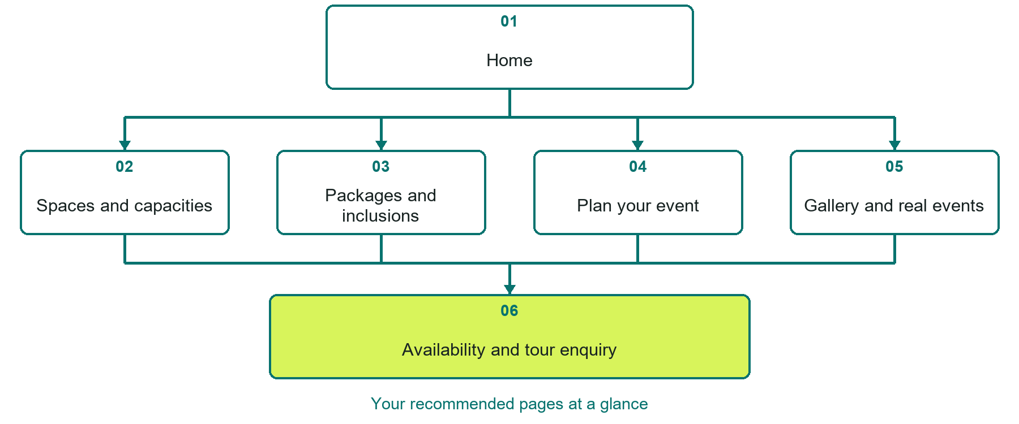

Inside this workbook
Six page examples • Practical writing exercises • A launch review
Use it in a workshop or at your own pace. Write by hand or complete the response fields in Word. The final page links to Website Builder, plans and account signup.
Example business Prairie Lantern Events

EVENT VENUES

Your website brief
A SaaSTech Servers workshop for event venues. Plan your website, learn from the Prairie Lantern Events example and draft content for your own business.
Each page has a reference sheet followed by a writing sheet. Demo excerpts are labelled separately from new sample wording, which may differ from the screenshot. Click a blank response line to type; longer answers may add pages. Replace fictional details and verify every claim before publishing.
Your business or organization and workshop date

Who should visit your site and what do they need

The main action you want a visitor to take

What you offer and where or how you provide it

Facts photos and permissions to gather before publishing

Workshop rhythm: review the example, write your draft and exchange feedback. Use the final review to choose your next changes. Website Builder and account links are on the last page.

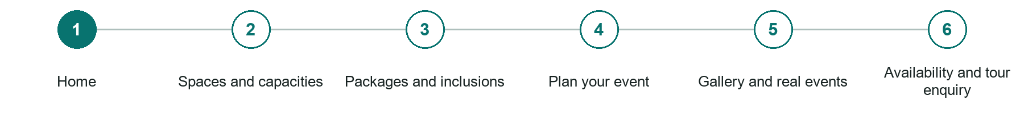
LOOK AND LEARN

Home

The job of this page
Introduce the venue, location, supported event types, representative photography, and one clear availability or tour action.
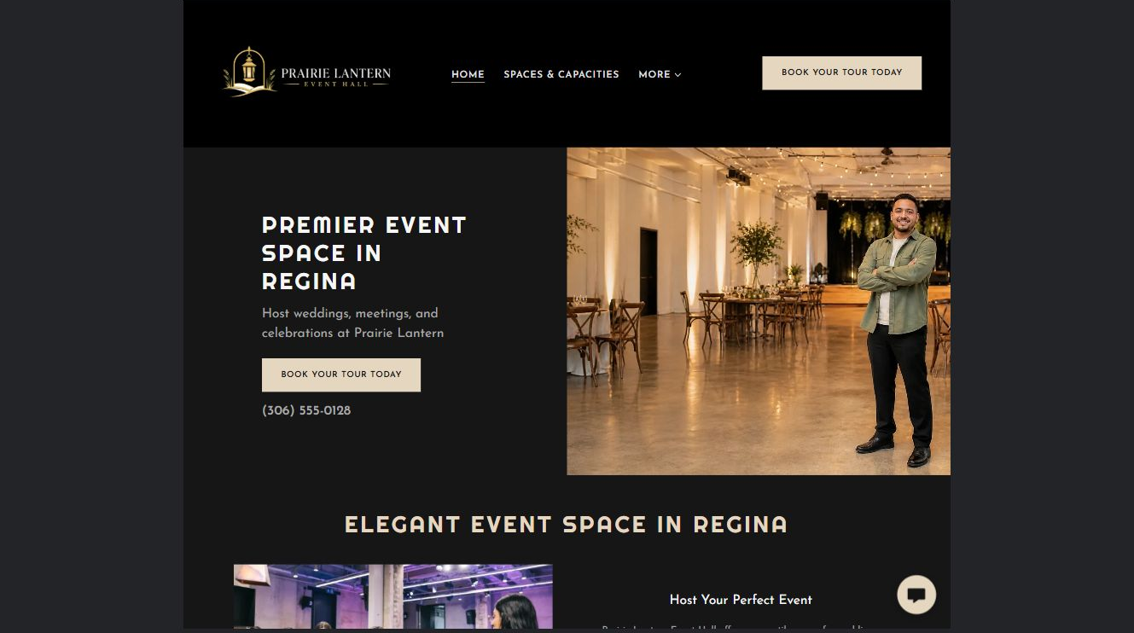
Prairie Lantern Events example | Explore SaaSTech Website Builder

Sample wording to adapt
Picture your event at Prairie Lantern
Explore the spaces and planning information, then ask about a tour or your preferred date. Capacity, inclusions and availability depend on the event and must be confirmed.

Pause and plan
Could a first-time visitor explain what you do and who it is for after one glance? Choose one main action and the strongest truthful detail that gives them confidence to continue.

WRITE YOUR PAGE

Home
Write for your visitor. Be specific about what they need to know and what happens next. You can revise the wording after the workshop.
Your page headline

Your opening paragraph

Your offer audience location and most useful supporting details

Button or link wording and where it should lead

Photo idea caption and permission or credit needed

Facts to verify or questions to resolve

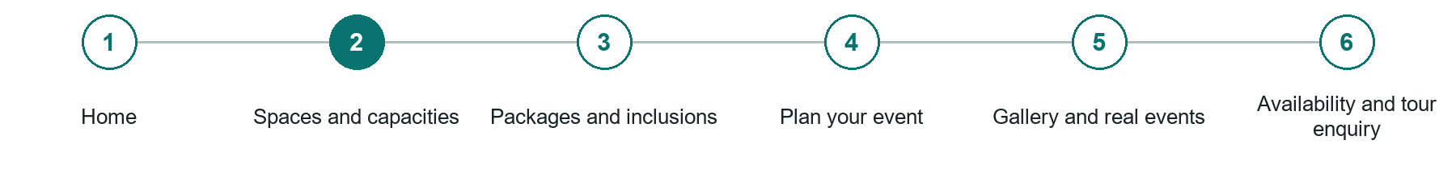
LOOK AND LEARN

Spaces and capacities

The job of this page
Show each room or outdoor area with accurate capacities by layout, dimensions, accessibility, washrooms, entrances, and representative photographs.
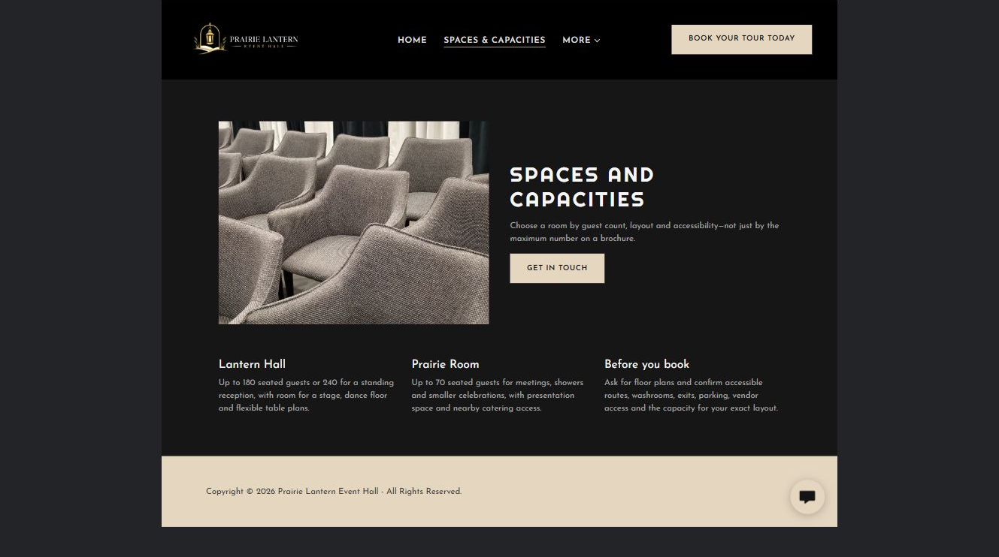
Prairie Lantern Events example | Explore SaaSTech Website Builder

Sample wording to adapt
Find a space for your guest list
Compare room layouts and the facilities relevant to your event. Ask the venue to confirm capacity for the proposed setup. Photographs are not a substitute for an agreed floor plan.

Pause and plan
What question brings a visitor to this page? List the details they need, the evidence you can provide and the next useful action. Remove content that does not help them decide or proceed.

WRITE YOUR PAGE

Spaces and capacities
Write for your visitor. Be specific about what they need to know and what happens next. You can revise the wording after the workshop.
Your page headline

Your opening paragraph

Key sections visitor questions and supporting details

Button or link wording and where it should lead

Photo idea caption and permission or credit needed

Facts to verify or questions to resolve

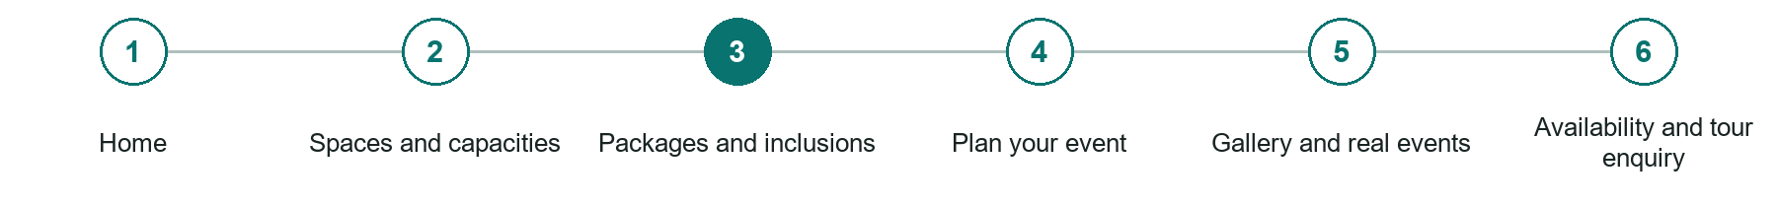
LOOK AND LEARN

Packages and inclusions

The job of this page
Explain rental periods, furnishings, equipment, staffing, setup, cleanup, catering, bar service, deposits, taxes, damage terms, and optional extras.
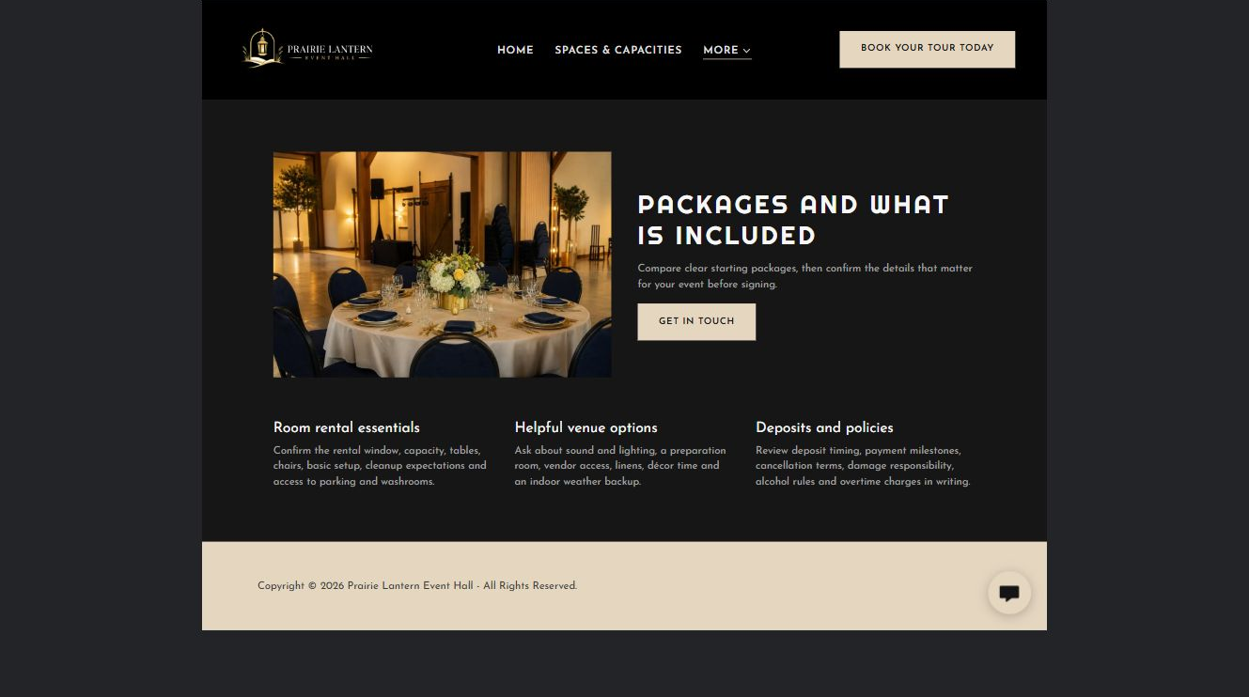
Prairie Lantern Events example | Explore SaaSTech Website Builder

Sample wording to adapt
Know what the package includes
Review the space, furniture, staffing and service hours included in a proposal. Ask about exclusions and additional charges. Confirm the complete scope before accepting a booking agreement.

Pause and plan
What is included and what needs separate confirmation? Make quantities, timing, exclusions and price conditions understandable. Avoid implying that an example price or image guarantees availability.

WRITE YOUR PAGE

Packages and inclusions
Write for your visitor. Be specific about what they need to know and what happens next. You can revise the wording after the workshop.
Your page headline

Your opening paragraph

Options inclusions price conditions and availability details

Button or link wording and where it should lead

Photo idea caption and permission or credit needed

Facts to verify or questions to resolve

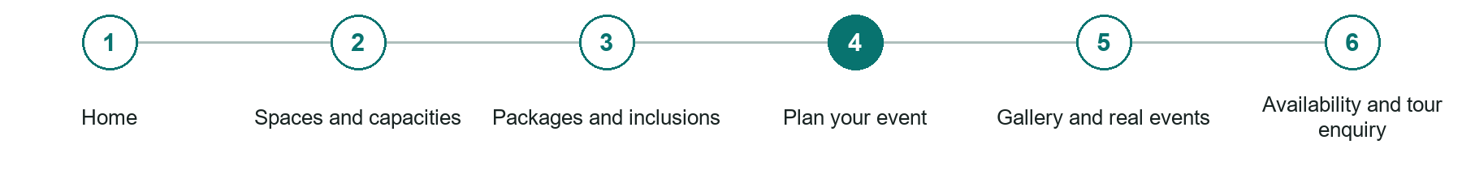
LOOK AND LEARN

Plan your event

The job of this page
Cover parking, transportation, deliveries, vendors, sound limits, decorating, rehearsals, weather alternatives, security, insurance, and venue restrictions.
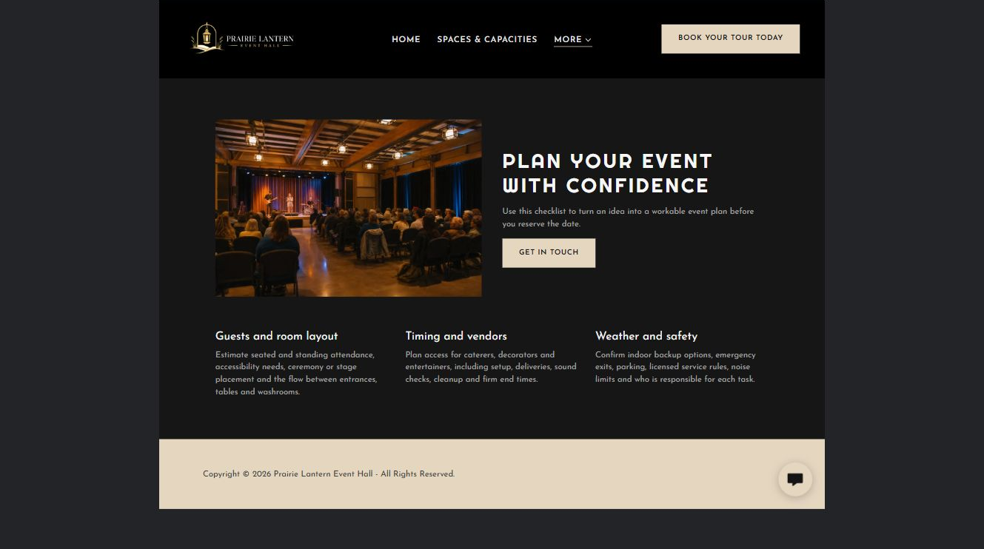
Prairie Lantern Events example | Explore SaaSTech Website Builder

Sample wording to adapt
Plan the practical details
Discuss vendor access, setup times, catering arrangements and any restrictions. Share accessibility needs and the event schedule early. Agree responsibilities with the venue before inviting suppliers to proceed.

Pause and plan
Which dates and locations need to stay current? Decide who will update changes and where visitors should check before travelling. Separate archived information and illustrative schedules from current availability.

WRITE YOUR PAGE

Plan your event
Write for your visitor. Be specific about what they need to know and what happens next. You can revise the wording after the workshop.
Your page headline

Your opening paragraph

Dates locations update process and participation details

Button or link wording and where it should lead

Photo idea caption and permission or credit needed

Facts to verify or questions to resolve

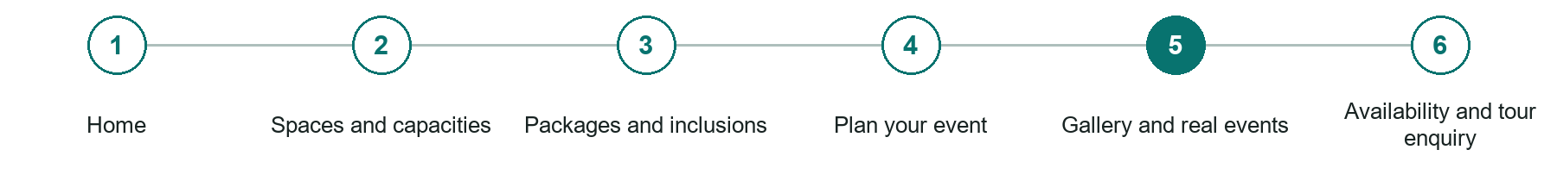
LOOK AND LEARN

Gallery and real events

The job of this page
Show permission-based examples across the event types and room arrangements the venue actively supports.
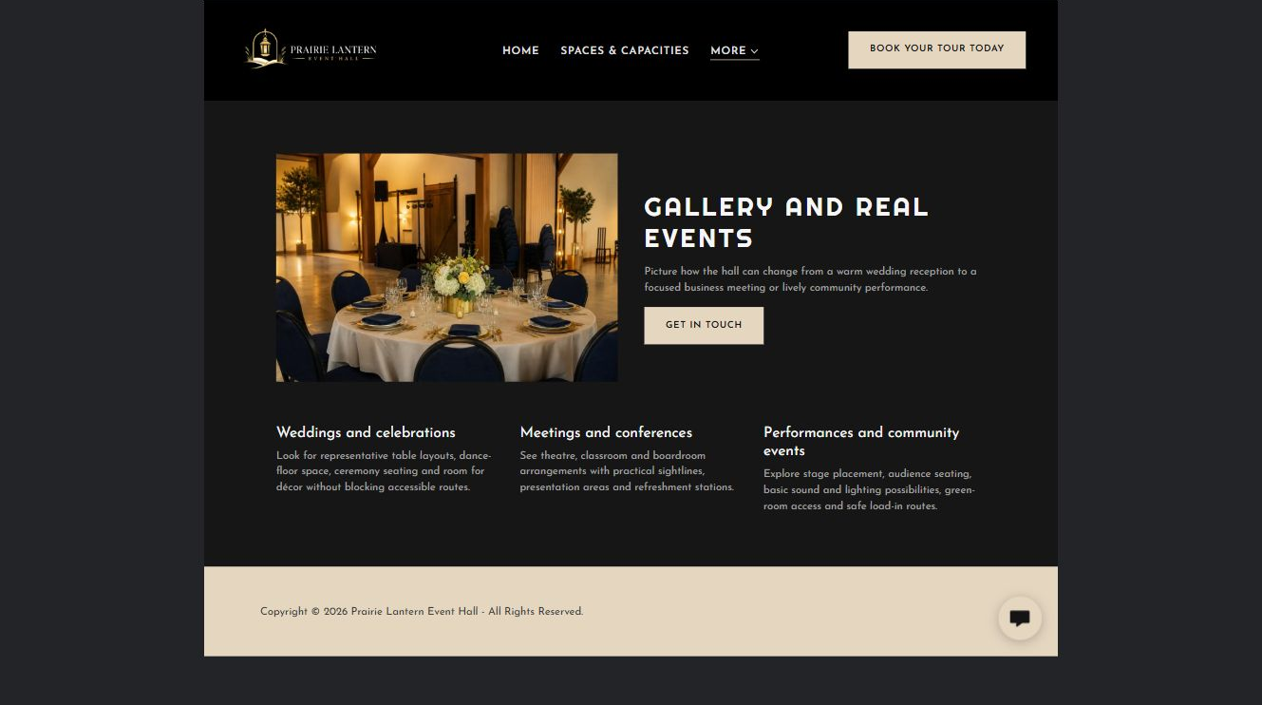
Prairie Lantern Events example | Explore SaaSTech Website Builder

Sample wording to adapt
Explore layouts and event ideas
Look at how the space has been arranged and read the context for each image. Distinguish genuine event photographs from illustrative inspiration. Ask which elements are available for your booking.

Pause and plan
Which examples best support this page? Explain the context, your contribution and the permissions or credits needed. Label illustrative work and distinguish it from genuine completed projects or customer results.

WRITE YOUR PAGE

Gallery and real events
Write for your visitor. Be specific about what they need to know and what happens next. You can revise the wording after the workshop.
Your page headline

Your opening paragraph

Examples captions context and evidence to include

Button or link wording and where it should lead

Photo idea caption and permission or credit needed

Facts to verify or questions to resolve

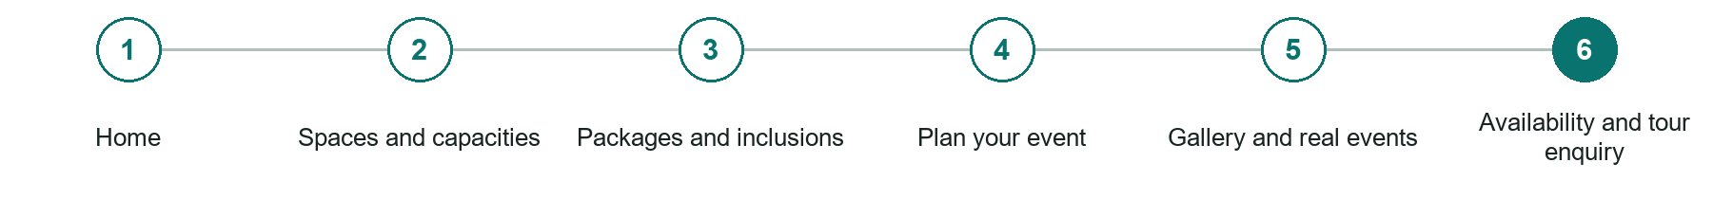
LOOK AND LEARN

Availability and tour enquiry

The job of this page
Collect date flexibility, event type, attendance, spaces, timing, accessibility, catering, technical needs, budget guidance, and planner contact.
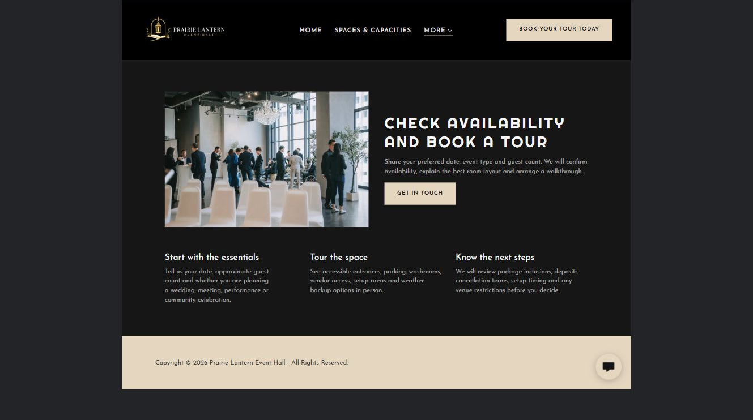
Prairie Lantern Events example | Explore SaaSTech Website Builder

Sample wording to adapt
Ask about a date or tour
Include the occasion, date, guest count and preferred layout. The venue will confirm availability and the next step. An enquiry does not hold a date or confirm a package.

Pause and plan
What must someone provide, and what happens after they send it? Separate a request from a confirmed booking, order or place. Decide what information should stay out of a public form.

WRITE YOUR PAGE

Availability and tour enquiry
Write for your visitor. Be specific about what they need to know and what happens next. You can revise the wording after the workshop.
Your page headline

Your opening paragraph

Information to request and how you will reply or confirm

Button or link wording and where it should lead

Photo idea caption and permission or credit needed

Facts to verify or questions to resolve

WORKSHOP CLOSE

Review and next steps
Ask a partner to read your draft as a first-time visitor. Can they explain what you offer, who it is for and the next step without extra help?

Before you publish
[ ] Every page has a clear purpose and a useful next step.
[ ] Headlines are specific and the wording sounds like your business.
[ ] Names, service areas, prices, dates and policies have been checked.
[ ] Credentials, testimonials and results are genuine and permission-cleared.
[ ] Photos support the text, do not repeat needlessly and have appropriate permissions.
[ ] Forms ask only for necessary information and explain what happens next.
[ ] Links, downloads and the main visitor task work on a phone.
The most useful feedback from your workshop partner

First change to make and who will do it

Information or photographs still needed

Target review date and who will approve the final content

Keep sensitive customer, patient, employee and payment information out of this workbook. Completing it does not publish a website or connect to Website Builder.

BUILD WITH SAASTECH SERVERS

Put your draft into Website Builder
Use the content you have written to build your own site. Keep the event venues demo as a reference, and replace its company name, images and claims with your verified business information.

Explore the builder
See the editor, compare available plans and decide which features your business needs. Confirm current pricing and terms before purchasing.
Website Builder overview

Create your account
Set up your SaaSTech Servers customer account using your own details. Creating an account is separate from purchasing a Website Builder plan.
Create your SaaSTech account

Choose your plan
Open the secure shop to review the plan, subscription term and final total. Use the account connected to your purchase when you open your service.
View Website Builder plans

Build and check your pages
Add the pages from this workbook. Transfer your approved wording, upload permission-cleared photos and review each page on desktop and mobile before publishing.
Return to the Website Builder guide

Using a printed workbook
Type these short addresses into your browser. The account guide includes the Create My Account button.
www.saastech.net/products/website-builder
www.saastech.net/create-account
This workbook does not create an account, purchase a plan or publish your website. Keep passwords, payment details and confidential customer information out of your draft.

