
WEBSITE PLANNING WORKSHOP

Economic Development
Website workbook
Plan a clear website for economic development. Explore a worked example, shape your own message and prepare to build with SaaSTech Servers.
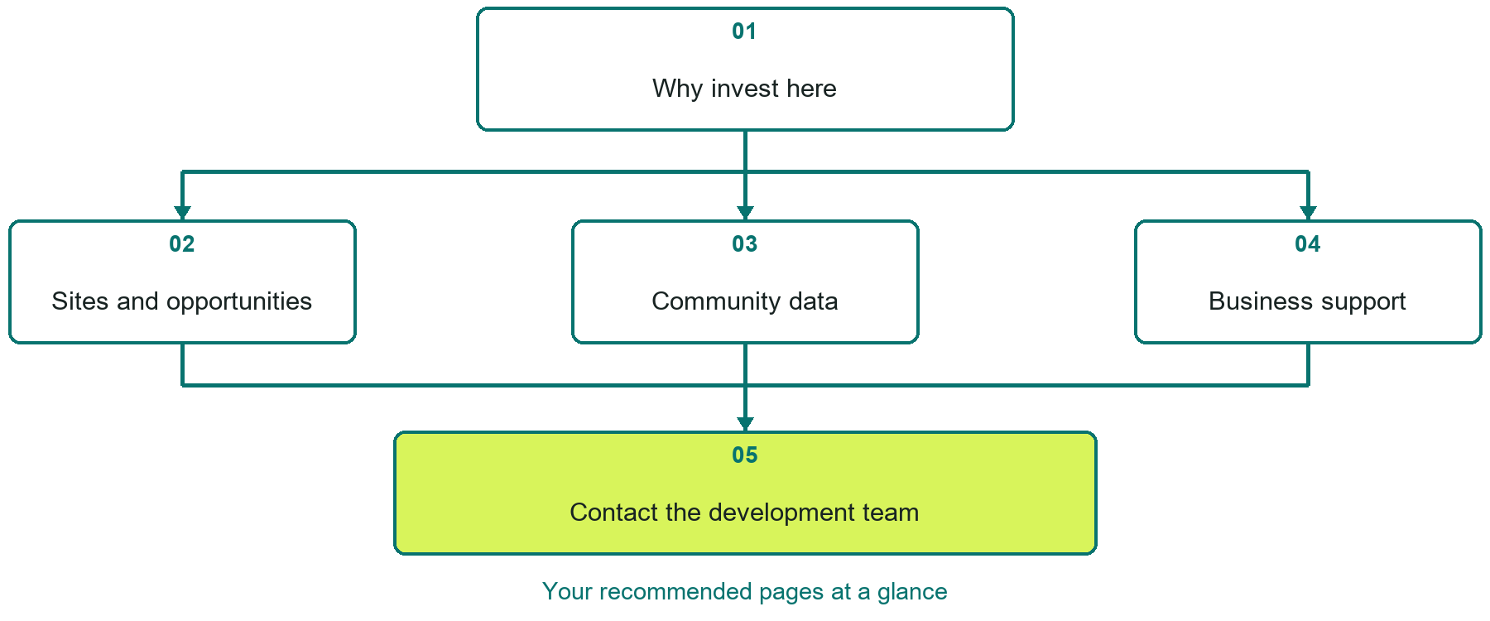

Inside this workbook
Five page examples • Practical writing exercises • A launch review
Use it in a workshop or at your own pace. Write by hand or complete the response fields in Word. The final page links to Website Builder, plans and account signup.
Example business Prairie Horizon Development Alliance

ECONOMIC DEVELOPMENT

Your website brief
A SaaSTech Servers workshop for economic development. Plan your website, learn from the Prairie Horizon Development Alliance example and draft content for your own business.
Each page has a reference sheet followed by a writing sheet. Demo excerpts are labelled separately from new sample wording, which may differ from the screenshot. Click a blank response line to type; longer answers may add pages. Replace fictional details and verify every claim before publishing.
Your business or organization and workshop date

Who should visit your site and what do they need

The main action you want a visitor to take

What you offer and where or how you provide it

Facts photos and permissions to gather before publishing

Workshop rhythm: review the example, write your draft and exchange feedback. Use the final review to choose your next changes. Website Builder and account links are on the last page.

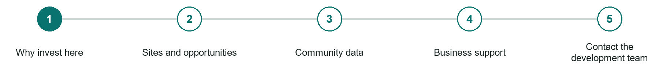
LOOK AND LEARN

Why invest here

The job of this page
Summarize the location advantage with evidence, priority sectors, infrastructure, workforce, and market access.
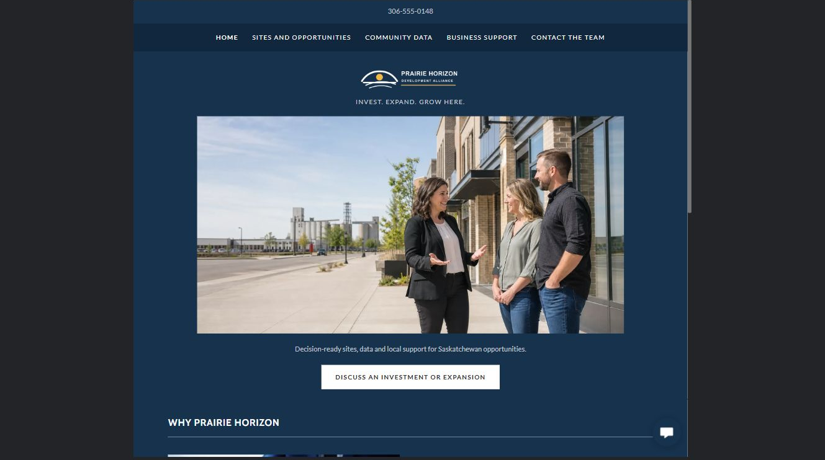
Prairie Horizon Development Alliance example | Explore SaaSTech Website Builder

Demo text example
INVEST. EXPAND. GROW HERE.
Decision-ready sites, data and local support for Saskatchewan opportunities.

Pause and plan
Could a first-time visitor explain what you do and who it is for after one glance? Choose one main action and the strongest truthful detail that gives them confidence to continue.

WRITE YOUR PAGE

Why invest here
Write for your visitor. Be specific about what they need to know and what happens next. You can revise the wording after the workshop.
Your page headline

Your opening paragraph

Your offer audience location and most useful supporting details

Button or link wording and where it should lead

Photo idea caption and permission or credit needed

Facts to verify or questions to resolve

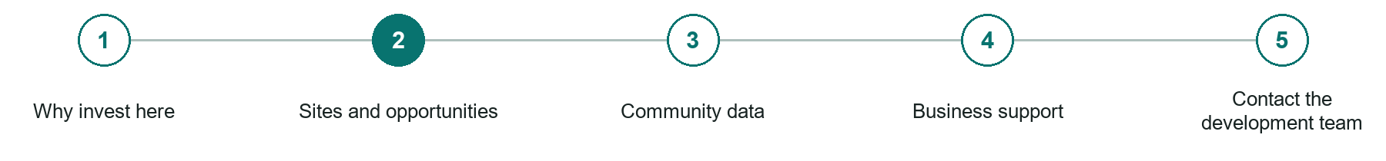
LOOK AND LEARN

Sites and opportunities

The job of this page
Publish available land, buildings, development areas, and opportunity profiles with ownership and update dates.
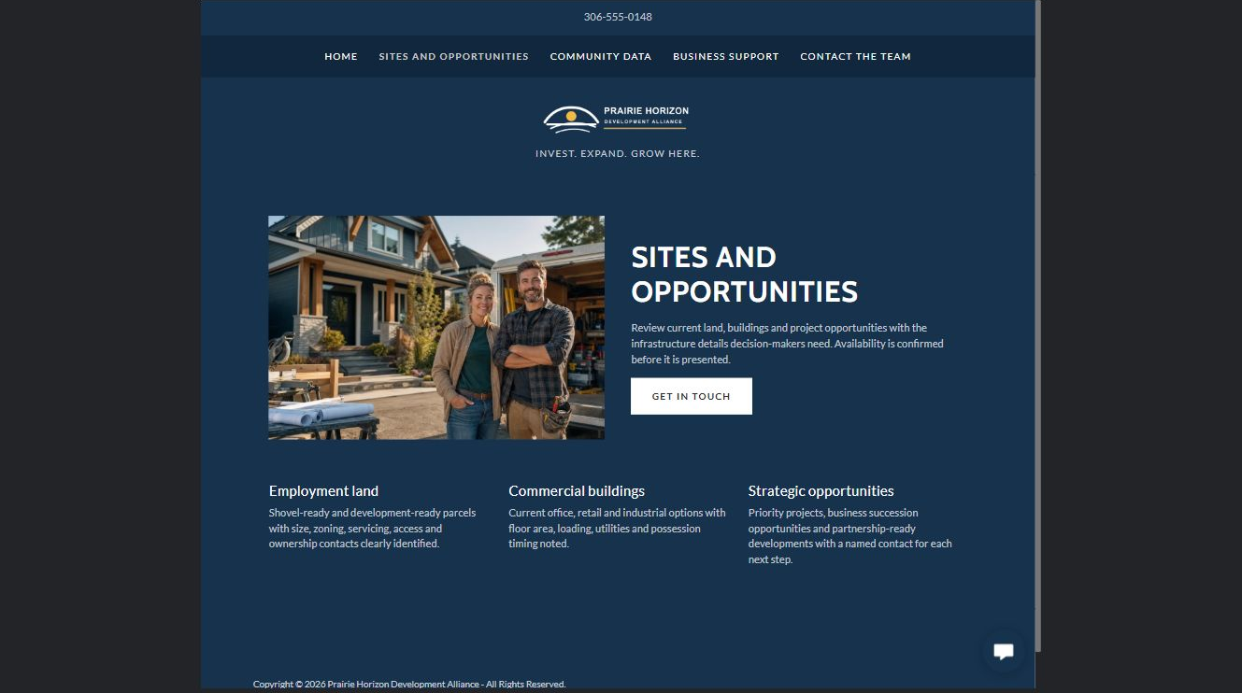
Prairie Horizon Development Alliance example | Explore SaaSTech Website Builder

Sample wording to adapt
Explore a potential location
Review the property details, servicing, access and named contact. Ask the team to confirm current availability and constraints before relying on a listing. A featured opportunity is not an offer or approval.

Pause and plan
What question brings a visitor to this page? List the details they need, the evidence you can provide and the next useful action. Remove content that does not help them decide or proceed.

WRITE YOUR PAGE

Sites and opportunities
Write for your visitor. Be specific about what they need to know and what happens next. You can revise the wording after the workshop.
Your page headline

Your opening paragraph

Key sections visitor questions and supporting details

Button or link wording and where it should lead

Photo idea caption and permission or credit needed

Facts to verify or questions to resolve

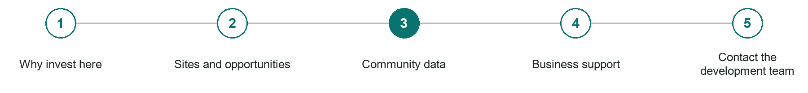
LOOK AND LEARN

Community data

The job of this page
Present sourced population, workforce, transportation, utilities, taxation, and market information in a usable format.
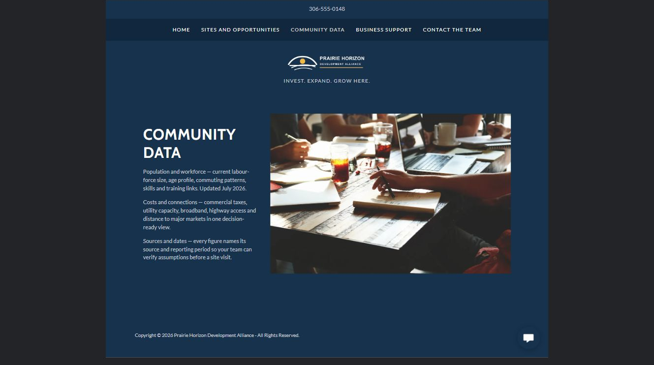
Prairie Horizon Development Alliance example | Explore SaaSTech Website Builder

Sample wording to adapt
Use current evidence for your decision
Review population, workforce and infrastructure information with its source and reporting date. Ask for clarification where a figure affects your plans. Verify assumptions before committing to a site.

Pause and plan
What question brings a visitor to this page? List the details they need, the evidence you can provide and the next useful action. Remove content that does not help them decide or proceed.

WRITE YOUR PAGE

Community data
Write for your visitor. Be specific about what they need to know and what happens next. You can revise the wording after the workshop.
Your page headline

Your opening paragraph

Key sections visitor questions and supporting details

Button or link wording and where it should lead

Photo idea caption and permission or credit needed

Facts to verify or questions to resolve

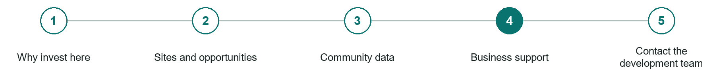
LOOK AND LEARN

Business support

The job of this page
Explain permits, incentives, financing referrals, startup resources, and the organizations involved.
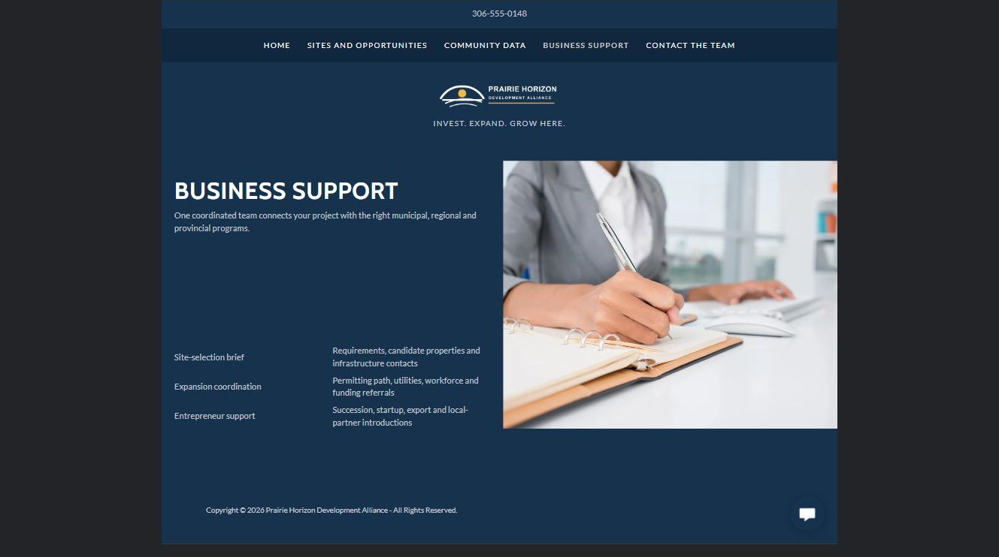
Prairie Horizon Development Alliance example | Explore SaaSTech Website Builder

Sample wording to adapt
Find the next useful connection
Describe your expansion or startup plans so the team can identify relevant contacts and programs. Eligibility, approvals and funding are determined by the responsible organizations, not by a website enquiry.

Pause and plan
Who is each option for, what does it include and where are its limits? Describe the information needed to check fit. Make the next step clear without promising an outcome before assessment.

WRITE YOUR PAGE

Business support
Write for your visitor. Be specific about what they need to know and what happens next. You can revise the wording after the workshop.
Your page headline

Your opening paragraph

Service options who they suit and what each includes

Button or link wording and where it should lead

Photo idea caption and permission or credit needed

Facts to verify or questions to resolve

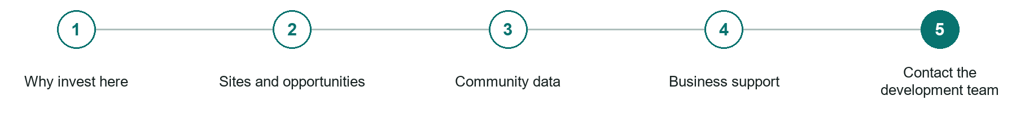
LOOK AND LEARN

Contact the development team

The job of this page
Offer a named, discreet contact path for investment, expansion, site-selection, and succession enquiries.
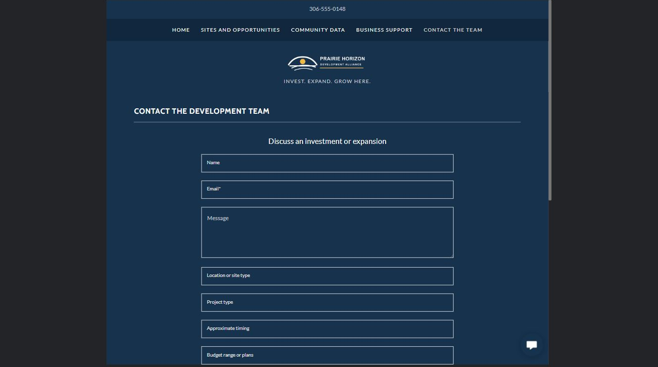
Prairie Horizon Development Alliance example | Explore SaaSTech Website Builder

Sample wording to adapt
Discuss an investment or expansion
Share the project type, general location needs and approximate timing. Keep commercially sensitive documents out of the initial form. The team can explain an appropriate follow-up process.

Pause and plan
What must someone provide, and what happens after they send it? Separate a request from a confirmed booking, order or place. Decide what information should stay out of a public form.

WRITE YOUR PAGE

Contact the development team
Write for your visitor. Be specific about what they need to know and what happens next. You can revise the wording after the workshop.
Your page headline

Your opening paragraph

Information to request and how you will reply or confirm

Button or link wording and where it should lead

Photo idea caption and permission or credit needed

Facts to verify or questions to resolve

WORKSHOP CLOSE

Review and next steps
Ask a partner to read your draft as a first-time visitor. Can they explain what you offer, who it is for and the next step without extra help?

Before you publish
[ ] Every page has a clear purpose and a useful next step.
[ ] Headlines are specific and the wording sounds like your business.
[ ] Names, service areas, prices, dates and policies have been checked.
[ ] Credentials, testimonials and results are genuine and permission-cleared.
[ ] Photos support the text, do not repeat needlessly and have appropriate permissions.
[ ] Forms ask only for necessary information and explain what happens next.
[ ] Links, downloads and the main visitor task work on a phone.
The most useful feedback from your workshop partner

First change to make and who will do it

Information or photographs still needed

Target review date and who will approve the final content

Keep sensitive customer, patient, employee and payment information out of this workbook. Completing it does not publish a website or connect to Website Builder.

BUILD WITH SAASTECH SERVERS

Put your draft into Website Builder
Use the content you have written to build your own site. Keep the economic development demo as a reference, and replace its company name, images and claims with your verified business information.

Explore the builder
See the editor, compare available plans and decide which features your business needs. Confirm current pricing and terms before purchasing.
Website Builder overview

Create your account
Set up your SaaSTech Servers customer account using your own details. Creating an account is separate from purchasing a Website Builder plan.
Create your SaaSTech account

Choose your plan
Open the secure shop to review the plan, subscription term and final total. Use the account connected to your purchase when you open your service.
View Website Builder plans

Build and check your pages
Add the pages from this workbook. Transfer your approved wording, upload permission-cleared photos and review each page on desktop and mobile before publishing.
Return to the Website Builder guide

Using a printed workbook
Type these short addresses into your browser. The account guide includes the Create My Account button.
www.saastech.net/products/website-builder
www.saastech.net/create-account
This workbook does not create an account, purchase a plan or publish your website. Keep passwords, payment details and confidential customer information out of your draft.

