

Dry Cleaners and Garment Care website workbook
A practical workshop guide for planning a clear service website that explains garment care, turnaround and pickup or delivery.
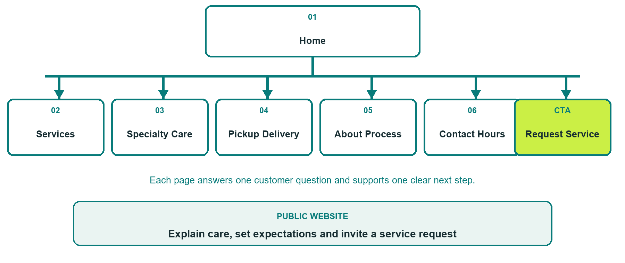

Inside this workbook
Six page examples, writing exercises, photo planning and a final launch review
Explore Website Builder and compare plans
Open the Dry Cleaners and Garment Care industry guide

WORKSHOP START

Define the customer journey
A useful garment-care website answers practical questions before a customer calls, visits or requests pickup.
□ Choose one customer question for each page.
□ Confirm current services, price examples, turnaround ranges and service area.
□ Gather distinct, permission-cleared photos that match each page.
□ State that stain removal and specialty outcomes cannot be guaranteed.
□ Assign a business owner for every published detail.

What should a first-time customer understand or do

Business facts, photos and approvals still needed

PAGE 1

Home
Introduce the business, service area and primary request path in the first screen.
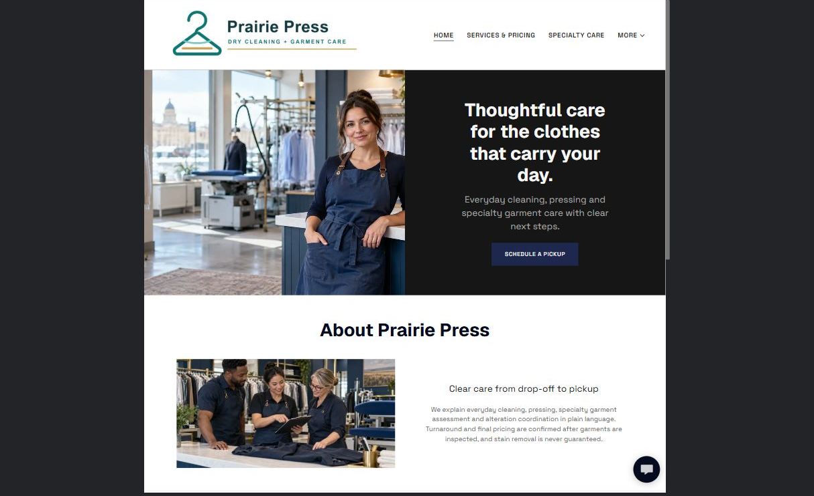

Clearly labelled sample wording
Sample wording: Dependable garment care for everyday clothing and special pieces. Review services, prepare your items, or request pickup and delivery.

Draft your own page wording

Photos, proof, links and approvals to prepare

PAGE 2

Services and Pricing
Group common services and explain how final pricing and timing are confirmed.
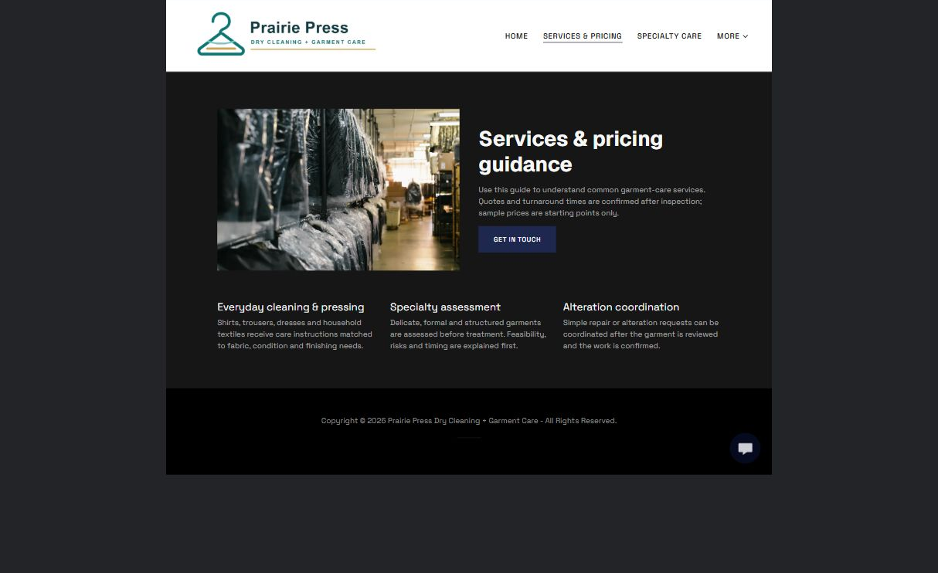

Clearly labelled sample wording
Sample wording: Explore cleaning, pressing and alteration options. Bring or describe the garment so the team can confirm care, price and turnaround.

Draft your own page wording

Photos, proof, links and approvals to prepare

PAGE 3

Specialty Care
Explain the assessment process for delicate garments without promising a particular result.
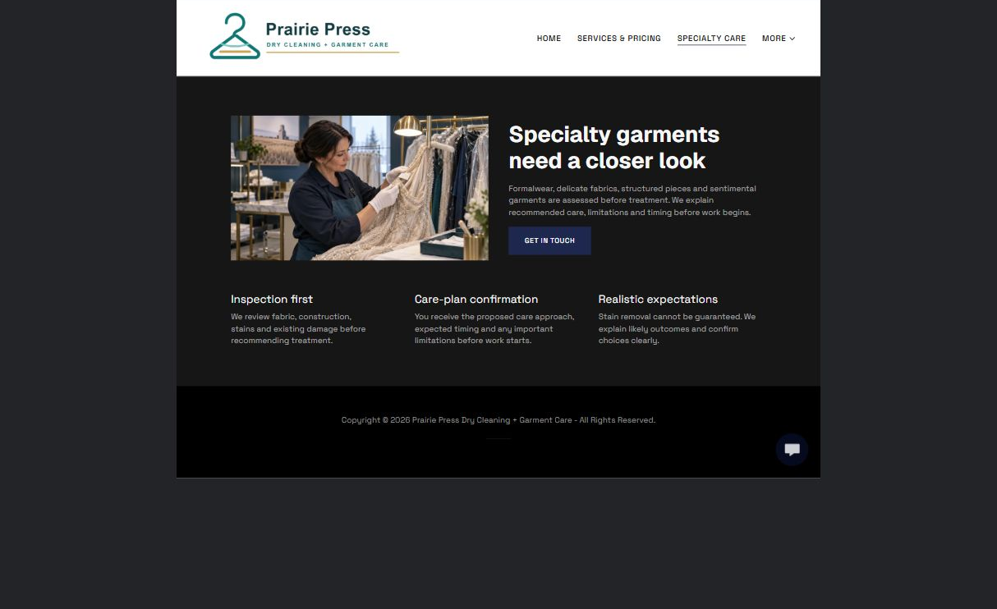

Clearly labelled sample wording
Sample wording: Wedding wear, formal pieces and delicate fabrics begin with a garment review. The team confirms the recommended process before work starts.

Draft your own page wording

Photos, proof, links and approvals to prepare

PAGE 4

Pickup and Delivery
Show the service area, request steps, minimums and confirmation process.
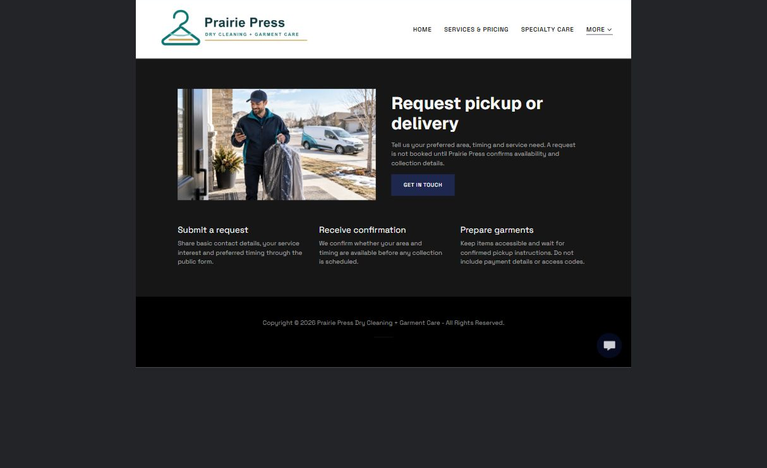

Clearly labelled sample wording
Sample wording: Request a preferred pickup window and service address. The team confirms availability, timing and return details before the route is scheduled.

Draft your own page wording

Photos, proof, links and approvals to prepare

PAGE 5

About and Process
Build trust by explaining inspection, cleaning, finishing and quality-review steps.
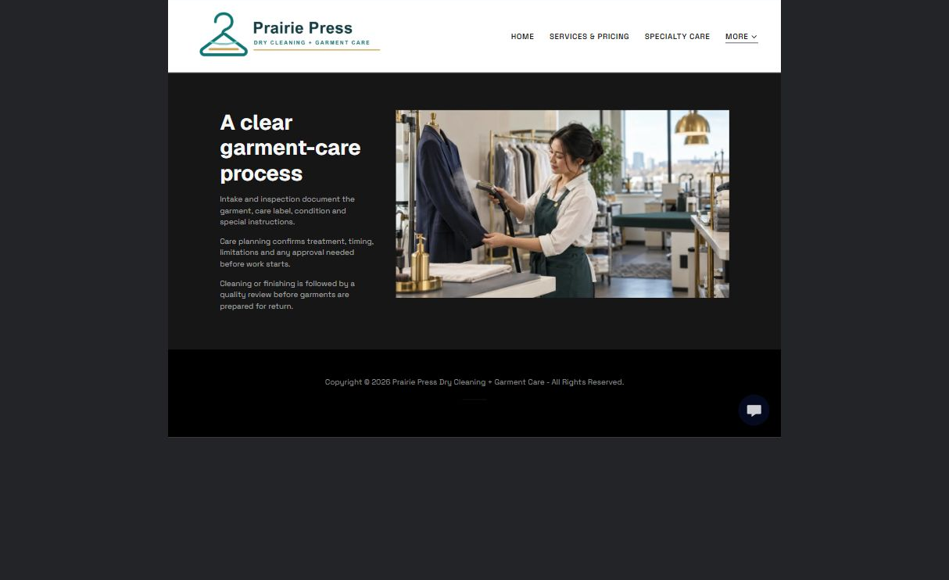

Clearly labelled sample wording
Sample wording: Each order is tagged, reviewed and processed according to the garment label and agreed care plan, then checked before return.

Draft your own page wording

Photos, proof, links and approvals to prepare

PAGE 6

Contact and Hours
Keep location, hours, contact choices and service-request expectations easy to verify.
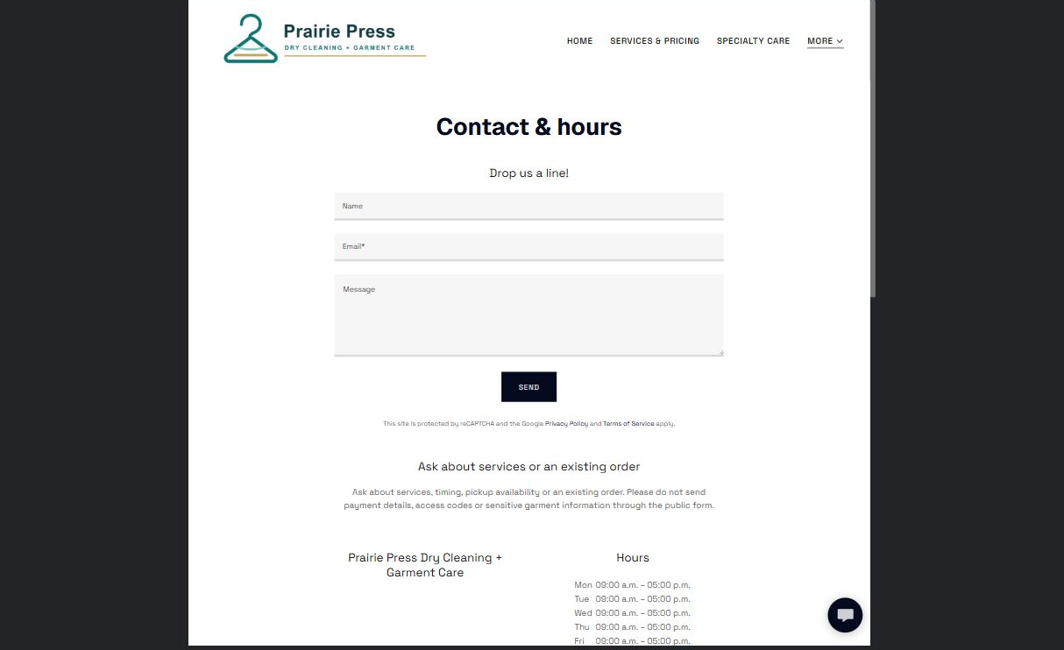

Clearly labelled sample wording
Sample wording: Ask a general question or request service. The team will confirm timing, pricing and any special-care requirements before accepting the order.

Draft your own page wording

Photos, proof, links and approvals to prepare

FINAL REVIEW

Test the complete service journey
Ask someone unfamiliar with the business to find a service, understand the next step and request pickup or counter service.
□ Each page has one clear purpose and one primary action.
□ Desktop and mobile previews are readable and use the correct logo contrast.
□ Every photo is relevant, distinct and permission-cleared.
□ Price, turnaround and pickup wording explains what must be confirmed.
□ Hours, address, service area and contact links are current.
□ A clearly named backup and future content-review date are recorded.

Changes found during review

Content owner and next review date

