

Disaster Restoration
Website workbook
A practical workshop for a 6-page website. Study the example, plan the content and draft your own version in Word or on paper.
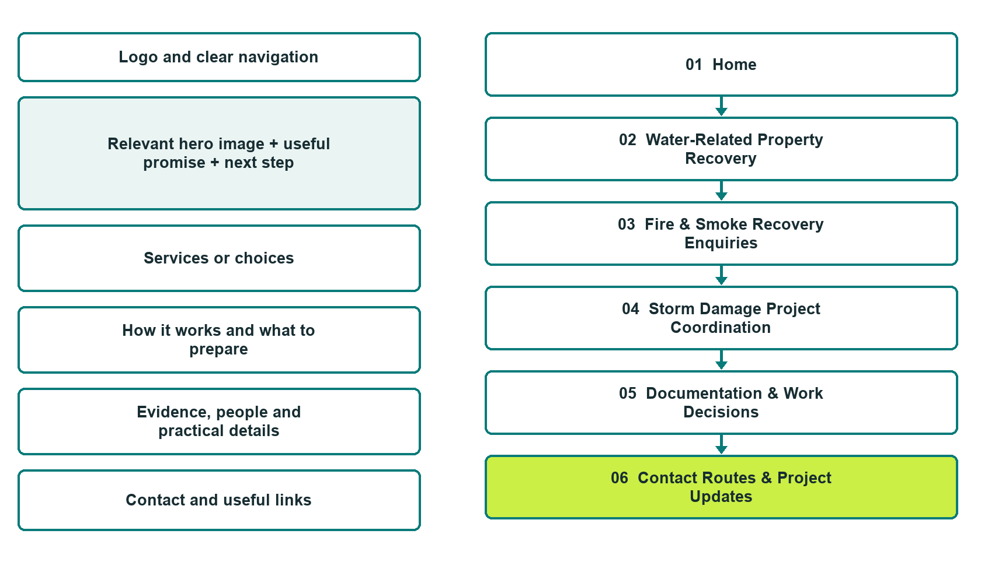

Plan → Draft → Build → Test
Captured demo edition. Study the unpublished six-page Website Builder example. Desktop and mobile previews, Editor Highlights, Themes and Paint comparisons are available on the industry page.
Explore Website Builder and compare plans

Before you build
Your business supplies the facts. Prairie Recovery Works is a fictional teaching example, not a live service.

□ Contact the restoration coordinator
□ Verified business identity, services and current contact information
□ A clear enquiry, review and confirmation process
□ Choose original photographs and confirm permission to use them.
□ Keep private customer records out of public website forms.

Your audience and the action you want them to take

Facts to verify and people who must approve them
Create your SaaSTech account

01 Home
Give this page one clear job in the customer journey.
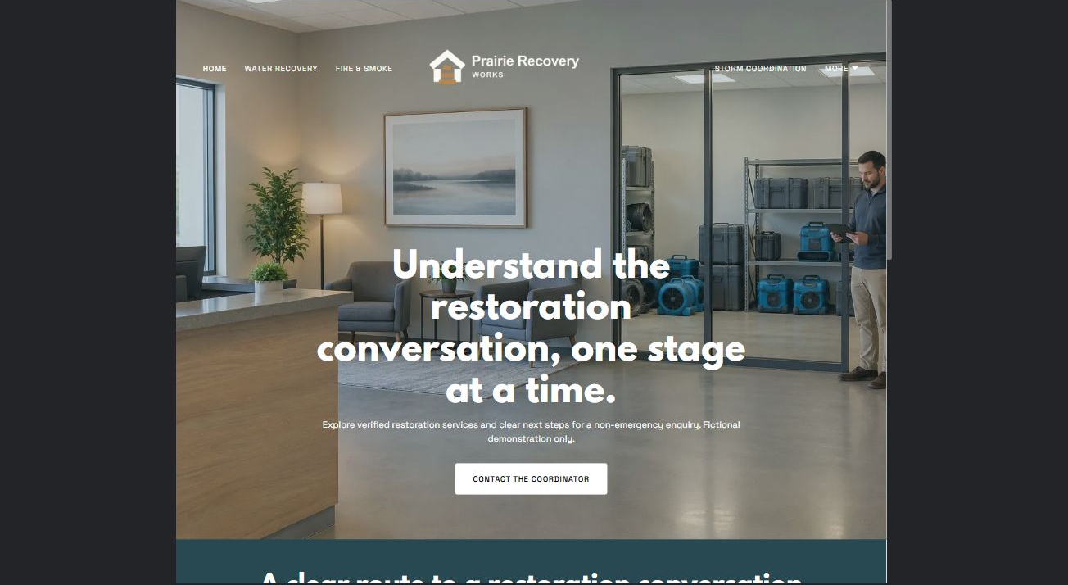
Actual desktop Website Builder preview. Open the industry gallery for the paired mobile view.

Sample wording — adapt and verify
Understand the restoration conversation, one stage at a time.
Explore the property-recovery categories the operator has verified and learn how enquiries, assessments and work approvals are coordinated.
If there is an immediate danger, use the appropriate emergency services rather than this demonstration form.
Suggested button: Contact the coordinator. Route to the reviewed non-emergency enquiry form.

Website advice
Separate water-related, fire-related and storm-related property recovery enquiries from emergency response, routine cleaning and insurance decisions.

Your draft: Home
Write in the voice of your own business. Use facts you can verify, not promises copied from the example.

Headline and short introduction

Main content and details visitors need

Button wording and destination

Photo choice, permission and facts still to confirm
Partner check: can someone unfamiliar with the business find a useful next step?

02 Water-Related Property Recovery
Give this page one clear job in the customer journey.
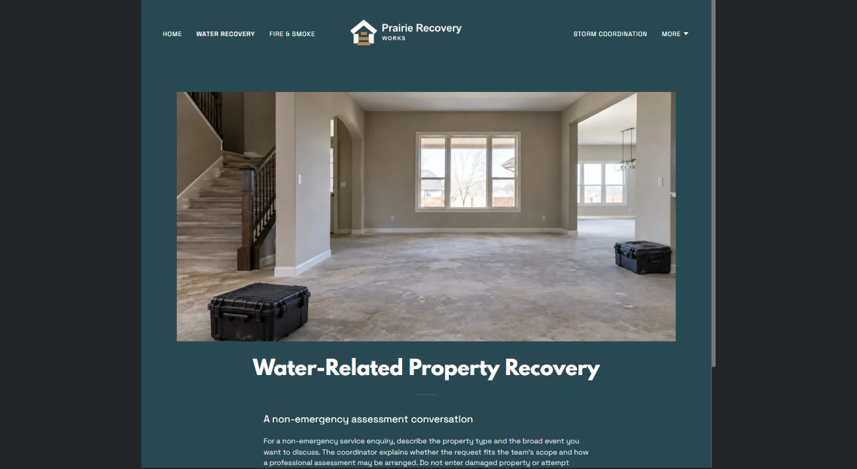
Actual desktop Website Builder preview. Open the industry gallery for the paired mobile view.

Sample wording — adapt and verify
A non-emergency assessment conversation
For a non-emergency service enquiry, describe the property type and the broad event you want to discuss.
The coordinator explains whether the request fits the team’s scope and how a professional assessment may be arranged.
Suggested button: Contact the coordinator. Route to the reviewed non-emergency enquiry form.

Website advice
Describe assessment and restoration coordination without giving drying, entry or contamination instructions.

Your draft: Water-Related Property Recovery
Write in the voice of your own business. Use facts you can verify, not promises copied from the example.

Headline and short introduction

Main content and details visitors need

Button wording and destination

Photo choice, permission and facts still to confirm
Partner check: can someone unfamiliar with the business find a useful next step?

03 Fire & Smoke Recovery Enquiries
Give this page one clear job in the customer journey.
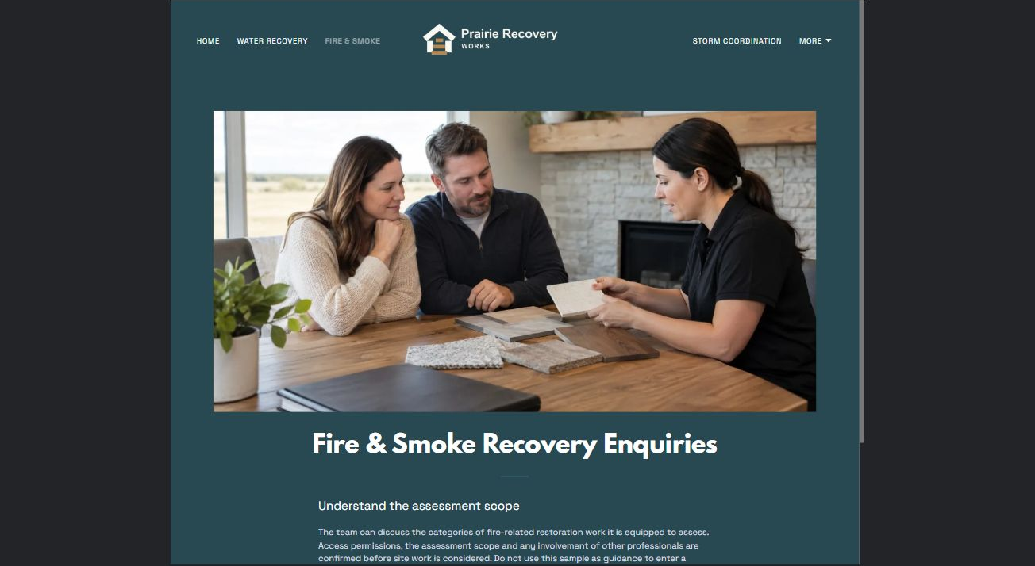
Actual desktop Website Builder preview. Open the industry gallery for the paired mobile view.

Sample wording — adapt and verify
Understand the assessment scope
The team can discuss the categories of fire-related restoration work it is equipped to assess.
Access permissions, the assessment scope and any involvement of other professionals are confirmed before site work is considered.
Suggested button: Contact the coordinator. Route to the reviewed non-emergency enquiry form.

Website advice
Explain the coordination route for fire-related property work without claims about safe occupancy or salvage.

Your draft: Fire & Smoke Recovery Enquiries
Write in the voice of your own business. Use facts you can verify, not promises copied from the example.

Headline and short introduction

Main content and details visitors need

Button wording and destination

Photo choice, permission and facts still to confirm
Partner check: can someone unfamiliar with the business find a useful next step?

04 Storm Damage Project Coordination
Give this page one clear job in the customer journey.
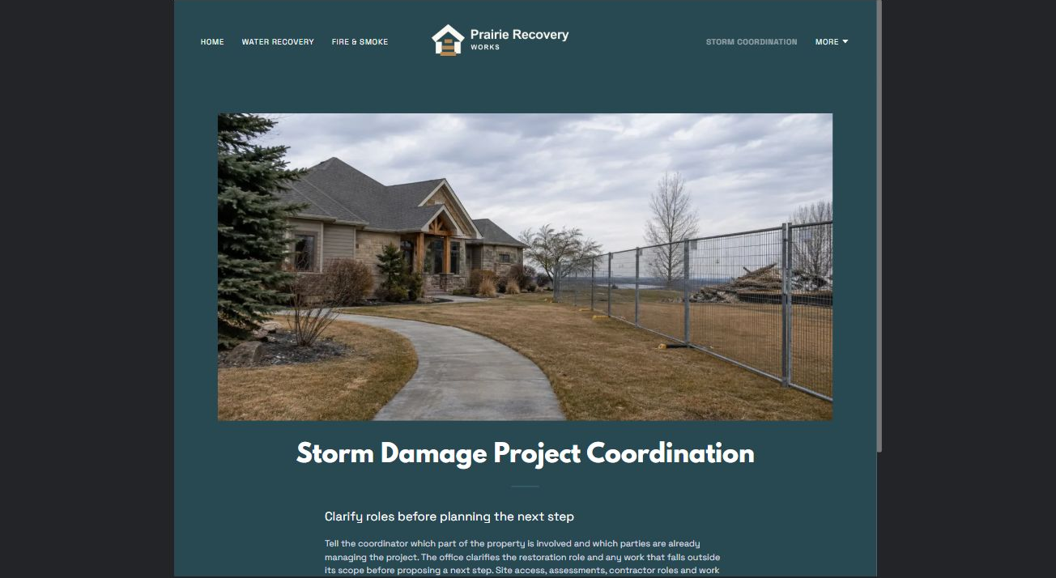
Actual desktop Website Builder preview. Open the industry gallery for the paired mobile view.

Sample wording — adapt and verify
Clarify roles before planning the next step
Tell the coordinator which part of the property is involved and which parties are already managing the project.
The office clarifies the restoration role and any work that falls outside its scope before proposing a next step.
Suggested button: Contact the coordinator. Route to the reviewed non-emergency enquiry form.

Website advice
Separate reviewed building-recovery work from tree removal, rescue and other unverified services.

Your draft: Storm Damage Project Coordination
Write in the voice of your own business. Use facts you can verify, not promises copied from the example.

Headline and short introduction

Main content and details visitors need

Button wording and destination

Photo choice, permission and facts still to confirm
Partner check: can someone unfamiliar with the business find a useful next step?

05 Documentation & Work Decisions
Give this page one clear job in the customer journey.
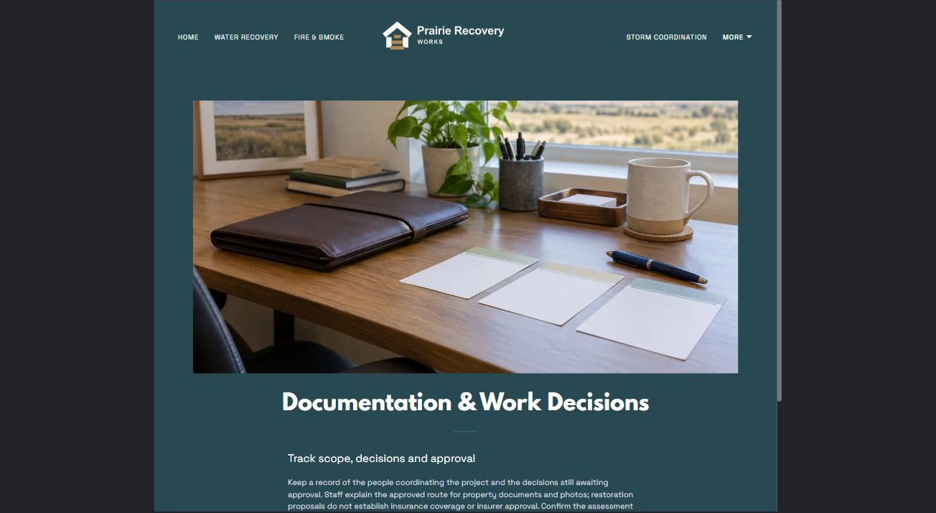
Actual desktop Website Builder preview. Open the industry gallery for the paired mobile view.

Sample wording — adapt and verify
Track scope, decisions and approval
Keep a record of the people coordinating the project and the decisions still awaiting approval.
Staff explain the approved route for property documents and photos; restoration proposals do not establish insurance coverage or insurer approval.
Suggested button: Contact the coordinator. Route to the reviewed non-emergency enquiry form.

Website advice
Outline private documentation, assessment proposals, change records and owner authorization without insurance advice.

Your draft: Documentation & Work Decisions
Write in the voice of your own business. Use facts you can verify, not promises copied from the example.

Headline and short introduction

Main content and details visitors need

Button wording and destination

Photo choice, permission and facts still to confirm
Partner check: can someone unfamiliar with the business find a useful next step?

06 Contact Routes & Project Updates
Give this page one clear job in the customer journey.
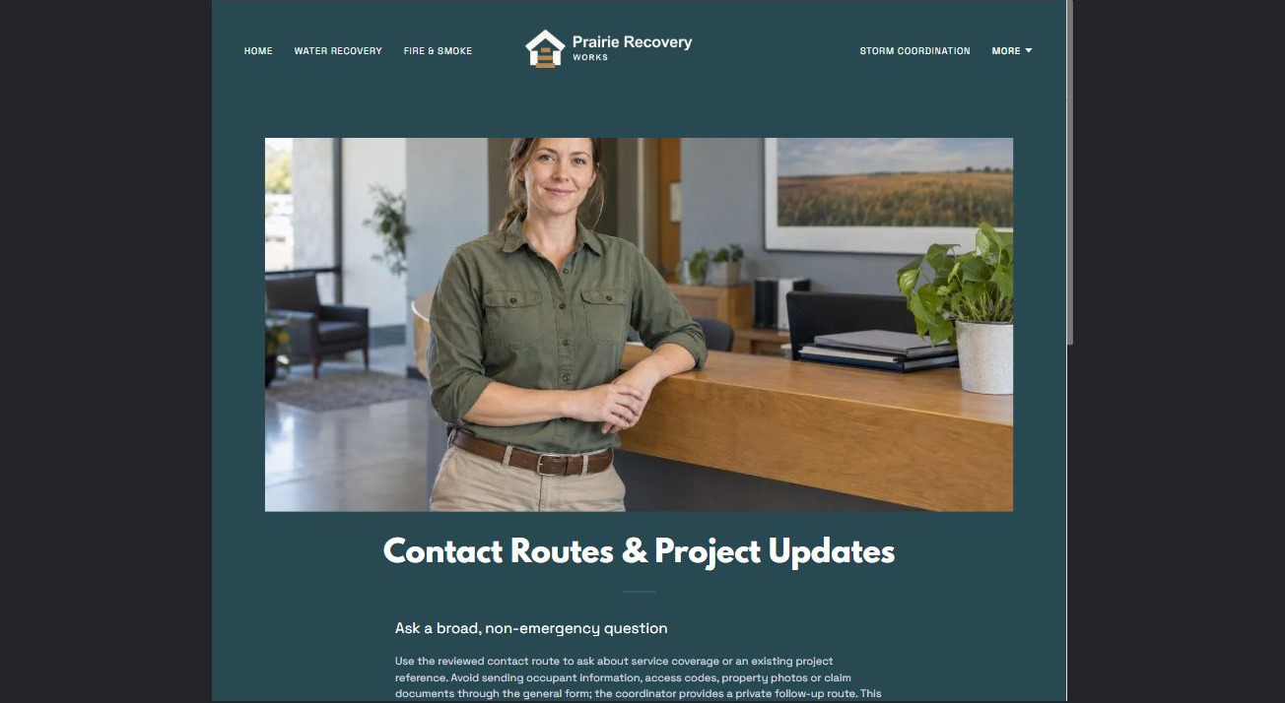
Actual desktop Website Builder preview. Open the industry gallery for the paired mobile view.

Sample wording — adapt and verify
Ask a broad, non-emergency question
Use the reviewed contact route to ask about service coverage or an existing project reference.
Avoid sending occupant information, access codes or claim documents through the general form; the coordinator provides a private follow-up route.
Suggested button: Contact the coordinator. Route to the reviewed non-emergency enquiry form.

Website advice
The actual demo form uses Name, required Email and a broad service-question field. Attachments are off. Keep occupant details, access codes, property photos, claim documents and payment information out of public forms. It is not an emergency route or a dispatch promise. Confirm the recipient, privacy wording and follow-up process before publication; no submission or delivery test has been performed.

Your draft: Contact Routes & Project Updates
Write in the voice of your own business. Use facts you can verify, not promises copied from the example.

Headline and short introduction

Main content and details visitors need

Button wording and destination

Photo choice, permission and facts still to confirm
Partner check: can someone unfamiliar with the business find a useful next step?

Test before publishing
Review the captured journey on a desktop and phone. The demo remains unpublished. Its forms have not been submitted or delivery-tested; verify delivery, privacy wording and operator approval before a real launch.
□ Fictional demonstration only. Not an emergency service or a source of entry, cleanup, structural, electrical, contamination or health advice. Publish only verified contact hours and scope. Staff must review job suitability, site access authorization and documentation routes; no insurer acceptance or coverage promises.
□ Verify every service description, contact route and operating detail.
□ Replace fictional identity and example information before a live launch.
□ Test enquiries, links and downloads on desktop and mobile.
□ Keep confidential records in approved private systems.
□ Obtain operator approval for public wording and images.
□ Check every link, form destination, download and confirmation message.
□ Check logo contrast, hero framing, text sizes and image loading.
□ Save a named backup and assign a content-review date.

Changes to finish and person responsible

Approval and next review date
Website Builder plans and signup

