

Dental & Orthodontic Clinics website workbook
A practical workshop guide for planning a calm, useful and privacy-aware clinic website.
Prairie Smile Dental + Orthodontics is a fictional workshop example. Replace all sample details with approved clinic information. Do not collect patient histories, insurance identifiers, clinical photographs or urgent-care details through a general website form.
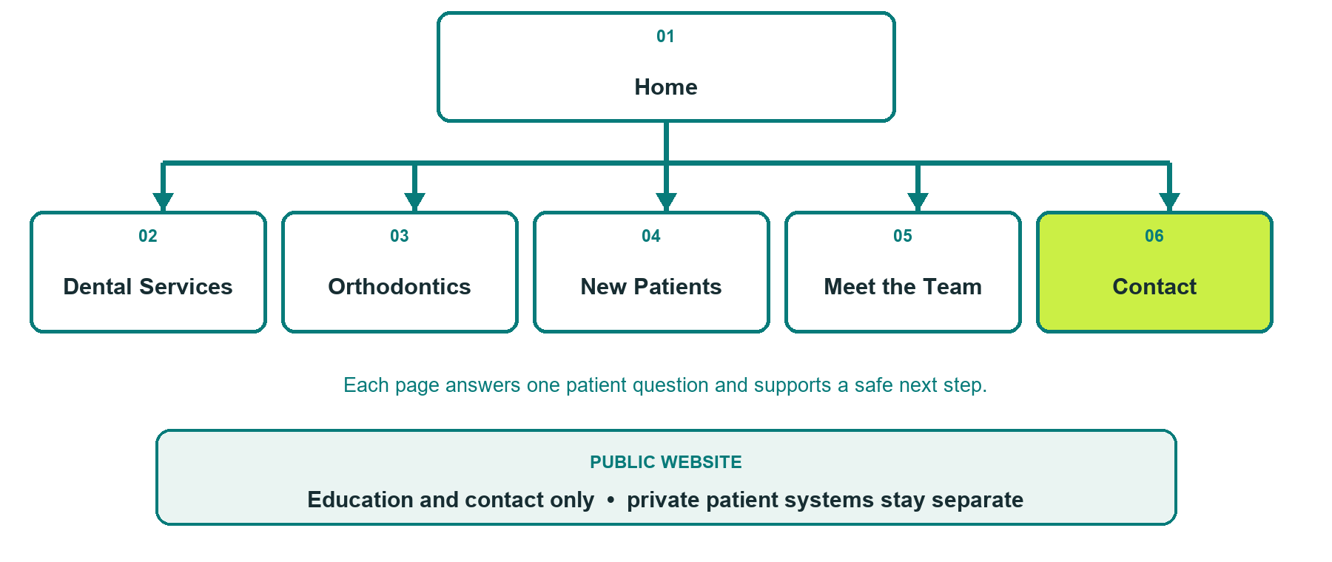

Inside this workbook
Six page examples • writing exercises • photo and proof planning • final launch review
Explore Website Builder and compare plans
Open the Dental & Orthodontic Clinics industry guide

WORKSHOP START

Define the safe public journey
The website should explain the clinic and make a clear first contact possible. Clinical decisions and patient records stay in approved private systems.
□ Choose one patient question for each page.
□ Gather current, permission-cleared staff and clinic photos.
□ Verify services, hours, accessibility and urgent instructions.
□ Decide what the public form must never collect.
□ Assign a clinic owner for every published claim.

What should a visitor understand or do

Facts and approvals still needed

PAGE 1

Home
Build reassurance, location context and one primary next step.
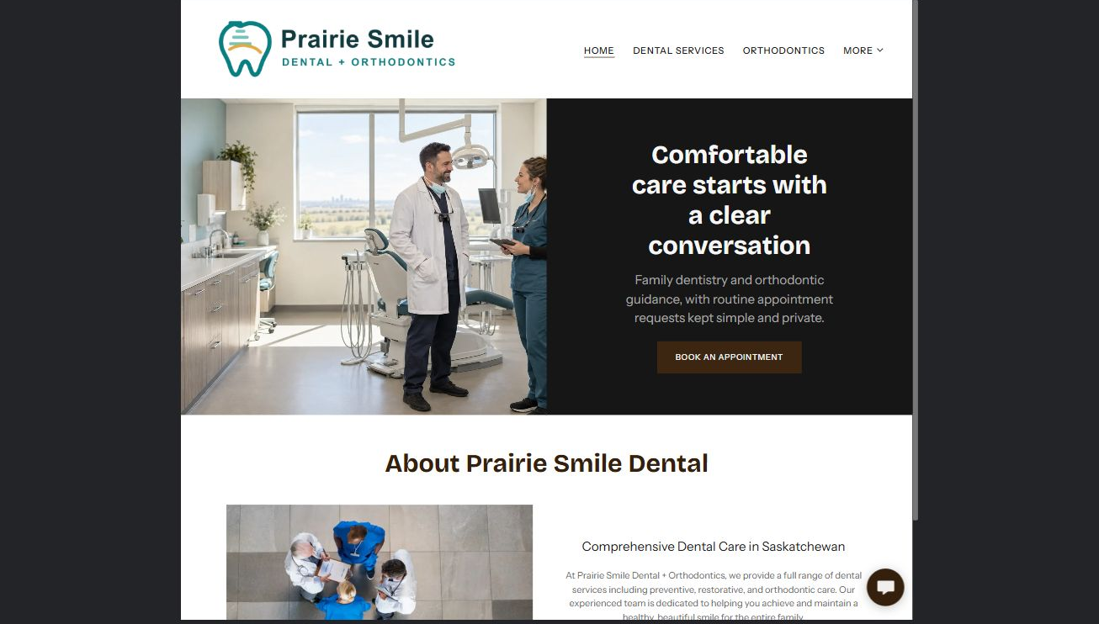

Clearly labelled sample wording
Sample wording: Comfortable care starts with a clear conversation. Learn about general dentistry and orthodontics, prepare for a first visit, or contact the clinic team.

Draft your own page wording

Photos, proof, links and approvals to prepare

PAGE 2

Dental Services
Group public service information clearly without diagnosing visitors or promising outcomes.
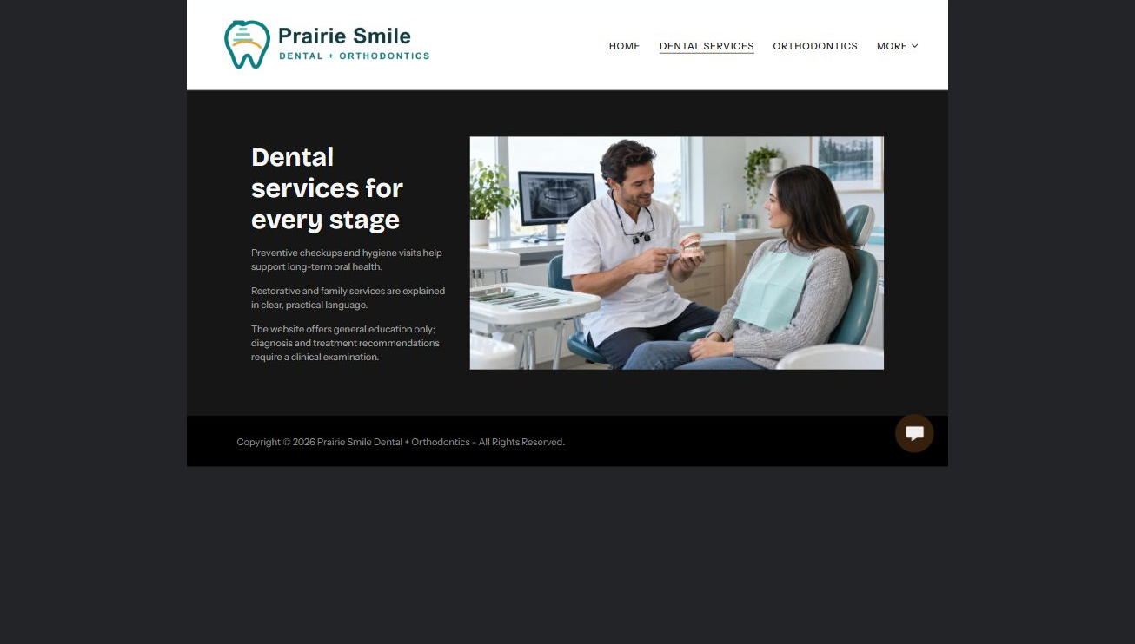

Clearly labelled sample wording
Sample wording: Explore preventive and restorative care, then contact the clinic for an individual assessment and confirmed recommendation.

Draft your own page wording

Photos, proof, links and approvals to prepare

PAGE 3

Orthodontics
Explain the consultation process, who may benefit and what happens before treatment begins.
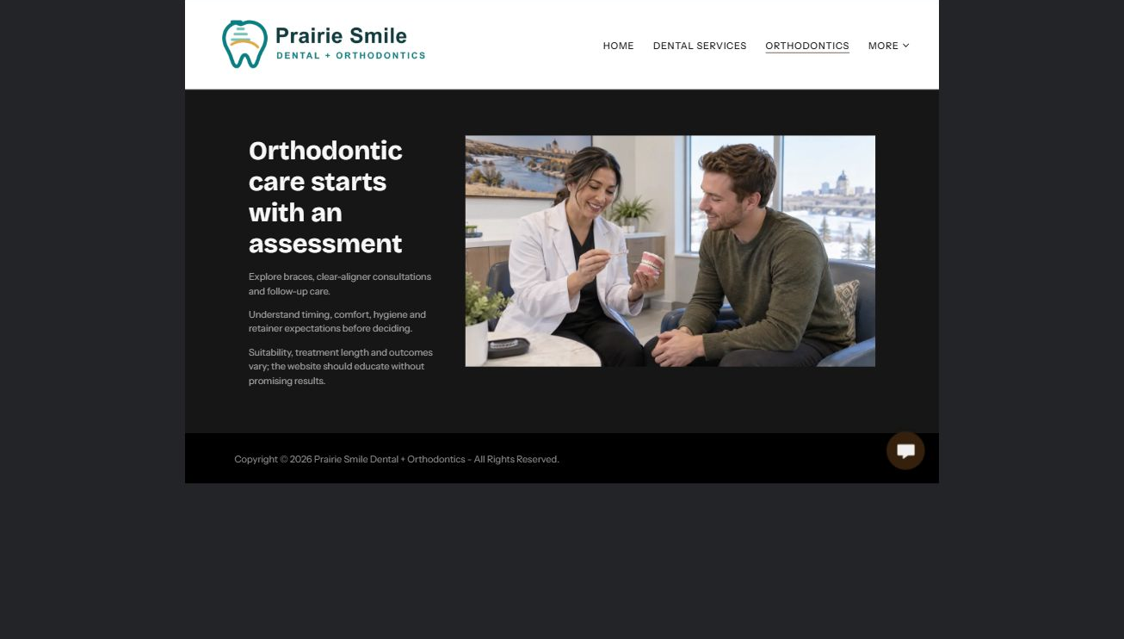

Clearly labelled sample wording
Sample wording: Start with a conversation about goals, assessment and available approaches. The clinic confirms suitability after an in-person review.

Draft your own page wording

Photos, proof, links and approvals to prepare

PAGE 4

New Patients
Reduce uncertainty with arrival, accessibility, records-transfer and appointment-request guidance.
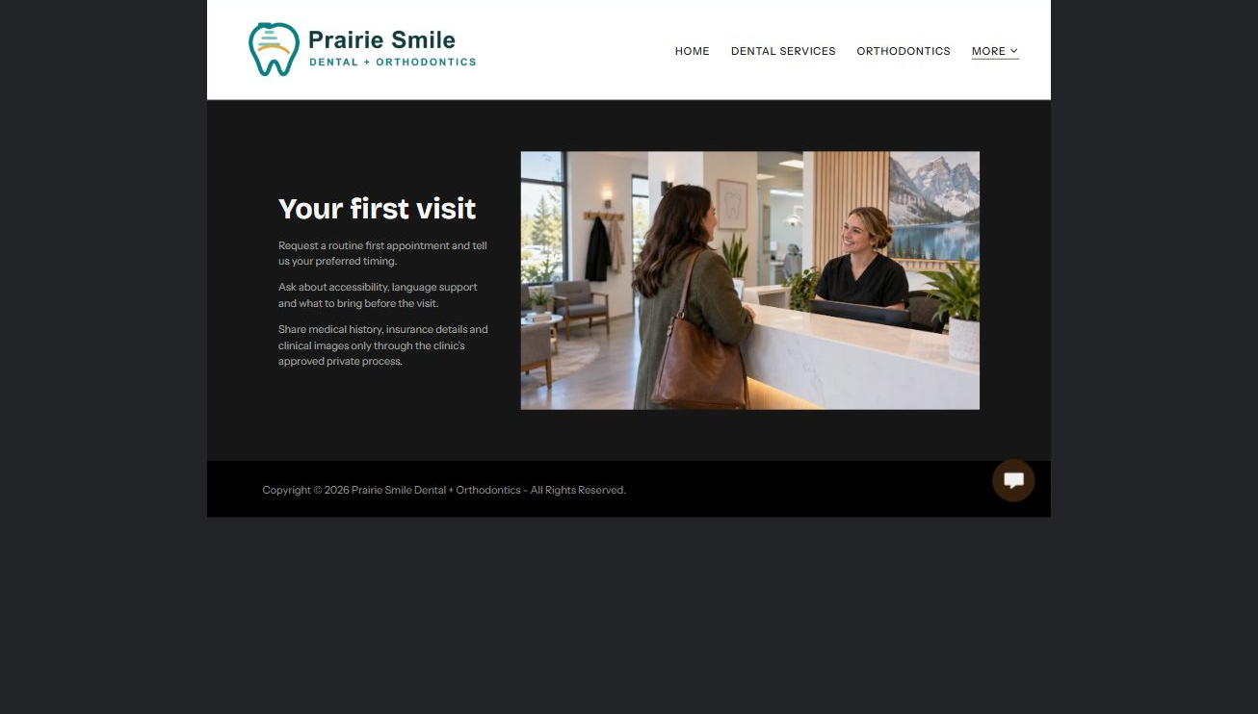

Clearly labelled sample wording
Sample wording: Know what to bring, when to arrive and how the clinic will confirm your first appointment.

Draft your own page wording

Photos, proof, links and approvals to prepare

PAGE 5

Meet the Team
Introduce regulated professionals and support staff accurately with approved biographies and distinct portraits.
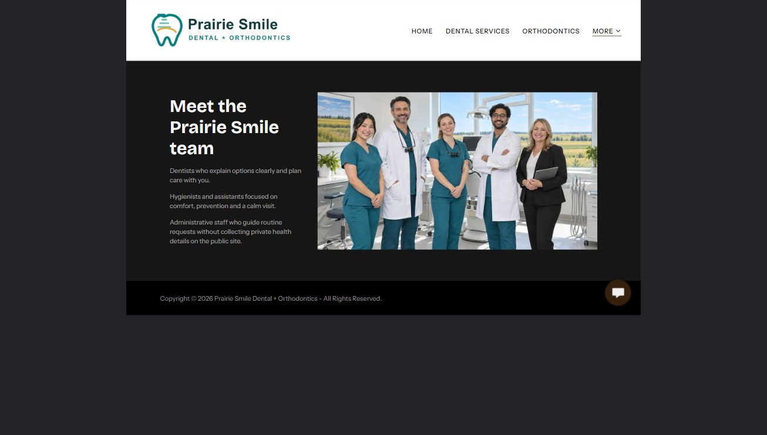

Clearly labelled sample wording
Sample wording: Meet the people who guide each visit, from reception and prevention to restorative and orthodontic care.

Draft your own page wording

Photos, proof, links and approvals to prepare

PAGE 6

Contact & Appointments
Provide verified contact routes and a minimal, privacy-aware request form.
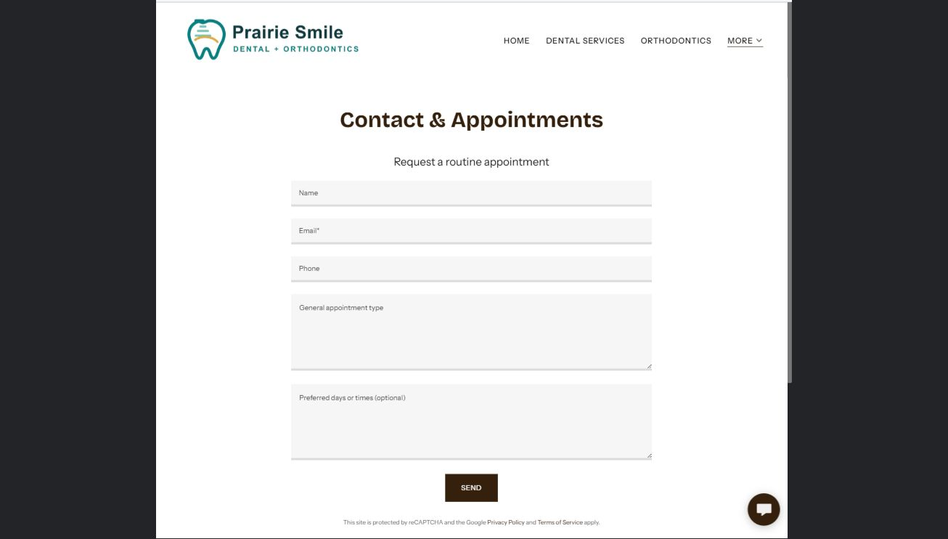

Clearly labelled sample wording
Sample wording: Request a preferred time and general appointment type. Staff will contact you to confirm; do not send health histories or urgent details here.

Draft your own page wording

Photos, proof, links and approvals to prepare

FINAL REVIEW

Test the whole patient journey
Ask a reviewer unfamiliar with the clinic to find services, prepare for a first visit and choose a safe contact route.
□ Each page has one purpose and next action.
□ Desktop and mobile previews are readable.
□ Dark and light logos have sufficient contrast.
□ Every image is relevant, distinct and permission-cleared.
□ Appointment wording distinguishes a request from confirmation.
□ Urgent-care, privacy, hours and accessibility wording is verified.
□ A clearly named backup and future review date are recorded.

Changes found during review

Content owner and next review date

