
WEBSITE PLANNING WORKSHOP

Crafts & Arts
Website workbook
Plan a clear website for crafts & arts. Explore a worked example, shape your own message and prepare to build with SaaSTech Servers.
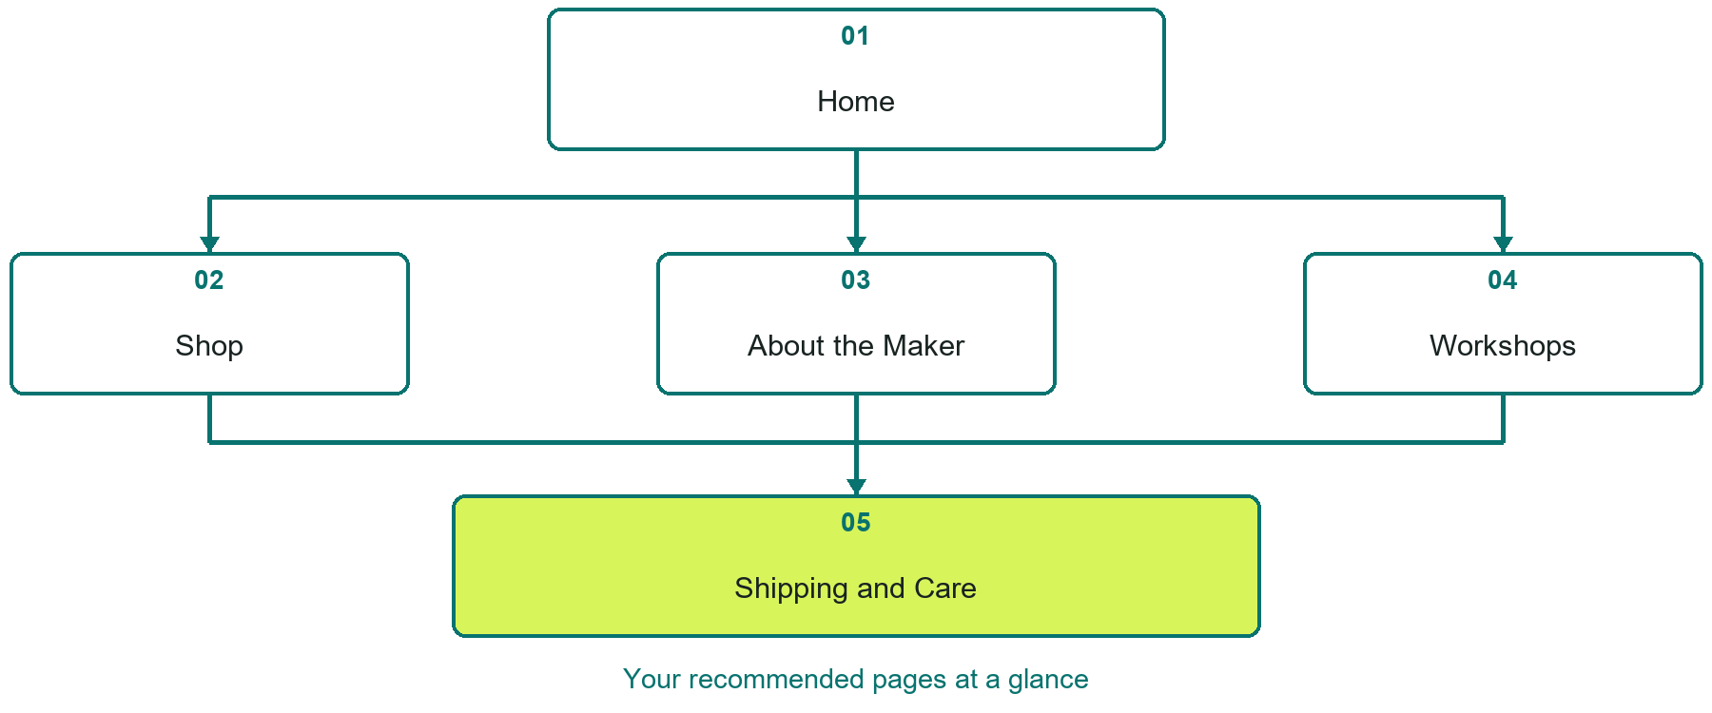

Inside this workbook
Five page examples • Practical writing exercises • A launch review
Use it in a workshop or at your own pace. Write by hand or complete the response fields in Word. The final page links to Website Builder, plans and account signup.
Example business Copper Willow Studio

CRAFTS & ARTS

Your website brief
A SaaSTech Servers workshop for crafts & arts. Plan your website, learn from the Copper Willow Studio example and draft content for your own business.
Each page has a reference sheet followed by a writing sheet. Demo excerpts are labelled separately from new sample wording, which may differ from the screenshot. Click a blank response line to type; longer answers may add pages. Replace fictional details and verify every claim before publishing.
Your business or organization and workshop date

Who should visit your site and what do they need

The main action you want a visitor to take

What you offer and where or how you provide it

Facts photos and permissions to gather before publishing

Workshop rhythm: review the example, write your draft and exchange feedback. Use the final review to choose your next changes. Website Builder and account links are on the last page.

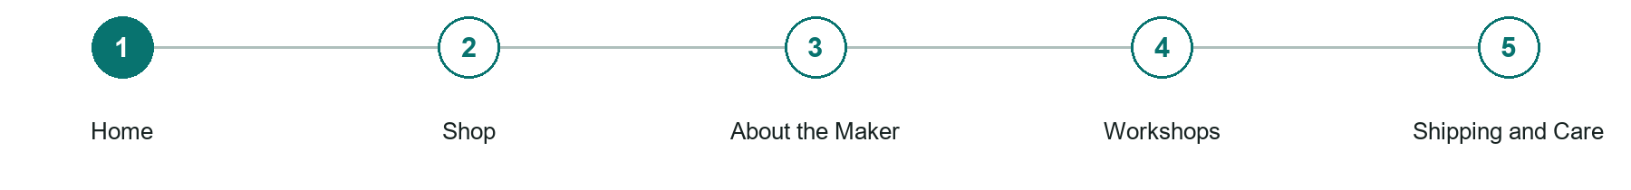
LOOK AND LEARN

Home

The job of this page
Show the strongest current work, identify the medium, and lead to the shop, commission, or workshop action.
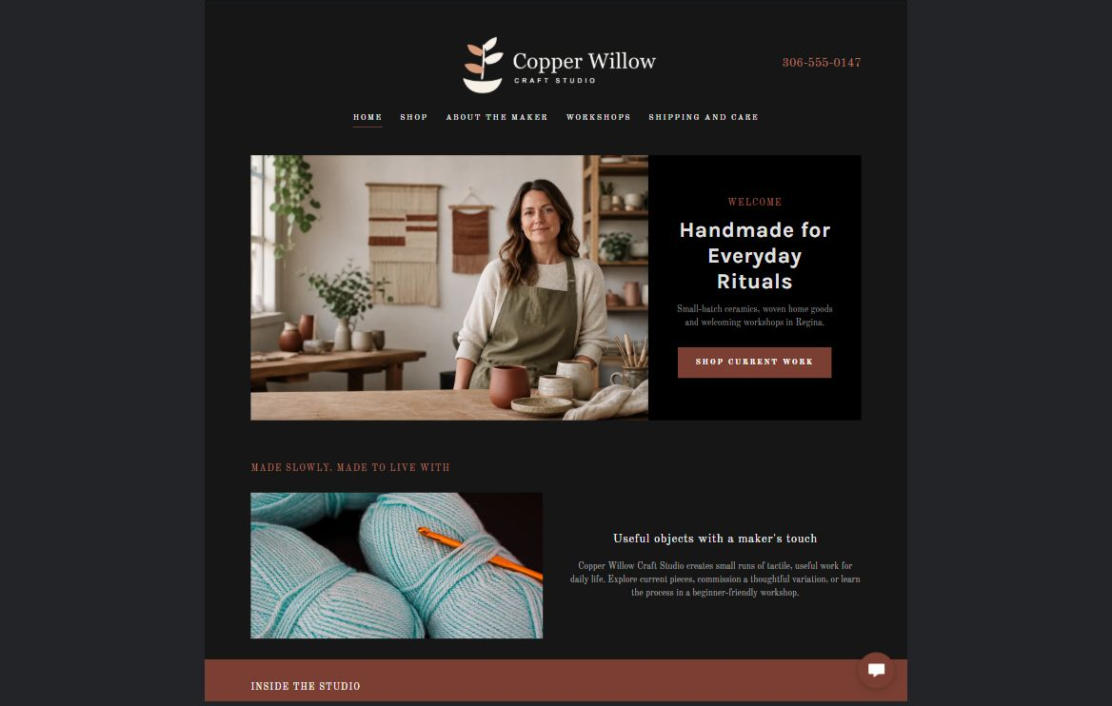
Copper Willow Studio example | Explore SaaSTech Website Builder

Demo text example
Handmade for Everyday Rituals
Useful objects with a maker's touch

Pause and plan
Could a first-time visitor explain what you do and who it is for after one glance? Choose one main action and the strongest truthful detail that gives them confidence to continue.

WRITE YOUR PAGE

Home
Write for your visitor. Be specific about what they need to know and what happens next. You can revise the wording after the workshop.
Your page headline

Your opening paragraph

Your offer audience location and most useful supporting details

Button or link wording and where it should lead

Photo idea caption and permission or credit needed

Facts to verify or questions to resolve

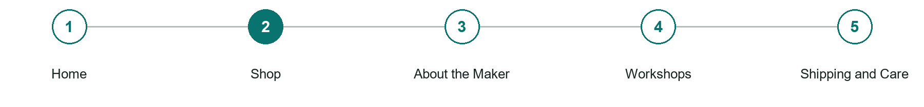
LOOK AND LEARN

Shop

The job of this page
Organize current work into clear collections with accurate photographs, dimensions, materials, prices, and availability.
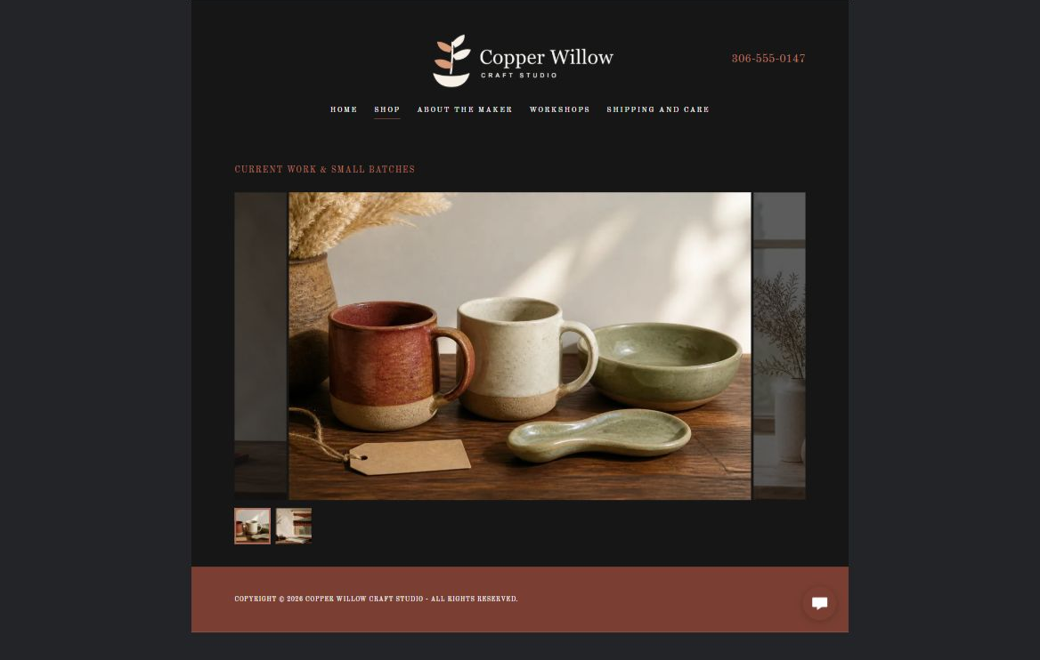
Copper Willow Studio example | Explore SaaSTech Website Builder

Sample wording to adapt
Explore the current collection
See the materials, dimensions and care information for each piece. Check availability and delivery options before ordering. Small variations can be part of handmade work; ask about the specific item you are considering.

Pause and plan
What is included and what needs separate confirmation? Make quantities, timing, exclusions and price conditions understandable. Avoid implying that an example price or image guarantees availability.

WRITE YOUR PAGE

Shop
Write for your visitor. Be specific about what they need to know and what happens next. You can revise the wording after the workshop.
Your page headline

Your opening paragraph

Options inclusions price conditions and availability details

Button or link wording and where it should lead

Photo idea caption and permission or credit needed

Facts to verify or questions to resolve

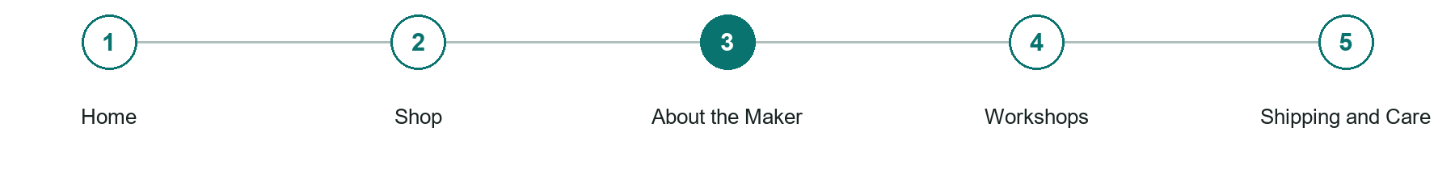
LOOK AND LEARN

About the Maker

The job of this page
Connect the maker's process, place, materials, and experience to the work without overwhelming the products.
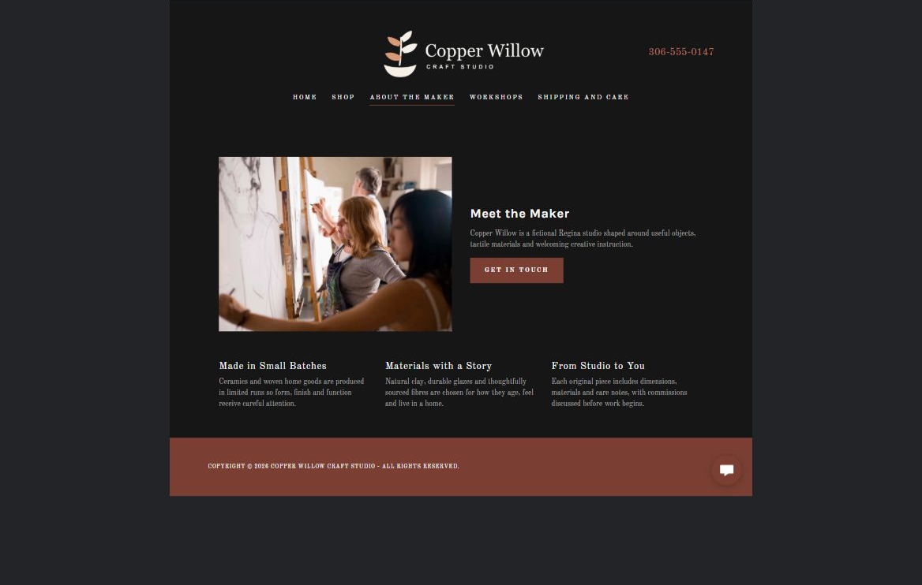
Copper Willow Studio example | Explore SaaSTech Website Builder

Sample wording to adapt
Meet the maker
Discover the materials and process behind the collection. Share genuine studio photographs and explain what makes each piece useful. Distinguish handmade work from sourced or collaborative products.

Pause and plan
Which names, roles and qualifications can you verify? What would help a visitor feel comfortable contacting you? Obtain permission for portraits and describe actual experience without unsupported claims.

WRITE YOUR PAGE

About the Maker
Write for your visitor. Be specific about what they need to know and what happens next. You can revise the wording after the workshop.
Your page headline

Your opening paragraph

People roles approach and verified credentials to introduce

Button or link wording and where it should lead

Photo idea caption and permission or credit needed

Facts to verify or questions to resolve

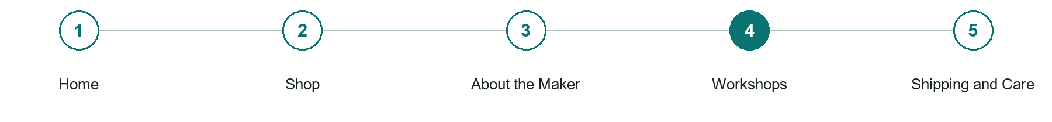
LOOK AND LEARN

Workshops

The job of this page
Explain workshop fit, timing, pricing approach, capacity, materials, accessibility, and how a customer begins.
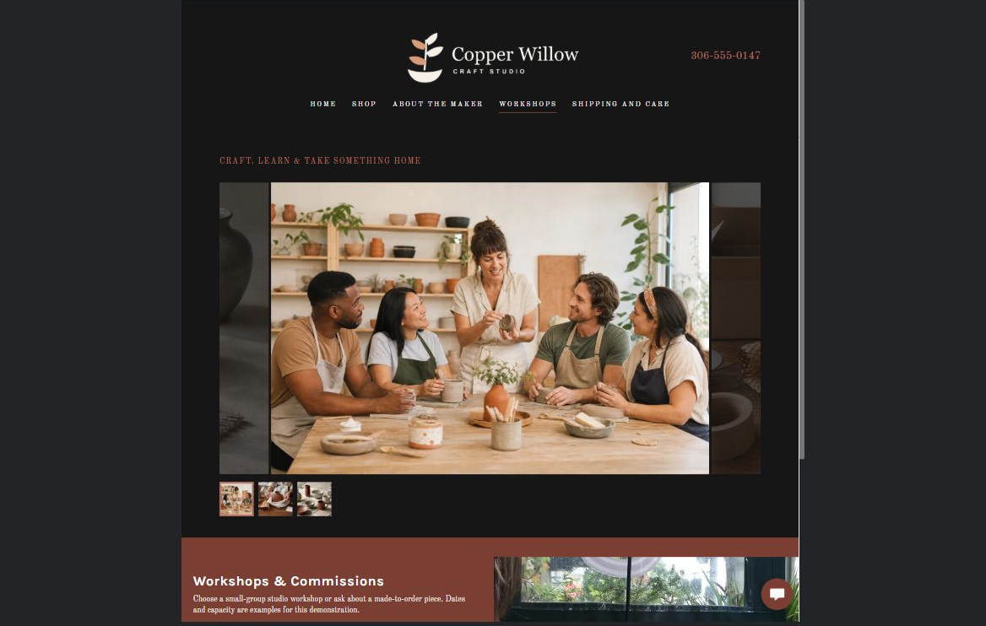
Copper Willow Studio example | Explore SaaSTech Website Builder

Sample wording to adapt
Make something in the studio
Ask about the workshop level, materials, duration and available dates. Confirm what is included and any access needs before booking. A workshop enquiry does not reserve a place.

Pause and plan
Who is the workshop for and what will participants make or learn? Confirm the duration, materials, access arrangements and how a place is reserved. State any prerequisites before people commit.

WRITE YOUR PAGE

Workshops
Write for your visitor. Be specific about what they need to know and what happens next. You can revise the wording after the workshop.
Your page headline

Your opening paragraph

Workshop level materials dates and participation details

Button or link wording and where it should lead

Photo idea caption and permission or credit needed

Facts to verify or questions to resolve

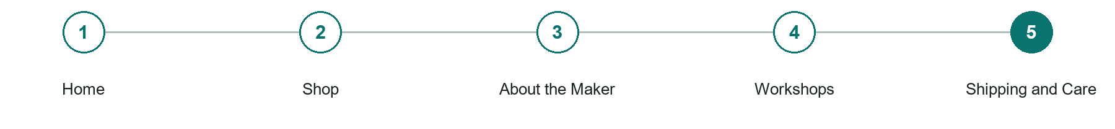
LOOK AND LEARN

Shipping and Care

The job of this page
Set expectations for packaging, delivery, local pickup, returns, and product care.
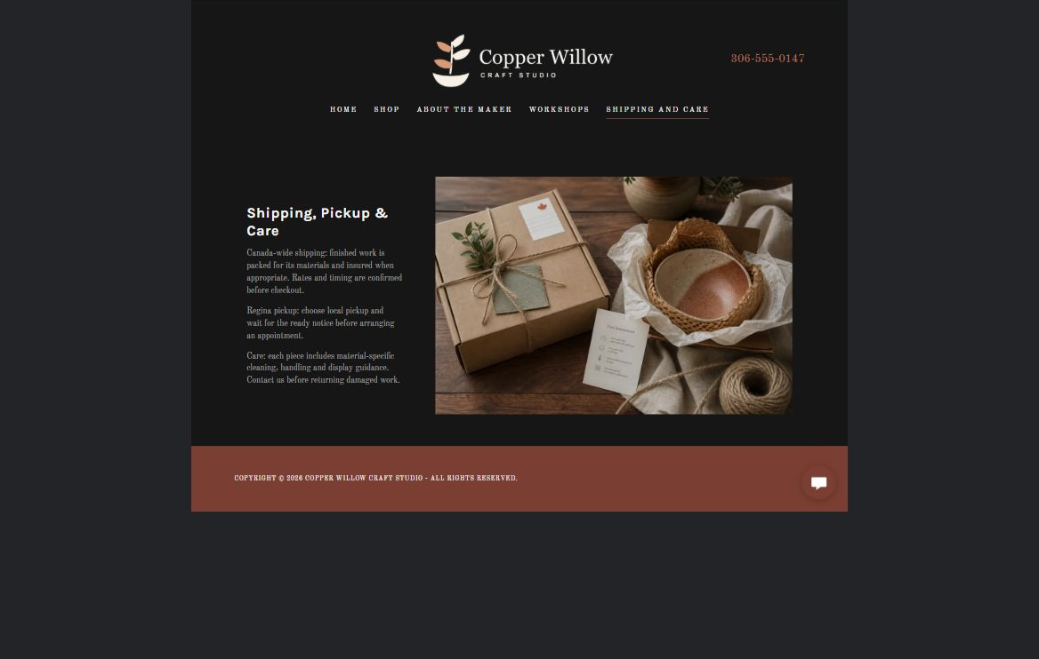
Copper Willow Studio example | Explore SaaSTech Website Builder

Sample wording to adapt
Care for the piece you choose
Read the item's care instructions and confirm pickup or shipping arrangements. Review delivery costs, timings and return terms before purchasing. Ask the studio if you are unsure which guidance applies.

Pause and plan
What should someone know before arriving or proceeding? Clarify preparation, access and the right contact route. Verify policies and avoid promising urgent help or specialist advice the website cannot provide.

WRITE YOUR PAGE

Shipping and Care
Write for your visitor. Be specific about what they need to know and what happens next. You can revise the wording after the workshop.
Your page headline

Your opening paragraph

Preparation access policies and practical questions to answer

Button or link wording and where it should lead

Photo idea caption and permission or credit needed

Facts to verify or questions to resolve

WORKSHOP CLOSE

Review and next steps
Ask a partner to read your draft as a first-time visitor. Can they explain what you offer, who it is for and the next step without extra help?

Before you publish
[ ] Every page has a clear purpose and a useful next step.
[ ] Headlines are specific and the wording sounds like your business.
[ ] Names, service areas, prices, dates and policies have been checked.
[ ] Credentials, testimonials and results are genuine and permission-cleared.
[ ] Photos support the text, do not repeat needlessly and have appropriate permissions.
[ ] Forms ask only for necessary information and explain what happens next.
[ ] Links, downloads and the main visitor task work on a phone.
The most useful feedback from your workshop partner

First change to make and who will do it

Information or photographs still needed

Target review date and who will approve the final content

Keep sensitive customer, patient, employee and payment information out of this workbook. Completing it does not publish a website or connect to Website Builder.

BUILD WITH SAASTECH SERVERS

Put your draft into Website Builder
Use the content you have written to build your own site. Keep the crafts & arts demo as a reference, and replace its company name, images and claims with your verified business information.

Explore the builder
See the editor, compare available plans and decide which features your business needs. Confirm current pricing and terms before purchasing.
Website Builder overview

Create your account
Set up your SaaSTech Servers customer account using your own details. Creating an account is separate from purchasing a Website Builder plan.
Create your SaaSTech account

Choose your plan
Open the secure shop to review the plan, subscription term and final total. Use the account connected to your purchase when you open your service.
View Website Builder plans

Build and check your pages
Add the pages from this workbook. Transfer your approved wording, upload permission-cleared photos and review each page on desktop and mobile before publishing.
Return to the Website Builder guide

Using a printed workbook
Type these short addresses into your browser. The account guide includes the Create My Account button.
www.saastech.net/products/website-builder
www.saastech.net/create-account
This workbook does not create an account, purchase a plan or publish your website. Keep passwords, payment details and confidential customer information out of your draft.

