

Counsellors & Mental Health Practices
Website workbook
A practical workshop for a 5-page website. Study the example, plan the content and draft your own version in Word or on paper.
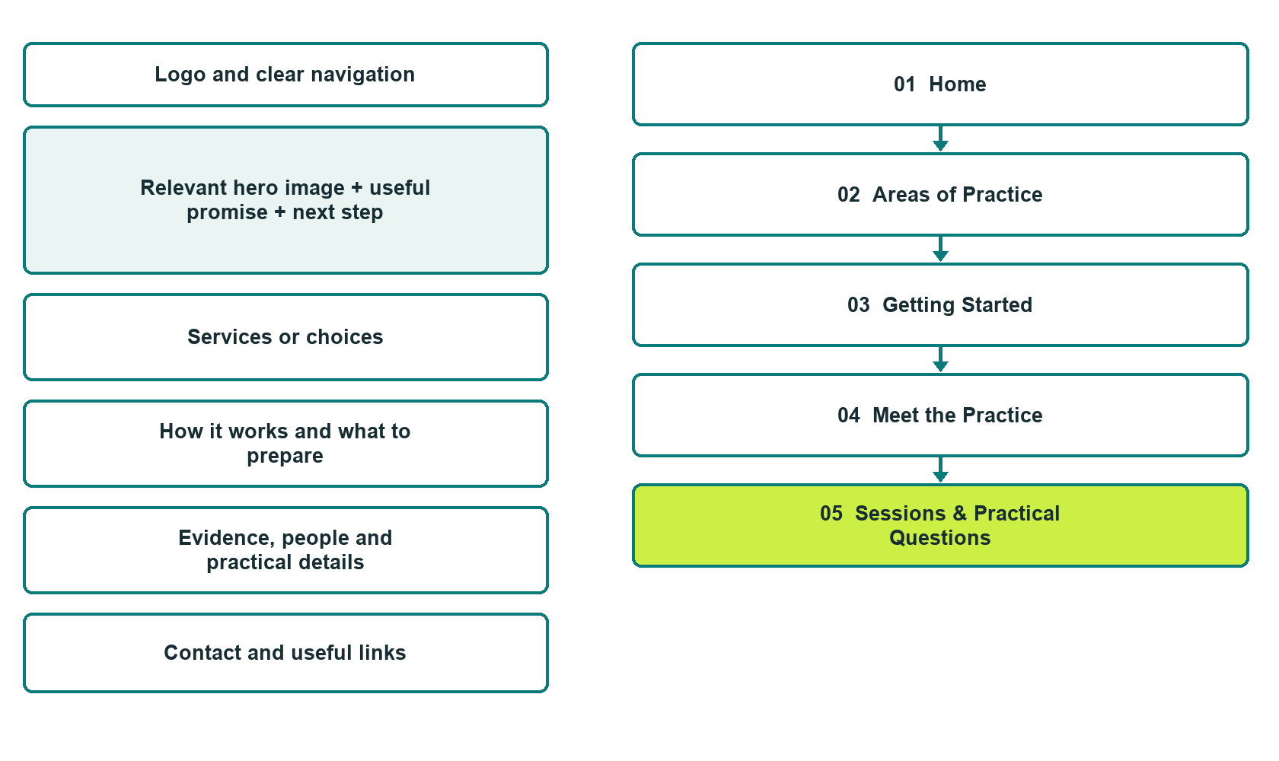

Plan → Draft → Build → Test
Demo-capture edition: actual Website Builder desktop previews and clearly labelled sample wording to adapt. See each matching mobile preview in the industry page gallery. The example business and its AI-generated photographs are fictional.
Explore Website Builder and compare plans

Before you build
Your business supplies the facts. Prairie Willow Counselling is a fictional teaching example, not a live service.

□ Ask about an introductory conversation
□ Verified business identity and current contact information
□ Clear request and confirmation process
□ Choose original photographs and confirm permission to use them.
□ Keep private customer records out of public website forms.

Your audience and the action you want them to take

Facts to verify and people who must approve them
Create your SaaSTech account

01 Home
Give this page one clear job in the customer journey.
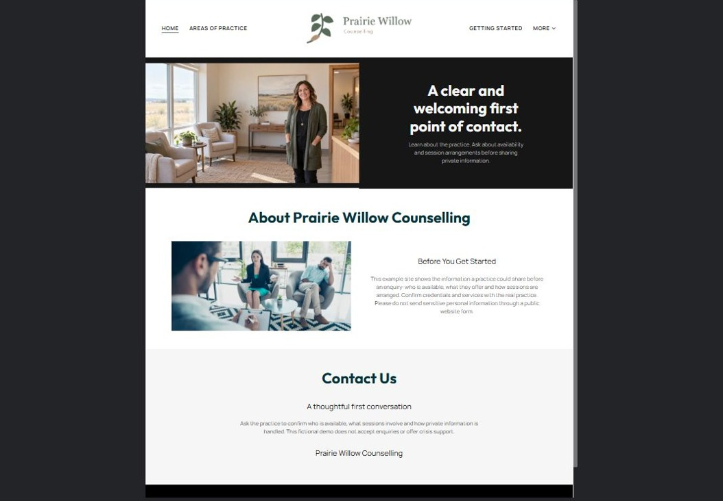
Actual desktop preview - unpublished fictional demonstration

Sample wording — adapt and verify
A clear and welcoming first point of contact.
Learn about the practice and what an introductory conversation can cover. Ask the team about availability, session arrangements and the next step before sharing private information.
Contact the team to discuss your questions and confirm what happens next. Please wait for a direct response before making arrangements.
Suggested button: Ask about an introductory conversation

Website advice
Explain the practice, verified practitioner roles, session arrangements and secure enquiry process in plain language. Avoid diagnosis, treatment promises or crisis-service claims.

Your draft: Home
Write in the voice of your own business. Use facts you can verify, not promises copied from the example.

Headline and short introduction

Main content and details visitors need

Button wording and destination

Photo choice, permission and facts still to confirm
Partner check: can someone unfamiliar with the business find a useful next step?

02 Areas of Practice
Give this page one clear job in the customer journey.
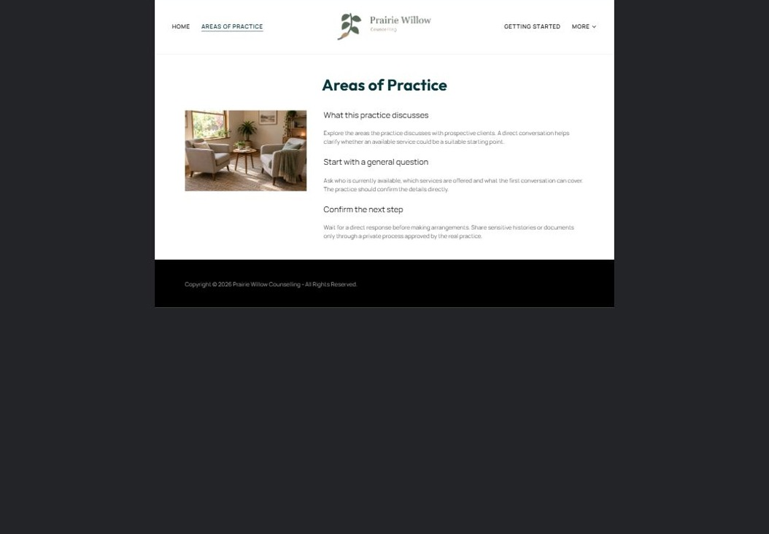
Actual desktop preview - unpublished fictional demonstration

Sample wording — adapt and verify
Areas of Practice
Explore the areas the practice discusses with prospective clients. A direct conversation helps clarify whether the available service is a suitable starting point.
Contact the team to discuss your questions and confirm what happens next. Please wait for a direct response before making arrangements.
Suggested button: Contact the team

Website advice
Describe the practitioner-approved scope without self-diagnosis checklists or outcome promises. Separate services from general information.

Your draft: Areas of Practice
Write in the voice of your own business. Use facts you can verify, not promises copied from the example.

Headline and short introduction

Main content and details visitors need

Button wording and destination

Photo choice, permission and facts still to confirm
Partner check: can someone unfamiliar with the business find a useful next step?

03 Getting Started
Give this page one clear job in the customer journey.
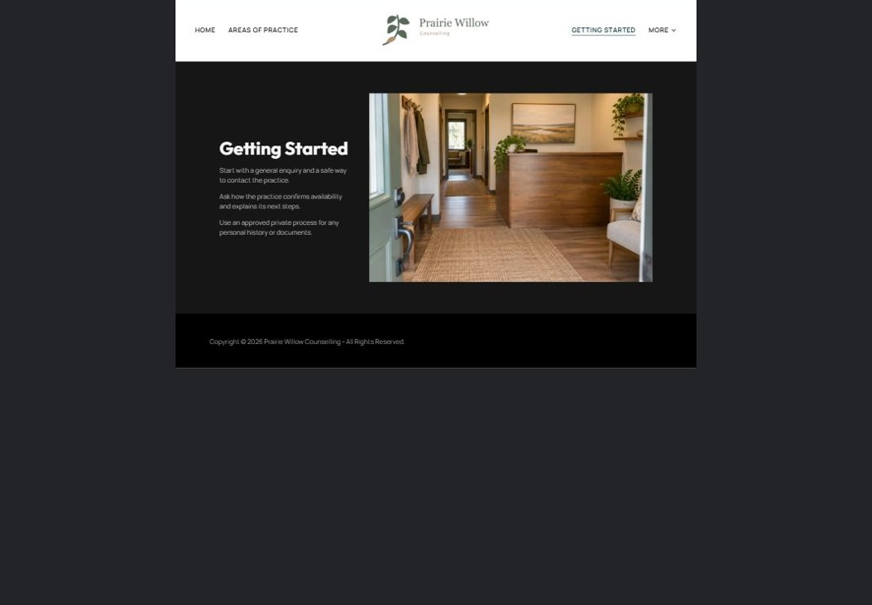
Actual desktop preview - unpublished fictional demonstration

Sample wording — adapt and verify
Getting Started
Start with a general enquiry and a safe way to contact you. The practice explains the next steps and where any private information should be provided.
Contact the team to discuss your questions and confirm what happens next. Please wait for a direct response before making arrangements.
Suggested button: Contact the team

Website advice
Describe contact, practice response and the private intake process. Make response expectations explicit and operator-approved.

Your draft: Getting Started
Write in the voice of your own business. Use facts you can verify, not promises copied from the example.

Headline and short introduction

Main content and details visitors need

Button wording and destination

Photo choice, permission and facts still to confirm
Partner check: can someone unfamiliar with the business find a useful next step?

04 Meet the Practice
Give this page one clear job in the customer journey.
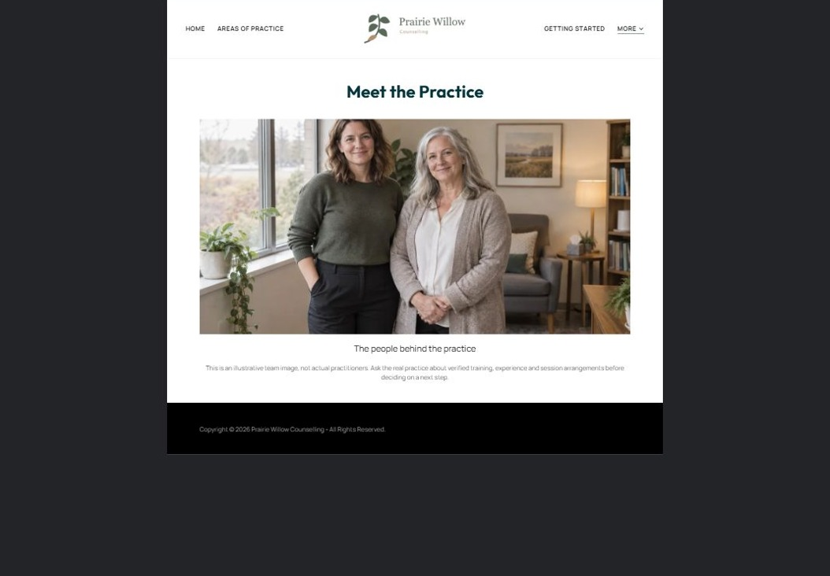
Actual desktop preview - unpublished fictional demonstration

Sample wording — adapt and verify
Meet the Practice
Meet the people behind the practice and learn how they describe their approach. You can ask questions about experience and session arrangements before deciding what to do next.
Contact the team to discuss your questions and confirm what happens next. Please wait for a direct response before making arrangements.
Suggested button: Contact the team

Website advice
Show verified professional identities, training and approach with permission-cleared portraits. Do not invent testimonials.

Your draft: Meet the Practice
Write in the voice of your own business. Use facts you can verify, not promises copied from the example.

Headline and short introduction

Main content and details visitors need

Button wording and destination

Photo choice, permission and facts still to confirm
Partner check: can someone unfamiliar with the business find a useful next step?

05 Sessions & Practical Questions
Give this page one clear job in the customer journey.
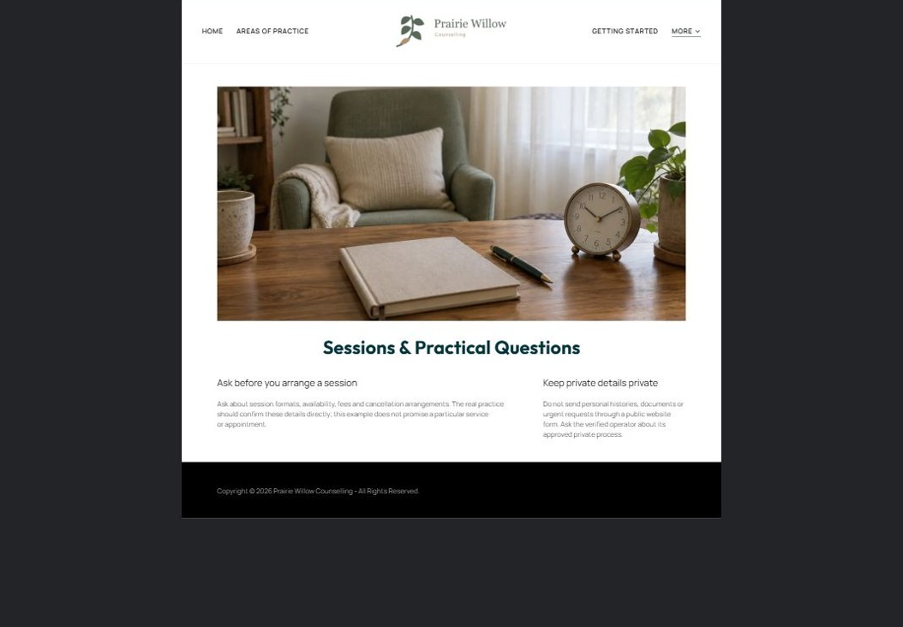
Actual desktop preview - unpublished fictional demonstration

Sample wording — adapt and verify
Sessions & Practical Questions
Ask about the session formats currently offered, how appointments are confirmed and which practical arrangements apply. The team will explain the relevant details directly.
Contact the team to discuss your questions and confirm what happens next. Please wait for a direct response before making arrangements.
Suggested button: Contact the team

Website advice
Explain confirmed session formats, access, fees and cancellation arrangements. Avoid unsupported insurance or confidentiality guarantees.

Your draft: Sessions & Practical Questions
Write in the voice of your own business. Use facts you can verify, not promises copied from the example.

Headline and short introduction

Main content and details visitors need

Button wording and destination

Photo choice, permission and facts still to confirm
Partner check: can someone unfamiliar with the business find a useful next step?

Test before publishing
Review the whole journey on a desktop and phone. The industry page pairs each desktop capture with its mobile preview and provides the complete sample page copy.
□ This fictional practice is not a crisis or clinical service. Have qualified practitioners review all scope, privacy and urgent-help wording before publication; public forms should not request personal histories.
□ Verify contact routes, hours, location and every offered service.
□ Remove invented prices, claims, testimonials and availability.
□ Keep sensitive records and payment details out of ordinary public forms.
□ Check all image permissions, downloads and page links on a phone.
□ Check every link, form destination, download and confirmation message.
□ Check logo contrast, hero framing, text sizes and image loading.
□ Save a named backup and assign a content-review date.

Changes to finish and person responsible

Approval and next review date
Website Builder plans and signup

