
WEBSITE PLANNING WORKSHOP

Convenience Stores
Website workbook
Plan a clear website for convenience stores. Explore a worked example, shape your own message and prepare to build with SaaSTech Servers.
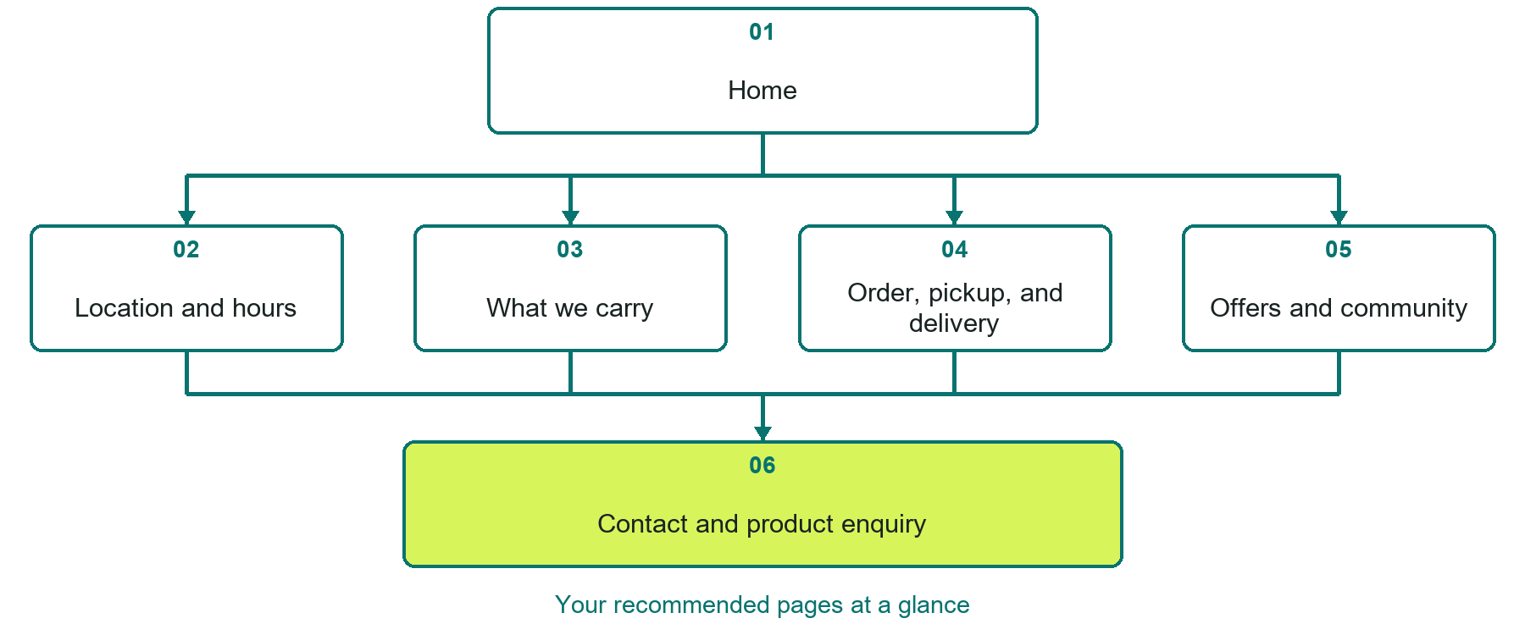

Inside this workbook
Six page examples • Practical writing exercises • A launch review
Use it in a workshop or at your own pace. Write by hand or complete the response fields in Word. The final page links to Website Builder, plans and account signup.
Example business Corner Pine Market

CONVENIENCE STORES

Your website brief
A SaaSTech Servers workshop for convenience stores. Plan your website, learn from the Corner Pine Market example and draft content for your own business.
Each page has a reference sheet followed by a writing sheet. Demo excerpts are labelled separately from new sample wording, which may differ from the screenshot. Click a blank response line to type; longer answers may add pages. Replace fictional details and verify every claim before publishing.
Your business or organization and workshop date

Who should visit your site and what do they need

The main action you want a visitor to take

What you offer and where or how you provide it

Facts photos and permissions to gather before publishing

Workshop rhythm: review the example, write your draft and exchange feedback. Use the final review to choose your next changes. Website Builder and account links are on the last page.

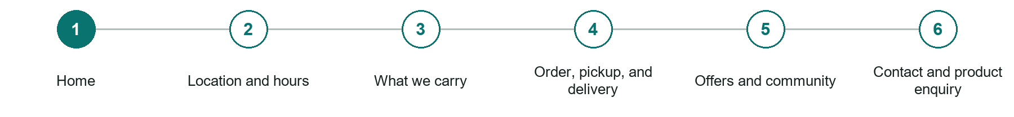
LOOK AND LEARN

Home

The job of this page
Lead with the location, current hours, strongest everyday categories, and immediate paths to directions, calling, or an available order option.
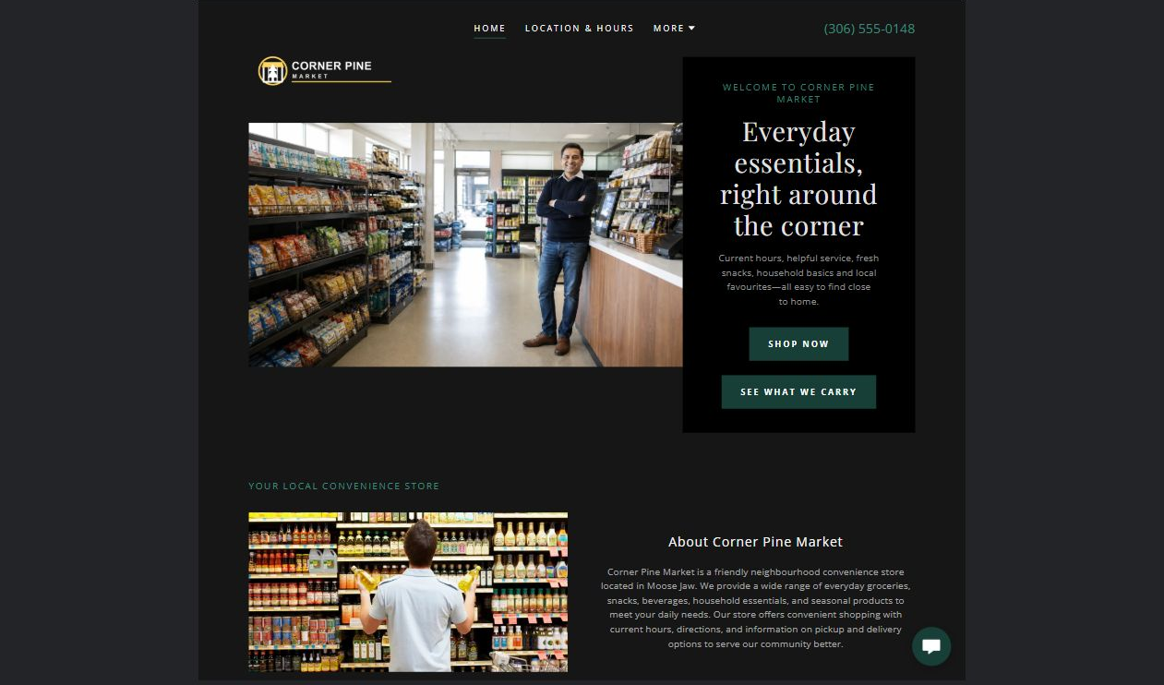
Corner Pine Market example | Explore SaaSTech Website Builder

Sample wording to adapt
Find the essentials close to home
Check the location, current hours and product categories before visiting. Contact the shop about a specific item. Availability can change and should be confirmed directly.

Pause and plan
Could a first-time visitor explain what you do and who it is for after one glance? Choose one main action and the strongest truthful detail that gives them confidence to continue.

WRITE YOUR PAGE

Home
Write for your visitor. Be specific about what they need to know and what happens next. You can revise the wording after the workshop.
Your page headline

Your opening paragraph

Your offer audience location and most useful supporting details

Button or link wording and where it should lead

Photo idea caption and permission or credit needed

Facts to verify or questions to resolve

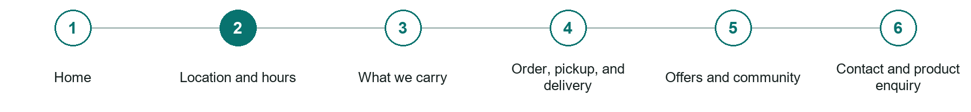
LOOK AND LEARN

Location and hours

The job of this page
Lead with a map, address, phone, regular and holiday hours, accessibility, parking, fuel or charging if applicable, and temporary closures.
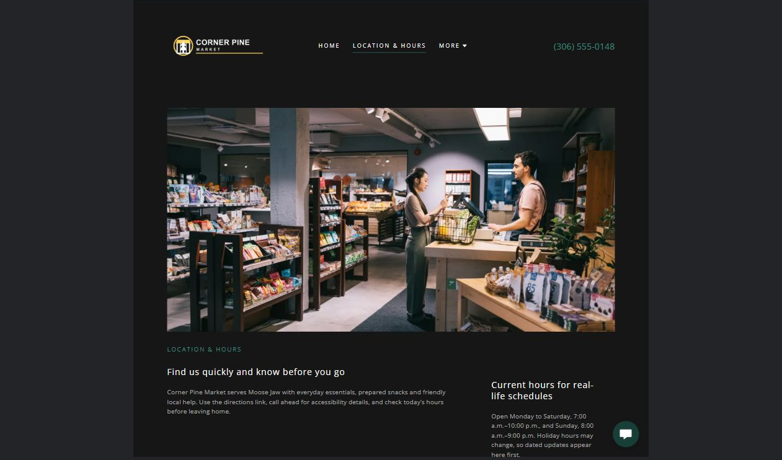
Corner Pine Market example | Explore SaaSTech Website Builder

Sample wording to adapt
Plan your visit
Check today's opening information and how to find the shop. Ask about access or holiday hours before travelling. Keep location details and public contact information current.

Pause and plan
What question brings a visitor to this page? List the details they need, the evidence you can provide and the next useful action. Remove content that does not help them decide or proceed.

WRITE YOUR PAGE

Location and hours
Write for your visitor. Be specific about what they need to know and what happens next. You can revise the wording after the workshop.
Your page headline

Your opening paragraph

Key sections visitor questions and supporting details

Button or link wording and where it should lead

Photo idea caption and permission or credit needed

Facts to verify or questions to resolve

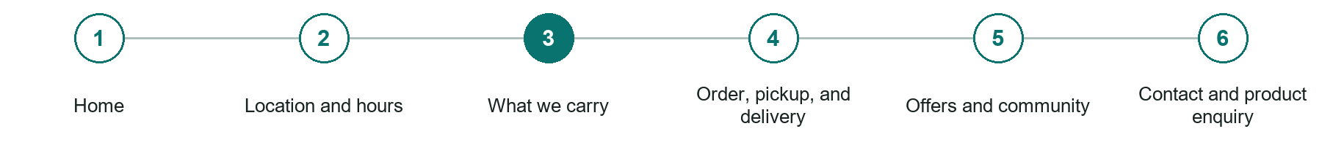
LOOK AND LEARN

What we carry

The job of this page
Describe dependable categories, prepared food, local products, household needs, seasonal items, and services without promising every item is always in stock.
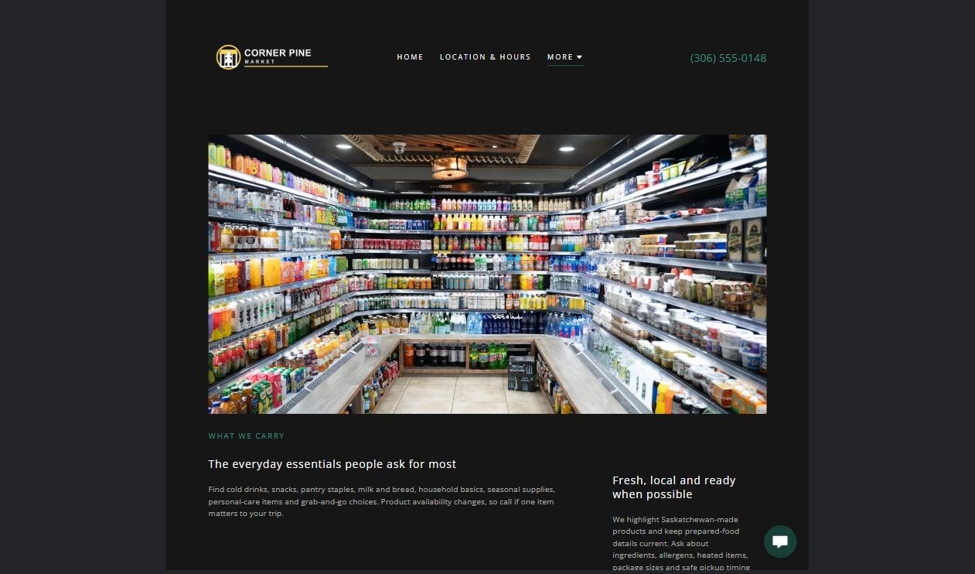
Corner Pine Market example | Explore SaaSTech Website Builder

Sample wording to adapt
Browse what we carry
Explore the main product categories and ask about a particular size or brand. A category photograph is illustrative and does not guarantee stock. Current availability and prices are confirmed by the store.

Pause and plan
What question brings a visitor to this page? List the details they need, the evidence you can provide and the next useful action. Remove content that does not help them decide or proceed.

WRITE YOUR PAGE

What we carry
Write for your visitor. Be specific about what they need to know and what happens next. You can revise the wording after the workshop.
Your page headline

Your opening paragraph

Key sections visitor questions and supporting details

Button or link wording and where it should lead

Photo idea caption and permission or credit needed

Facts to verify or questions to resolve

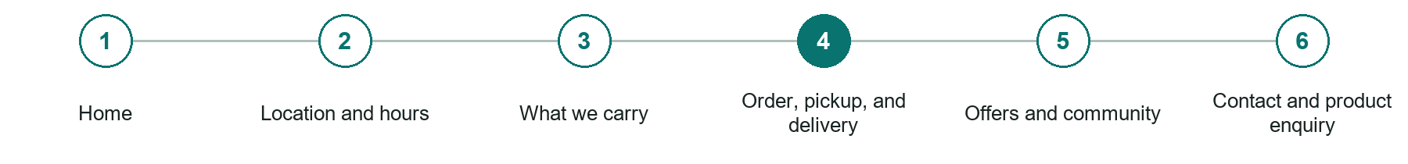
LOOK AND LEARN

Order pickup and delivery

The job of this page
Explain eligible products, service area, minimums, fees, substitutions, preparation times, pickup, delivery, refunds, and identification requirements.
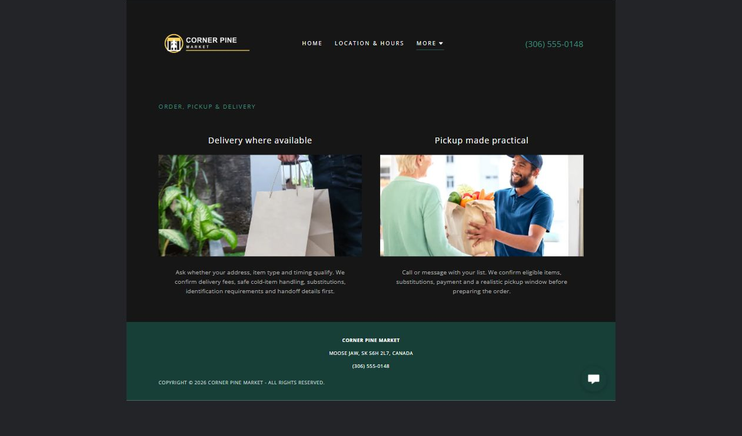
Corner Pine Market example | Explore SaaSTech Website Builder

Sample wording to adapt
Ask about pickup options
Contact the shop to confirm the items, total and collection arrangements. Check whether delivery is available for your location. A product enquiry is not a paid or accepted order.

Pause and plan
What should someone know before arriving or proceeding? Clarify preparation, access and the right contact route. Verify policies and avoid promising urgent help or specialist advice the website cannot provide.

WRITE YOUR PAGE

Order pickup and delivery
Write for your visitor. Be specific about what they need to know and what happens next. You can revise the wording after the workshop.
Your page headline

Your opening paragraph

Preparation access policies and practical questions to answer

Button or link wording and where it should lead

Photo idea caption and permission or credit needed

Facts to verify or questions to resolve

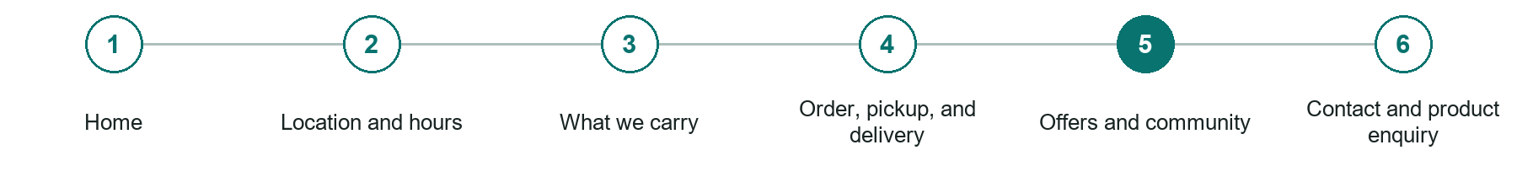
LOOK AND LEARN

Offers and community

The job of this page
Publish current dated promotions, store news, community involvement, local suppliers, employment information, and appropriate customer updates.
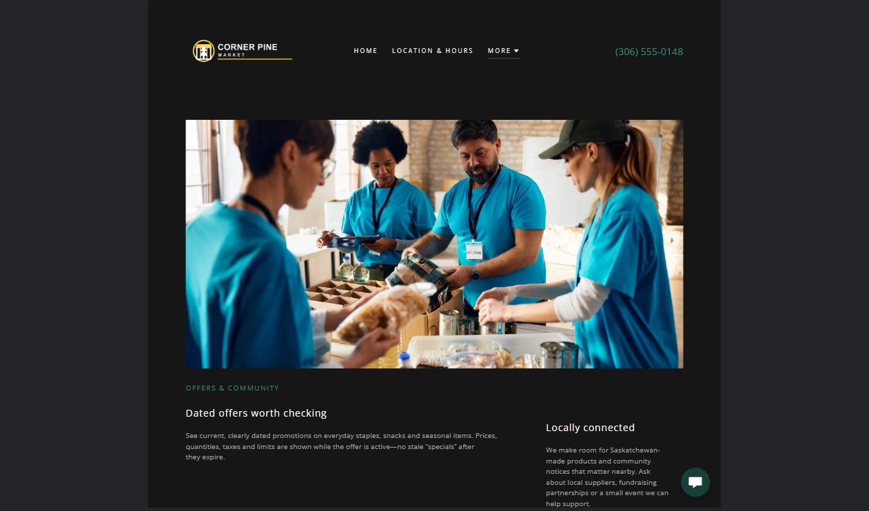
Corner Pine Market example | Explore SaaSTech Website Builder

Sample wording to adapt
Check current offers and local updates
Read the dates and conditions on each offer before visiting. Community announcements should identify the organizer and contact. Expired offers should not appear as current promotions.

Pause and plan
What question brings a visitor to this page? List the details they need, the evidence you can provide and the next useful action. Remove content that does not help them decide or proceed.

WRITE YOUR PAGE

Offers and community
Write for your visitor. Be specific about what they need to know and what happens next. You can revise the wording after the workshop.
Your page headline

Your opening paragraph

Key sections visitor questions and supporting details

Button or link wording and where it should lead

Photo idea caption and permission or credit needed

Facts to verify or questions to resolve

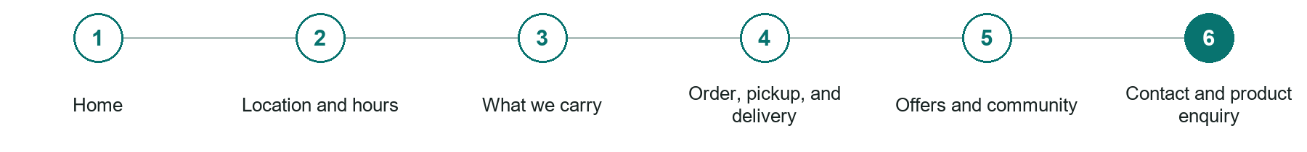
LOOK AND LEARN

Contact and product enquiry

The job of this page
Provide a fast phone-first path plus a simple form for general availability, catering trays, local products, supplier, and employment questions.
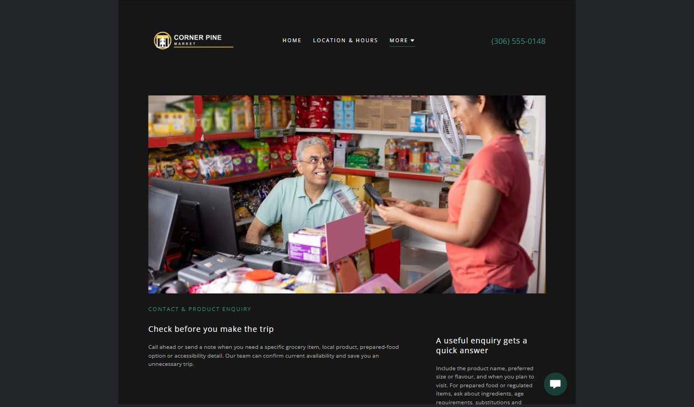
Corner Pine Market example | Explore SaaSTech Website Builder

Sample wording to adapt
Ask about an item
Tell us the product, size or brand you need and your preferred reply method. The team can confirm current availability. Do not send payment-card details through the enquiry form.

Pause and plan
What must someone provide, and what happens after they send it? Separate a request from a confirmed booking, order or place. Decide what information should stay out of a public form.

WRITE YOUR PAGE

Contact and product enquiry
Write for your visitor. Be specific about what they need to know and what happens next. You can revise the wording after the workshop.
Your page headline

Your opening paragraph

Information to request and how you will reply or confirm

Button or link wording and where it should lead

Photo idea caption and permission or credit needed

Facts to verify or questions to resolve

WORKSHOP CLOSE

Review and next steps
Ask a partner to read your draft as a first-time visitor. Can they explain what you offer, who it is for and the next step without extra help?

Before you publish
[ ] Every page has a clear purpose and a useful next step.
[ ] Headlines are specific and the wording sounds like your business.
[ ] Names, service areas, prices, dates and policies have been checked.
[ ] Credentials, testimonials and results are genuine and permission-cleared.
[ ] Photos support the text, do not repeat needlessly and have appropriate permissions.
[ ] Forms ask only for necessary information and explain what happens next.
[ ] Links, downloads and the main visitor task work on a phone.
The most useful feedback from your workshop partner

First change to make and who will do it

Information or photographs still needed

Target review date and who will approve the final content

Keep sensitive customer, patient, employee and payment information out of this workbook. Completing it does not publish a website or connect to Website Builder.

BUILD WITH SAASTECH SERVERS

Put your draft into Website Builder
Use the content you have written to build your own site. Keep the convenience stores demo as a reference, and replace its company name, images and claims with your verified business information.

Explore the builder
See the editor, compare available plans and decide which features your business needs. Confirm current pricing and terms before purchasing.
Website Builder overview

Create your account
Set up your SaaSTech Servers customer account using your own details. Creating an account is separate from purchasing a Website Builder plan.
Create your SaaSTech account

Choose your plan
Open the secure shop to review the plan, subscription term and final total. Use the account connected to your purchase when you open your service.
View Website Builder plans

Build and check your pages
Add the pages from this workbook. Transfer your approved wording, upload permission-cleared photos and review each page on desktop and mobile before publishing.
Return to the Website Builder guide

Using a printed workbook
Type these short addresses into your browser. The account guide includes the Create My Account button.
www.saastech.net/products/website-builder
www.saastech.net/create-account
This workbook does not create an account, purchase a plan or publish your website. Keep passwords, payment details and confidential customer information out of your draft.

