
WEBSITE PLANNING WORKSHOP

Concrete Companies
Website workbook
Plan a clear website for concrete companies. Explore a worked example, shape your own message and prepare to build with SaaSTech Servers.
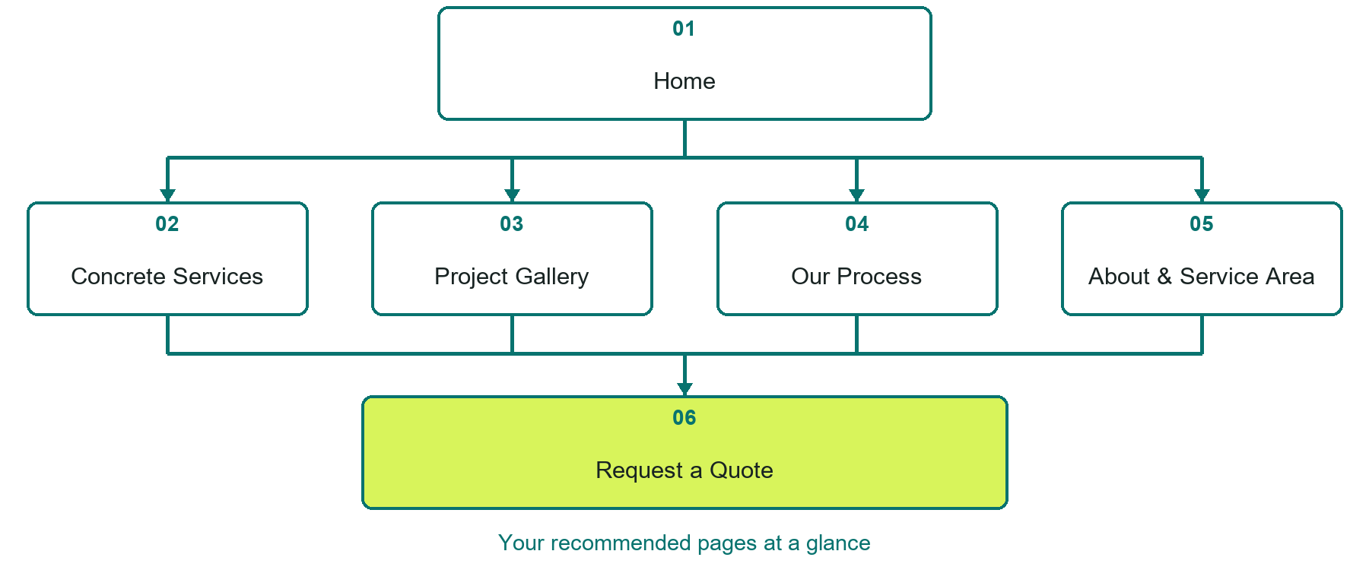

Inside this workbook
Six page examples • Practical writing exercises • A launch review
Use it in a workshop or at your own pace. Write by hand or complete the response fields in Word. The final page links to Website Builder, plans and account signup.
Example business Prairie Stone Concrete

CONCRETE COMPANIES

Your website brief
A SaaSTech Servers workshop for concrete companies. Plan your website, learn from the Prairie Stone Concrete example and draft content for your own business.
Each page has a reference sheet followed by a writing sheet. Demo excerpts are labelled separately from new sample wording, which may differ from the screenshot. Click a blank response line to type; longer answers may add pages. Replace fictional details and verify every claim before publishing.
Your business or organization and workshop date

Who should visit your site and what do they need

The main action you want a visitor to take

What you offer and where or how you provide it

Facts photos and permissions to gather before publishing

Workshop rhythm: review the example, write your draft and exchange feedback. Use the final review to choose your next changes. Website Builder and account links are on the last page.

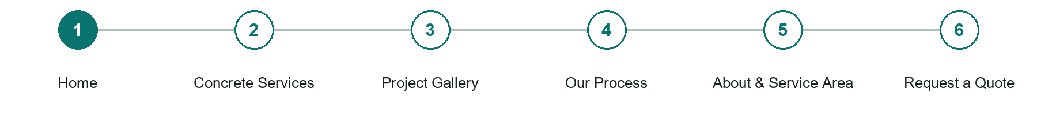
LOOK AND LEARN

Home

The job of this page
Introduce the crew with a contractor-led hero, the actual service area and one quote-request action.
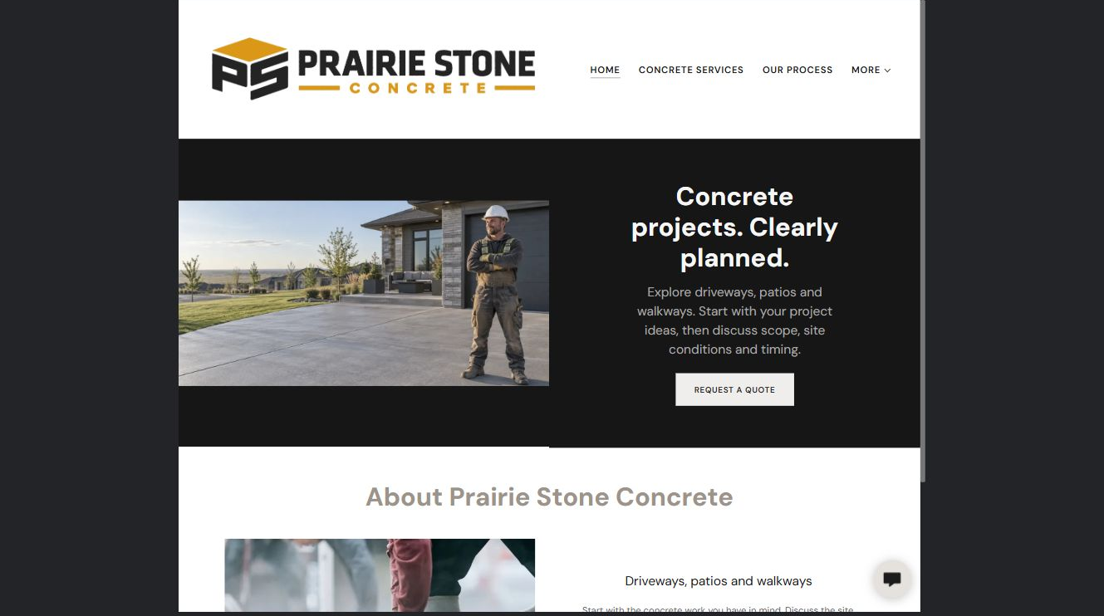
Prairie Stone Concrete example | Explore SaaSTech Website Builder

Demo text example
Concrete projects. Clearly planned.
Explore driveways, patios and walkways. Start with your project ideas, then discuss scope, site conditions and timing.

Pause and plan
Could a first-time visitor explain what you do and who it is for after one glance? Choose one main action and the strongest truthful detail that gives them confidence to continue.

WRITE YOUR PAGE

Home
Write for your visitor. Be specific about what they need to know and what happens next. You can revise the wording after the workshop.
Your page headline

Your opening paragraph

Your offer audience location and most useful supporting details

Button or link wording and where it should lead

Photo idea caption and permission or credit needed

Facts to verify or questions to resolve

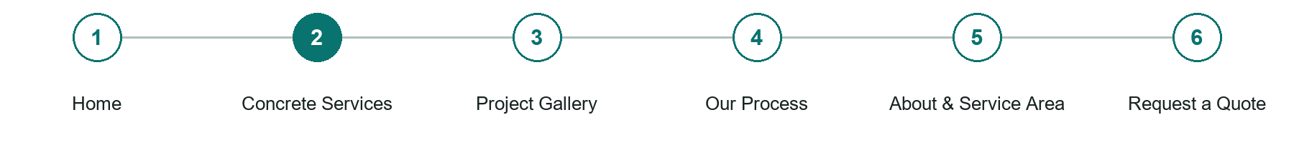
LOOK AND LEARN

Concrete Services

The job of this page
Explain driveways, patios, walkways and foundation work actually offered. Distinguish new work, replacement and specialist work that requires assessment.
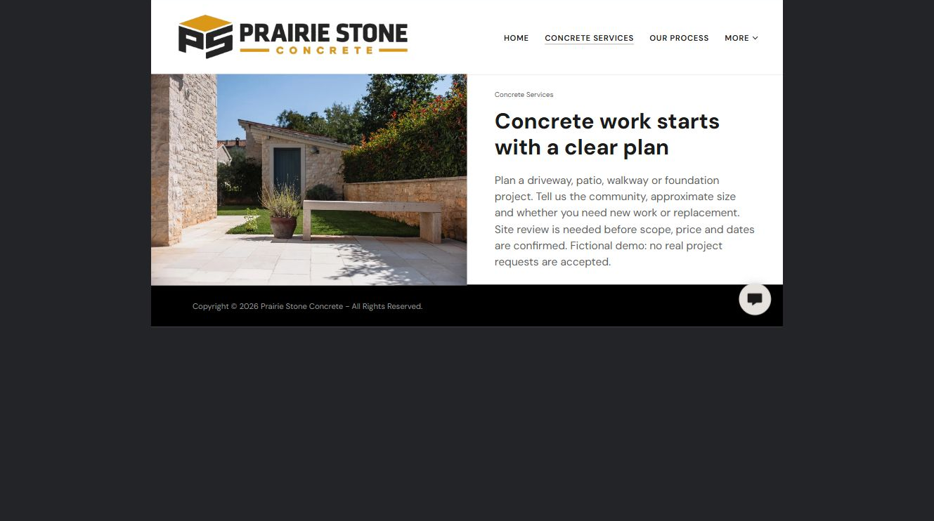
Prairie Stone Concrete example | Explore SaaSTech Website Builder

Demo text example
Concrete work starts with a clear plan
Plan a driveway, patio, walkway or foundation project. Tell us the community, approximate size and whether you need new work or replacement.

Pause and plan
Who is each option for, what does it include and where are its limits? Describe the information needed to check fit. Make the next step clear without promising an outcome before assessment.

WRITE YOUR PAGE

Concrete Services
Write for your visitor. Be specific about what they need to know and what happens next. You can revise the wording after the workshop.
Your page headline

Your opening paragraph

Service options who they suit and what each includes

Button or link wording and where it should lead

Photo idea caption and permission or credit needed

Facts to verify or questions to resolve

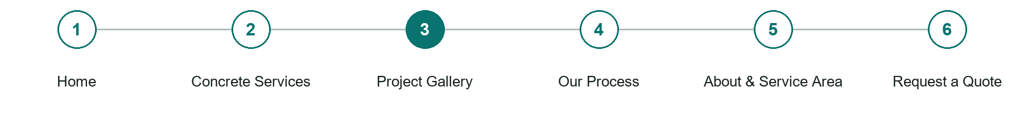
LOOK AND LEARN

Project Gallery

The job of this page
Show distinct examples with captions describing the work and finish. Label illustrative images; use genuine completed-project photos only with permission.
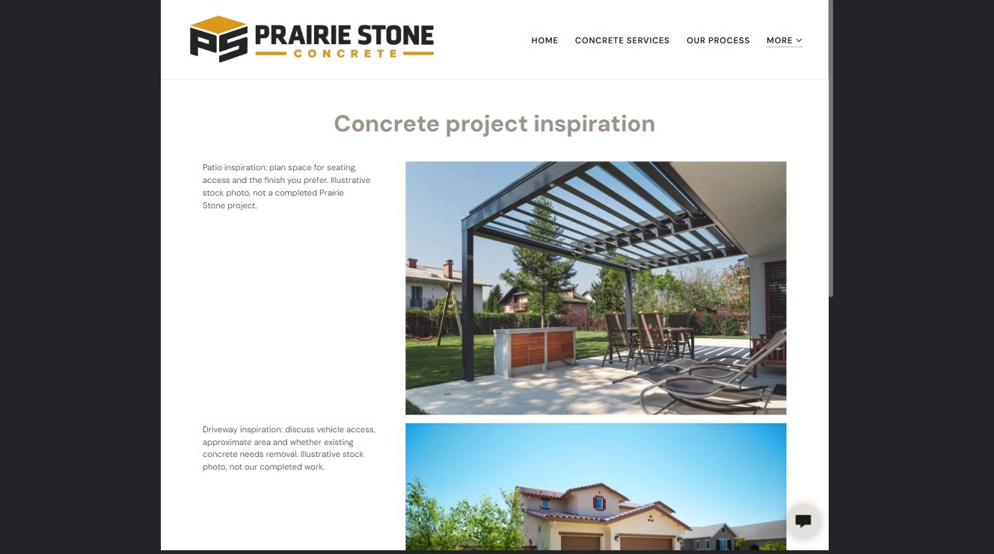
Prairie Stone Concrete example | Explore SaaSTech Website Builder

Demo text example
Concrete project inspiration
Patio inspiration: plan space for seating, access and the finish you prefer.

Pause and plan
Which examples best support this page? Explain the context, your contribution and the permissions or credits needed. Label illustrative work and distinguish it from genuine completed projects or customer results.

WRITE YOUR PAGE

Project Gallery
Write for your visitor. Be specific about what they need to know and what happens next. You can revise the wording after the workshop.
Your page headline

Your opening paragraph

Examples captions context and evidence to include

Button or link wording and where it should lead

Photo idea caption and permission or credit needed

Facts to verify or questions to resolve

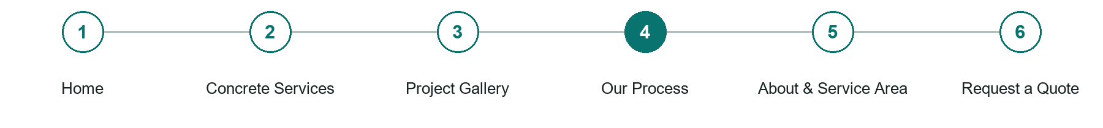
LOOK AND LEARN

Our Process

The job of this page
Explain enquiry, site review, written scope, scheduling and handover. Confirm site access, preparation and care instructions with the contractor rather than offering generic technical advice.
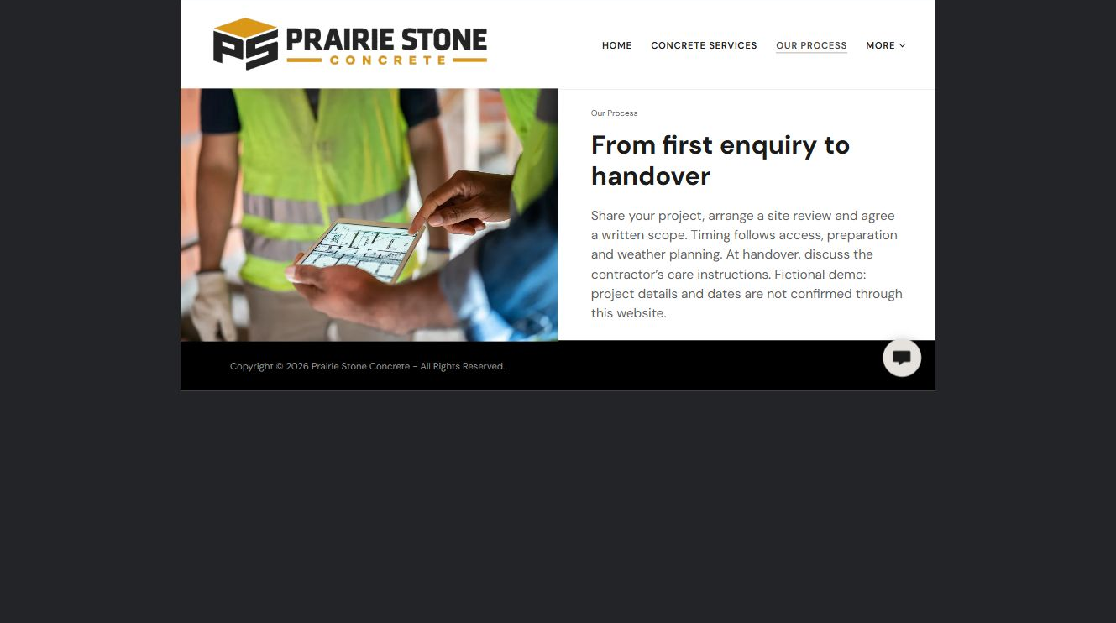
Prairie Stone Concrete example | Explore SaaSTech Website Builder

Demo text example
From first enquiry to handover
Share your project, arrange a site review and agree a written scope.

Pause and plan
What question brings a visitor to this page? List the details they need, the evidence you can provide and the next useful action. Remove content that does not help them decide or proceed.

WRITE YOUR PAGE

Our Process
Write for your visitor. Be specific about what they need to know and what happens next. You can revise the wording after the workshop.
Your page headline

Your opening paragraph

Key sections visitor questions and supporting details

Button or link wording and where it should lead

Photo idea caption and permission or credit needed

Facts to verify or questions to resolve

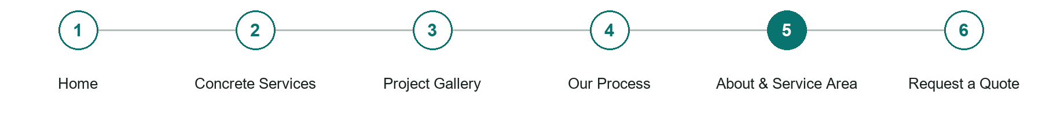
LOOK AND LEARN

About Service Area

The job of this page
Introduce the team and communities served. Publish only verified qualifications, insurance, experience and customer feedback.
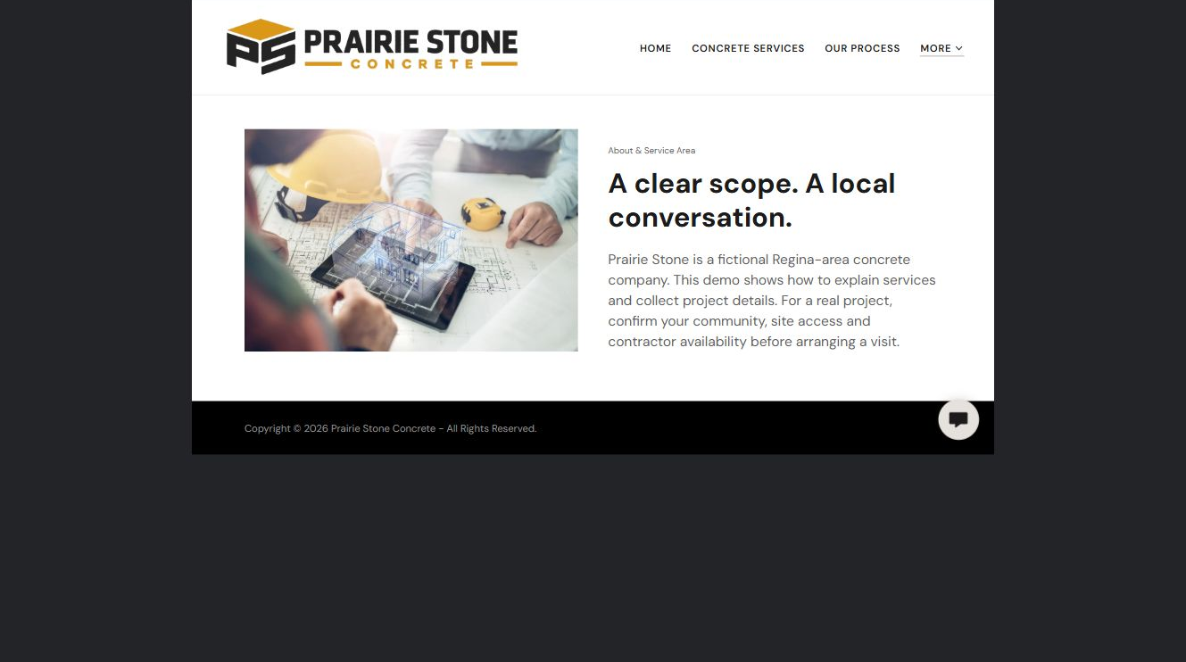
Prairie Stone Concrete example | Explore SaaSTech Website Builder

Demo text example
A clear scope. A local conversation.
Prairie Stone is a fictional Regina-area concrete company. This demo shows how to explain services and collect project details.

Pause and plan
Which names, roles and qualifications can you verify? What would help a visitor feel comfortable contacting you? Obtain permission for portraits and describe actual experience without unsupported claims.

WRITE YOUR PAGE

About Service Area
Write for your visitor. Be specific about what they need to know and what happens next. You can revise the wording after the workshop.
Your page headline

Your opening paragraph

People roles approach and verified credentials to introduce

Button or link wording and where it should lead

Photo idea caption and permission or credit needed

Facts to verify or questions to resolve

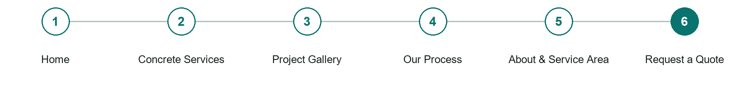
LOOK AND LEARN

Request a Quote

The job of this page
Ask for contact details, community, project type, approximate dimensions, existing surface, access considerations and preferred timing. Explain that scope, price and scheduling require confirmation.
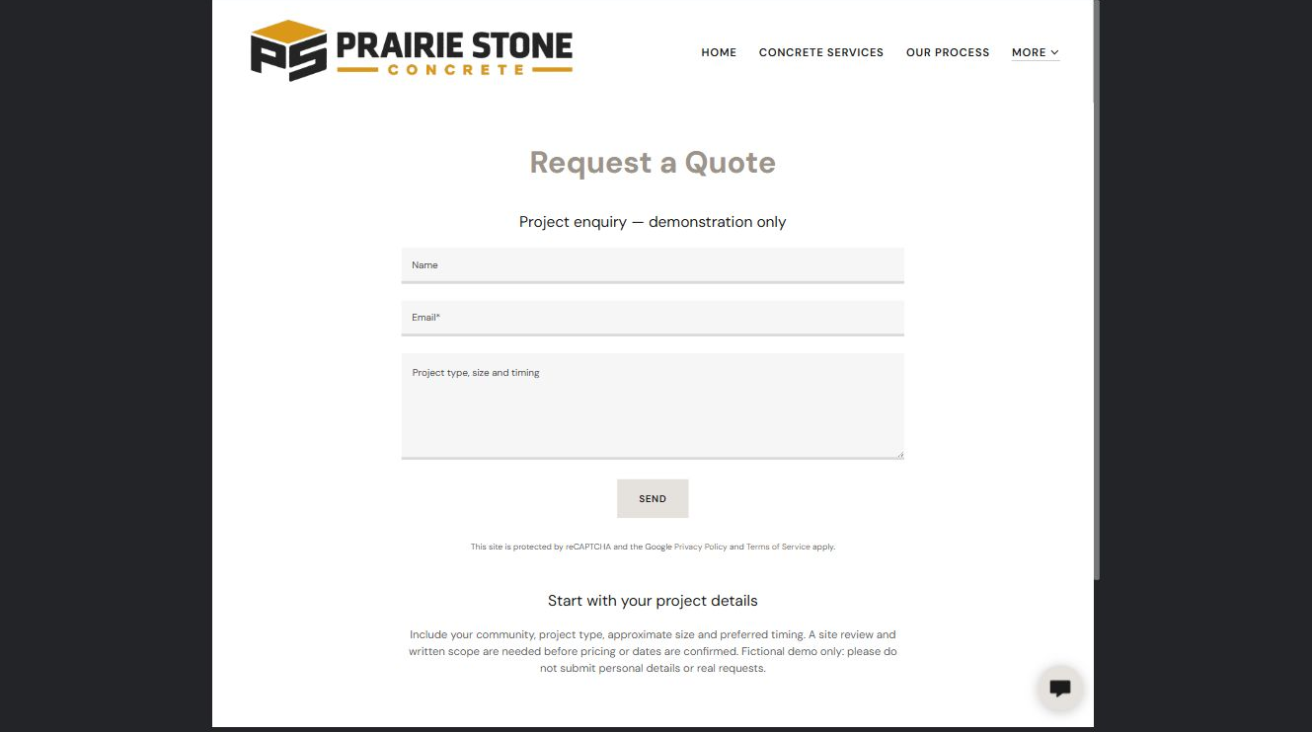
Prairie Stone Concrete example | Explore SaaSTech Website Builder

Sample wording to adapt
Start with your project details
Tell us your community, approximate area, existing surface and preferred timing. We will discuss site access and the next assessment step before confirming scope, price or a construction date.

Pause and plan
What must someone provide, and what happens after they send it? Separate a request from a confirmed booking, order or place. Decide what information should stay out of a public form.

WRITE YOUR PAGE

Request a Quote
Write for your visitor. Be specific about what they need to know and what happens next. You can revise the wording after the workshop.
Your page headline

Your opening paragraph

Information to request and how you will reply or confirm

Button or link wording and where it should lead

Photo idea caption and permission or credit needed

Facts to verify or questions to resolve

WORKSHOP CLOSE

Review and next steps
Ask a partner to read your draft as a first-time visitor. Can they explain what you offer, who it is for and the next step without extra help?

Before you publish
[ ] Every page has a clear purpose and a useful next step.
[ ] Headlines are specific and the wording sounds like your business.
[ ] Names, service areas, prices, dates and policies have been checked.
[ ] Credentials, testimonials and results are genuine and permission-cleared.
[ ] Photos support the text, do not repeat needlessly and have appropriate permissions.
[ ] Forms ask only for necessary information and explain what happens next.
[ ] Links, downloads and the main visitor task work on a phone.
The most useful feedback from your workshop partner

First change to make and who will do it

Information or photographs still needed

Target review date and who will approve the final content

Keep sensitive customer, patient, employee and payment information out of this workbook. Completing it does not publish a website or connect to Website Builder.

BUILD WITH SAASTECH SERVERS

Put your draft into Website Builder
Use the content you have written to build your own site. Keep the concrete companies demo as a reference, and replace its company name, images and claims with your verified business information.

Explore the builder
See the editor, compare available plans and decide which features your business needs. Confirm current pricing and terms before purchasing.
Website Builder overview

Create your account
Set up your SaaSTech Servers customer account using your own details. Creating an account is separate from purchasing a Website Builder plan.
Create your SaaSTech account

Choose your plan
Open the secure shop to review the plan, subscription term and final total. Use the account connected to your purchase when you open your service.
View Website Builder plans

Build and check your pages
Add the pages from this workbook. Transfer your approved wording, upload permission-cleared photos and review each page on desktop and mobile before publishing.
Return to the Website Builder guide

Using a printed workbook
Type these short addresses into your browser. The account guide includes the Create My Account button.
www.saastech.net/products/website-builder
www.saastech.net/create-account
This workbook does not create an account, purchase a plan or publish your website. Keep passwords, payment details and confidential customer information out of your draft.

