SaaSTech Servers | 

Computer and IT support website workbook
Plan a clear six-page support website before entering content in Website Builder. Each page combines practical advice, Prairie Byte example wording, and space for your own draft.
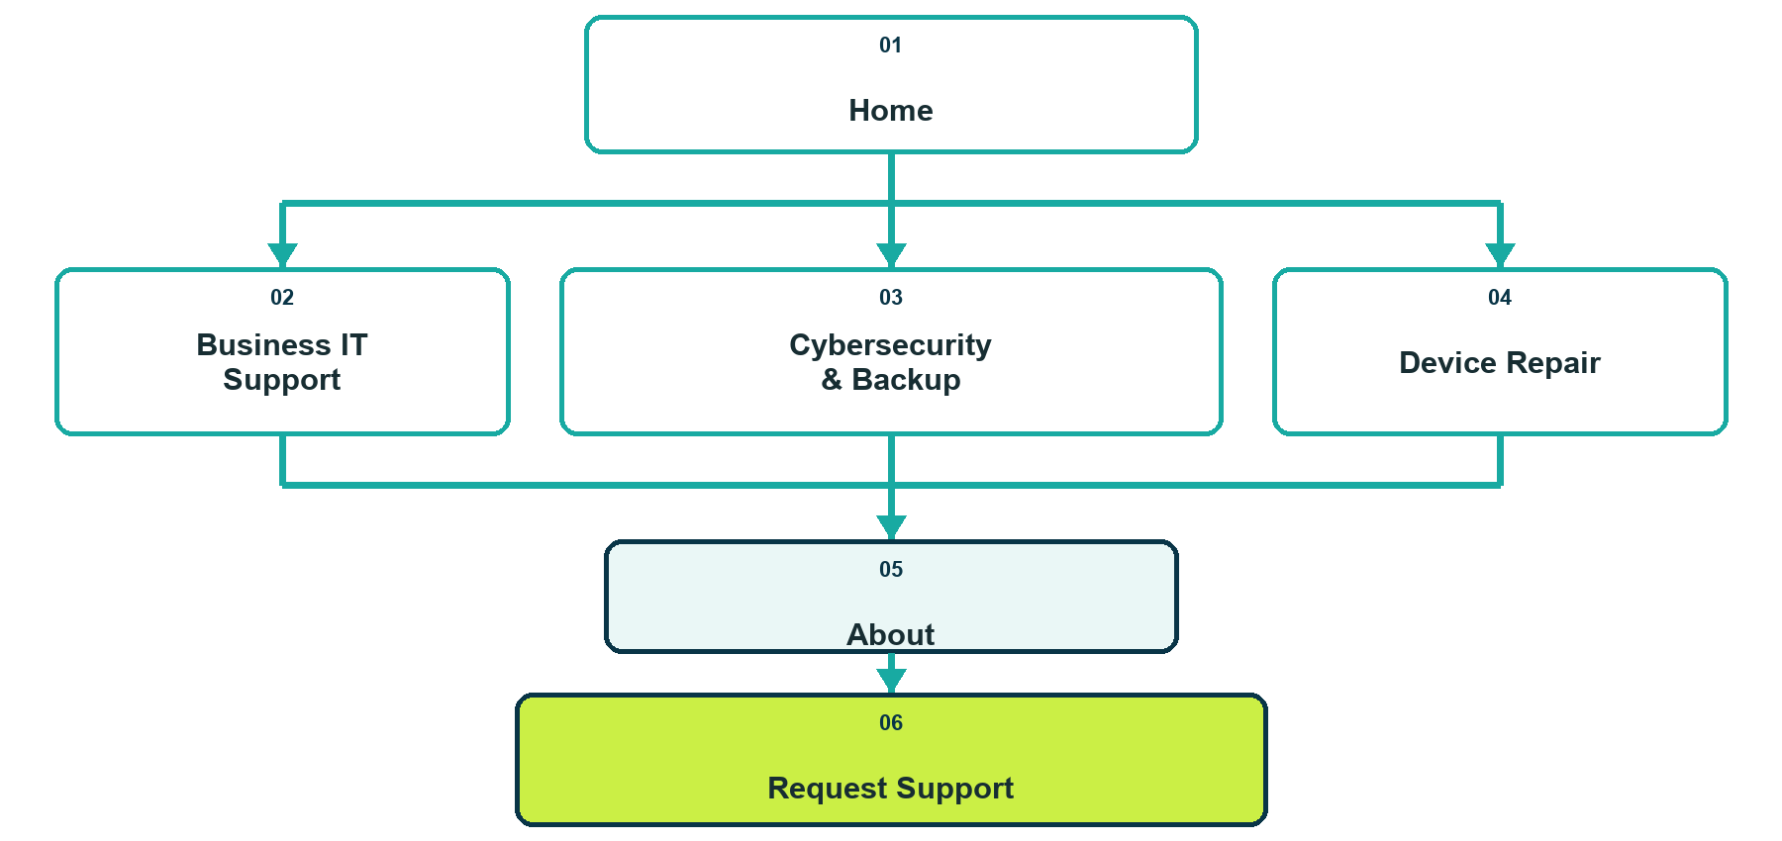
A visitor chooses the problem path, confirms who is behind the service, then requests support safely.

Before the workshop
Bring your verified business name, service area, business hours, public contact details, current logo files, and a list of services you can explain accurately. Keep private customer records and credentials out of the website draft.
The main customer problem this website should solve
________________________________________________________________________________
________________________________________________________________________________
________________________________________________________________________________

SaaSTech Servers

1 Home
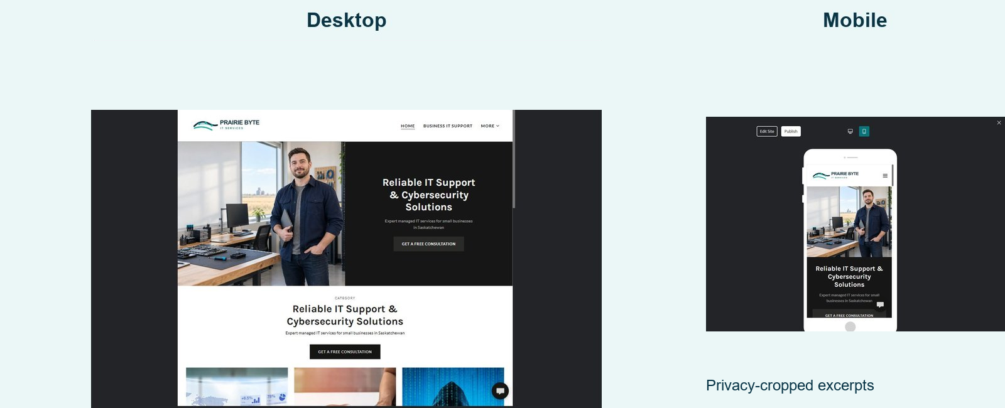
Current Prairie Byte Home page on desktop and mobile

Website advice
Explain who you help, the common problems you solve, and the safest next step.

Prairie Byte example
Clear technology help for the way your business works. Prairie Byte supports workstations, Microsoft 365, networks, backups, and everyday device issues for small organizations.

Your draft
Page headline
________________________________________________________________________________
Supporting message
________________________________________________________________________________
________________________________________________________________________________
Primary action and destination
________________________________________________________________________________

SaaSTech Servers

2 Business IT Support
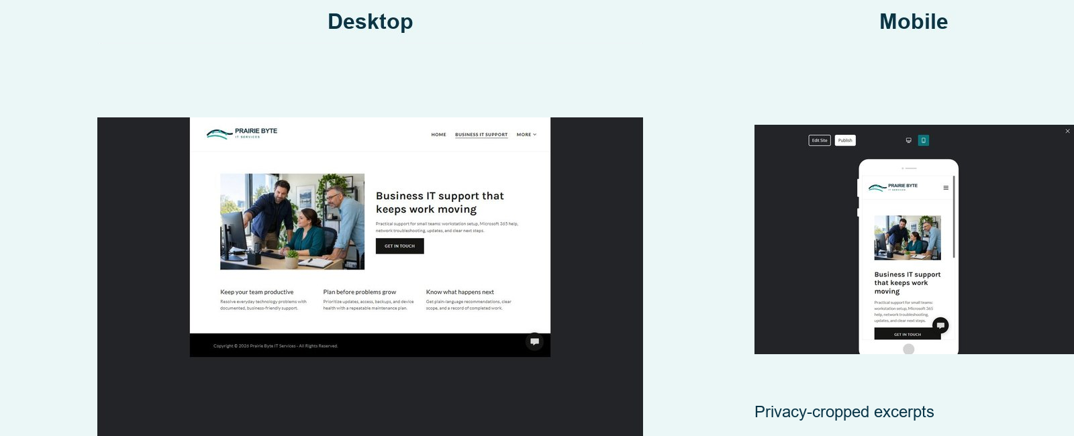
Current Prairie Byte Business IT Support page on desktop and mobile

Website advice
Group recurring business support around outcomes instead of technical product names.

Prairie Byte example
Keep your team productive with practical help for devices, accounts, updates, network problems, and new staff setup.

Your draft
Page headline
________________________________________________________________________________
Supporting message
________________________________________________________________________________
________________________________________________________________________________
Primary action and destination
________________________________________________________________________________

SaaSTech Servers

3 Cybersecurity and Backup
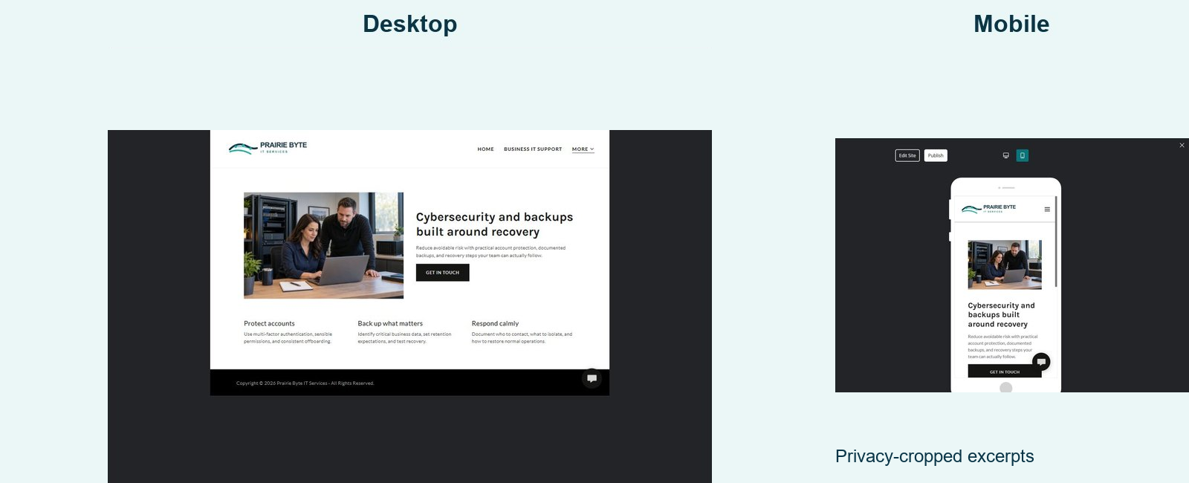
Current Prairie Byte Cybersecurity and Backup page on desktop and mobile

Website advice
Explain prevention, recovery, and limits without making guarantees.

Prairie Byte example
Protect accounts, back up important business information, and prepare a clear response plan before a disruption.

Your draft
Page headline
________________________________________________________________________________
Supporting message
________________________________________________________________________________
________________________________________________________________________________
Primary action and destination
________________________________________________________________________________

SaaSTech Servers

4 Device Repair
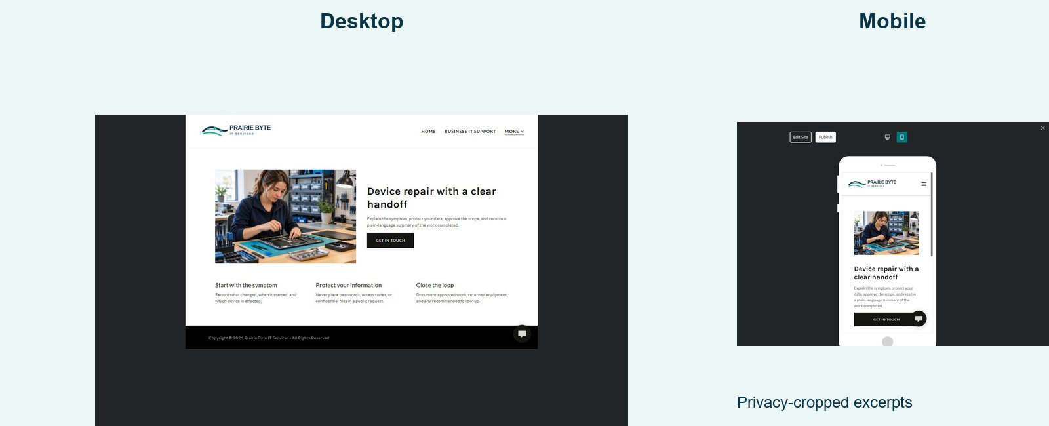
Current Prairie Byte Device Repair page on desktop and mobile

Website advice
Set expectations for assessment, privacy, approvals, and handoff.

Prairie Byte example
Start with the symptom, explain the proposed repair, protect customer information, and close the loop with clear pickup notes.

Your draft
Page headline
________________________________________________________________________________
Supporting message
________________________________________________________________________________
________________________________________________________________________________
Primary action and destination
________________________________________________________________________________

SaaSTech Servers

5 About
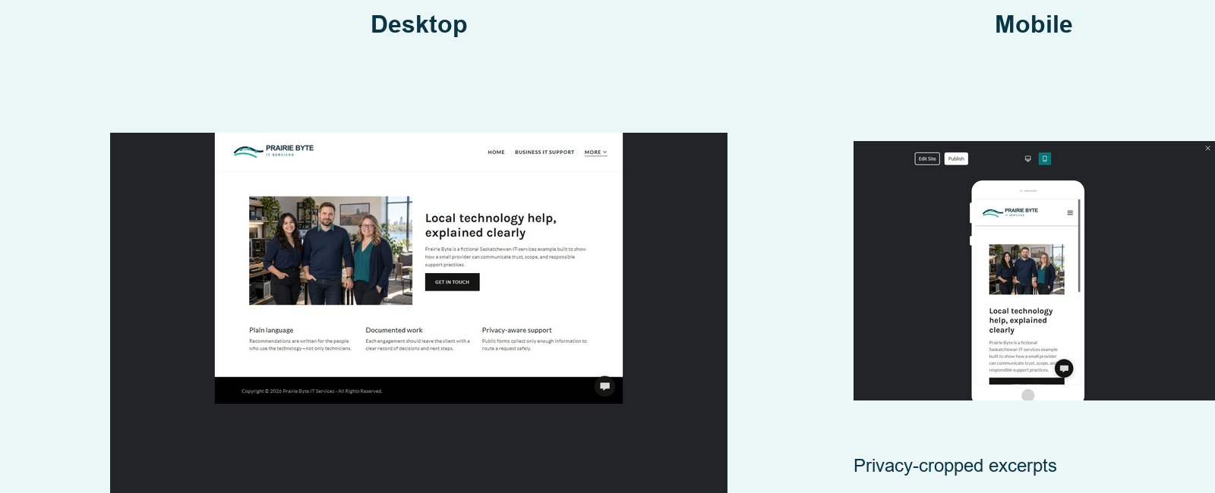
Current Prairie Byte About page on desktop and mobile

Website advice
Show the people and working principles behind the service.

Prairie Byte example
Prairie Byte provides local technology help in plain language, documents completed work, and uses privacy-aware support practices.

Your draft
Page headline
________________________________________________________________________________
Supporting message
________________________________________________________________________________
________________________________________________________________________________
Primary action and destination
________________________________________________________________________________

SaaSTech Servers

6 Request Support
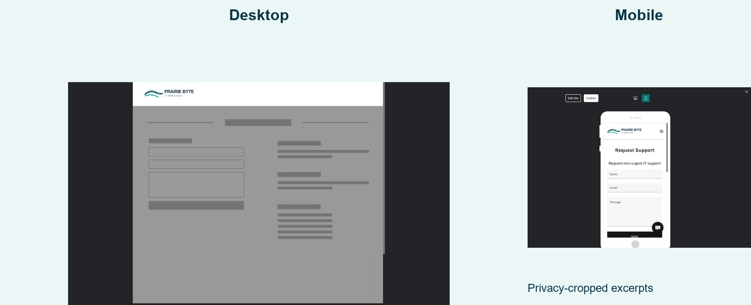
Current Prairie Byte Request Support page on desktop and mobile

Website advice
Collect only the details needed to route a non-urgent request.

Prairie Byte example
Tell us what stopped working without including passwords, access codes, confidential files, health information, or payment information.

Your draft
Page headline
________________________________________________________________________________
Supporting message
________________________________________________________________________________
________________________________________________________________________________
Primary action and destination
________________________________________________________________________________

SaaSTech Servers

Launch review
☐ Every page answers a distinct visitor question.
☐ All services, hours, prices, response times, and qualifications are verified.
☐ Each page uses a distinct, relevant image with permission to publish.
☐ The support form excludes credentials and sensitive records.
☐ Buttons work on desktop and mobile, and contact details are consistent.
☐ A named backup is saved before major revisions or publishing.

Website Builder
Learn about Website Builder: https://www.saastech.net/products/website-builder
Return to this industry guide: https://www.saastech.net/industry/computer-it-support

