
WEBSITE PLANNING WORKSHOP

Clubs & Special-Interest Groups
Website workbook
Plan a clear website for clubs & special-interest groups. Explore a worked example, shape your own message and prepare to build with SaaSTech Servers.
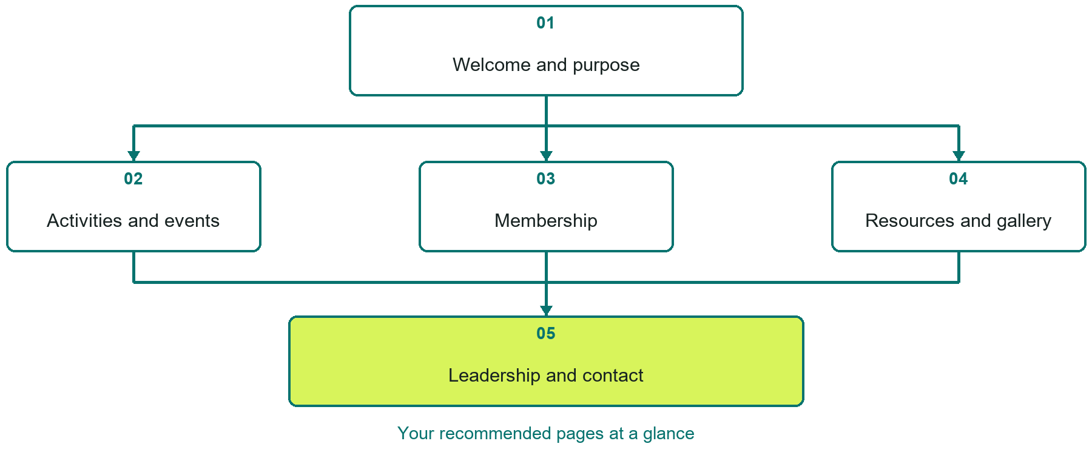

Inside this workbook
Five page examples • Practical writing exercises • A launch review
Use it in a workshop or at your own pace. Write by hand or complete the response fields in Word. The final page links to Website Builder, plans and account signup.
Example business Prairie Sky Astronomy Club

CLUBS & SPECIAL-INTEREST GROUPS

Your website brief
A SaaSTech Servers workshop for clubs & special-interest groups. Plan your website, learn from the Prairie Sky Astronomy Club example and draft content for your own business.
Each page has a reference sheet followed by a writing sheet. Demo excerpts are labelled separately from new sample wording, which may differ from the screenshot. Click a blank response line to type; longer answers may add pages. Replace fictional details and verify every claim before publishing.
Your business or organization and workshop date

Who should visit your site and what do they need

The main action you want a visitor to take

What you offer and where or how you provide it

Facts photos and permissions to gather before publishing

Workshop rhythm: review the example, write your draft and exchange feedback. Use the final review to choose your next changes. Website Builder and account links are on the last page.

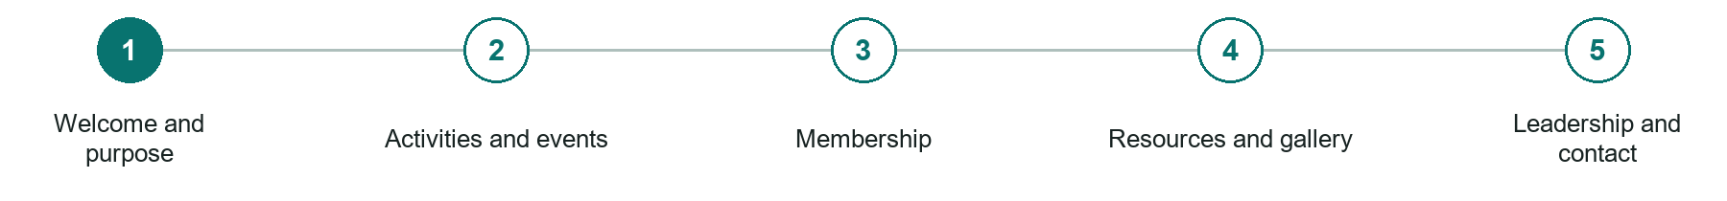
LOOK AND LEARN

Welcome and purpose

The job of this page
Explain the interest, who can participate, where the group meets, and the easiest first activity for a newcomer.
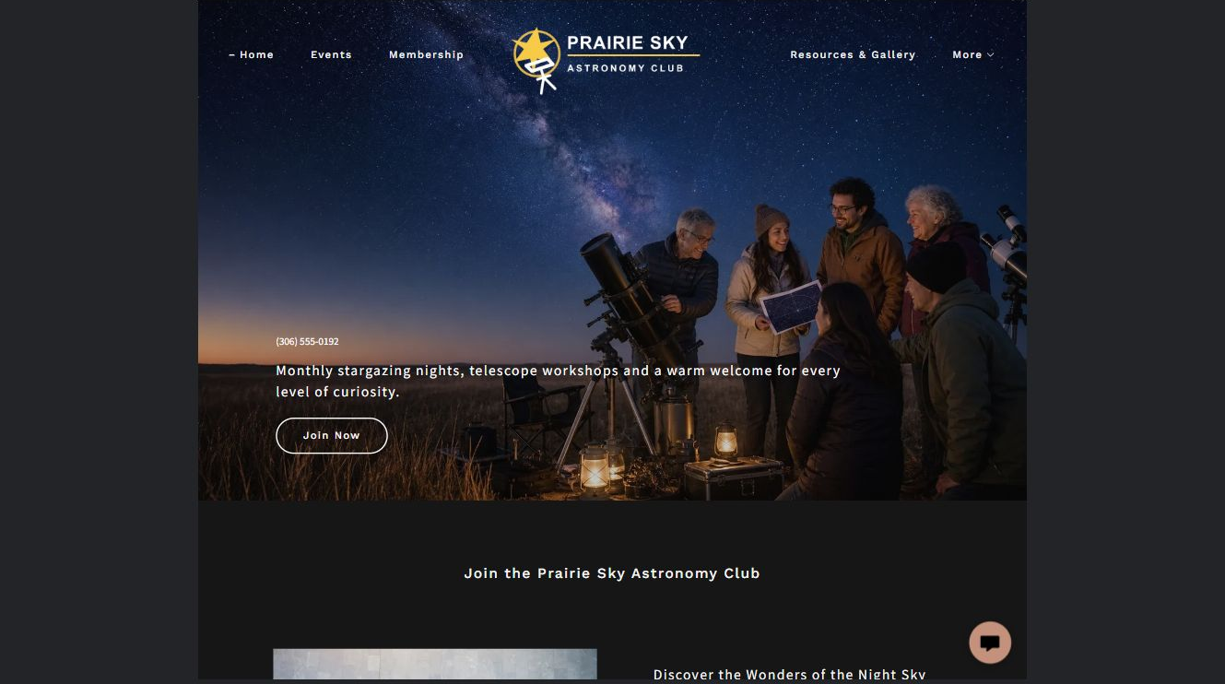
Prairie Sky Astronomy Club example | Explore SaaSTech Website Builder

Sample wording to adapt
Explore the night sky with others
Find out what the club does, who can join and how to attend a first gathering. Check current event details before travelling. Beginners can ask about equipment and what to expect.

Pause and plan
Could a first-time visitor explain what you do and who it is for after one glance? Choose one main action and the strongest truthful detail that gives them confidence to continue.

WRITE YOUR PAGE

Welcome and purpose
Write for your visitor. Be specific about what they need to know and what happens next. You can revise the wording after the workshop.
Your page headline

Your opening paragraph

Your offer audience location and most useful supporting details

Button or link wording and where it should lead

Photo idea caption and permission or credit needed

Facts to verify or questions to resolve

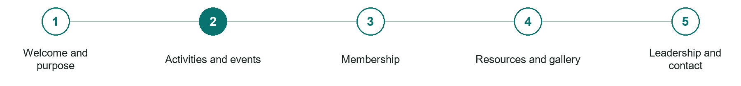
LOOK AND LEARN

Activities and events

The job of this page
Publish current meetings, workshops, outings, shows, competitions, accessibility, costs, and registration details.
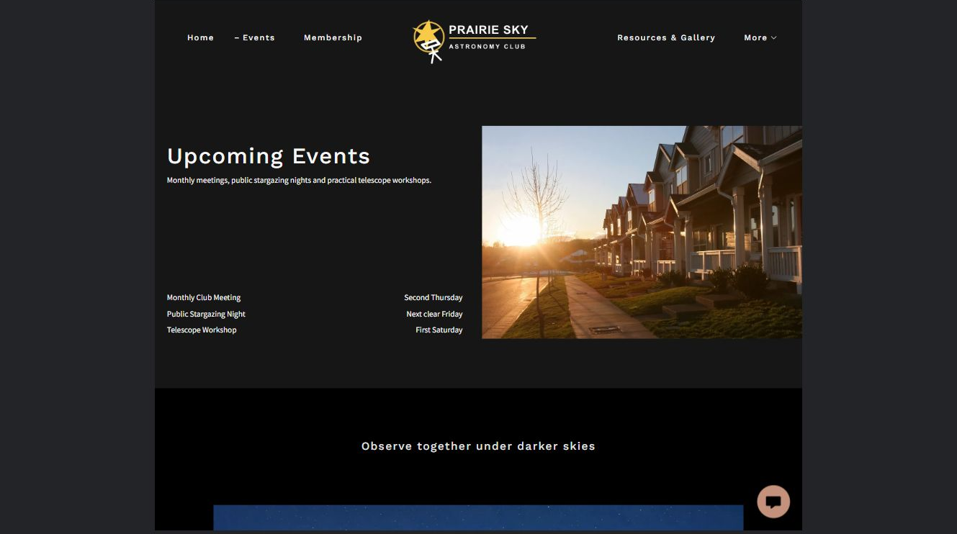
Prairie Sky Astronomy Club example | Explore SaaSTech Website Builder

Sample wording to adapt
Plan your next club outing
Read the date, location, weather arrangements and participation requirements. Confirm changes through the club's update channel. Some activities may need registration or suitable equipment.

Pause and plan
Which dates and locations need to stay current? Decide who will update changes and where visitors should check before travelling. Separate archived information and illustrative schedules from current availability.

WRITE YOUR PAGE

Activities and events
Write for your visitor. Be specific about what they need to know and what happens next. You can revise the wording after the workshop.
Your page headline

Your opening paragraph

Dates locations update process and participation details

Button or link wording and where it should lead

Photo idea caption and permission or credit needed

Facts to verify or questions to resolve

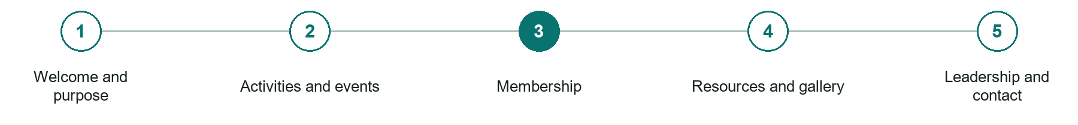
LOOK AND LEARN

Membership

The job of this page
Explain benefits, eligibility, dues, renewal, conduct, insurance boundaries, and what happens after joining.
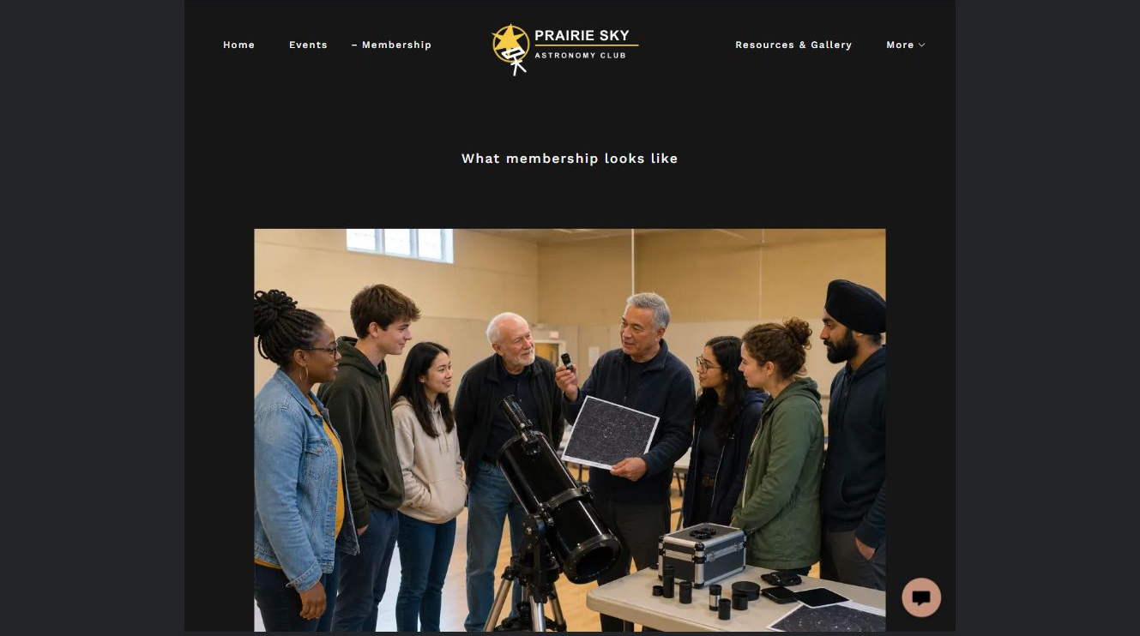
Prairie Sky Astronomy Club example | Explore SaaSTech Website Builder

Sample wording to adapt
Find out how membership works
Review the current fees, benefits and expectations before joining. Ask how your application is confirmed and when renewal is due. An enquiry does not automatically create membership.

Pause and plan
What question brings a visitor to this page? List the details they need, the evidence you can provide and the next useful action. Remove content that does not help them decide or proceed.

WRITE YOUR PAGE

Membership
Write for your visitor. Be specific about what they need to know and what happens next. You can revise the wording after the workshop.
Your page headline

Your opening paragraph

Key sections visitor questions and supporting details

Button or link wording and where it should lead

Photo idea caption and permission or credit needed

Facts to verify or questions to resolve

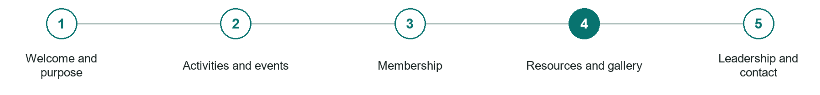
LOOK AND LEARN

Resources and gallery

The job of this page
Share useful public resources, project or event highlights, newsletters, and appropriate member contributions.
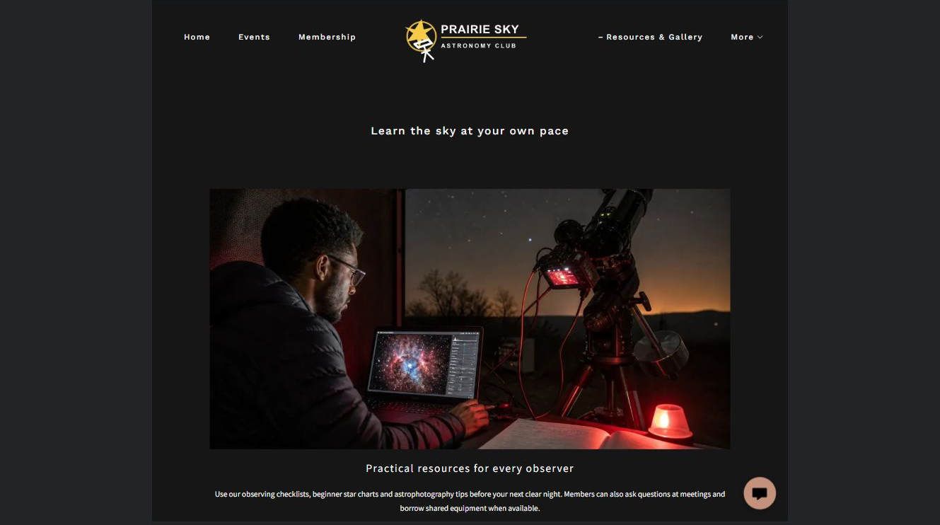
Prairie Sky Astronomy Club example | Explore SaaSTech Website Builder

Sample wording to adapt
Learn from shared resources
Browse observation notes, useful links and permission-cleared photographs. Captions explain what was observed and when. Check any external guidance before relying on it for an outing.

Pause and plan
Which examples best support this page? Explain the context, your contribution and the permissions or credits needed. Label illustrative work and distinguish it from genuine completed projects or customer results.

WRITE YOUR PAGE

Resources and gallery
Write for your visitor. Be specific about what they need to know and what happens next. You can revise the wording after the workshop.
Your page headline

Your opening paragraph

Examples captions context and evidence to include

Button or link wording and where it should lead

Photo idea caption and permission or credit needed

Facts to verify or questions to resolve

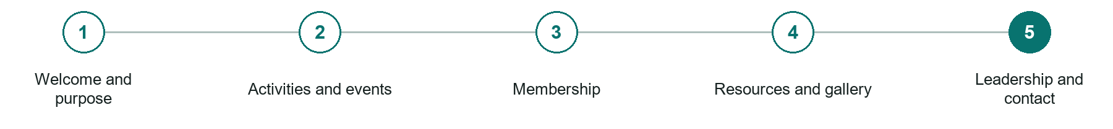
LOOK AND LEARN

Leadership and contact

The job of this page
Identify current officers, governance, committees, partner groups, and role-based contact information.
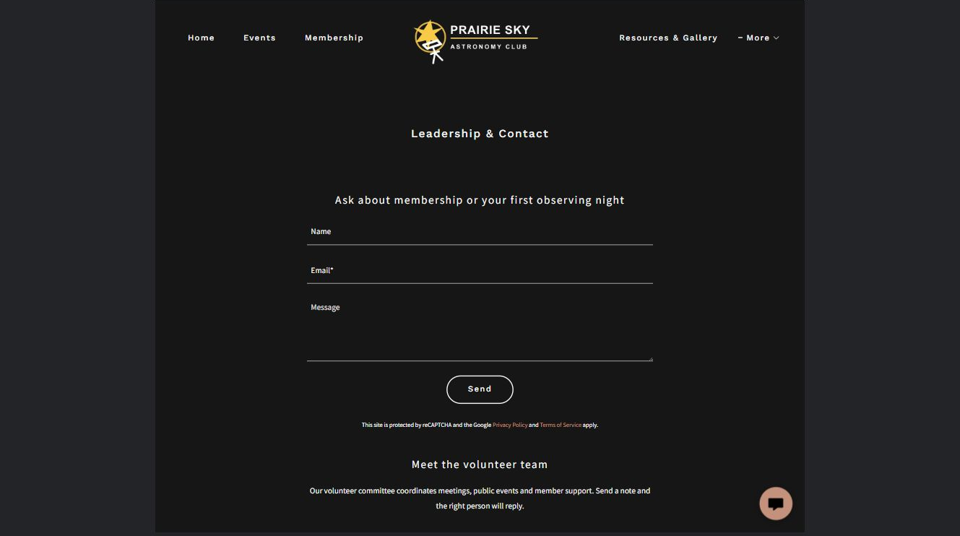
Prairie Sky Astronomy Club example | Explore SaaSTech Website Builder

Sample wording to adapt
Contact the club team
Ask about membership, an event or a volunteer role using the relevant contact. Keep your message brief and include a reply address. Do not publish members' private contact details without permission.

Pause and plan
What must someone provide, and what happens after they send it? Separate a request from a confirmed booking, order or place. Decide what information should stay out of a public form.

WRITE YOUR PAGE

Leadership and contact
Write for your visitor. Be specific about what they need to know and what happens next. You can revise the wording after the workshop.
Your page headline

Your opening paragraph

Information to request and how you will reply or confirm

Button or link wording and where it should lead

Photo idea caption and permission or credit needed

Facts to verify or questions to resolve

WORKSHOP CLOSE

Review and next steps
Ask a partner to read your draft as a first-time visitor. Can they explain what you offer, who it is for and the next step without extra help?

Before you publish
[ ] Every page has a clear purpose and a useful next step.
[ ] Headlines are specific and the wording sounds like your business.
[ ] Names, service areas, prices, dates and policies have been checked.
[ ] Credentials, testimonials and results are genuine and permission-cleared.
[ ] Photos support the text, do not repeat needlessly and have appropriate permissions.
[ ] Forms ask only for necessary information and explain what happens next.
[ ] Links, downloads and the main visitor task work on a phone.
The most useful feedback from your workshop partner

First change to make and who will do it

Information or photographs still needed

Target review date and who will approve the final content

Keep sensitive customer, patient, employee and payment information out of this workbook. Completing it does not publish a website or connect to Website Builder.

BUILD WITH SAASTECH SERVERS

Put your draft into Website Builder
Use the content you have written to build your own site. Keep the clubs & special-interest groups demo as a reference, and replace its company name, images and claims with your verified business information.

Explore the builder
See the editor, compare available plans and decide which features your business needs. Confirm current pricing and terms before purchasing.
Website Builder overview

Create your account
Set up your SaaSTech Servers customer account using your own details. Creating an account is separate from purchasing a Website Builder plan.
Create your SaaSTech account

Choose your plan
Open the secure shop to review the plan, subscription term and final total. Use the account connected to your purchase when you open your service.
View Website Builder plans

Build and check your pages
Add the pages from this workbook. Transfer your approved wording, upload permission-cleared photos and review each page on desktop and mobile before publishing.
Return to the Website Builder guide

Using a printed workbook
Type these short addresses into your browser. The account guide includes the Create My Account button.
www.saastech.net/products/website-builder
www.saastech.net/create-account
This workbook does not create an account, purchase a plan or publish your website. Keep passwords, payment details and confidential customer information out of your draft.

