Clothing Boutique Website Workbook
A printable SaaSTech Servers workshop guide for planning a useful boutique website
Use this workbook to plan each customer-facing page before building. The Prairie Thread example shows one possible approach. Write your own wording in the draft space and confirm every operational detail before publishing.

Website flow
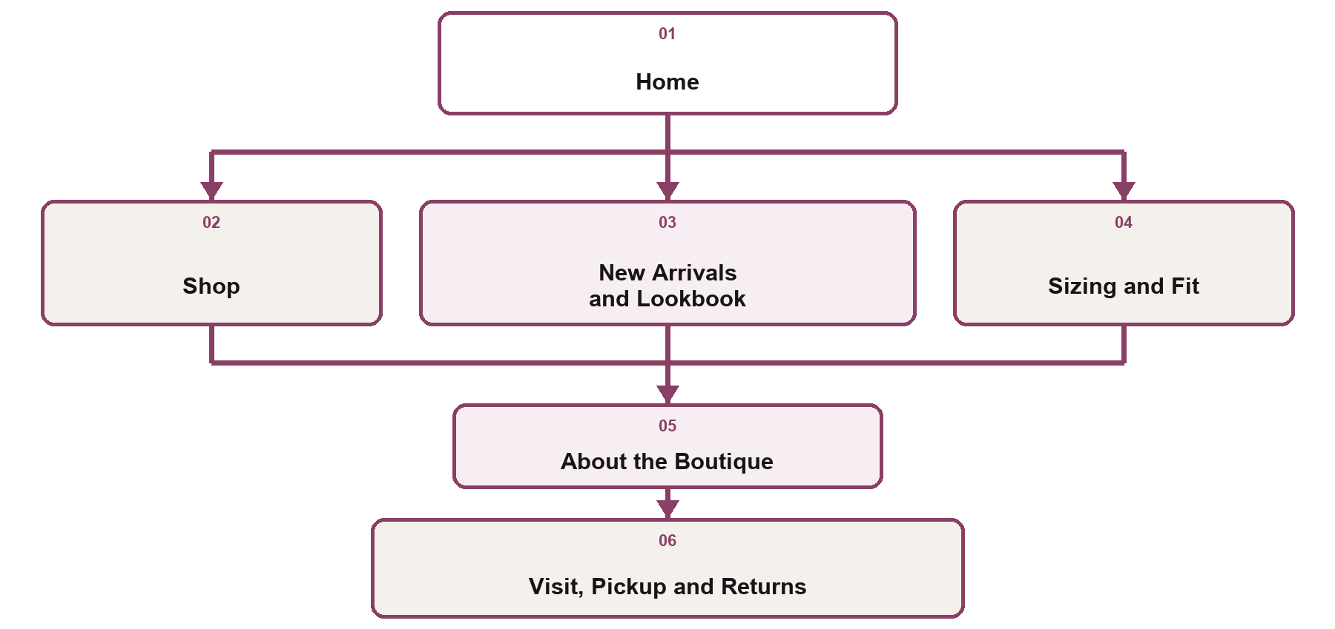

Open the SaaSTech Website Builder page View the Clothing Boutiques guide

Home
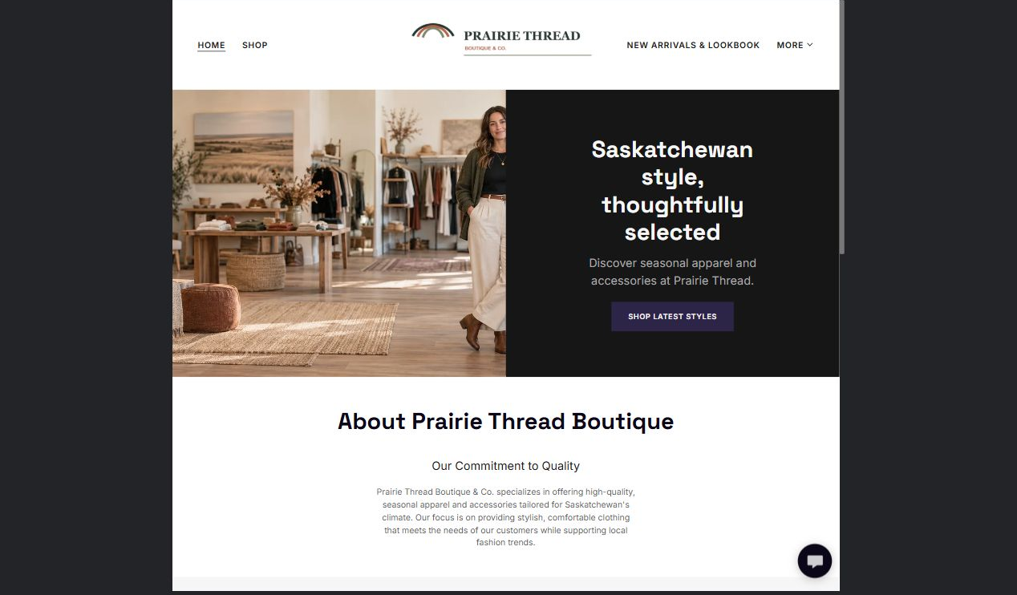

Website advice
Lead with the boutique’s point of view and one clear shopping action.

Prairie Thread example
Saskatchewan style, thoughtfully selected. Discover seasonal apparel and accessories at Prairie Thread.

Your draft
Write the headline, key information and next step for this page
________________________________________________________________________________
________________________________________________________________________________
________________________________________________________________________________
________________________________________________________________________________

Shop
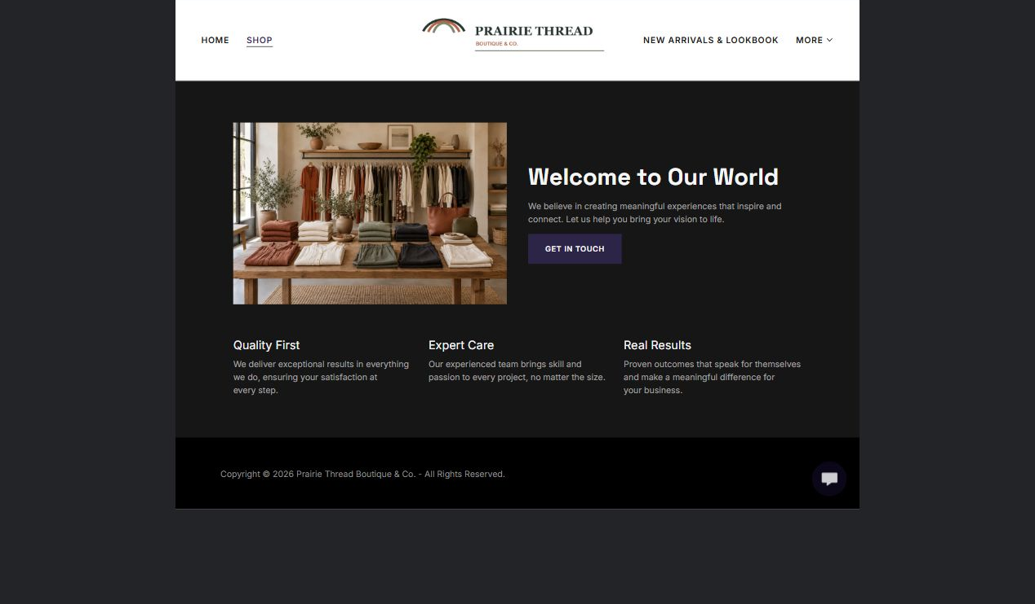

Website advice
Group products by the way customers browse. Keep prices, availability and fulfilment expectations current.

Prairie Thread example
Shop the Prairie Thread collection. Browse seasonal apparel and accessories selected for Saskatchewan life.

Your draft
Write the headline, key information and next step for this page
________________________________________________________________________________
________________________________________________________________________________
________________________________________________________________________________
________________________________________________________________________________

New Arrivals and Lookbook
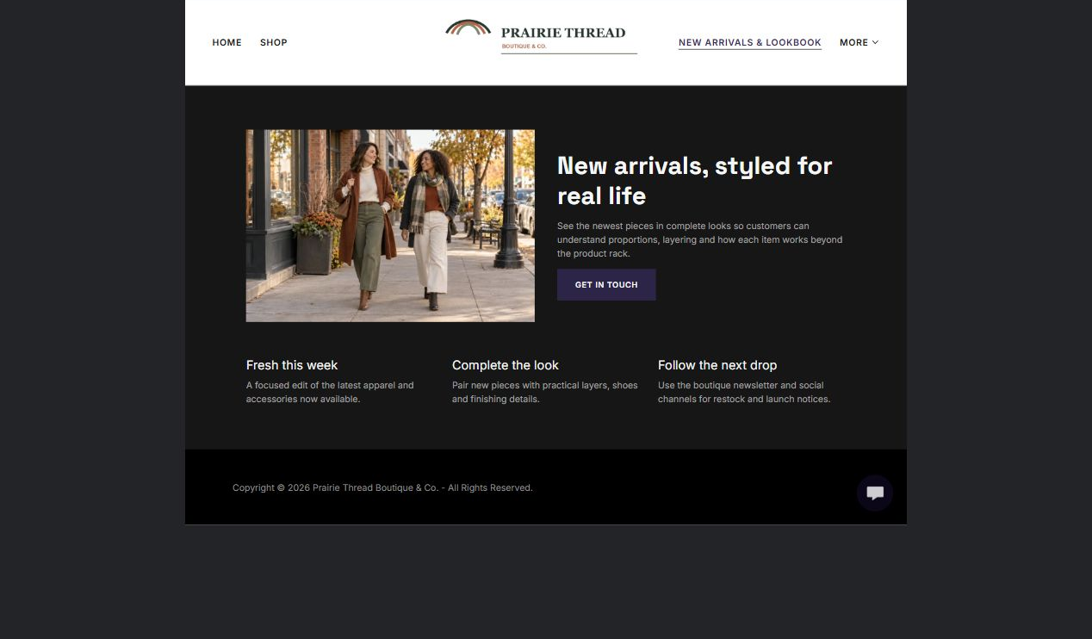

Website advice
Use distinct styled images to help shoppers see complete looks without repeating the same photograph elsewhere.

Prairie Thread example
See what is new and how the pieces work together. Each look links back to practical product and fit information.

Your draft
Write the headline, key information and next step for this page
________________________________________________________________________________
________________________________________________________________________________
________________________________________________________________________________
________________________________________________________________________________

Sizing and Fit
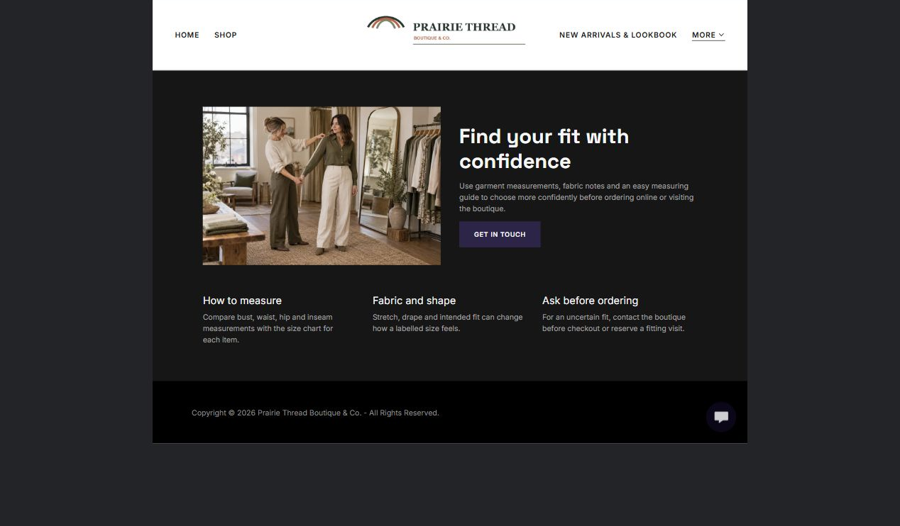

Website advice
Answer measurement and fit questions before checkout. Explain how customers can ask for help without making promises about every garment.

Prairie Thread example
Start with your measurements, compare them with the product notes and contact us when you need a second opinion on fit.

Your draft
Write the headline, key information and next step for this page
________________________________________________________________________________
________________________________________________________________________________
________________________________________________________________________________
________________________________________________________________________________

About the Boutique
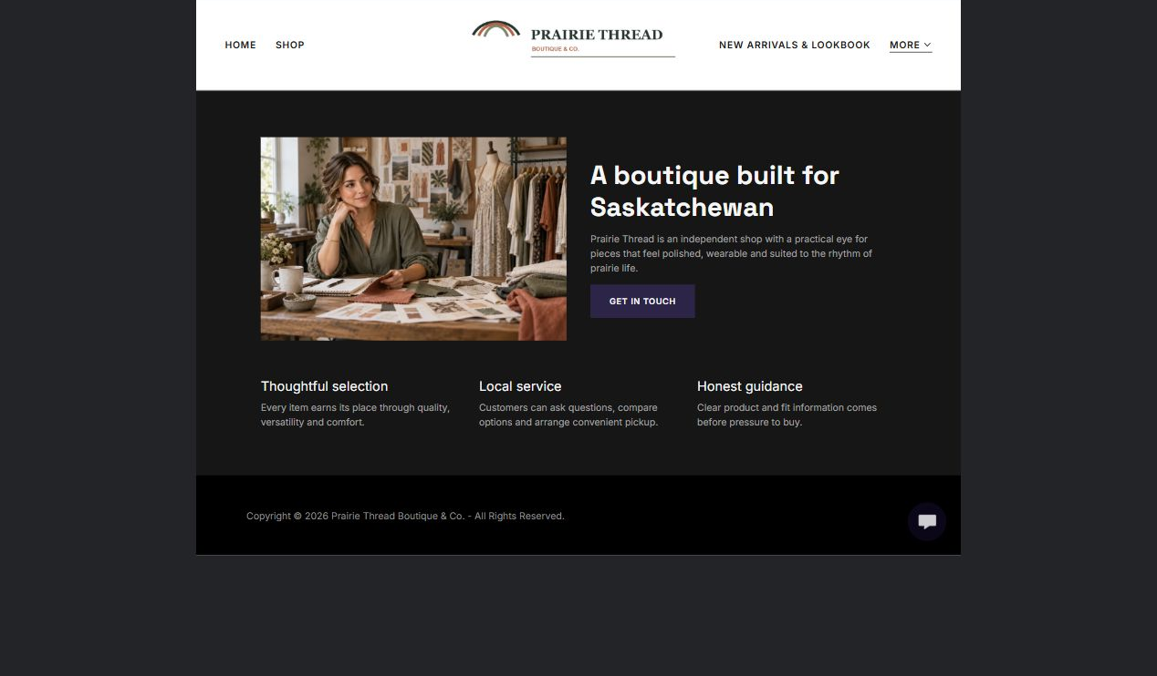

Website advice
Introduce the owner, selection approach and service style. Use a real team or owner image when available.

Prairie Thread example
Prairie Thread selects practical layers and polished everyday pieces for Saskatchewan seasons, with personal help when fit or styling is uncertain.

Your draft
Write the headline, key information and next step for this page
________________________________________________________________________________
________________________________________________________________________________
________________________________________________________________________________
________________________________________________________________________________

Visit, Pickup and Returns
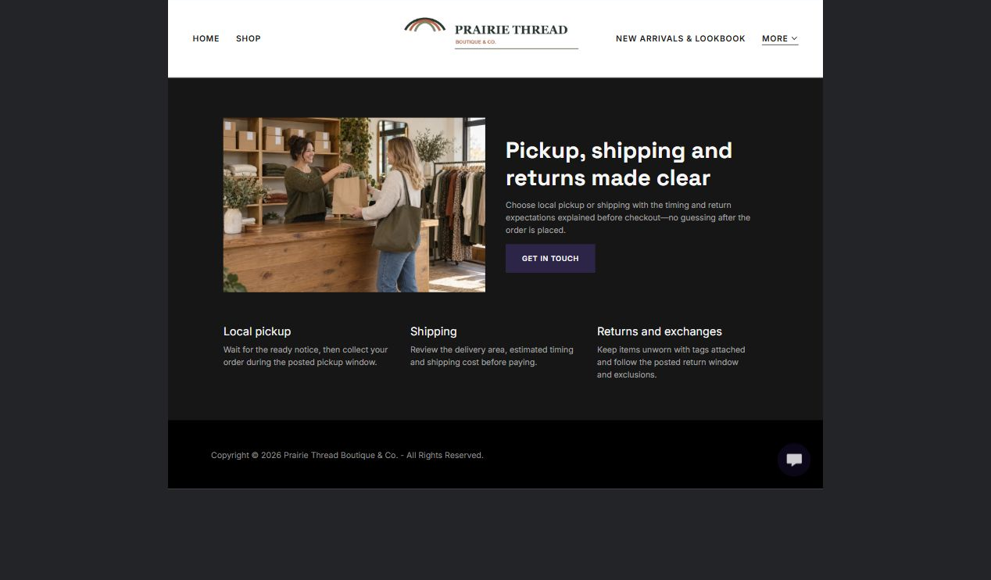

Website advice
Put location, hours, pickup timing, shipping boundaries and return rules together so customers know what happens after purchase.

Prairie Thread example
Choose local pickup or shipping where available. Review the current return window and item condition requirements before ordering.

Your draft
Write the headline, key information and next step for this page
________________________________________________________________________________
________________________________________________________________________________
________________________________________________________________________________
________________________________________________________________________________

Final website review
Review | Complete | Notes
Every page has one clear visitor job | ☐
Desktop and mobile views keep people, products and logos visible | ☐
No supporting photograph is repeated without a reason | ☐
Product, size, price and availability details are current | ☐
Pickup, shipping and return information matches operations | ☐
Buttons and navigation lead to the intended destination | ☐
Contact details and hours are accurate | ☐
The site has been reviewed by the person responsible for fulfilment | ☐
Workshop notes and launch actions
________________________________________________________________________________
________________________________________________________________________________
________________________________________________________________________________
________________________________________________________________________________
________________________________________________________________________________
________________________________________________________________________________

