
WEBSITE PLANNING WORKSHOP

Churches & Faith Communities
Website workbook
Plan a clear website for churches & faith communities. Explore a worked example, shape your own message and prepare to build with SaaSTech Servers.
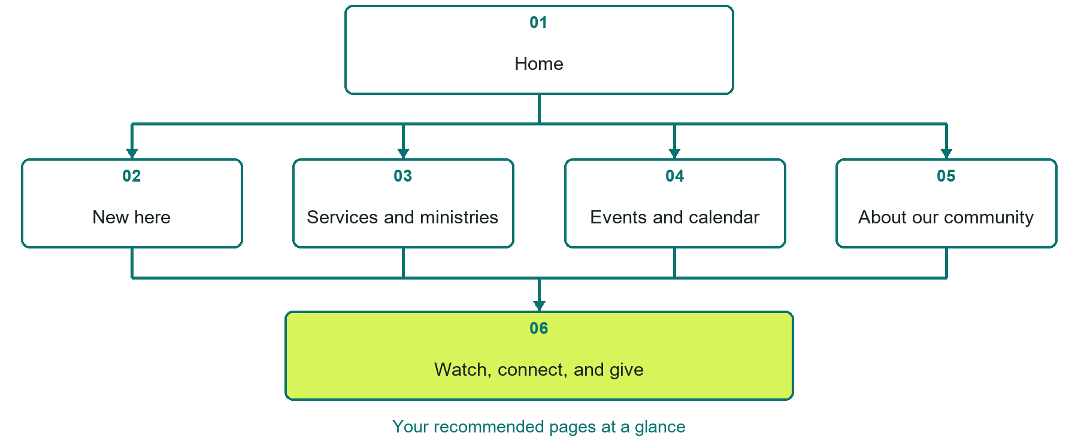

Inside this workbook
Six page examples • Practical writing exercises • A launch review
Use it in a workshop or at your own pace. Write by hand or complete the response fields in Word. The final page links to Website Builder, plans and account signup.
Example business Cedar Way Community Church

CHURCHES & FAITH COMMUNITIES

Your website brief
A SaaSTech Servers workshop for churches & faith communities. Plan your website, learn from the Cedar Way Community Church example and draft content for your own business.
Each page has a reference sheet followed by a writing sheet. Demo excerpts are labelled separately from new sample wording, which may differ from the screenshot. Click a blank response line to type; longer answers may add pages. Replace fictional details and verify every claim before publishing.
Your business or organization and workshop date

Who should visit your site and what do they need

The main action you want a visitor to take

What you offer and where or how you provide it

Facts photos and permissions to gather before publishing

Workshop rhythm: review the example, write your draft and exchange feedback. Use the final review to choose your next changes. Website Builder and account links are on the last page.

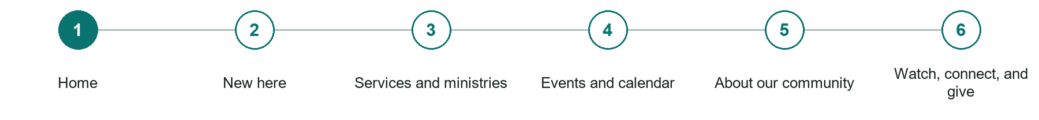
LOOK AND LEARN

Home

The job of this page
Show the service time, location, welcome, and one clear next step.
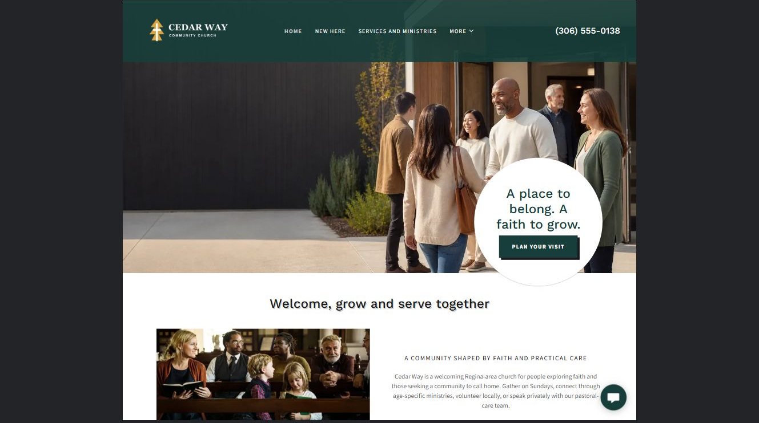
Cedar Way Community Church example | Explore SaaSTech Website Builder

Demo text example
Welcome, grow and serve together
Cedar Way is a welcoming Regina-area church for people exploring faith and those seeking a community to call home. Gather on Sundays, connect through age-specific ministries, volunteer locally, or speak privately with our pastoral-care team.

Pause and plan
Could a first-time visitor explain what you do and who it is for after one glance? Choose one main action and the strongest truthful detail that gives them confidence to continue.

WRITE YOUR PAGE

Home
Write for your visitor. Be specific about what they need to know and what happens next. You can revise the wording after the workshop.
Your page headline

Your opening paragraph

Your offer audience location and most useful supporting details

Button or link wording and where it should lead

Photo idea caption and permission or credit needed

Facts to verify or questions to resolve

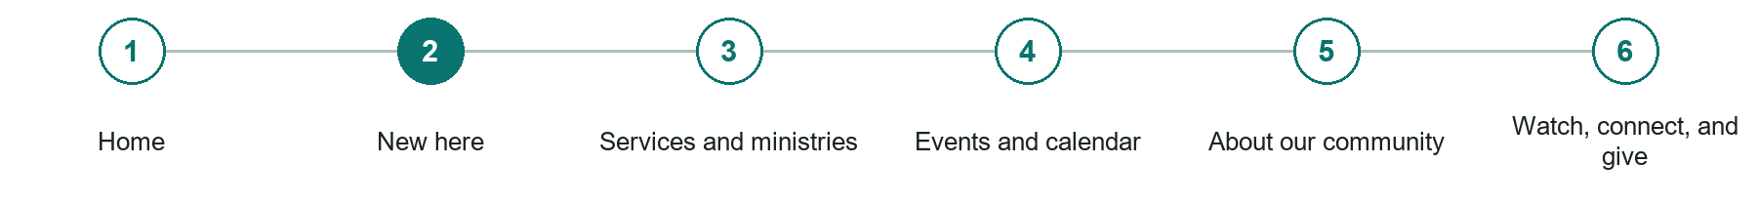
LOOK AND LEARN

New here

The job of this page
Set expectations for a first visit, including children, parking, accessibility, and dress.
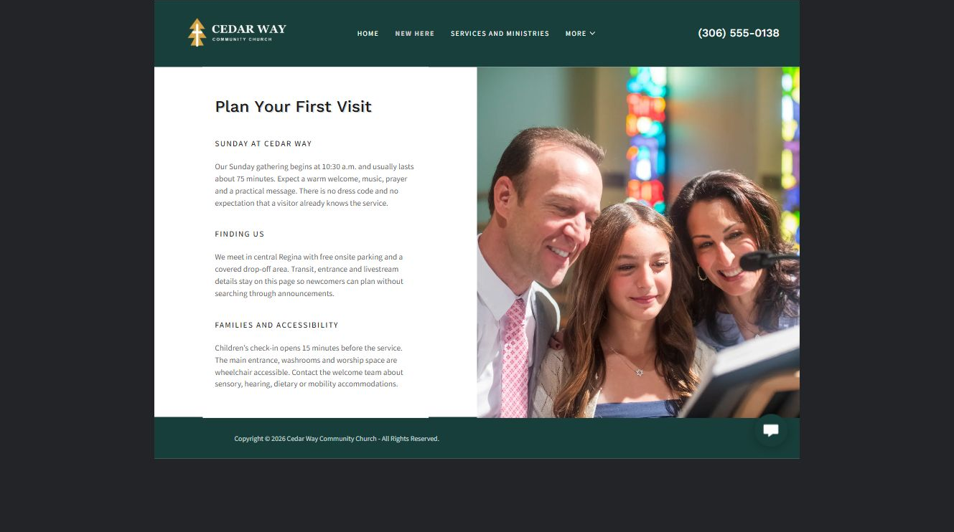
Cedar Way Community Church example | Explore SaaSTech Website Builder

Demo text example
Plan Your First Visit
There is no dress code and no expectation that a visitor already knows the service.

Pause and plan
What should someone know before arriving or proceeding? Clarify preparation, access and the right contact route. Verify policies and avoid promising urgent help or specialist advice the website cannot provide.

WRITE YOUR PAGE

New here
Write for your visitor. Be specific about what they need to know and what happens next. You can revise the wording after the workshop.
Your page headline

Your opening paragraph

Preparation access policies and practical questions to answer

Button or link wording and where it should lead

Photo idea caption and permission or credit needed

Facts to verify or questions to resolve

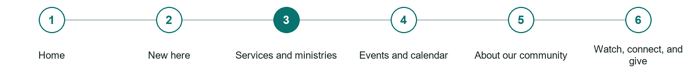
LOOK AND LEARN

Services and ministries

The job of this page
Summarize worship, care, groups, age-specific programs, and participation contacts.
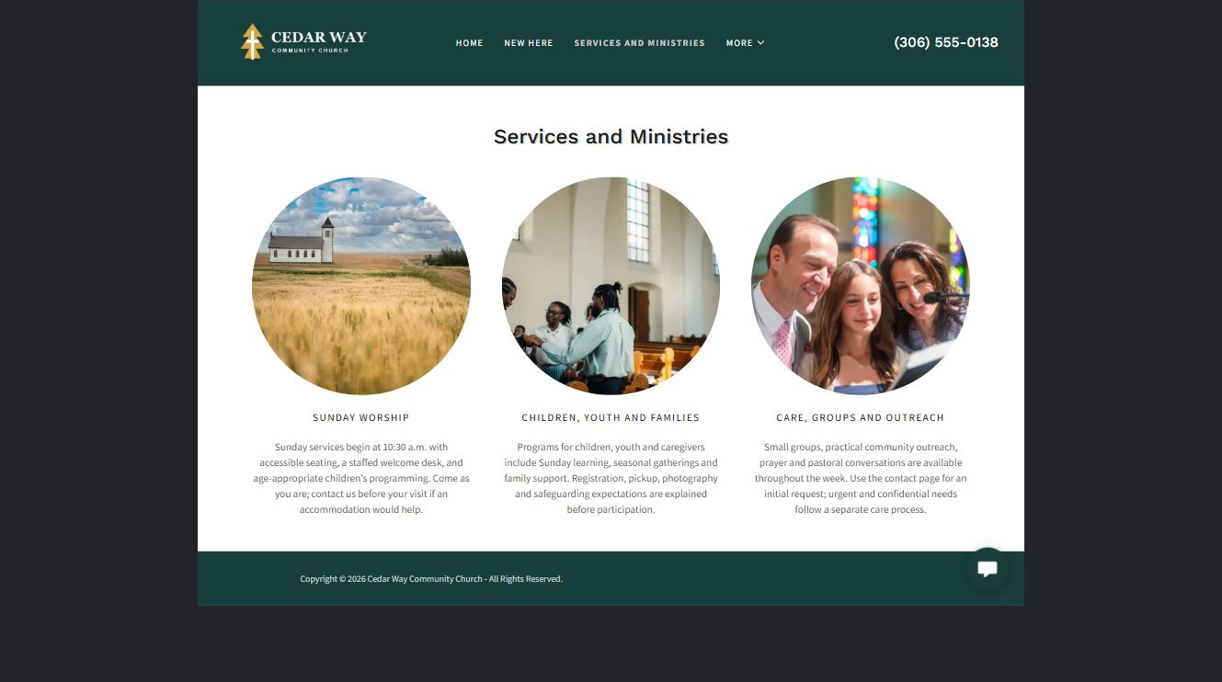
Cedar Way Community Church example | Explore SaaSTech Website Builder

Demo text example
CHILDREN, YOUTH AND FAMILIES
Programs for children, youth and caregivers include Sunday learning, seasonal gatherings and family support. Registration, pickup, photography and safeguarding expectations are explained before participation.

Pause and plan
Who is each option for, what does it include and where are its limits? Describe the information needed to check fit. Make the next step clear without promising an outcome before assessment.

WRITE YOUR PAGE

Services and ministries
Write for your visitor. Be specific about what they need to know and what happens next. You can revise the wording after the workshop.
Your page headline

Your opening paragraph

Service options who they suit and what each includes

Button or link wording and where it should lead

Photo idea caption and permission or credit needed

Facts to verify or questions to resolve

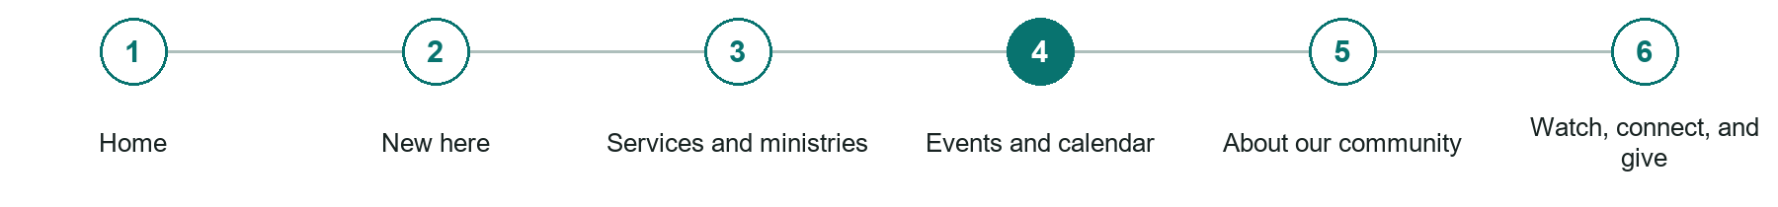
LOOK AND LEARN

Events and calendar

The job of this page
Keep dates, locations, registration, costs, accessibility, and changes current.
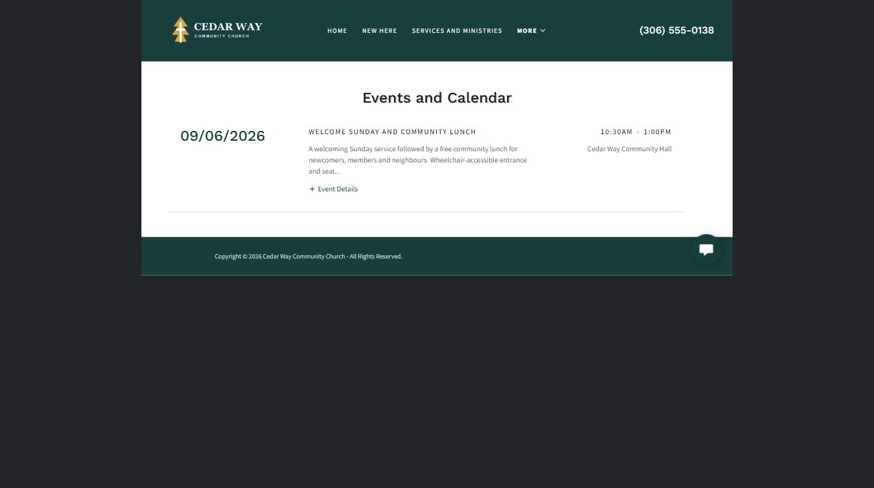
Cedar Way Community Church example | Explore SaaSTech Website Builder

Demo text example
WELCOME SUNDAY AND COMMUNITY LUNCH
A welcoming Sunday service followed by a free community lunch for newcomers, members and neighbours.

Pause and plan
Which dates and locations need to stay current? Decide who will update changes and where visitors should check before travelling. Separate archived information and illustrative schedules from current availability.

WRITE YOUR PAGE

Events and calendar
Write for your visitor. Be specific about what they need to know and what happens next. You can revise the wording after the workshop.
Your page headline

Your opening paragraph

Dates locations update process and participation details

Button or link wording and where it should lead

Photo idea caption and permission or credit needed

Facts to verify or questions to resolve

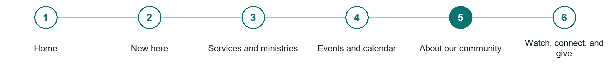
LOOK AND LEARN

About our community

The job of this page
Introduce beliefs, leadership, governance, safeguarding, and affiliations.
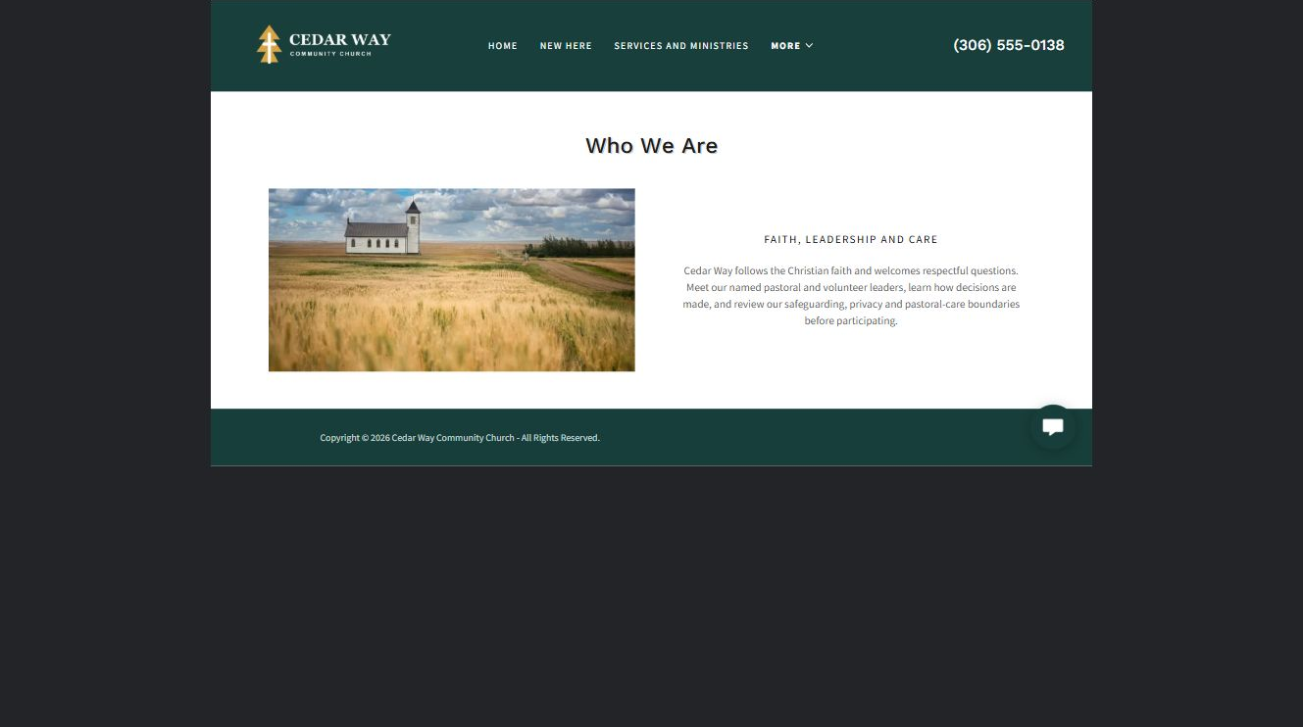
Cedar Way Community Church example | Explore SaaSTech Website Builder

Demo text example
Who We Are
Cedar Way follows the Christian faith and welcomes respectful questions.

Pause and plan
Which names, roles and qualifications can you verify? What would help a visitor feel comfortable contacting you? Obtain permission for portraits and describe actual experience without unsupported claims.

WRITE YOUR PAGE

About our community
Write for your visitor. Be specific about what they need to know and what happens next. You can revise the wording after the workshop.
Your page headline

Your opening paragraph

People roles approach and verified credentials to introduce

Button or link wording and where it should lead

Photo idea caption and permission or credit needed

Facts to verify or questions to resolve

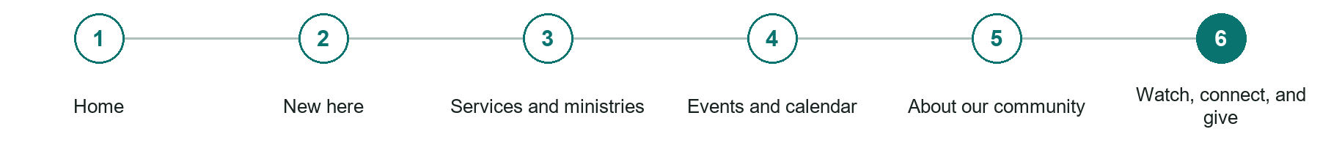
LOOK AND LEARN

Watch connect and give

The job of this page
Offer recordings, care contact, newcomer follow-up, and secure giving.
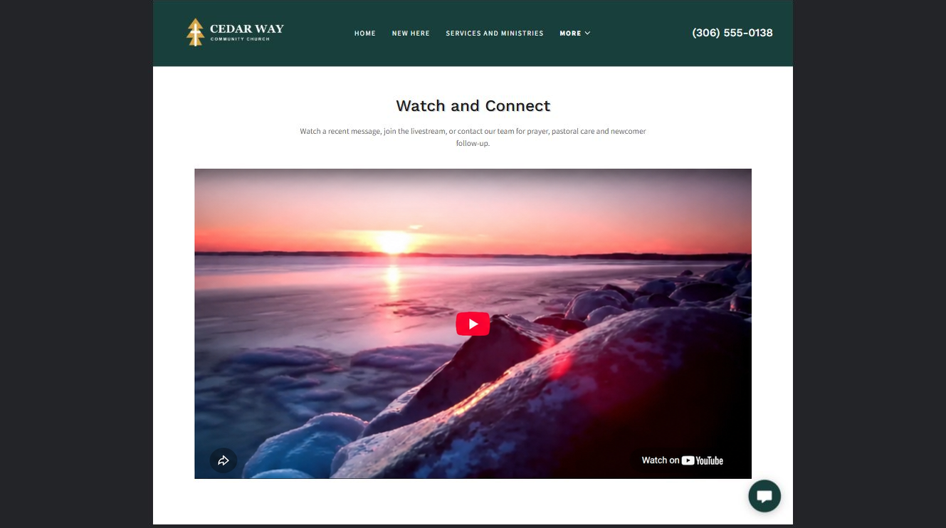
Cedar Way Community Church example | Explore SaaSTech Website Builder

Demo text example
Watch and Connect
Watch a recent message, join the livestream

Pause and plan
What question brings a visitor to this page? List the details they need, the evidence you can provide and the next useful action. Remove content that does not help them decide or proceed.

WRITE YOUR PAGE

Watch connect and give
Write for your visitor. Be specific about what they need to know and what happens next. You can revise the wording after the workshop.
Your page headline

Your opening paragraph

Key sections visitor questions and supporting details

Button or link wording and where it should lead

Photo idea caption and permission or credit needed

Facts to verify or questions to resolve

WORKSHOP CLOSE

Review and next steps
Ask a partner to read your draft as a first-time visitor. Can they explain what you offer, who it is for and the next step without extra help?

Before you publish
[ ] Every page has a clear purpose and a useful next step.
[ ] Headlines are specific and the wording sounds like your business.
[ ] Names, service areas, prices, dates and policies have been checked.
[ ] Credentials, testimonials and results are genuine and permission-cleared.
[ ] Photos support the text, do not repeat needlessly and have appropriate permissions.
[ ] Forms ask only for necessary information and explain what happens next.
[ ] Links, downloads and the main visitor task work on a phone.
The most useful feedback from your workshop partner

First change to make and who will do it

Information or photographs still needed

Target review date and who will approve the final content

Keep sensitive customer, patient, employee and payment information out of this workbook. Completing it does not publish a website or connect to Website Builder.

BUILD WITH SAASTECH SERVERS

Put your draft into Website Builder
Use the content you have written to build your own site. Keep the churches & faith communities demo as a reference, and replace its company name, images and claims with your verified business information.

Explore the builder
See the editor, compare available plans and decide which features your business needs. Confirm current pricing and terms before purchasing.
Website Builder overview

Create your account
Set up your SaaSTech Servers customer account using your own details. Creating an account is separate from purchasing a Website Builder plan.
Create your SaaSTech account

Choose your plan
Open the secure shop to review the plan, subscription term and final total. Use the account connected to your purchase when you open your service.
View Website Builder plans

Build and check your pages
Add the pages from this workbook. Transfer your approved wording, upload permission-cleared photos and review each page on desktop and mobile before publishing.
Return to the Website Builder guide

Using a printed workbook
Type these short addresses into your browser. The account guide includes the Create My Account button.
www.saastech.net/products/website-builder
www.saastech.net/create-account
This workbook does not create an account, purchase a plan or publish your website. Keep passwords, payment details and confidential customer information out of your draft.

