
WEBSITE PLANNING WORKSHOP

Chambers of Commerce
Website workbook
Plan a clear website for chambers of commerce. Explore a worked example, shape your own message and prepare to build with SaaSTech Servers.
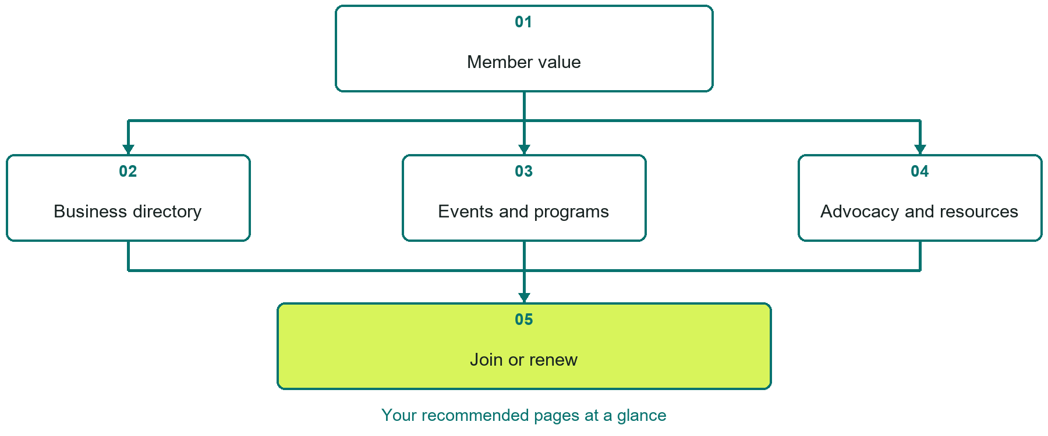

Inside this workbook
Five page examples • Practical writing exercises • A launch review
Use it in a workshop or at your own pace. Write by hand or complete the response fields in Word. The final page links to Website Builder, plans and account signup.
Example business Prairie Junction Chamber of Commerce

CHAMBERS OF COMMERCE

Your website brief
A SaaSTech Servers workshop for chambers of commerce. Plan your website, learn from the Prairie Junction Chamber of Commerce example and draft content for your own business.
Each page has a reference sheet followed by a writing sheet. Demo excerpts are labelled separately from new sample wording, which may differ from the screenshot. Click a blank response line to type; longer answers may add pages. Replace fictional details and verify every claim before publishing.
Your business or organization and workshop date

Who should visit your site and what do they need

The main action you want a visitor to take

What you offer and where or how you provide it

Facts photos and permissions to gather before publishing

Workshop rhythm: review the example, write your draft and exchange feedback. Use the final review to choose your next changes. Website Builder and account links are on the last page.

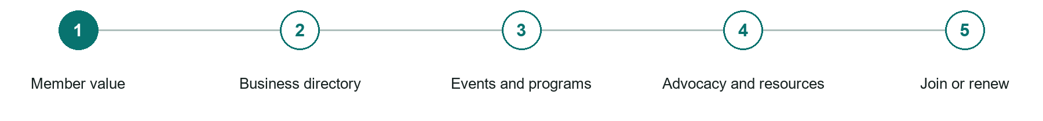
LOOK AND LEARN

Member value

The job of this page
Explain concrete benefits, who membership serves, pricing, and the first useful action after joining.
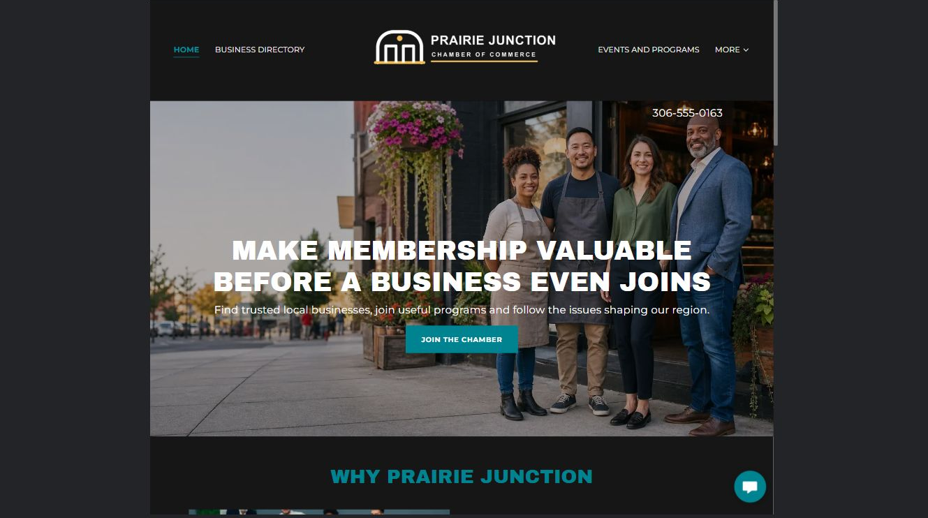
Prairie Junction Chamber of Commerce example | Explore SaaSTech Website Builder

Sample wording to adapt
Membership that supports local connections
Explore the directory, events and business resources before choosing membership. Ask which benefits fit your organization and how to take part. Confirm current fees and inclusions before joining.

Pause and plan
Could a first-time visitor explain what you do and who it is for after one glance? Choose one main action and the strongest truthful detail that gives them confidence to continue.

WRITE YOUR PAGE

Member value
Write for your visitor. Be specific about what they need to know and what happens next. You can revise the wording after the workshop.
Your page headline

Your opening paragraph

Your offer audience location and most useful supporting details

Button or link wording and where it should lead

Photo idea caption and permission or credit needed

Facts to verify or questions to resolve

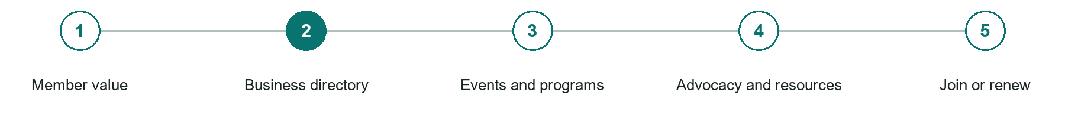
LOOK AND LEARN

Business directory

The job of this page
Help visitors find current members by category, community, or service with accurate contact information.
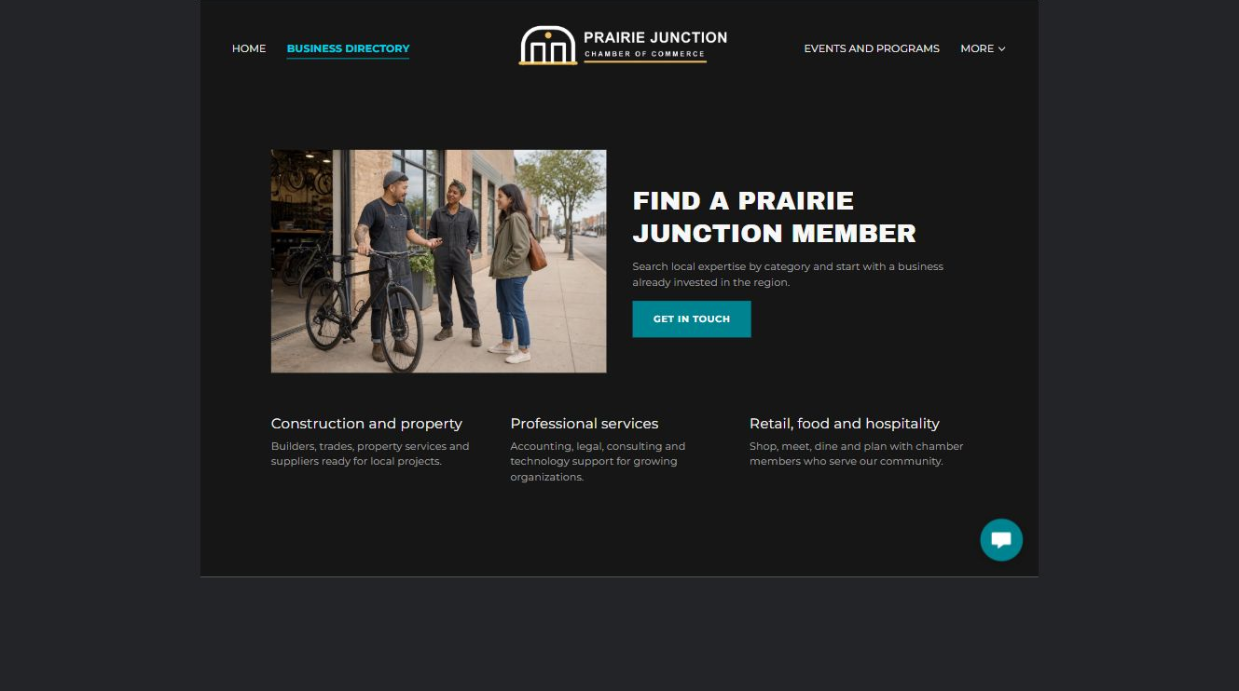
Prairie Junction Chamber of Commerce example | Explore SaaSTech Website Builder

Demo text example
FIND A PRAIRIE JUNCTION MEMBER
Search local expertise by category and start with a business already invested in the region.

Pause and plan
What question brings a visitor to this page? List the details they need, the evidence you can provide and the next useful action. Remove content that does not help them decide or proceed.

WRITE YOUR PAGE

Business directory
Write for your visitor. Be specific about what they need to know and what happens next. You can revise the wording after the workshop.
Your page headline

Your opening paragraph

Key sections visitor questions and supporting details

Button or link wording and where it should lead

Photo idea caption and permission or credit needed

Facts to verify or questions to resolve

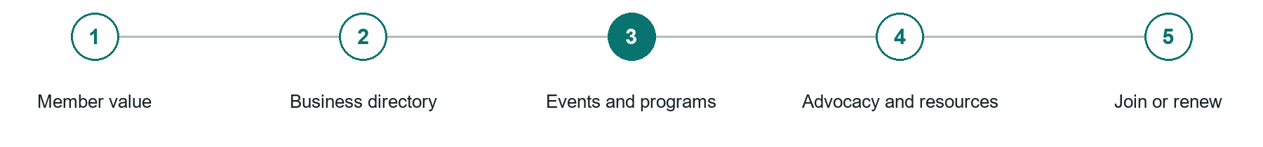
LOOK AND LEARN

Events and programs

The job of this page
Publish dates, audience, location, accessibility, price, capacity, sponsors, and registration details.
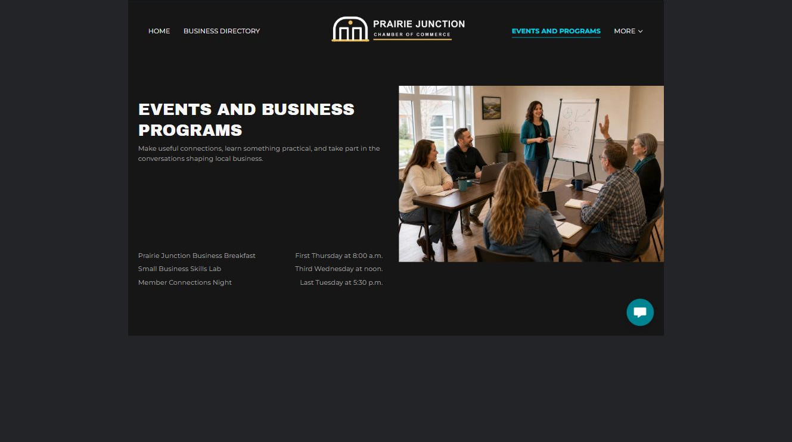
Prairie Junction Chamber of Commerce example | Explore SaaSTech Website Builder

Demo text example
EVENTS AND BUSINESS PROGRAMS
Make useful connections, learn something practical, and take part in the conversations shaping local business.

Pause and plan
Which dates and locations need to stay current? Decide who will update changes and where visitors should check before travelling. Separate archived information and illustrative schedules from current availability.

WRITE YOUR PAGE

Events and programs
Write for your visitor. Be specific about what they need to know and what happens next. You can revise the wording after the workshop.
Your page headline

Your opening paragraph

Dates locations update process and participation details

Button or link wording and where it should lead

Photo idea caption and permission or credit needed

Facts to verify or questions to resolve

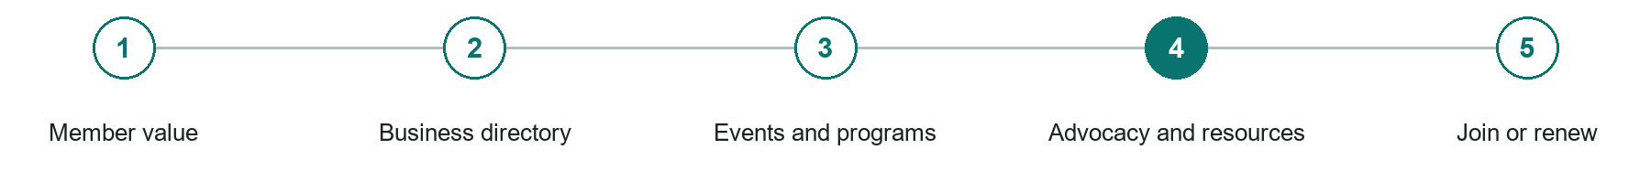
LOOK AND LEARN

Advocacy and resources

The job of this page
Show current priorities, submissions, programs, business tools, and partner resources with dates and context.
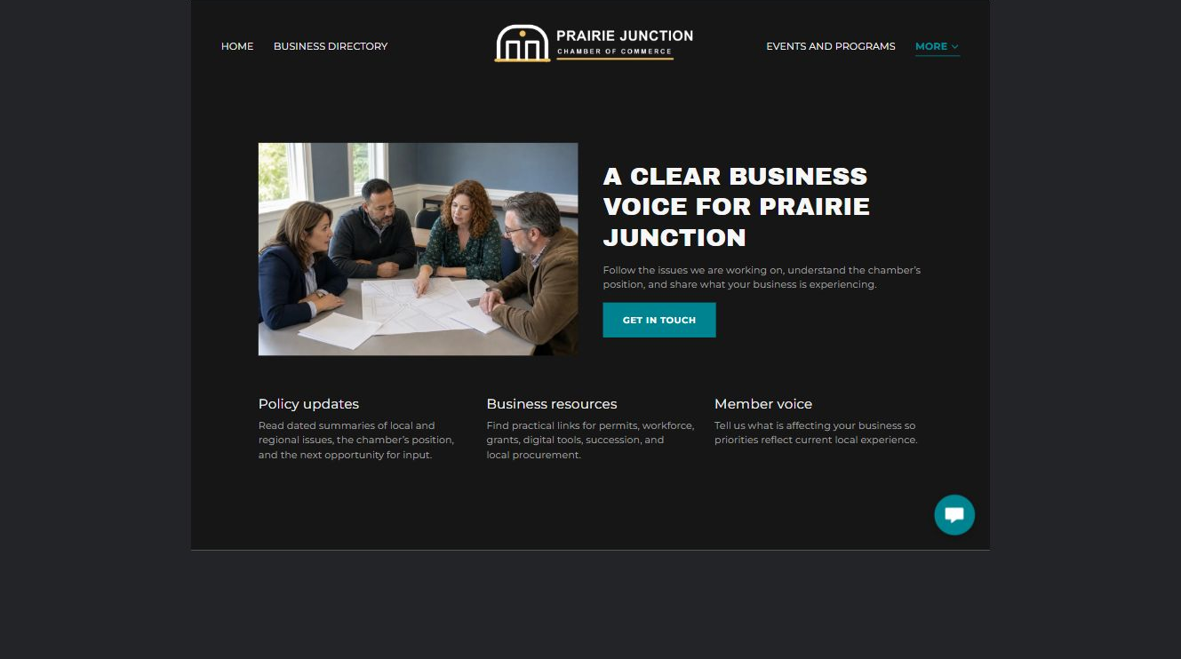
Prairie Junction Chamber of Commerce example | Explore SaaSTech Website Builder

Demo text example
A CLEAR BUSINESS VOICE FOR PRAIRIE JUNCTION
Follow the issues we are working on, understand the chamber's position, and share what your business is experiencing.

Pause and plan
What question brings a visitor to this page? List the details they need, the evidence you can provide and the next useful action. Remove content that does not help them decide or proceed.

WRITE YOUR PAGE

Advocacy and resources
Write for your visitor. Be specific about what they need to know and what happens next. You can revise the wording after the workshop.
Your page headline

Your opening paragraph

Key sections visitor questions and supporting details

Button or link wording and where it should lead

Photo idea caption and permission or credit needed

Facts to verify or questions to resolve

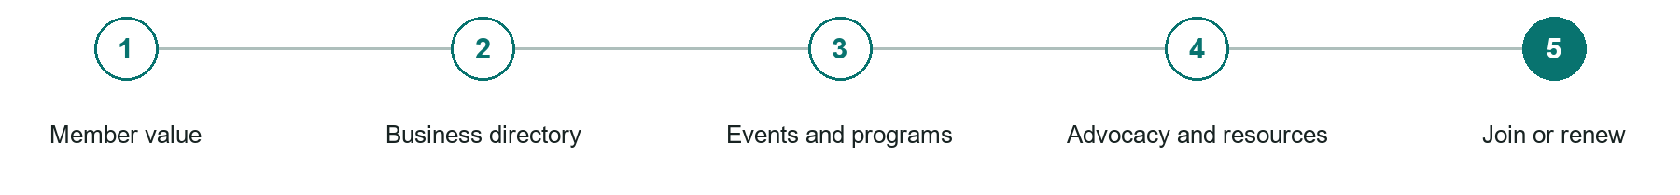
LOOK AND LEARN

Join or renew

The job of this page
Present membership levels, eligibility, terms, payment options, and what happens after submission.
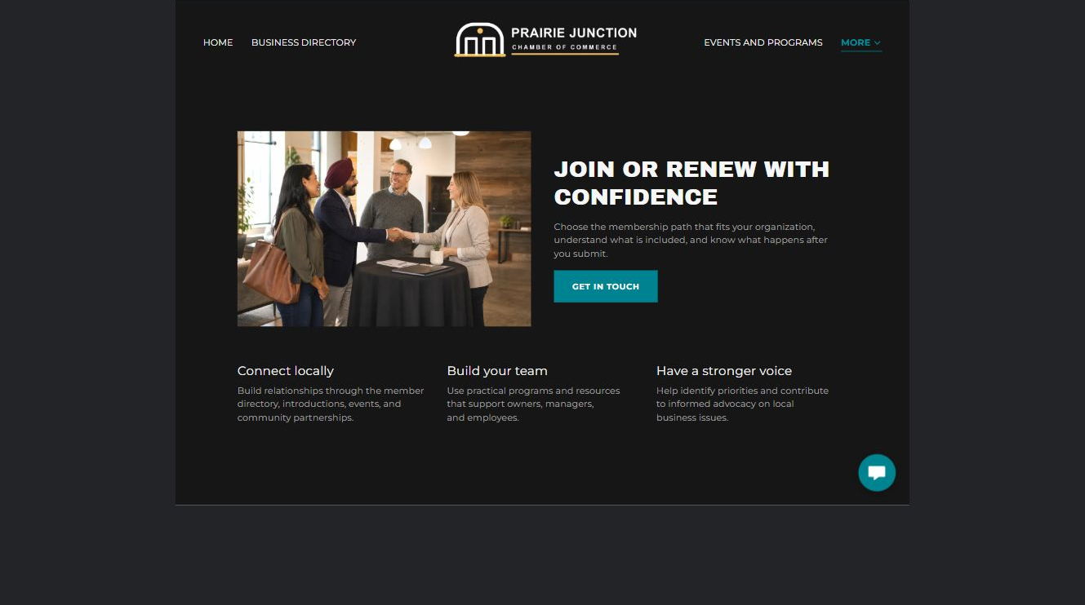
Prairie Junction Chamber of Commerce example | Explore SaaSTech Website Builder

Demo text example
JOIN OR RENEW WITH CONFIDENCE
Choose the membership path that fits your organization, understand what is included, and know what happens after you submit.

Pause and plan
What must someone provide, and what happens after they send it? Separate a request from a confirmed booking, order or place. Decide what information should stay out of a public form.

WRITE YOUR PAGE

Join or renew
Write for your visitor. Be specific about what they need to know and what happens next. You can revise the wording after the workshop.
Your page headline

Your opening paragraph

Information to request and how you will reply or confirm

Button or link wording and where it should lead

Photo idea caption and permission or credit needed

Facts to verify or questions to resolve

WORKSHOP CLOSE

Review and next steps
Ask a partner to read your draft as a first-time visitor. Can they explain what you offer, who it is for and the next step without extra help?

Before you publish
[ ] Every page has a clear purpose and a useful next step.
[ ] Headlines are specific and the wording sounds like your business.
[ ] Names, service areas, prices, dates and policies have been checked.
[ ] Credentials, testimonials and results are genuine and permission-cleared.
[ ] Photos support the text, do not repeat needlessly and have appropriate permissions.
[ ] Forms ask only for necessary information and explain what happens next.
[ ] Links, downloads and the main visitor task work on a phone.
The most useful feedback from your workshop partner

First change to make and who will do it

Information or photographs still needed

Target review date and who will approve the final content

Keep sensitive customer, patient, employee and payment information out of this workbook. Completing it does not publish a website or connect to Website Builder.

BUILD WITH SAASTECH SERVERS

Put your draft into Website Builder
Use the content you have written to build your own site. Keep the chambers of commerce demo as a reference, and replace its company name, images and claims with your verified business information.

Explore the builder
See the editor, compare available plans and decide which features your business needs. Confirm current pricing and terms before purchasing.
Website Builder overview

Create your account
Set up your SaaSTech Servers customer account using your own details. Creating an account is separate from purchasing a Website Builder plan.
Create your SaaSTech account

Choose your plan
Open the secure shop to review the plan, subscription term and final total. Use the account connected to your purchase when you open your service.
View Website Builder plans

Build and check your pages
Add the pages from this workbook. Transfer your approved wording, upload permission-cleared photos and review each page on desktop and mobile before publishing.
Return to the Website Builder guide

Using a printed workbook
Type these short addresses into your browser. The account guide includes the Create My Account button.
www.saastech.net/products/website-builder
www.saastech.net/create-account
This workbook does not create an account, purchase a plan or publish your website. Keep passwords, payment details and confidential customer information out of your draft.

