

Cattle Ranches
Website workbook
A practical workshop for a 6-page website. Study the example, plan the content and draft your own version in Word or on paper.
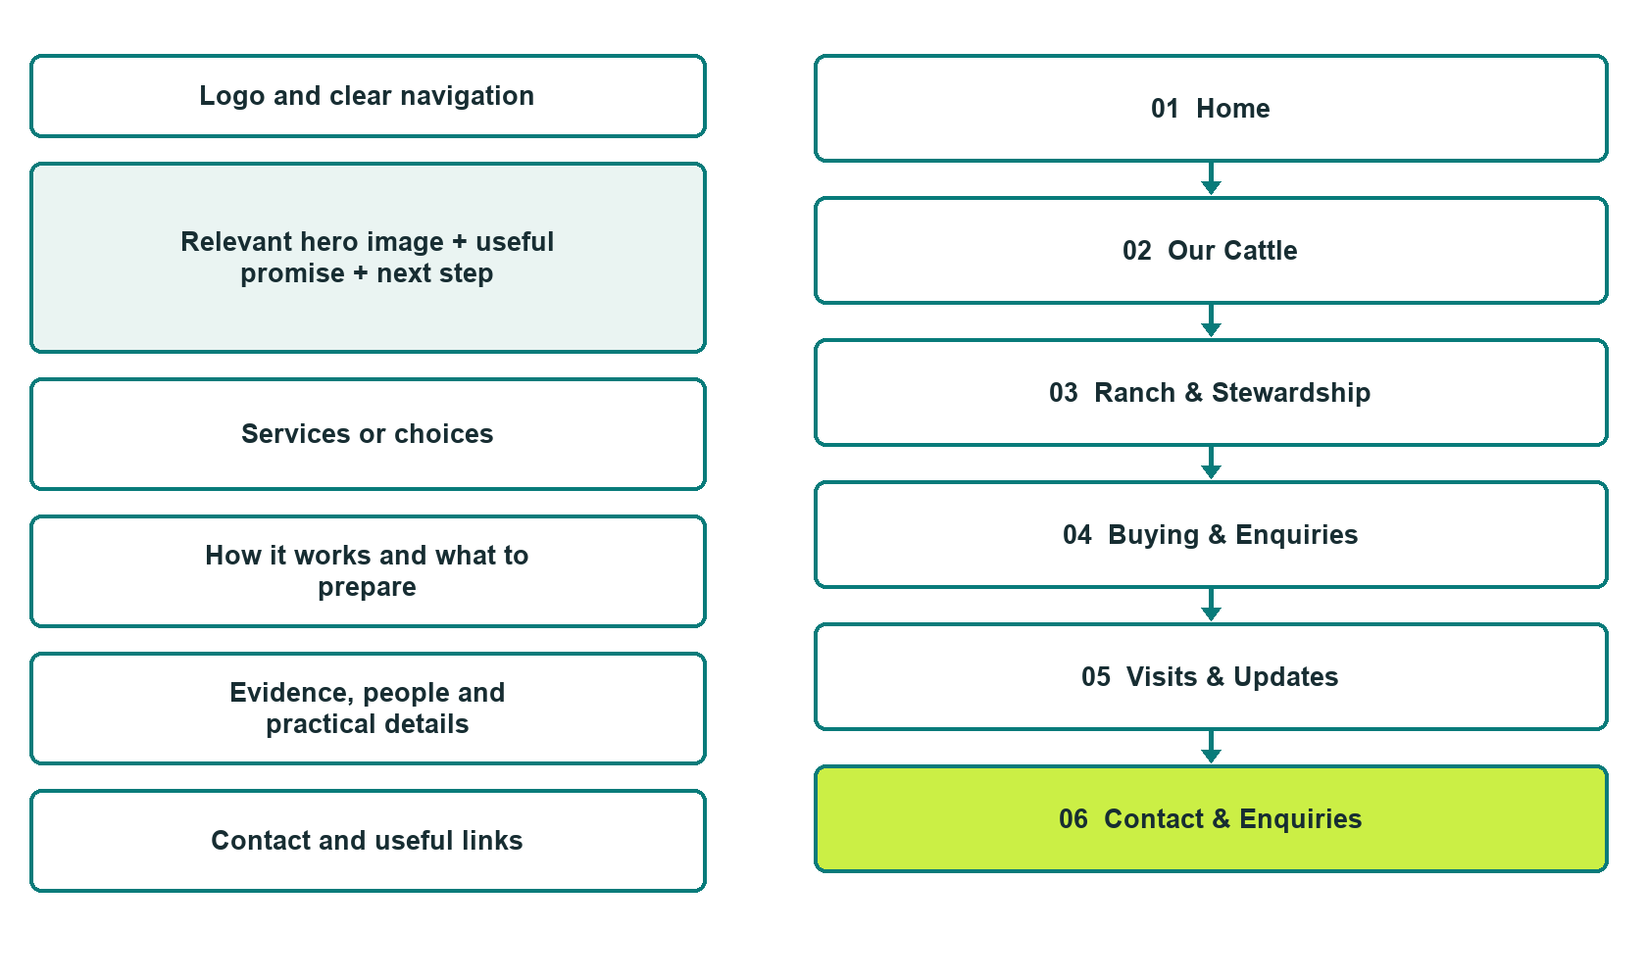

Plan → Draft → Build → Test
Demo-capture edition: actual Website Builder desktop previews and excerpts of the example wording. See each matching mobile preview in the industry page gallery. The example business and its AI-generated photographs are fictional.
Explore Website Builder and compare plans

Before you build
Your business supplies the facts. Prairie Range Cattle Co. is a fictional teaching example, not a live service.

□ Discuss the ranch offering or arrange a confirmed visit
□ Verified business identity and current contact information
□ Clear request and confirmation process
□ Choose original photographs and confirm permission to use them.
□ Keep private customer records out of public website forms.

Your audience and the action you want them to take

Facts to verify and people who must approve them
Create your SaaSTech account

01 Home
Give this page one clear job in the customer journey.
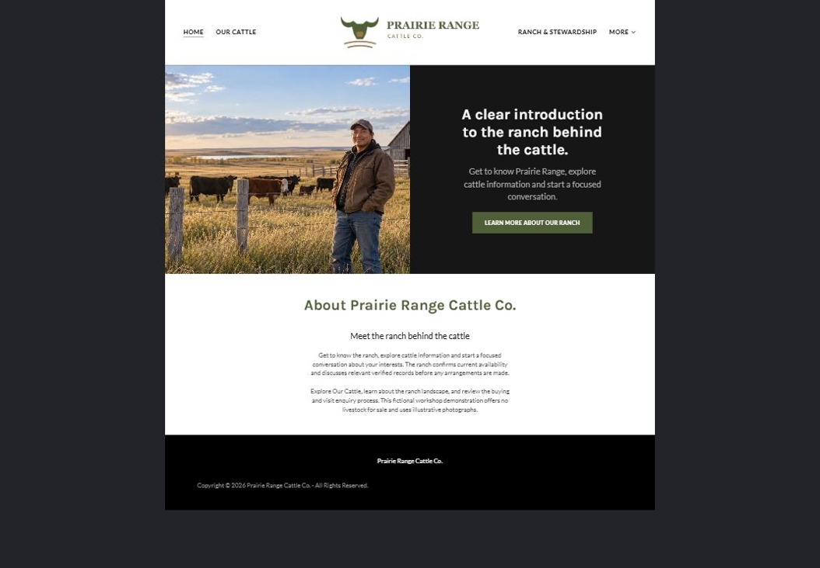
Actual desktop preview - unpublished fictional demonstration

Demo wording excerpt to adapt and verify
A clear introduction to the ranch behind the cattle.
Get to know Prairie Range, explore cattle information and start a focused conversation.
Get to know the ranch, explore cattle information and start a focused conversation about your interests. The ranch confirms current availability and discusses relevant verified records before any arrangements are made.
Explore Our Cattle, learn about the ranch landscape, and review the buying and visit enquiry process. This fictional workshop demonstration offers no livestock for sale and uses illustrative photographs.
Suggested button: Learn More About Our Ranch

Website advice
Introduce the ranch, verified cattle offering and approach to buyer enquiries. Keep example animals, dates and availability separate from real sale information.

Your draft: Home
Write in the voice of your own business. Use facts you can verify, not promises copied from the example.

Headline and short introduction

Main content and details visitors need

Button wording and destination

Photo choice, permission and facts still to confirm
Partner check: can someone unfamiliar with the business find a useful next step?

02 Our Cattle
Give this page one clear job in the customer journey.
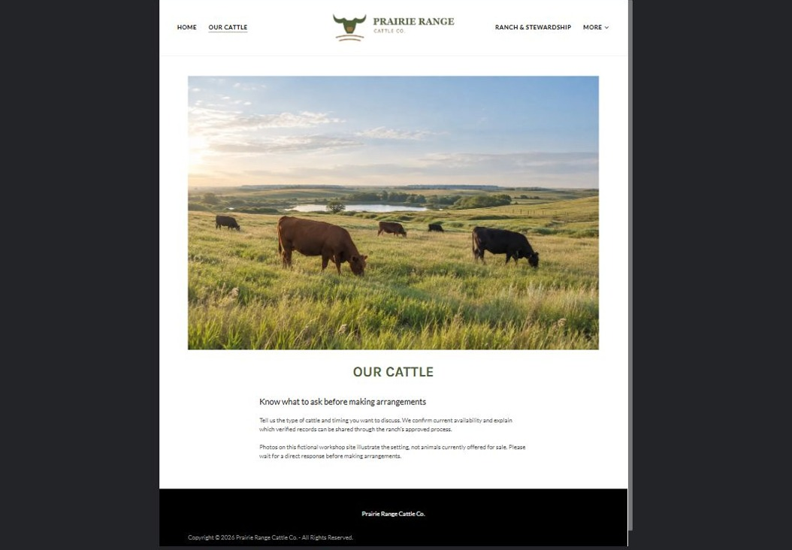
Actual desktop preview - unpublished fictional demonstration

Demo wording excerpt to adapt and verify
Know what to ask before making arrangements
Tell us the type of cattle and timing you want to discuss. We confirm current availability and explain which verified records can be shared through the ranch’s approved process.
Photos on this fictional workshop site illustrate the setting, not animals currently offered for sale. Please wait for a direct response before making arrangements.
Suggested button: No on-page button in this demo

Website advice
Describe verified cattle categories and the information buyers can request. Use real identification and performance claims only after approval.

Your draft: Our Cattle
Write in the voice of your own business. Use facts you can verify, not promises copied from the example.

Headline and short introduction

Main content and details visitors need

Button wording and destination

Photo choice, permission and facts still to confirm
Partner check: can someone unfamiliar with the business find a useful next step?

03 Ranch & Stewardship
Give this page one clear job in the customer journey.
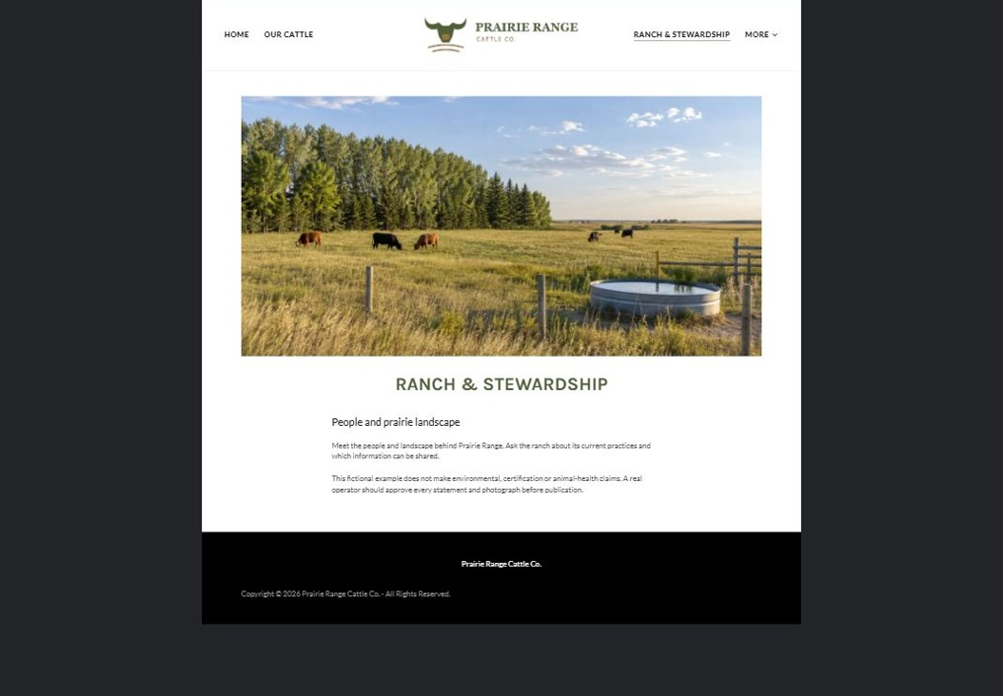
Actual desktop preview - unpublished fictional demonstration

Demo wording excerpt to adapt and verify
People and prairie landscape
Meet the people and landscape behind Prairie Range. Ask the ranch about its current practices and which information can be shared.
This fictional example does not make environmental, certification or animal-health claims. A real operator should approve every statement and photograph before publication.
Suggested button: No on-page button in this demo

Website advice
Show the actual ranch and describe practices the operator can substantiate. Avoid unsupported environmental or certification claims.

Your draft: Ranch & Stewardship
Write in the voice of your own business. Use facts you can verify, not promises copied from the example.

Headline and short introduction

Main content and details visitors need

Button wording and destination

Photo choice, permission and facts still to confirm
Partner check: can someone unfamiliar with the business find a useful next step?

04 Buying & Enquiries
Give this page one clear job in the customer journey.
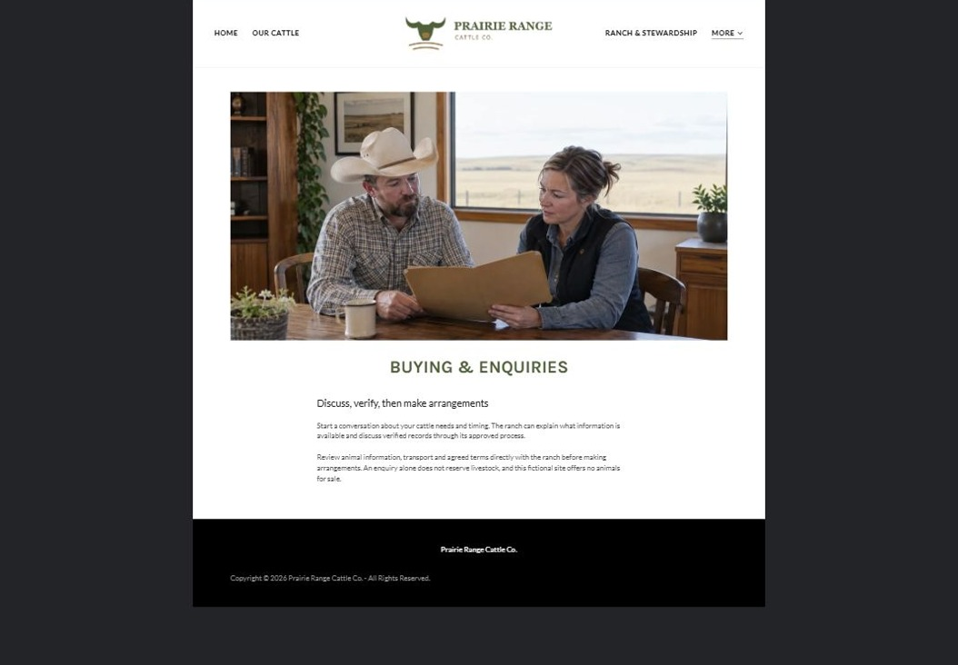
Actual desktop preview - unpublished fictional demonstration

Demo wording excerpt to adapt and verify
Discuss, verify, then make arrangements
Start a conversation about your cattle needs and timing. The ranch can explain what information is available and discuss verified records through its approved process.
Review animal information, transport and agreed terms directly with the ranch before making arrangements. An enquiry alone does not reserve livestock, and this fictional site offers no animals for sale.
Suggested button: No on-page button in this demo

Website advice
Explain the enquiry, information review and sale discussion sequence without creating a binding offer. Confirm transport and terms separately.

Your draft: Buying & Enquiries
Write in the voice of your own business. Use facts you can verify, not promises copied from the example.

Headline and short introduction

Main content and details visitors need

Button wording and destination

Photo choice, permission and facts still to confirm
Partner check: can someone unfamiliar with the business find a useful next step?

05 Visits & Updates
Give this page one clear job in the customer journey.
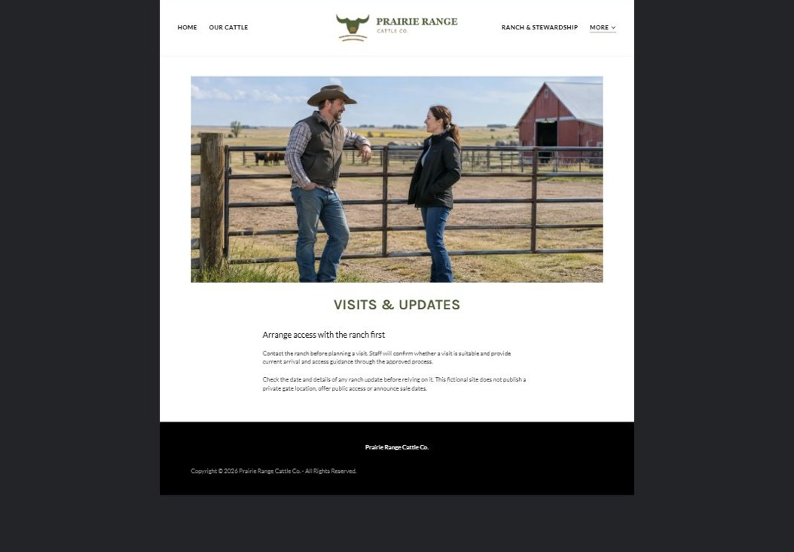
Actual desktop preview - unpublished fictional demonstration

Demo wording excerpt to adapt and verify
Arrange access with the ranch first
Contact the ranch before planning a visit. Staff will confirm whether a visit is suitable and provide current arrival and access guidance through the approved process.
Check the date and details of any ranch update before relying on it. This fictional site does not publish a private gate location, offer public access or announce sale dates.
Suggested button: No on-page button in this demo

Website advice
Publish only approved visit arrangements and dated ranch updates. Explain that access requires confirmation.

Your draft: Visits & Updates
Write in the voice of your own business. Use facts you can verify, not promises copied from the example.

Headline and short introduction

Main content and details visitors need

Button wording and destination

Photo choice, permission and facts still to confirm
Partner check: can someone unfamiliar with the business find a useful next step?

06 Contact & Enquiries
Give this page one clear job in the customer journey.
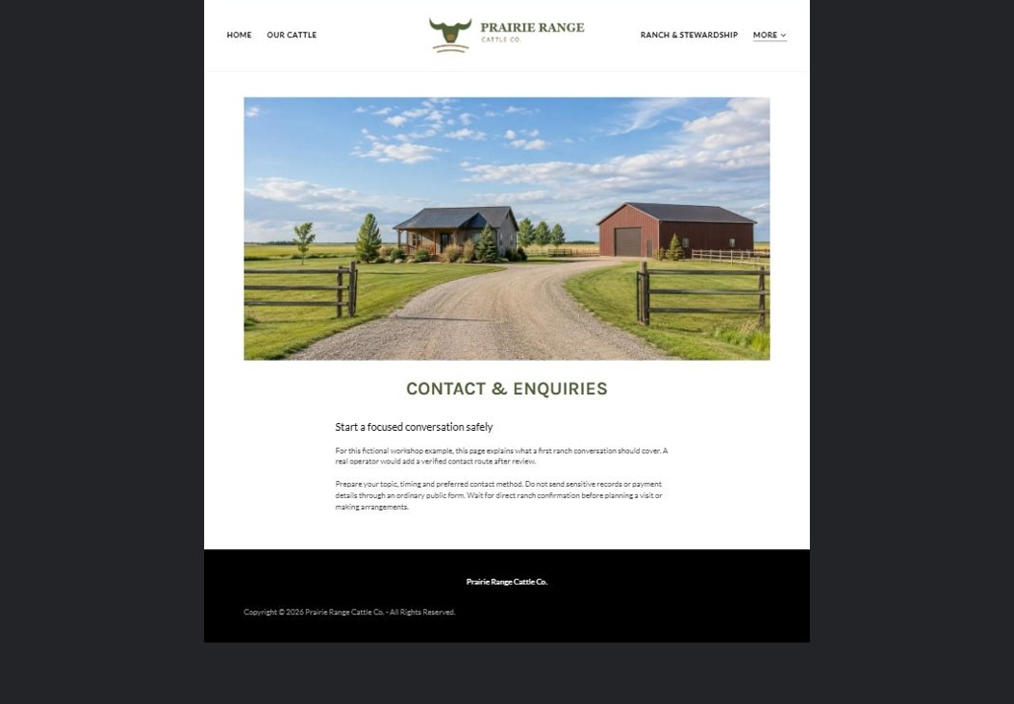
Actual desktop preview - unpublished fictional demonstration

Demo wording excerpt to adapt and verify
Start a focused conversation safely
For this fictional workshop example, this page explains what a first ranch conversation should cover. A real operator would add a verified contact route after review.
Prepare your topic, timing and preferred contact method. Do not send sensitive records or payment details through an ordinary public form. Wait for direct ranch confirmation before planning a visit or making arrangements.
Suggested button: No live form, messaging or button in this demo

Website advice
Give the verified address, hours and correct contact path. Collect only the minimum information needed for a first response; make confirmation requirements clear.

Your draft: Contact & Enquiries
Write in the voice of your own business. Use facts you can verify, not promises copied from the example.

Headline and short introduction

Main content and details visitors need

Button wording and destination

Photo choice, permission and facts still to confirm
Partner check: can someone unfamiliar with the business find a useful next step?

Test before publishing
Review the whole journey on a desktop and phone. The industry page pairs each desktop capture with its mobile preview and provides the complete sample page copy.
□ No animals are for sale through this fictional example. Have the ranch verify animal, pedigree, health, performance and sale claims; this guide provides no animal-health or husbandry advice.
□ Verify contact routes, hours, location and every offered service.
□ Remove invented prices, claims, testimonials and availability.
□ Keep sensitive records and payment details out of ordinary public forms.
□ Check all image permissions, downloads and page links on a phone.
□ Check every link, form destination, download and confirmation message.
□ Check logo contrast, hero framing, text sizes and image loading.
□ Save a named backup and assign a content-review date.

Changes to finish and person responsible

Approval and next review date
Website Builder plans and signup

