
WEBSITE PLANNING WORKSHOP

Caterers & Food Trucks
Website workbook
Plan a clear website for caterers & food trucks. Explore a worked example, shape your own message and prepare to build with SaaSTech Servers.
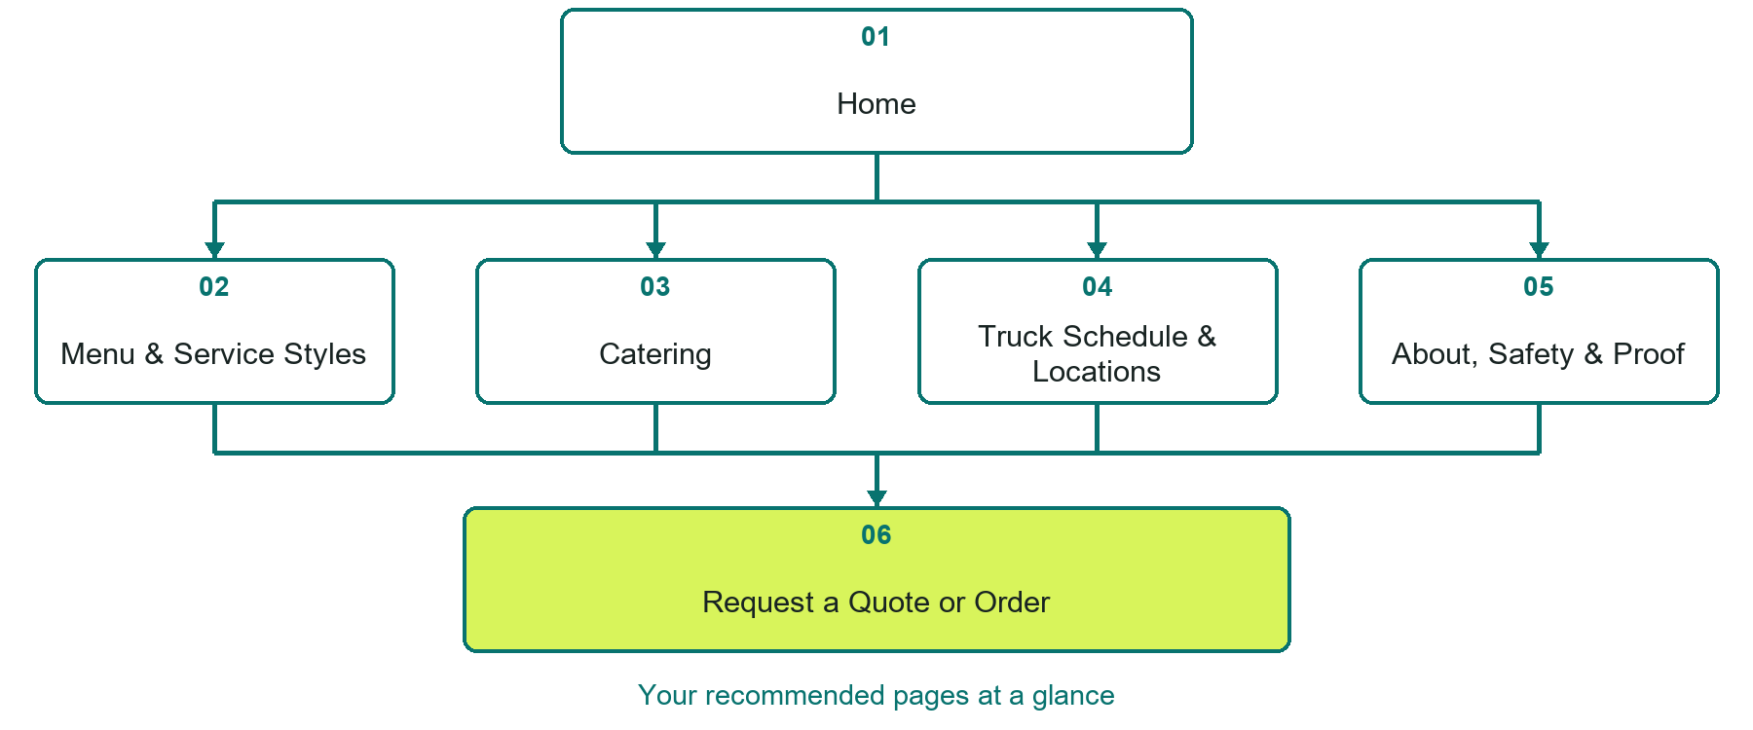

Inside this workbook
Six page examples • Practical writing exercises • A launch review
Use it in a workshop or at your own pace. Write by hand or complete the response fields in Word. The final page links to Website Builder, plans and account signup.
Example business Prairie Ember Catering

CATERERS & FOOD TRUCKS

Your website brief
A SaaSTech Servers workshop for caterers & food trucks. Plan your website, learn from the Prairie Ember Catering example and draft content for your own business.
Each page has a reference sheet followed by a writing sheet. Demo excerpts are labelled separately from new sample wording, which may differ from the screenshot. Click a blank response line to type; longer answers may add pages. Replace fictional details and verify every claim before publishing.
Your business or organization and workshop date

Who should visit your site and what do they need

The main action you want a visitor to take

What you offer and where or how you provide it

Facts photos and permissions to gather before publishing

Workshop rhythm: review the example, write your draft and exchange feedback. Use the final review to choose your next changes. Website Builder and account links are on the last page.

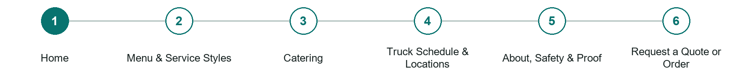
LOOK AND LEARN

Home

The job of this page
State whether the business offers catering, public food-truck stops, or both. Lead with the service area, the strongest customer action, representative food imagery, and direct paths to the menu, schedule, and event enquiry.
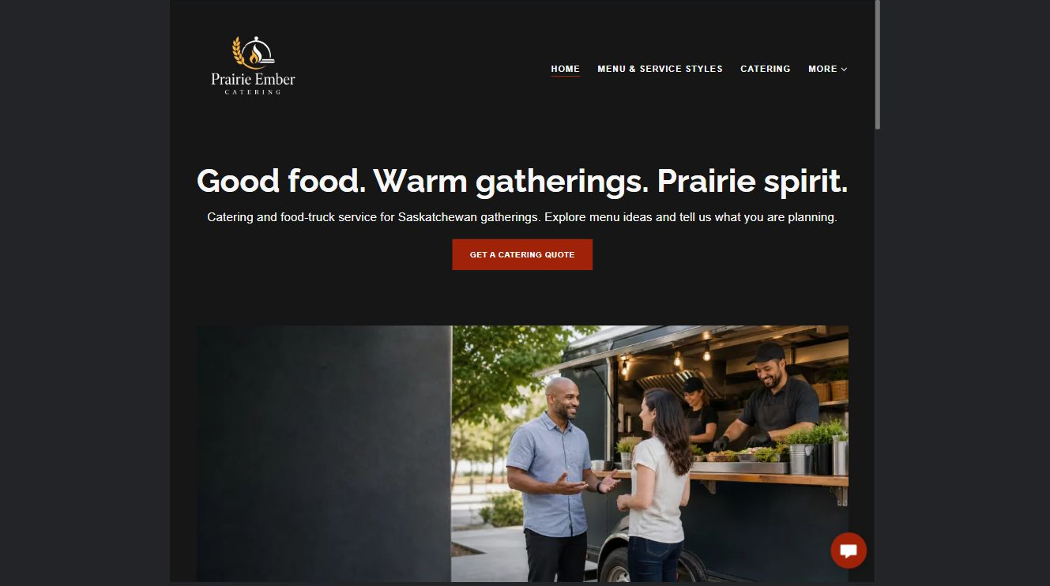
Prairie Ember Catering example | Explore SaaSTech Website Builder

Sample wording to adapt
Good food. Warm gatherings. Prairie spirit.
Catering and food-truck service for Saskatchewan gatherings. Explore menu ideas and tell us what you are planning.

Pause and plan
Could a first-time visitor explain what you do and who it is for after one glance? Choose one main action and the strongest truthful detail that gives them confidence to continue.

WRITE YOUR PAGE

Home
Write for your visitor. Be specific about what they need to know and what happens next. You can revise the wording after the workshop.
Your page headline

Your opening paragraph

Your offer audience location and most useful supporting details

Button or link wording and where it should lead

Photo idea caption and permission or credit needed

Facts to verify or questions to resolve

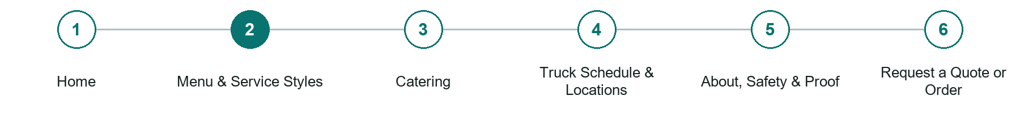
LOOK AND LEARN

Menu Service Styles

The job of this page
Publish current items, packages, serving formats, price guidance, dietary information, and availability boundaries.
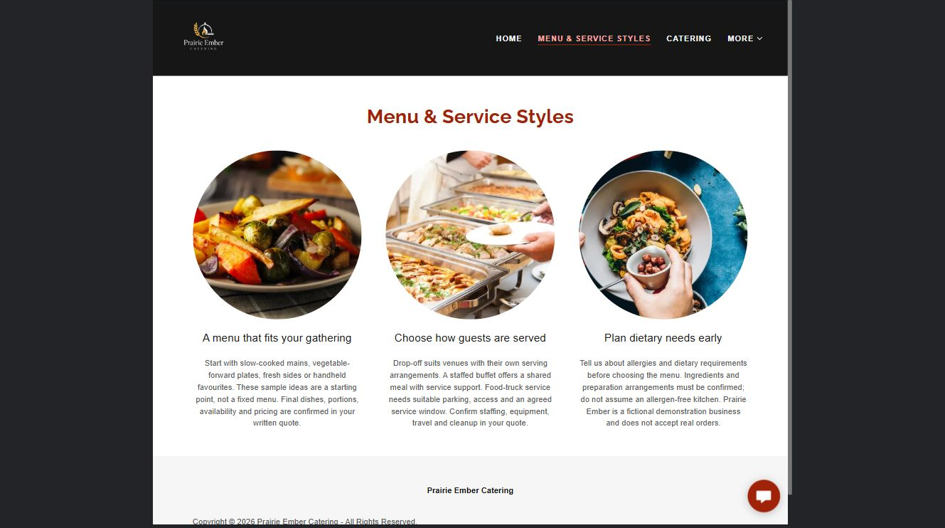
Prairie Ember Catering example | Explore SaaSTech Website Builder

Sample wording to adapt
A menu that fits your gathering
These sample ideas are a starting point, not a fixed menu. Final dishes, portions, availability and pricing belong in your written quote.

Pause and plan
What is included and what needs separate confirmation? Make quantities, timing, exclusions and price conditions understandable. Avoid implying that an example price or image guarantees availability.

WRITE YOUR PAGE

Menu Service Styles
Write for your visitor. Be specific about what they need to know and what happens next. You can revise the wording after the workshop.
Your page headline

Your opening paragraph

Options inclusions price conditions and availability details

Button or link wording and where it should lead

Photo idea caption and permission or credit needed

Facts to verify or questions to resolve

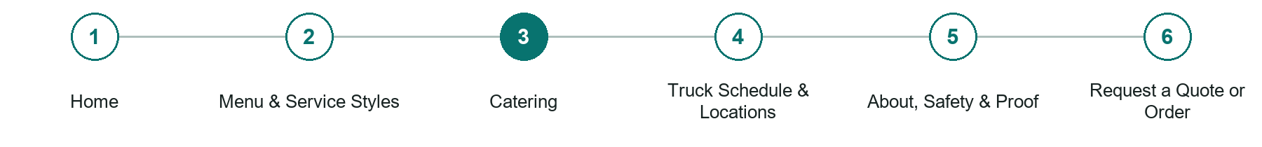
LOOK AND LEARN

Catering

The job of this page
Explain event types, guest ranges, minimums, staffing, rentals, setup, travel, lead times, deposits, and the quote process.
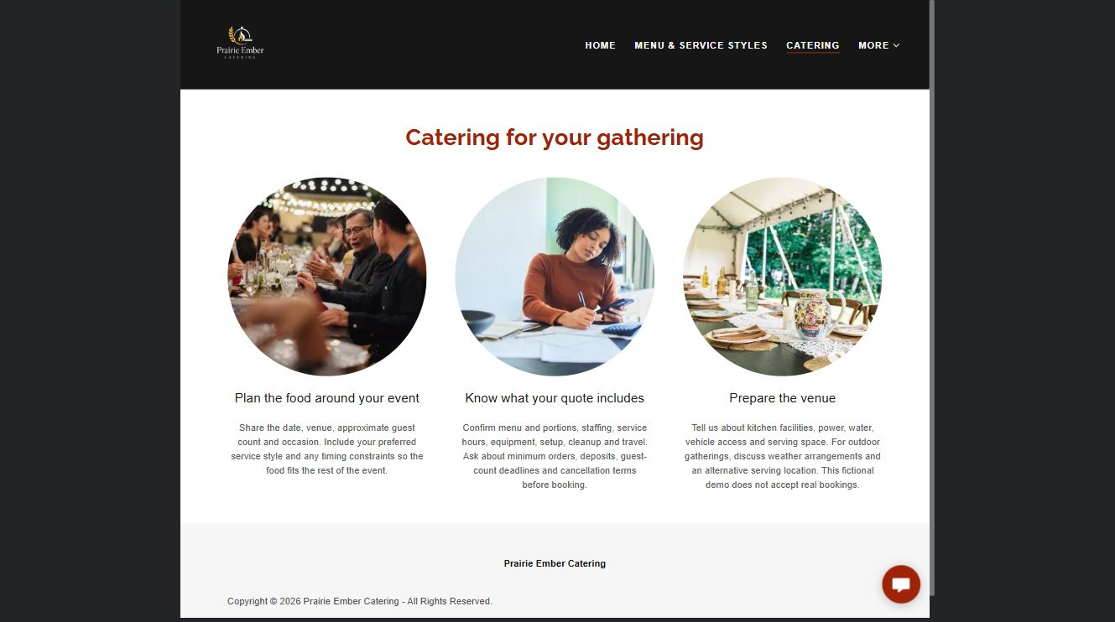
Prairie Ember Catering example | Explore SaaSTech Website Builder

Sample wording to adapt
Plan the food around your event
Share the date, venue, approximate guest count and occasion. Include your preferred service style and any timing constraints so the plan fits the rest of the event.

Pause and plan
What question brings a visitor to this page? List the details they need, the evidence you can provide and the next useful action. Remove content that does not help them decide or proceed.

WRITE YOUR PAGE

Catering
Write for your visitor. Be specific about what they need to know and what happens next. You can revise the wording after the workshop.
Your page headline

Your opening paragraph

Key sections visitor questions and supporting details

Button or link wording and where it should lead

Photo idea caption and permission or credit needed

Facts to verify or questions to resolve

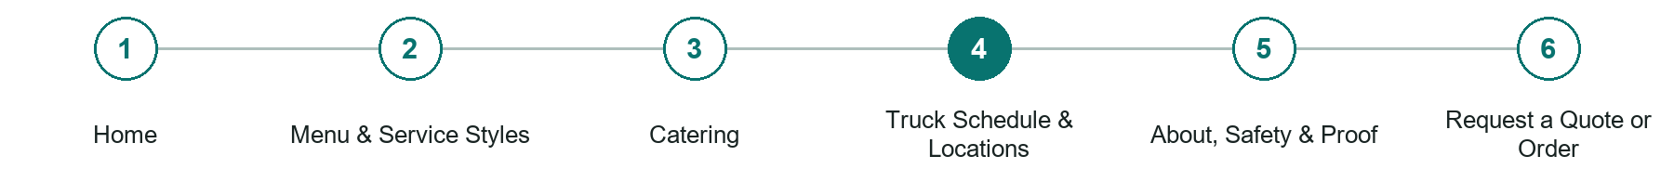
LOOK AND LEARN

Truck Schedule Locations

The job of this page
Show dated public stops, events, service area, weather changes, and the best live-update channel.
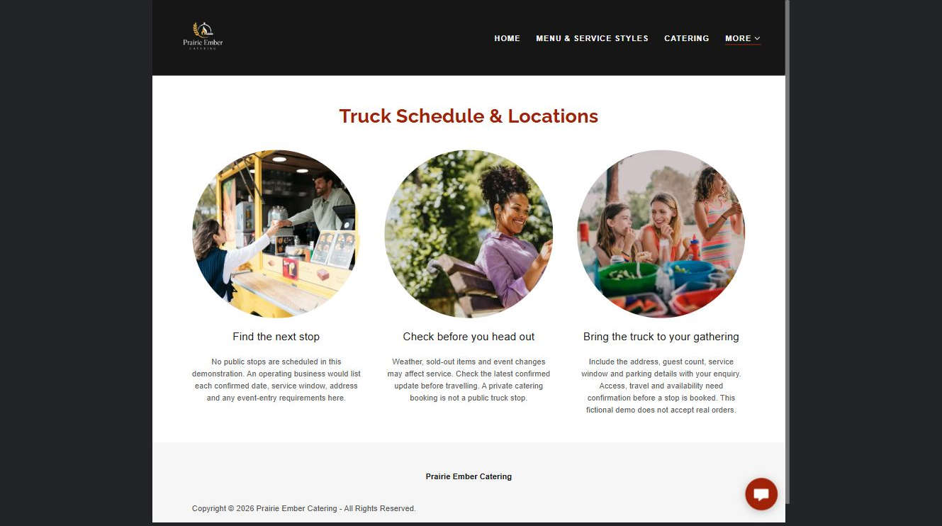
Prairie Ember Catering example | Explore SaaSTech Website Builder

Sample wording to adapt
Find the next stop
Check the confirmed date, location and service window before travelling. Weather, sold-out items and event changes may affect service. A private catering booking is not a public truck stop.

Pause and plan
Which dates and locations need to stay current? Decide who will update changes and where visitors should check before travelling. Separate archived information and illustrative schedules from current availability.

WRITE YOUR PAGE

Truck Schedule Locations
Write for your visitor. Be specific about what they need to know and what happens next. You can revise the wording after the workshop.
Your page headline

Your opening paragraph

Dates locations update process and participation details

Button or link wording and where it should lead

Photo idea caption and permission or credit needed

Facts to verify or questions to resolve

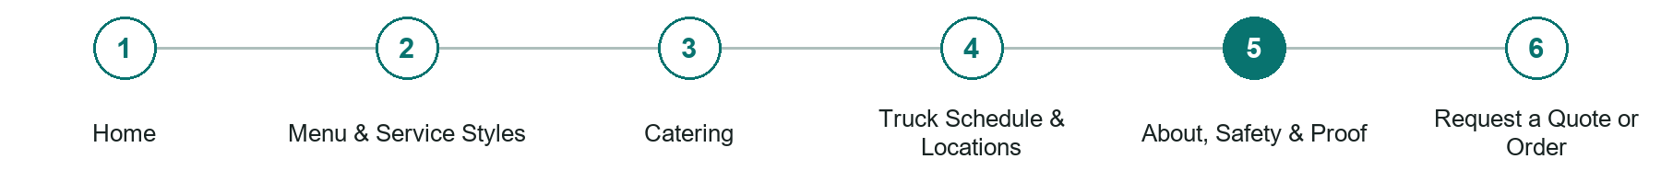
LOOK AND LEARN

About Safety Proof

The job of this page
Share the food story, team, permits or inspection information that can be verified, event examples, and reviews.
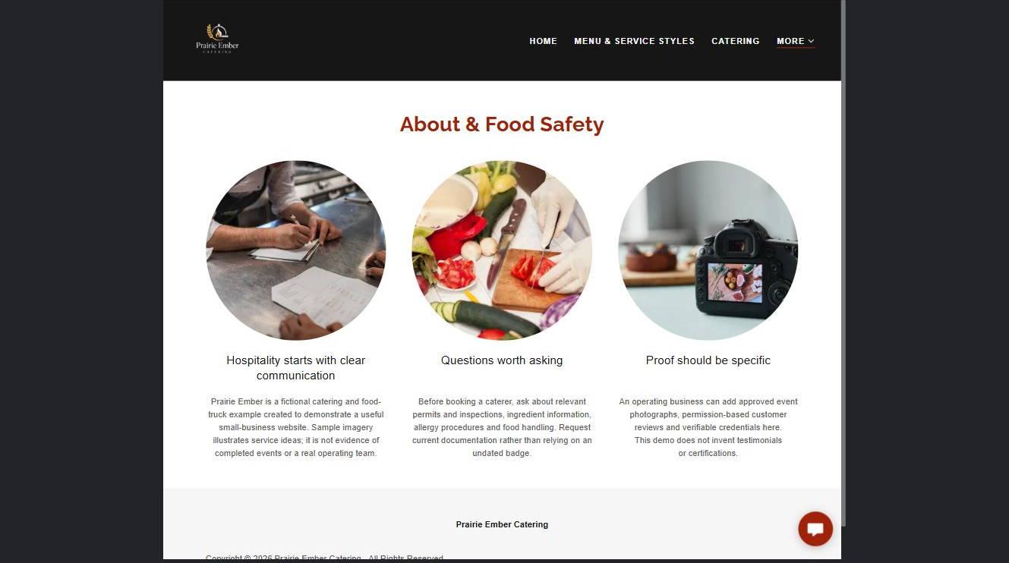
Prairie Ember Catering example | Explore SaaSTech Website Builder

Sample wording to adapt
Hospitality starts with clear communication
Ask about the permits, ingredient information and food-handling arrangements relevant to your event. Request current information rather than relying on an undated badge or an illustrative photograph.

Pause and plan
Which names, roles and qualifications can you verify? What would help a visitor feel comfortable contacting you? Obtain permission for portraits and describe actual experience without unsupported claims.

WRITE YOUR PAGE

About Safety Proof
Write for your visitor. Be specific about what they need to know and what happens next. You can revise the wording after the workshop.
Your page headline

Your opening paragraph

People roles approach and verified credentials to introduce

Button or link wording and where it should lead

Photo idea caption and permission or credit needed

Facts to verify or questions to resolve

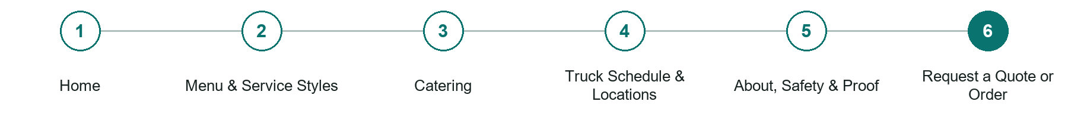
LOOK AND LEARN

Request a Quote or Order

The job of this page
Collect date, venue, location, guest count, service type, timing, menu interests, dietary needs, facilities, and contact details.
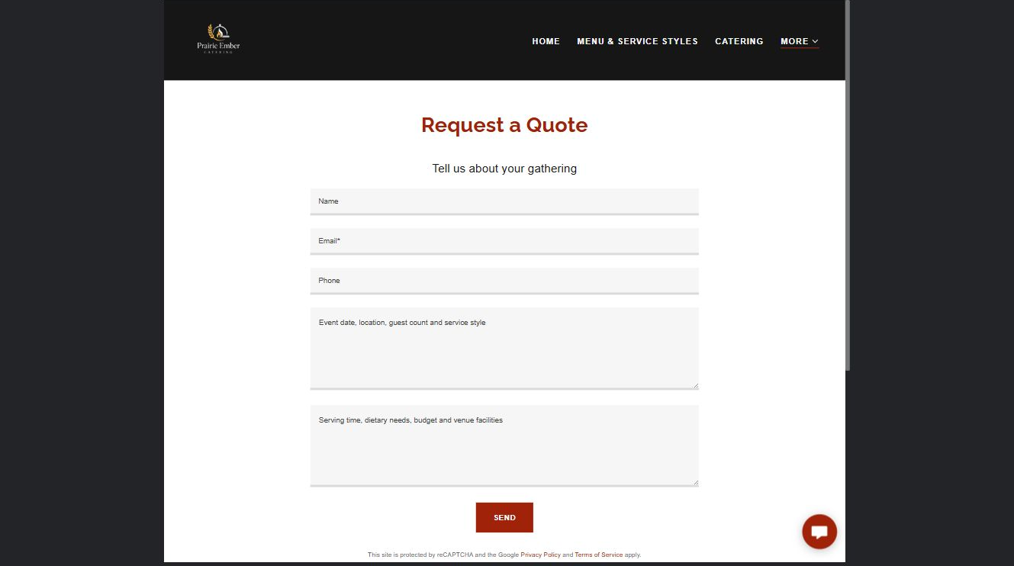
Prairie Ember Catering example | Explore SaaSTech Website Builder

Sample wording to adapt
Tell us about your gathering
Include the date, venue, guest count, service style and dietary requirements. Mention available facilities and access. Availability, scope and pricing must be agreed before a booking is accepted.

Pause and plan
What must someone provide, and what happens after they send it? Separate a request from a confirmed booking, order or place. Decide what information should stay out of a public form.

WRITE YOUR PAGE

Request a Quote or Order
Write for your visitor. Be specific about what they need to know and what happens next. You can revise the wording after the workshop.
Your page headline

Your opening paragraph

Information to request and how you will reply or confirm

Button or link wording and where it should lead

Photo idea caption and permission or credit needed

Facts to verify or questions to resolve

WORKSHOP CLOSE

Review and next steps
Ask a partner to read your draft as a first-time visitor. Can they explain what you offer, who it is for and the next step without extra help?

Before you publish
[ ] Every page has a clear purpose and a useful next step.
[ ] Headlines are specific and the wording sounds like your business.
[ ] Names, service areas, prices, dates and policies have been checked.
[ ] Credentials, testimonials and results are genuine and permission-cleared.
[ ] Photos support the text, do not repeat needlessly and have appropriate permissions.
[ ] Forms ask only for necessary information and explain what happens next.
[ ] Links, downloads and the main visitor task work on a phone.
The most useful feedback from your workshop partner

First change to make and who will do it

Information or photographs still needed

Target review date and who will approve the final content

Keep sensitive customer, patient, employee and payment information out of this workbook. Completing it does not publish a website or connect to Website Builder.

BUILD WITH SAASTECH SERVERS

Put your draft into Website Builder
Use the content you have written to build your own site. Keep the caterers & food trucks demo as a reference, and replace its company name, images and claims with your verified business information.

Explore the builder
See the editor, compare available plans and decide which features your business needs. Confirm current pricing and terms before purchasing.
Website Builder overview

Create your account
Set up your SaaSTech Servers customer account using your own details. Creating an account is separate from purchasing a Website Builder plan.
Create your SaaSTech account

Choose your plan
Open the secure shop to review the plan, subscription term and final total. Use the account connected to your purchase when you open your service.
View Website Builder plans

Build and check your pages
Add the pages from this workbook. Transfer your approved wording, upload permission-cleared photos and review each page on desktop and mobile before publishing.
Return to the Website Builder guide

Using a printed workbook
Type these short addresses into your browser. The account guide includes the Create My Account button.
www.saastech.net/products/website-builder
www.saastech.net/create-account
This workbook does not create an account, purchase a plan or publish your website. Keep passwords, payment details and confidential customer information out of your draft.

