

Car Dealerships
Website workbook
A practical workshop for a 6-page website. Study the example, plan the content and draft your own version in Word or on paper.
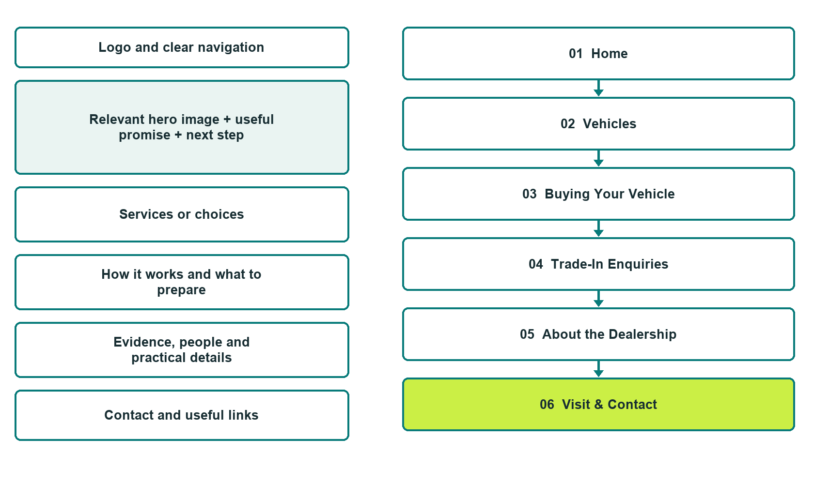

Plan → Draft → Build → Test
Demo-capture edition: actual Website Builder desktop previews and excerpts of the example wording. See each matching mobile preview in the industry page gallery. The example business and its AI-generated photographs are fictional.
Explore Website Builder and compare plans

Before you build
Your business supplies the facts. Prairie Horizon Motors is a fictional teaching example, not a live service.

□ Ask about a vehicle or request a viewing
□ Current vehicle information and original photographs
□ Transparent, verified price and purchase explanations
□ Choose original photographs and confirm permission to use them.
□ Keep private customer records out of public website forms.

Your audience and the action you want them to take

Facts to verify and people who must approve them
Create your SaaSTech account

01 Home
Give this page one clear job in the customer journey.
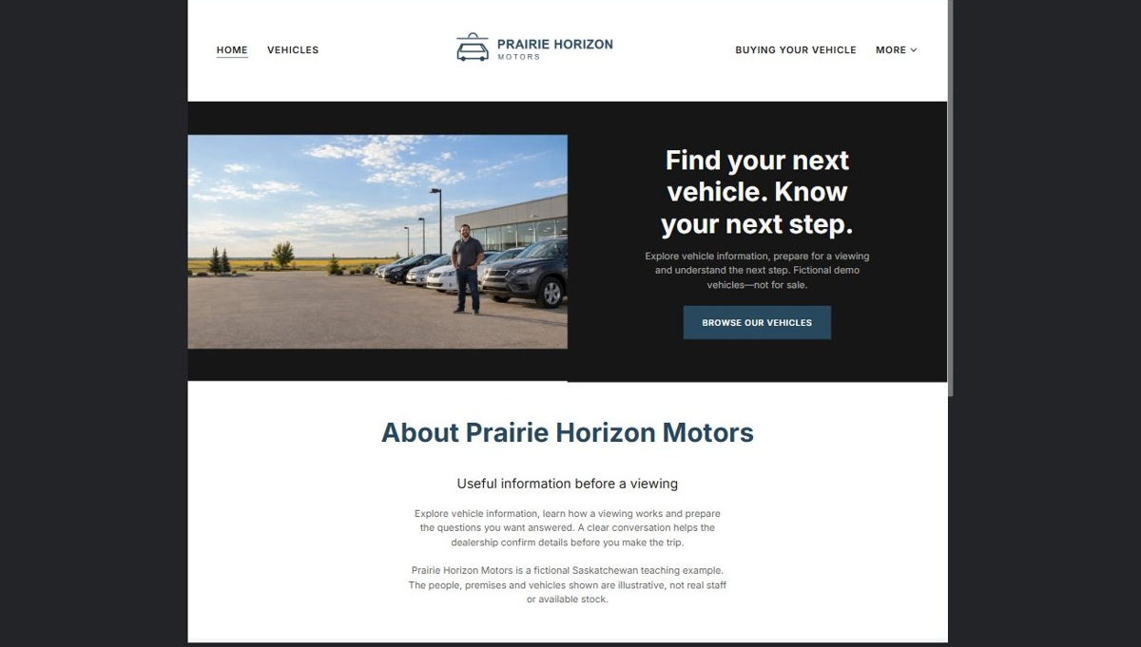
Actual desktop preview - unpublished fictional demonstration

Demo wording excerpt to adapt and verify
Find your next vehicle. Know your next step.
Explore vehicle information, prepare for a viewing and understand the next step. Fictional demo vehicles—not for sale.
Explore vehicle information, learn how a viewing works and prepare the questions you want answered. A clear conversation helps the dealership confirm details before you make the trip.
Prairie Horizon Motors is a fictional Saskatchewan teaching example. The people, premises and vehicles shown are illustrative, not real staff or available stock.
Suggested button: Browse Our Vehicles

Website advice
Introduce fictional Prairie Horizon Motors, explain its independent-dealer approach and link to Vehicles and Buying Your Vehicle. Label every demonstration listing as sample stock, not an available vehicle.

Your draft: Home
Write in the voice of your own business. Use facts you can verify, not promises copied from the example.

Headline and short introduction

Main content and details visitors need

Button wording and destination

Photo choice, permission and facts still to confirm
Partner check: can someone unfamiliar with the business find a useful next step?

02 Vehicles
Give this page one clear job in the customer journey.
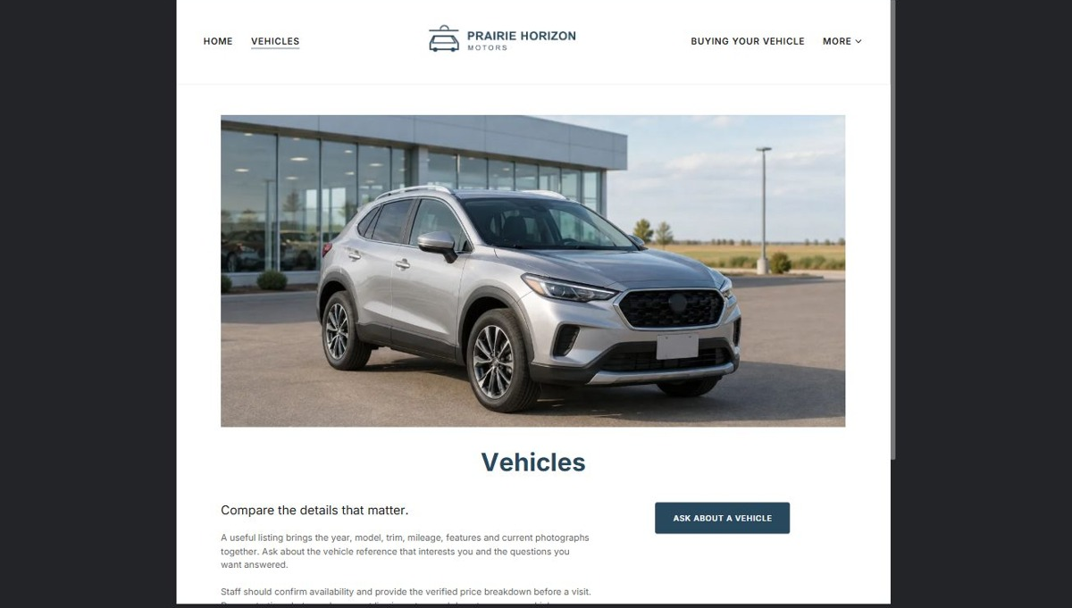
Actual desktop preview - unpublished fictional demonstration

Demo wording excerpt to adapt and verify
Compare the details that matter.
A useful listing brings the year, model, trim, mileage, features and current photographs together. Ask about the vehicle reference that interests you and the questions you want answered.
Staff should confirm availability and provide the verified price breakdown before a visit. Demonstration photographs are not live inventory and do not reserve a vehicle.
Suggested button: Ask about a vehicle

Website advice
Use a consistent detail layout with year, make, model, trim, mileage, key features, actual photos and a verified price breakdown. Add an availability timestamp and enquiry action. Do not show invented vehicles as live stock or imply automated inventory updates.

Your draft: Vehicles
Write in the voice of your own business. Use facts you can verify, not promises copied from the example.

Headline and short introduction

Main content and details visitors need

Button wording and destination

Photo choice, permission and facts still to confirm
Partner check: can someone unfamiliar with the business find a useful next step?

03 Buying Your Vehicle
Give this page one clear job in the customer journey.
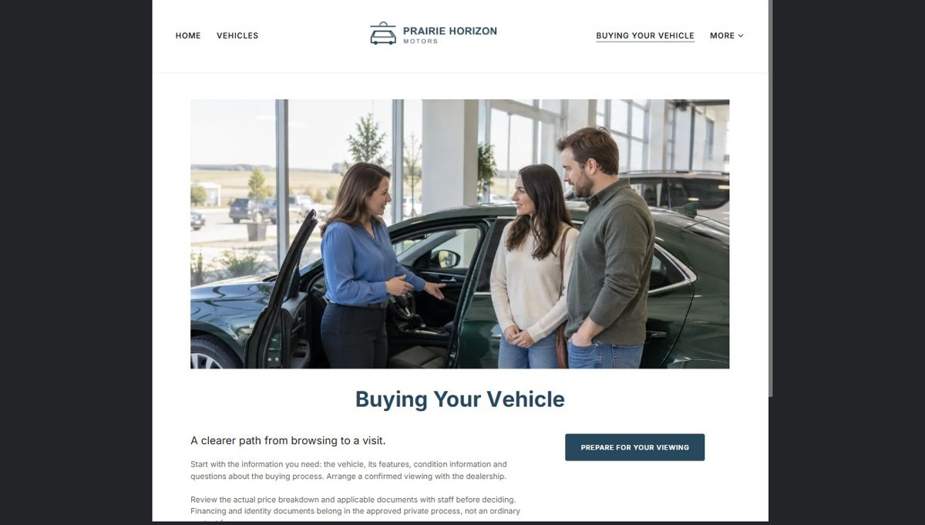
Actual desktop preview - unpublished fictional demonstration

Demo wording excerpt to adapt and verify
A clearer path from browsing to a visit.
Start with the information you need: the vehicle, its features, condition information and questions about the buying process. Arrange a confirmed viewing with the dealership.
Review the actual price breakdown and applicable documents with staff before deciding. Financing and identity documents belong in the approved private process, not an ordinary contact form.
Suggested button: Prepare for your viewing

Website advice
Explain viewing, questions, inspection information, pricing review and next steps. Have the dealer verify all advertising, disclosure and sales wording before launch. Avoid invented warranties, approval promises or finance rates.

Your draft: Buying Your Vehicle
Write in the voice of your own business. Use facts you can verify, not promises copied from the example.

Headline and short introduction

Main content and details visitors need

Button wording and destination

Photo choice, permission and facts still to confirm
Partner check: can someone unfamiliar with the business find a useful next step?

04 Trade-In Enquiries
Give this page one clear job in the customer journey.
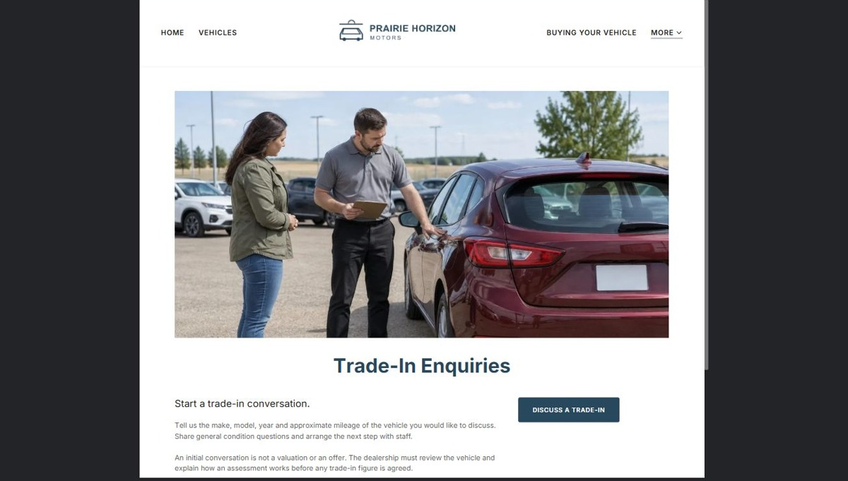
Actual desktop preview - unpublished fictional demonstration

Demo wording excerpt to adapt and verify
Start a trade-in conversation.
Tell us the make, model, year and approximate mileage of the vehicle you would like to discuss. Share general condition questions and arrange the next step with staff.
An initial conversation is not a valuation or an offer. The dealership must review the vehicle and explain how an assessment works before any trade-in figure is agreed.
Suggested button: Discuss a trade-in

Website advice
Explain that a preliminary conversation is not a binding valuation. Ask for basic vehicle details and arrange an assessment; keep ownership documents, identification and financial records out of the general website form.

Your draft: Trade-In Enquiries
Write in the voice of your own business. Use facts you can verify, not promises copied from the example.

Headline and short introduction

Main content and details visitors need

Button wording and destination

Photo choice, permission and facts still to confirm
Partner check: can someone unfamiliar with the business find a useful next step?

05 About the Dealership
Give this page one clear job in the customer journey.
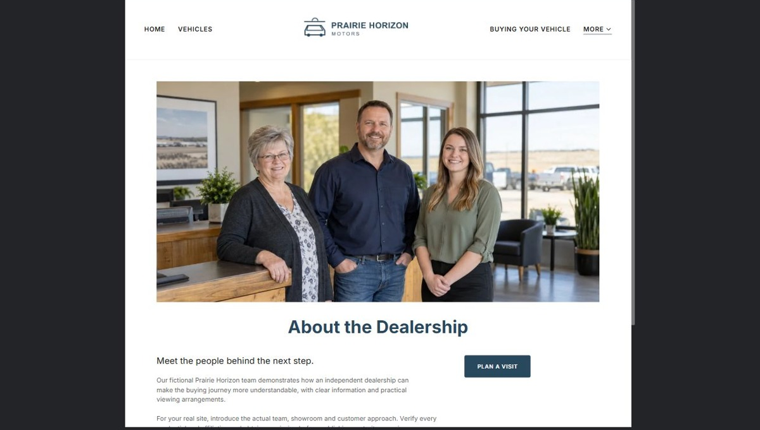
Actual desktop preview - unpublished fictional demonstration

Demo wording excerpt to adapt and verify
Meet the people behind the next step.
Our fictional Prairie Horizon team demonstrates how an independent dealership can make the buying journey more understandable, with clear information and practical viewing arrangements.
For your real site, introduce the actual team, showroom and customer approach. Verify every credential and affiliation and obtain permission before publishing portraits or reviews.
Suggested button: Plan a visit

Website advice
Introduce the real team, showroom and customer approach using verified business details and permission-cleared portraits. Only publish genuine reviews and confirmed affiliations.

Your draft: About the Dealership
Write in the voice of your own business. Use facts you can verify, not promises copied from the example.

Headline and short introduction

Main content and details visitors need

Button wording and destination

Photo choice, permission and facts still to confirm
Partner check: can someone unfamiliar with the business find a useful next step?

06 Visit & Contact
Give this page one clear job in the customer journey.
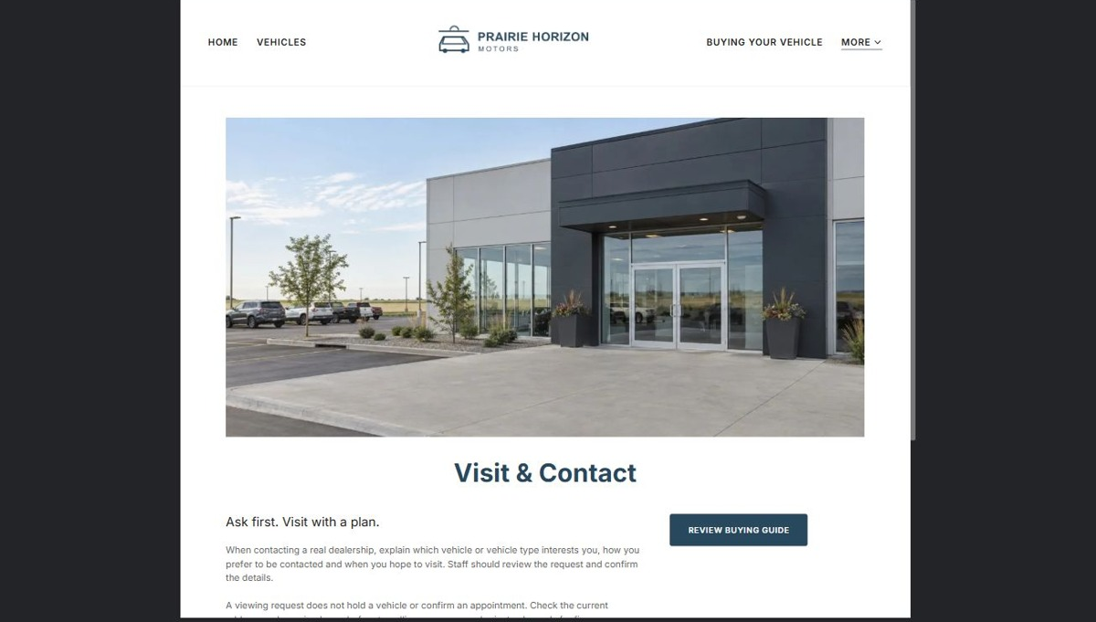
Actual desktop preview - unpublished fictional demonstration

Demo wording excerpt to adapt and verify
Ask first. Visit with a plan.
When contacting a real dealership, explain which vehicle or vehicle type interests you, how you prefer to be contacted and when you hope to visit. Staff should review the request and confirm the details.
A viewing request does not hold a vehicle or confirm an appointment. Check the current address and opening hours before travelling; use approved private channels for finance and identification.
This fictional workshop demo has no operating showroom, contact form or booking service. No enquiries or payments are accepted.
Suggested button: Review buying guide

Website advice
Show confirmed location, accessibility, opening hours and viewing-request options. Ask which vehicle interests the visitor and preferred timing. State that availability and appointments require staff confirmation.

Your draft: Visit & Contact
Write in the voice of your own business. Use facts you can verify, not promises copied from the example.

Headline and short introduction

Main content and details visitors need

Button wording and destination

Photo choice, permission and facts still to confirm
Partner check: can someone unfamiliar with the business find a useful next step?

Test before publishing
Review the whole journey on a desktop and phone. The industry page pairs each desktop capture with its mobile preview and provides the complete sample page copy.
□ Check every sample listing is visibly marked as fictional and not for sale.
□ Have the dealer review price, disclosure, warranty and financing statements before a real launch.
□ Test viewing requests without claiming a vehicle is held or an appointment confirmed.
□ Keep credit applications, identity documents, banking data and payments out of ordinary enquiry forms.
□ Assign responsibility for sold-vehicle updates and confirm the inventory source before claiming live availability.
□ Check every link, form destination, download and confirmation message.
□ Check logo contrast, hero framing, text sizes and image loading.
□ Save a named backup and assign a content-review date.

Changes to finish and person responsible

Approval and next review date
Website Builder plans and signup

