
WEBSITE PLANNING WORKSHOP

Bloggers & Influencers
Website workbook
Plan a clear website for bloggers & influencers. Explore a worked example, shape your own message and prepare to build with SaaSTech Servers.
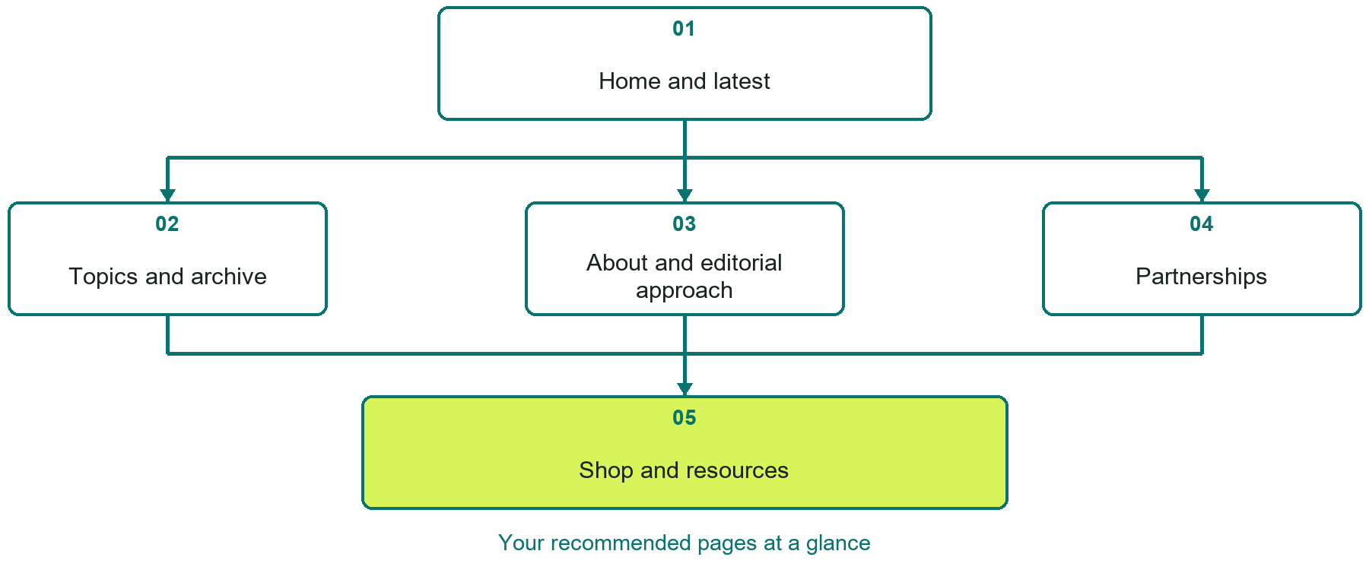

Inside this workbook
Five page examples • Practical writing exercises • A launch review
Use it in a workshop or at your own pace. Write by hand or complete the response fields in Word. The final page links to Website Builder, plans and account signup.
Example business The Northern Edit

BLOGGERS & INFLUENCERS

Your website brief
A SaaSTech Servers workshop for bloggers & influencers. Plan your website, learn from the The Northern Edit example and draft content for your own business.
Each page has a reference sheet followed by a writing sheet. Demo excerpts are labelled separately from new sample wording, which may differ from the screenshot. Click a blank response line to type; longer answers may add pages. Replace fictional details and verify every claim before publishing.
Your business or organization and workshop date

Who should visit your site and what do they need

The main action you want a visitor to take

What you offer and where or how you provide it

Facts photos and permissions to gather before publishing

Workshop rhythm: review the example, write your draft and exchange feedback. Use the final review to choose your next changes. Website Builder and account links are on the last page.

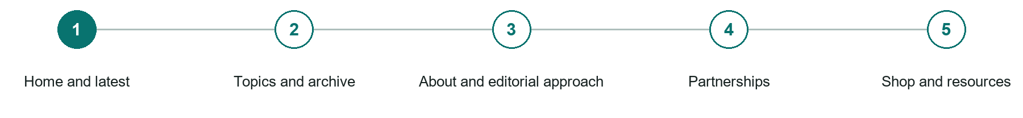
LOOK AND LEARN

Home and latest

The job of this page
Introduce the topic and creator, feature the strongest current work, and offer clear reading and subscription paths.
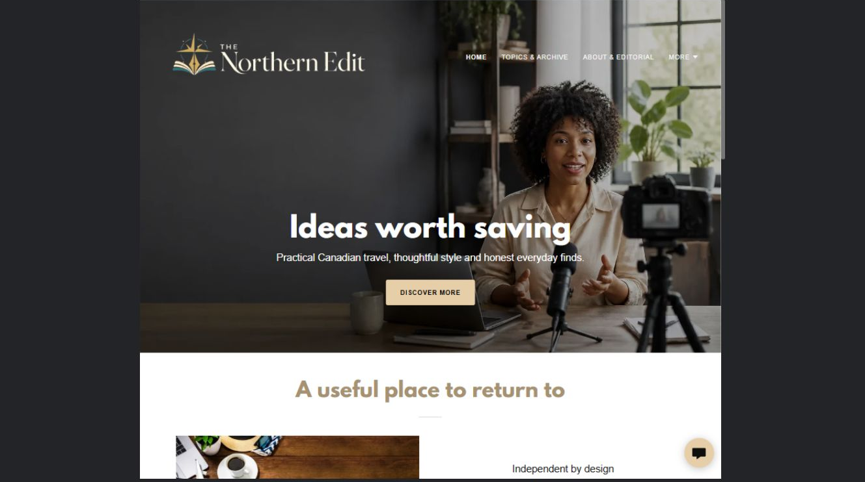
The Northern Edit example | Explore SaaSTech Website Builder

Sample wording to adapt
Find your next useful read
Browse recent stories and practical features from The Northern Edit. Publication dates and categories help you choose where to start. Sponsored or affiliate material is clearly identified.

Pause and plan
Which dates and locations need to stay current? Decide who will update changes and where visitors should check before travelling. Separate archived information and illustrative schedules from current availability.

WRITE YOUR PAGE

Home and latest
Write for your visitor. Be specific about what they need to know and what happens next. You can revise the wording after the workshop.
Your page headline

Your opening paragraph

Dates locations update process and participation details

Button or link wording and where it should lead

Photo idea caption and permission or credit needed

Facts to verify or questions to resolve

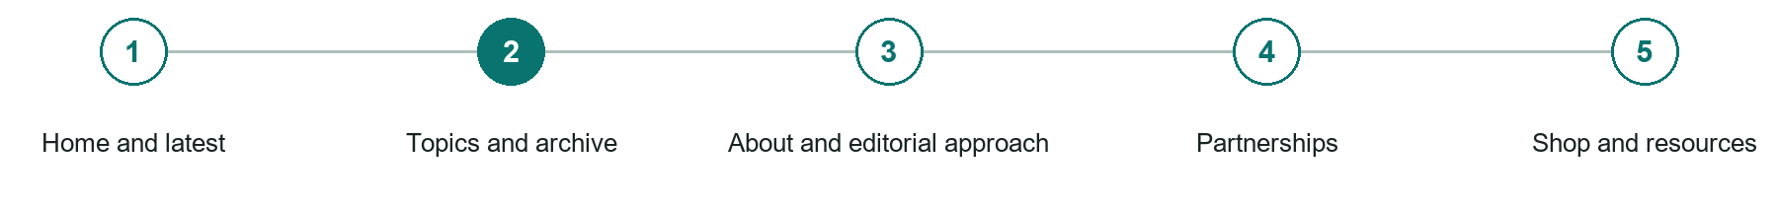
LOOK AND LEARN

Topics and archive

The job of this page
Organize useful posts, videos, podcasts, or guides into stable categories that remain discoverable.
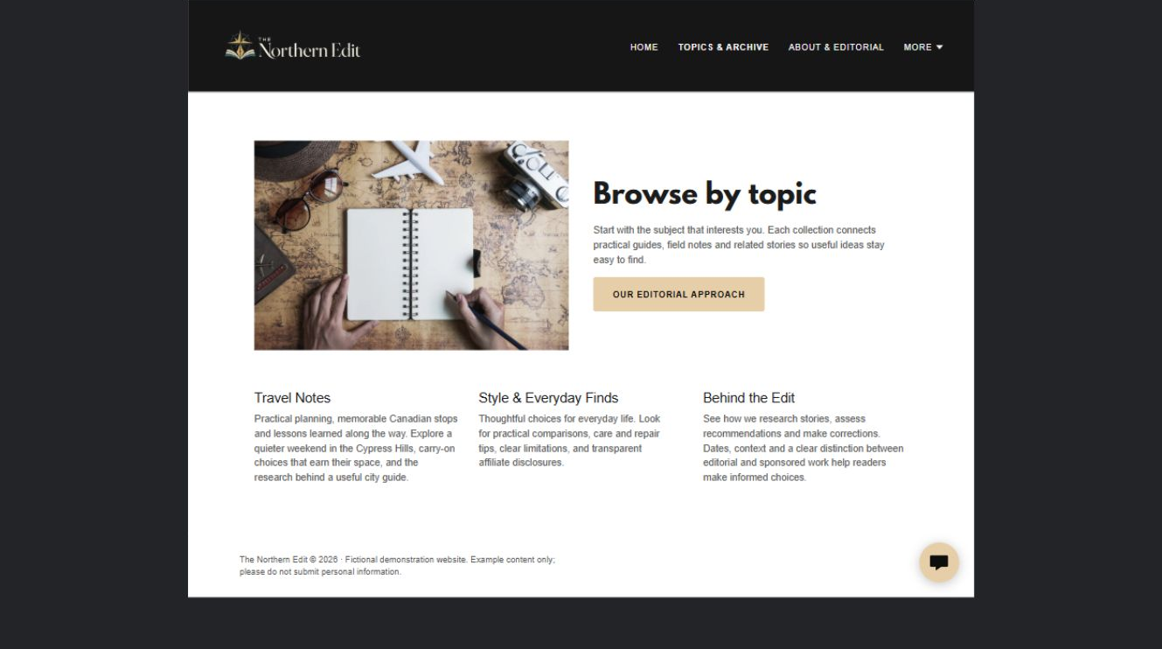
The Northern Edit example | Explore SaaSTech Website Builder

Sample wording to adapt
Explore the archive by topic
Choose a subject and browse related posts. Older articles retain their dates so you can judge their relevance. Check updated guidance where the topic may have changed.

Pause and plan
What question brings a visitor to this page? List the details they need, the evidence you can provide and the next useful action. Remove content that does not help them decide or proceed.

WRITE YOUR PAGE

Topics and archive
Write for your visitor. Be specific about what they need to know and what happens next. You can revise the wording after the workshop.
Your page headline

Your opening paragraph

Key sections visitor questions and supporting details

Button or link wording and where it should lead

Photo idea caption and permission or credit needed

Facts to verify or questions to resolve

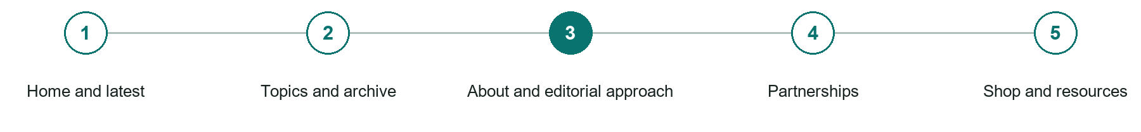
LOOK AND LEARN

About and editorial approach

The job of this page
Explain expertise, point of view, content standards, corrections, privacy, and how recommendations are selected.
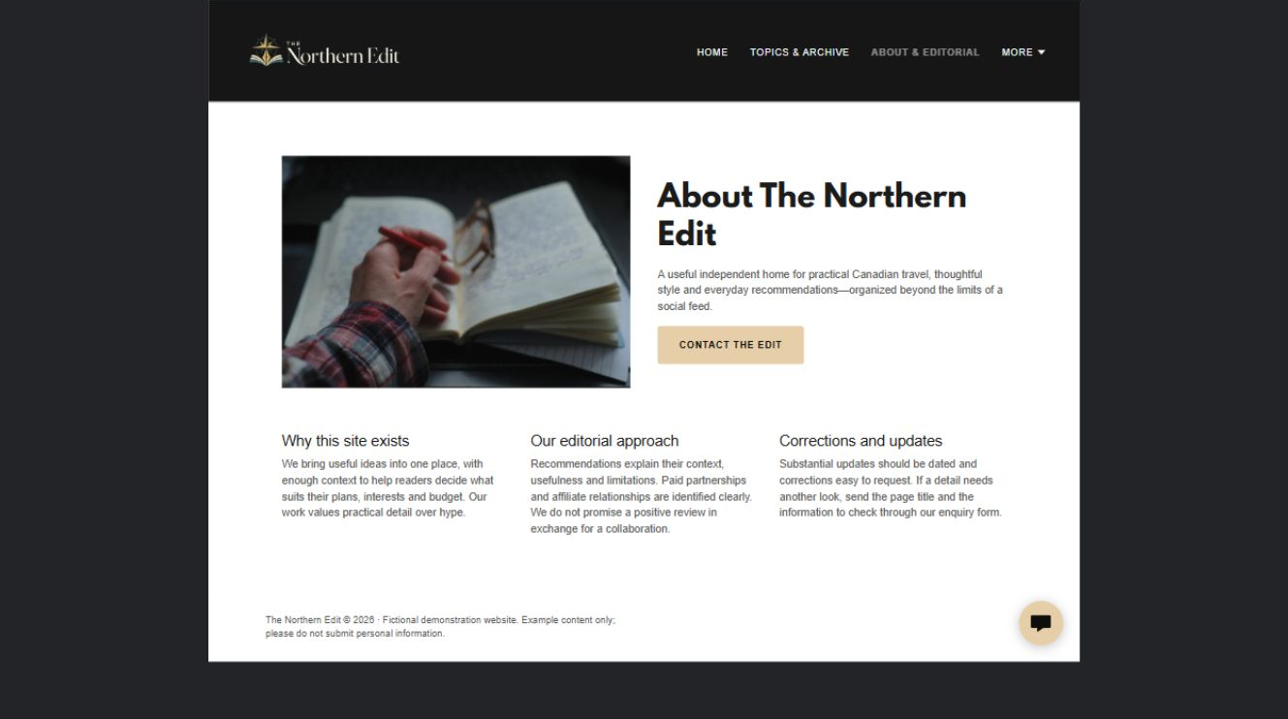
The Northern Edit example | Explore SaaSTech Website Builder

Sample wording to adapt
How the stories are put together
Learn about the author's interests, sourcing and editorial approach. Commercial relationships are disclosed where relevant. Personal experience and researched information should be distinguished.

Pause and plan
Which names, roles and qualifications can you verify? What would help a visitor feel comfortable contacting you? Obtain permission for portraits and describe actual experience without unsupported claims.

WRITE YOUR PAGE

About and editorial approach
Write for your visitor. Be specific about what they need to know and what happens next. You can revise the wording after the workshop.
Your page headline

Your opening paragraph

People roles approach and verified credentials to introduce

Button or link wording and where it should lead

Photo idea caption and permission or credit needed

Facts to verify or questions to resolve

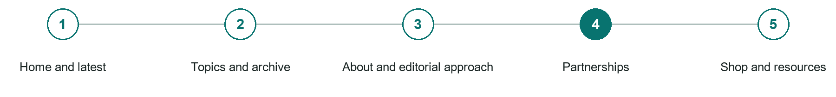
LOOK AND LEARN

Partnerships

The job of this page
Provide audience context, suitable partnerships, formats, availability, contact, and disclosure expectations without overstating reach.
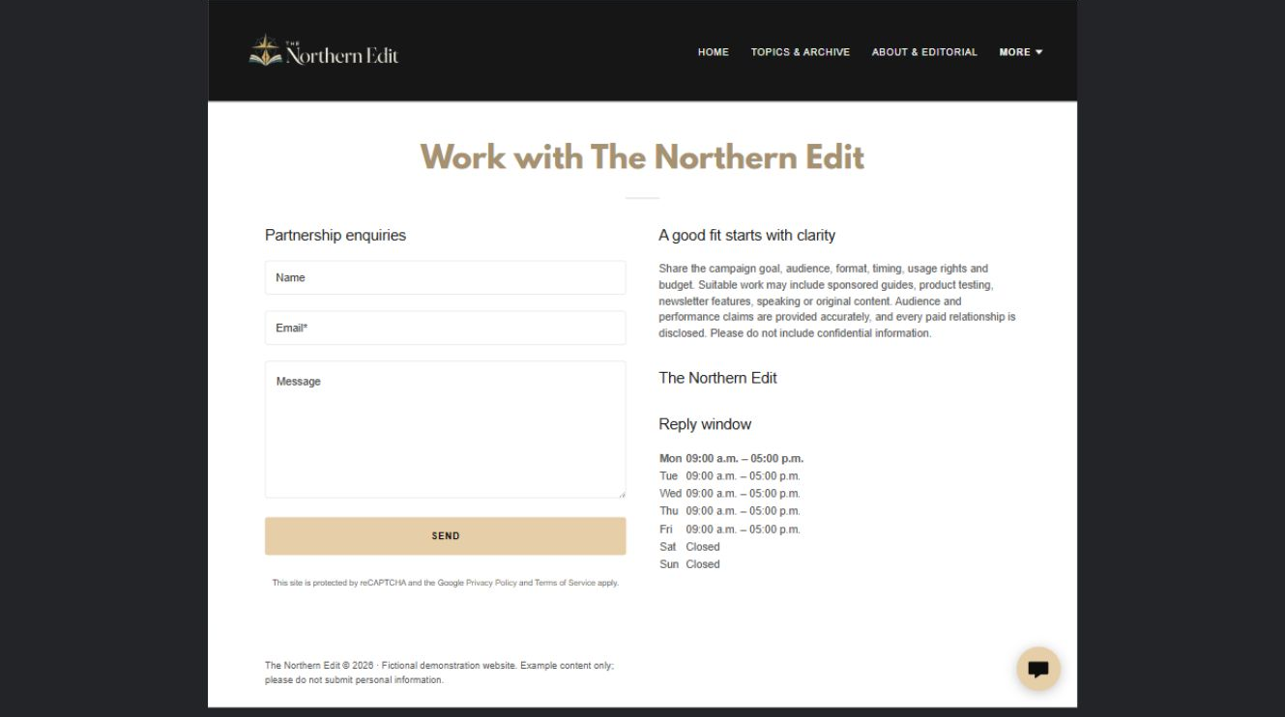
The Northern Edit example | Explore SaaSTech Website Builder

Sample wording to adapt
Discuss a relevant partnership
Describe the campaign, audience, timing and proposed deliverables. We will discuss editorial fit and disclosure before agreeing a collaboration. This example does not claim audience figures or past brand clients.

Pause and plan
What question brings a visitor to this page? List the details they need, the evidence you can provide and the next useful action. Remove content that does not help them decide or proceed.

WRITE YOUR PAGE

Partnerships
Write for your visitor. Be specific about what they need to know and what happens next. You can revise the wording after the workshop.
Your page headline

Your opening paragraph

Key sections visitor questions and supporting details

Button or link wording and where it should lead

Photo idea caption and permission or credit needed

Facts to verify or questions to resolve

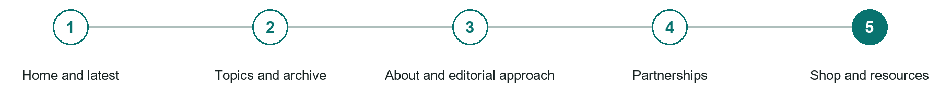
LOOK AND LEARN

Shop and resources

The job of this page
Present products, downloads, memberships, affiliate resources, terms, and fulfilment clearly.
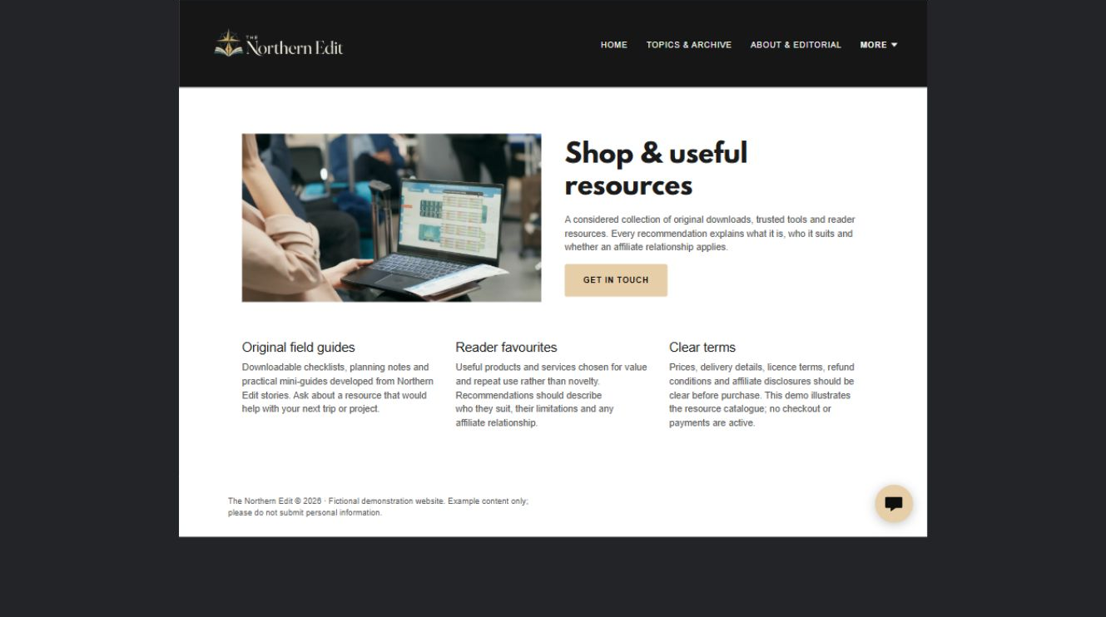
The Northern Edit example | Explore SaaSTech Website Builder

Sample wording to adapt
Resources to use in your own work
Read the description, file format and usage terms before downloading or buying. Check whether a resource is free or paid. External products and affiliate links should be labelled clearly.

Pause and plan
What is included and what needs separate confirmation? Make quantities, timing, exclusions and price conditions understandable. Avoid implying that an example price or image guarantees availability.

WRITE YOUR PAGE

Shop and resources
Write for your visitor. Be specific about what they need to know and what happens next. You can revise the wording after the workshop.
Your page headline

Your opening paragraph

Options inclusions price conditions and availability details

Button or link wording and where it should lead

Photo idea caption and permission or credit needed

Facts to verify or questions to resolve

WORKSHOP CLOSE

Review and next steps
Ask a partner to read your draft as a first-time visitor. Can they explain what you offer, who it is for and the next step without extra help?

Before you publish
[ ] Every page has a clear purpose and a useful next step.
[ ] Headlines are specific and the wording sounds like your business.
[ ] Names, service areas, prices, dates and policies have been checked.
[ ] Credentials, testimonials and results are genuine and permission-cleared.
[ ] Photos support the text, do not repeat needlessly and have appropriate permissions.
[ ] Forms ask only for necessary information and explain what happens next.
[ ] Links, downloads and the main visitor task work on a phone.
The most useful feedback from your workshop partner

First change to make and who will do it

Information or photographs still needed

Target review date and who will approve the final content

Keep sensitive customer, patient, employee and payment information out of this workbook. Completing it does not publish a website or connect to Website Builder.

BUILD WITH SAASTECH SERVERS

Put your draft into Website Builder
Use the content you have written to build your own site. Keep the bloggers & influencers demo as a reference, and replace its company name, images and claims with your verified business information.

Explore the builder
See the editor, compare available plans and decide which features your business needs. Confirm current pricing and terms before purchasing.
Website Builder overview

Create your account
Set up your SaaSTech Servers customer account using your own details. Creating an account is separate from purchasing a Website Builder plan.
Create your SaaSTech account

Choose your plan
Open the secure shop to review the plan, subscription term and final total. Use the account connected to your purchase when you open your service.
View Website Builder plans

Build and check your pages
Add the pages from this workbook. Transfer your approved wording, upload permission-cleared photos and review each page on desktop and mobile before publishing.
Return to the Website Builder guide

Using a printed workbook
Type these short addresses into your browser. The account guide includes the Create My Account button.
www.saastech.net/products/website-builder
www.saastech.net/create-account
This workbook does not create an account, purchase a plan or publish your website. Keep passwords, payment details and confidential customer information out of your draft.

