

Beekeepers & Honey Producers
Website workbook
A practical workshop for a 6-page website. Study the example, plan the content and draft your own version in Word or on paper.
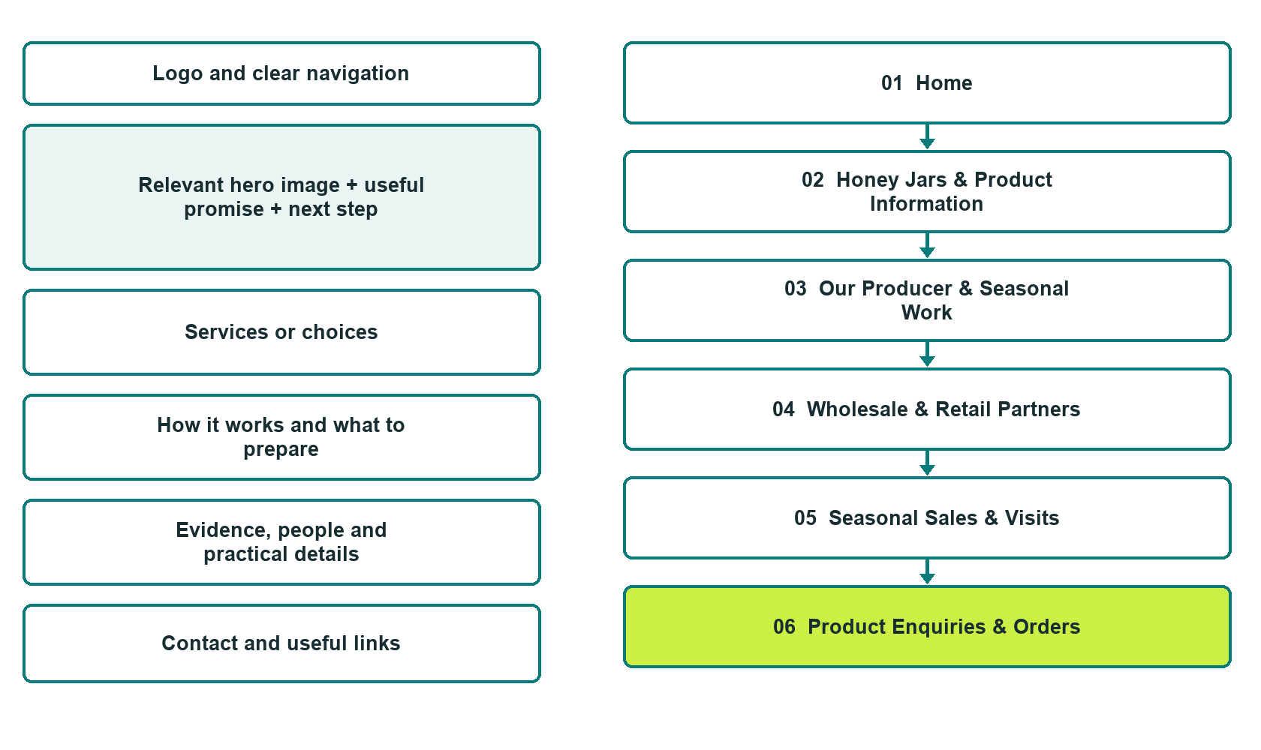

Plan → Draft → Build → Test
Captured demo edition. Study the unpublished six-page example. The gallery pairs desktop with mobile and includes Editor Highlights, Themes and Paint settings.
Explore Website Builder and compare plans

Before you build
Your business supplies the facts. Prairie Cloverline Honey is a fictional teaching example, not a live service.
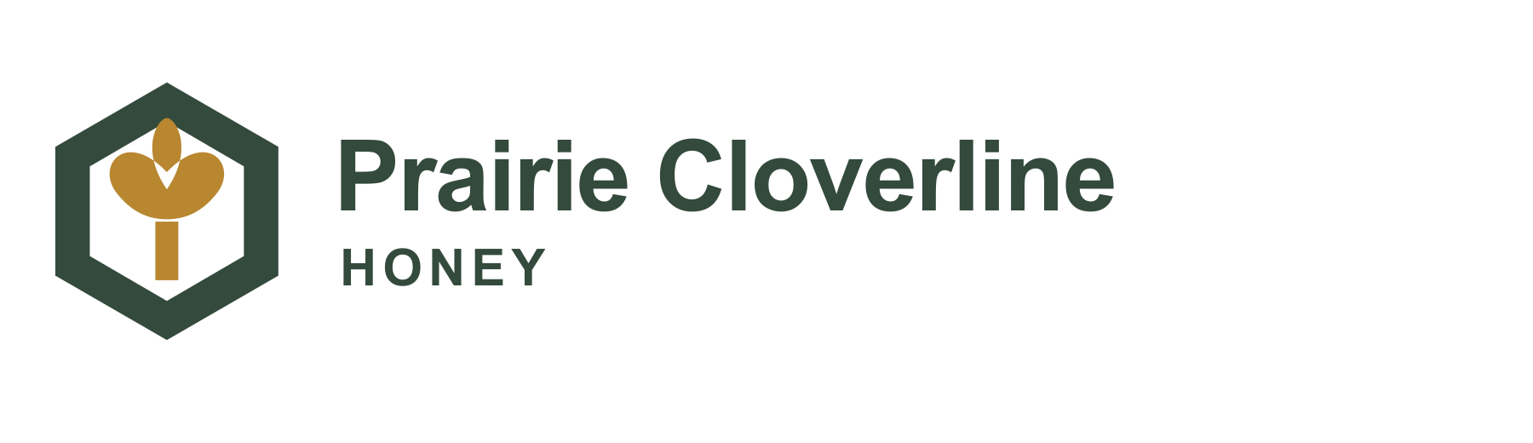
□ Ask about honey or a wholesale enquiry
□ Verified business identity, services and current contact information
□ A clear enquiry, review and confirmation process
□ Choose original photographs and confirm permission to use them.
□ Keep private customer records out of public website forms.

Your audience and the action you want them to take

Facts to verify and people who must approve them
Create your SaaSTech account

01 Home
Give this page one clear job in the customer journey.
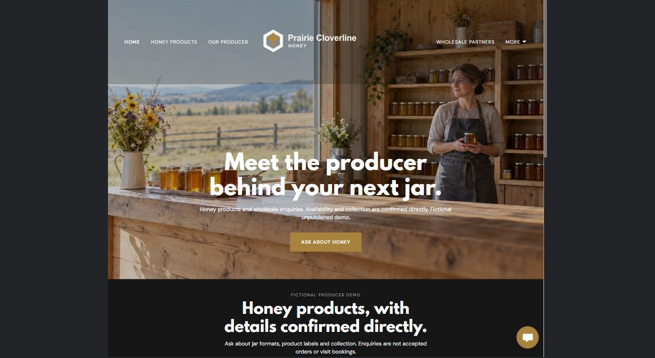
Actual desktop Website Builder preview. See the gallery for the paired mobile view.

Sample wording — adapt and verify
Meet the producer behind your next jar.
Explore the producer’s story and the honey formats available to discuss.
Seasonal availability, exact product information and collection or wholesale arrangements are confirmed directly before an order is accepted.
Suggested button: Ask about honey. Link to Product Enquiries.

Website advice
Present honey product categories, producer stories and separate retail, wholesale and farm-visit enquiries with verified seasonal details.

Your draft: Home
Write in the voice of your own business. Use facts you can verify, not promises copied from the example.

Headline and short introduction

Main content and details visitors need

Button wording and destination

Photo choice, permission and facts still to confirm
Partner check: can someone unfamiliar with the business find a useful next step?

02 Honey Jars & Product Information
Give this page one clear job in the customer journey.
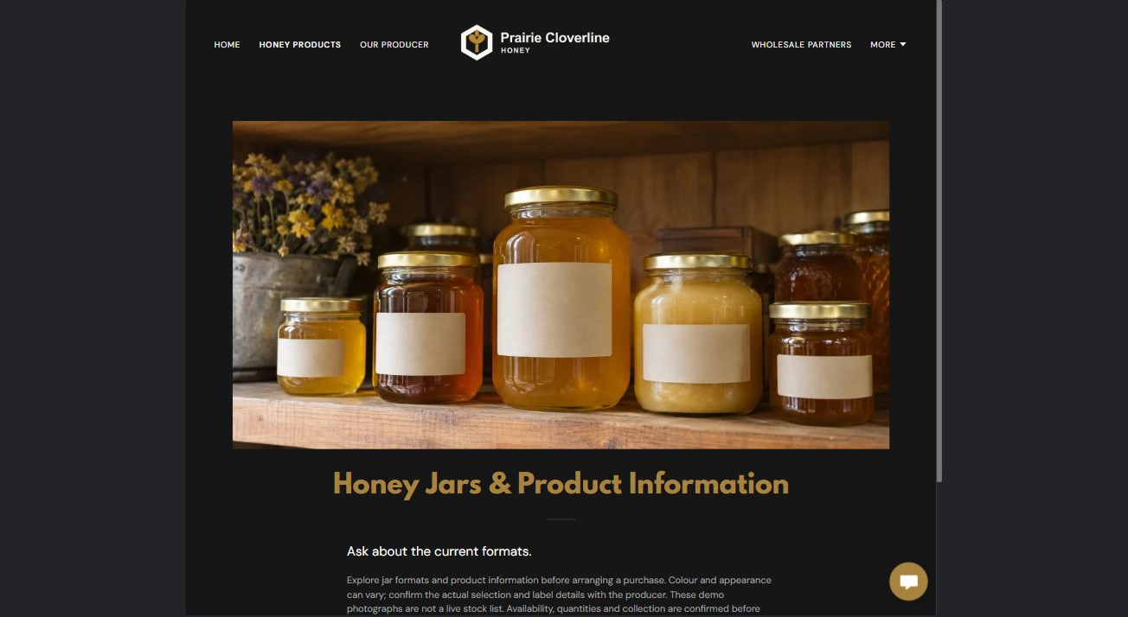
Actual desktop Website Builder preview. See the gallery for the paired mobile view.

Sample wording — adapt and verify
Honey Jars & Product Information
Ask about the current jar formats and the product information on the actual label.
Colour and appearance may vary between offered products, so confirm the selection you are ordering rather than relying on a demonstration photograph.
Suggested button: Ask about honey. Link to Product Enquiries.

Website advice
Present verified jar formats and batch-specific descriptions without unsubstantiated floral or origin claims.

Your draft: Honey Jars & Product Information
Write in the voice of your own business. Use facts you can verify, not promises copied from the example.

Headline and short introduction

Main content and details visitors need

Button wording and destination

Photo choice, permission and facts still to confirm
Partner check: can someone unfamiliar with the business find a useful next step?

03 Our Producer & Seasonal Work
Give this page one clear job in the customer journey.
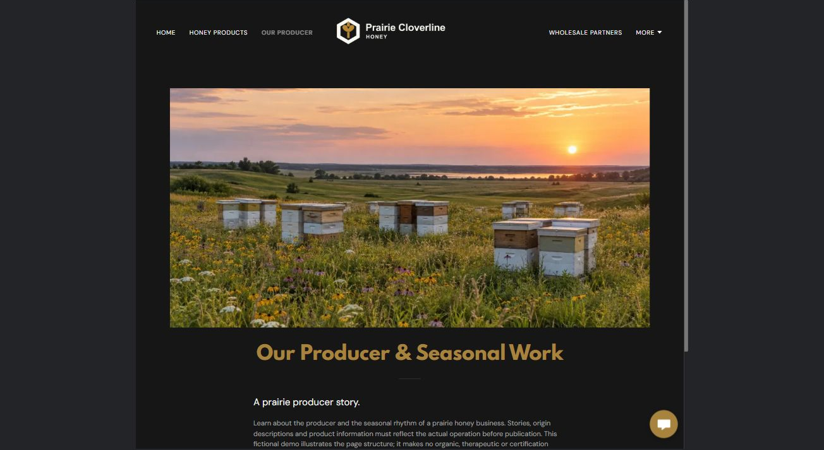
Actual desktop Website Builder preview. See the gallery for the paired mobile view.

Sample wording — adapt and verify
Our Producer & Seasonal Work
Learn where the producer works and how the business organizes its seasonal sales.
Stories and photographs should reflect the actual operation, with any origin or production descriptions checked before publication.
Suggested button: Ask about honey. Link to Product Enquiries.

Website advice
Provide a verified producer biography and permission-cleared landscape imagery without instructional hive content.

Your draft: Our Producer & Seasonal Work
Write in the voice of your own business. Use facts you can verify, not promises copied from the example.

Headline and short introduction

Main content and details visitors need

Button wording and destination

Photo choice, permission and facts still to confirm
Partner check: can someone unfamiliar with the business find a useful next step?

04 Wholesale & Retail Partners
Give this page one clear job in the customer journey.
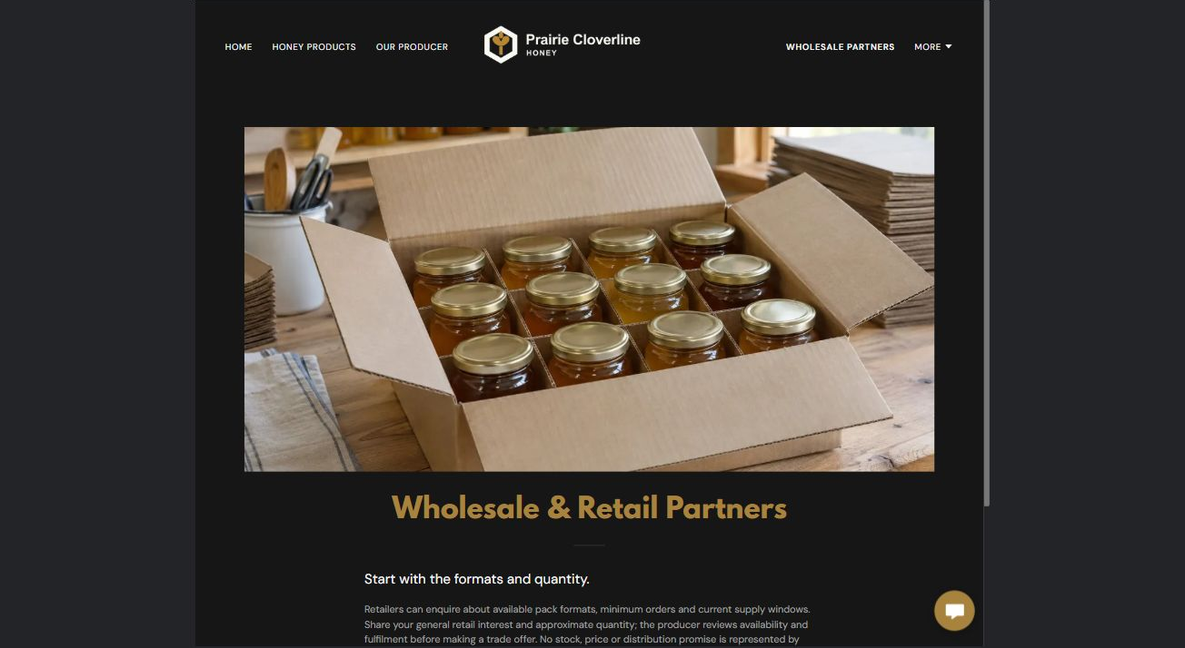
Actual desktop Website Builder preview. See the gallery for the paired mobile view.

Sample wording — adapt and verify
Wholesale & Retail Partners
Retailers can ask about available pack formats, minimum-order arrangements and current supply windows.
The producer reviews the proposed quantity and fulfilment details before sending any trade offer.
Suggested button: Ask about honey. Link to Product Enquiries.

Website advice
Give trade buyers pack-format and order-cycle questions, separate from consumer purchases.

Your draft: Wholesale & Retail Partners
Write in the voice of your own business. Use facts you can verify, not promises copied from the example.

Headline and short introduction

Main content and details visitors need

Button wording and destination

Photo choice, permission and facts still to confirm
Partner check: can someone unfamiliar with the business find a useful next step?

05 Seasonal Sales & Visits
Give this page one clear job in the customer journey.
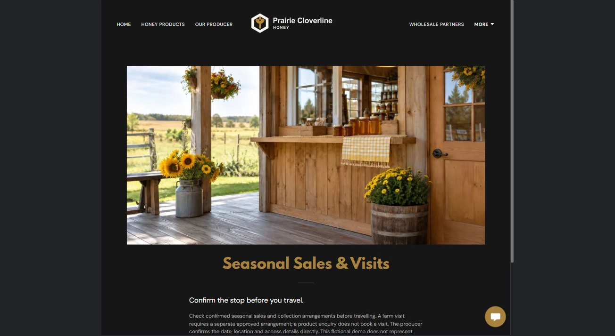
Actual desktop Website Builder preview. See the gallery for the paired mobile view.

Sample wording — adapt and verify
Seasonal Sales & Visits
Check the producer’s confirmed sales and collection arrangements before travelling.
Farm visits, if offered, require a separate conversation about the approved visitor arrangements; a purchase enquiry is not a visit booking.
Suggested button: Ask about honey. Link to Product Enquiries.

Website advice
Distinguish confirmed sales locations from farm visits and avoid implying unrestricted apiary access.

Your draft: Seasonal Sales & Visits
Write in the voice of your own business. Use facts you can verify, not promises copied from the example.

Headline and short introduction

Main content and details visitors need

Button wording and destination

Photo choice, permission and facts still to confirm
Partner check: can someone unfamiliar with the business find a useful next step?

06 Product Enquiries & Orders
Give this page one clear job in the customer journey.
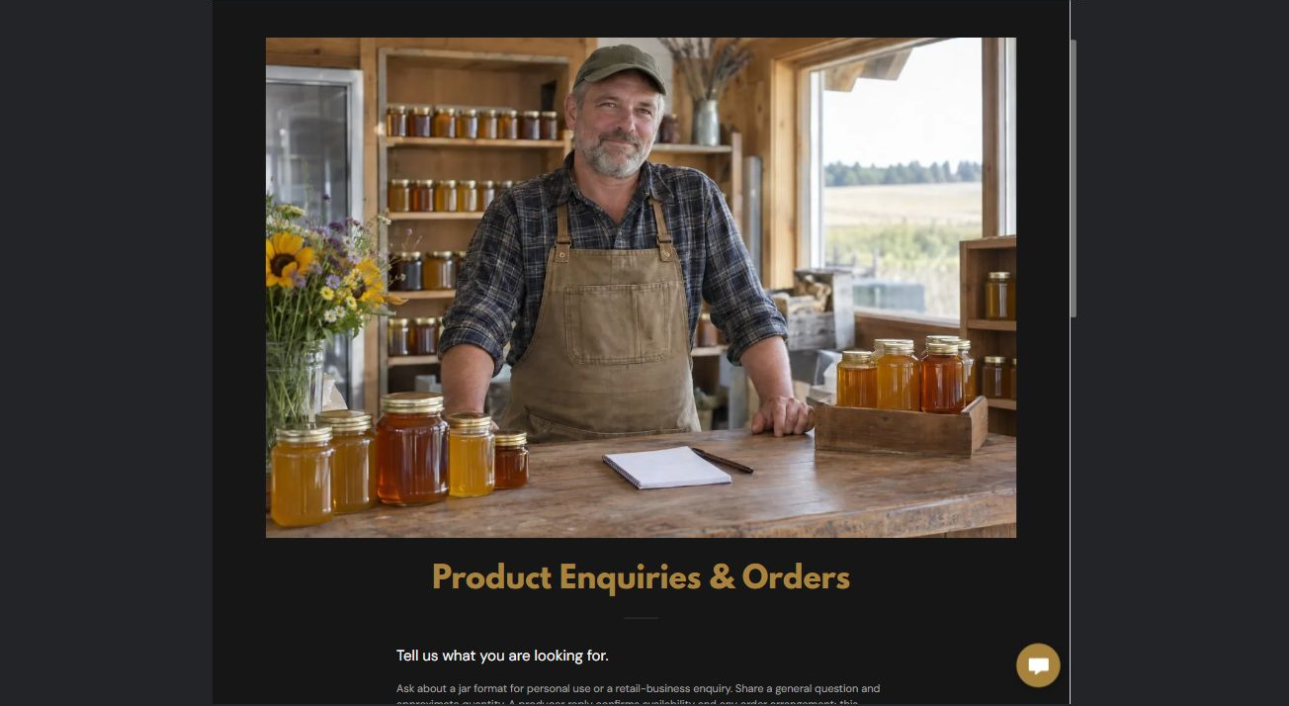
Actual desktop Website Builder preview. See the gallery for the paired mobile view.

Sample wording — adapt and verify
Product Enquiries & Orders
Tell the producer whether you are enquiring for yourself or a retail business and which format interests you.
The reply confirms product availability and ordering arrangements; no payment or reservation occurs through this demonstration form.
Suggested button: Ask about honey. Link to Product Enquiries.

Website advice
The demo form has Name, required Email, jar format or retail interest, and a general product or wholesale question. Phone and attachments are off; the recipient is blank. No submission or delivery test was performed. An enquiry does not accept an order or book a visit. Keep private documents, health information and payment details out. Confirm delivery and consent before a real launch.

Your draft: Product Enquiries & Orders
Write in the voice of your own business. Use facts you can verify, not promises copied from the example.

Headline and short introduction

Main content and details visitors need

Button wording and destination

Photo choice, permission and facts still to confirm
Partner check: can someone unfamiliar with the business find a useful next step?

Test before publishing
Review the captured journey on desktop and phone. The fictional demo remains unpublished. Verify the producer, label information, availability, form recipient and confirmation process before a real launch.
□ Fictional demonstration only. Verify origin, floral descriptions, product labels, quantities and visit arrangements. No therapeutic, nutritional, organic or certification claims without evidence; no beekeeping, sting treatment or food-handling instructions. A product enquiry is not an accepted order.
□ Verify every service description, contact route and operating detail.
□ Replace fictional identity and example information before a live launch.
□ Test enquiries, links and downloads on desktop and mobile.
□ Keep confidential records in approved private systems.
□ Obtain operator approval for public wording and images.
□ Check every link, form destination, download and confirmation message.
□ Check logo contrast, hero framing, text sizes and image loading.
□ Save a named backup and assign a content-review date.

Changes to finish and person responsible

Approval and next review date
Website Builder plans and signup

