

Bars & Pubs
Website workbook
A practical workshop for a 6-page website. Study the example, plan the content and draft your own version in Word or on paper.
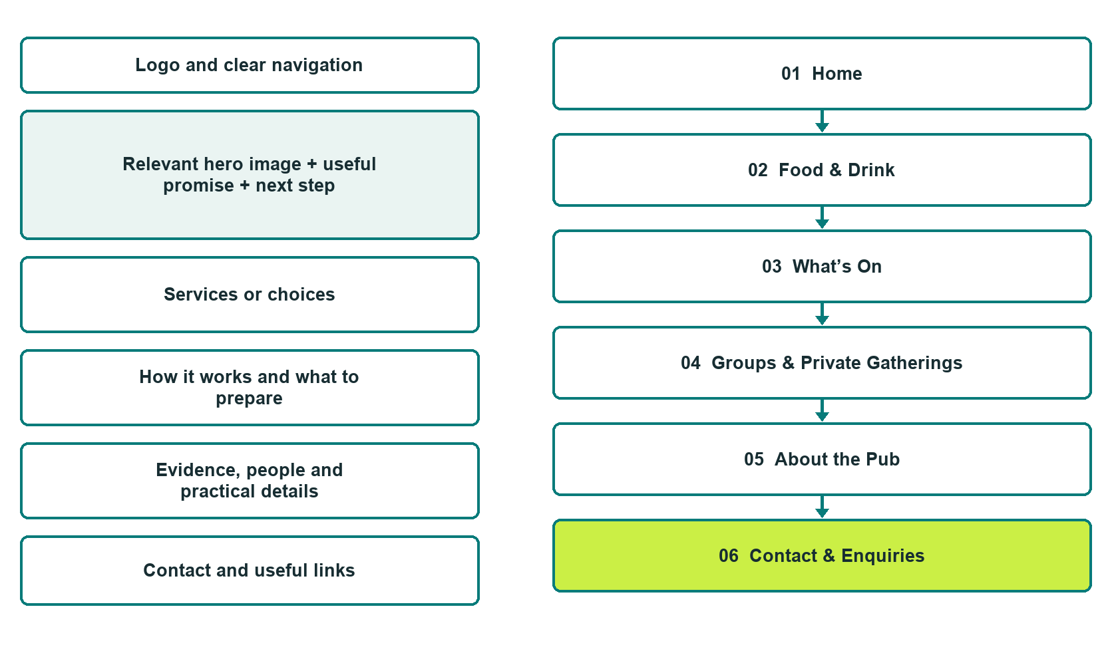

Plan → Draft → Build → Test
Demo-capture edition: actual Website Builder desktop previews and excerpts of the example wording. See each matching mobile preview in the industry page gallery. The example business and its AI-generated photographs are fictional.
Explore Website Builder and compare plans

Before you build
Your business supplies the facts. Prairie Lantern Public House is a fictional teaching example, not a live service.

□ Plan a visit or ask about a group gathering
□ Verified business identity and current contact information
□ Clear request and confirmation process
□ Choose original photographs and confirm permission to use them.
□ Keep private customer records out of public website forms.

Your audience and the action you want them to take

Facts to verify and people who must approve them
Create your SaaSTech account

01 Home
Give this page one clear job in the customer journey.
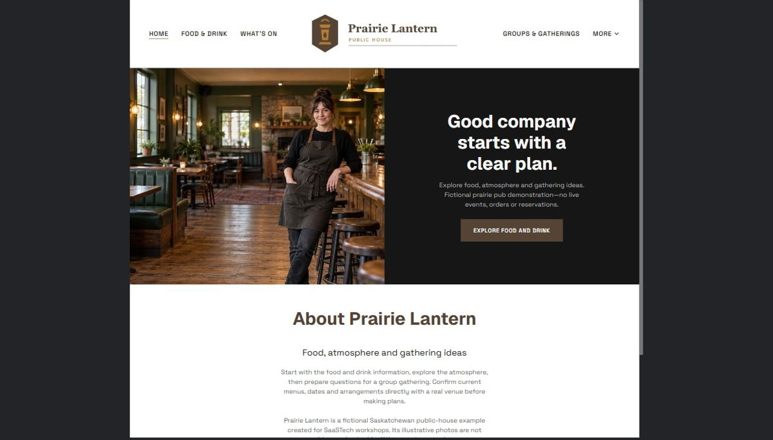
Actual desktop preview - unpublished fictional demonstration

Demo wording excerpt to adapt and verify
Good company starts with a clear plan.
Explore food, atmosphere and gathering ideas. Fictional prairie pub demonstration—no live events, orders or reservations.
Start with the food and drink information, explore the atmosphere, then prepare questions for a group gathering. Confirm current menus, dates and arrangements directly with a real venue before making plans.
Prairie Lantern is a fictional Saskatchewan public-house example created for SaaSTech workshops. Its illustrative photos are not evidence of actual facilities, events or services.
Suggested button: Explore food and drink

Website advice
Give visitors a clear view of the venue, food and drink information, current events and group-enquiry process. Keep hours, access and operator-approved house information current.

Your draft: Home
Write in the voice of your own business. Use facts you can verify, not promises copied from the example.

Headline and short introduction

Main content and details visitors need

Button wording and destination

Photo choice, permission and facts still to confirm
Partner check: can someone unfamiliar with the business find a useful next step?

02 Food & Drink
Give this page one clear job in the customer journey.
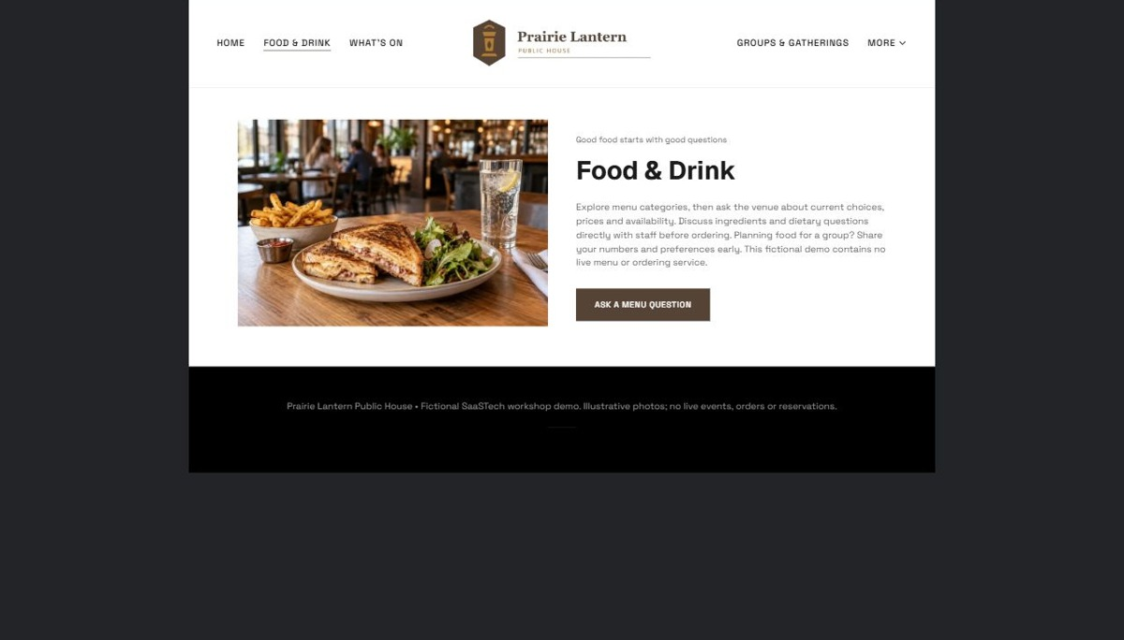
Actual desktop preview - unpublished fictional demonstration

Demo wording excerpt to adapt and verify
Good food starts with good questions
Explore menu categories, then ask the venue about current choices, prices and availability. Discuss ingredients and dietary questions directly with staff before ordering. Planning food for a group? Share your numbers and preferences early. This fictional demo contains no live menu or ordering service.
Suggested button: Ask a menu question

Website advice
Show current menu categories with readable prices and operator-approved descriptions. Do not invent dietary, allergen or availability assurances.

Your draft: Food & Drink
Write in the voice of your own business. Use facts you can verify, not promises copied from the example.

Headline and short introduction

Main content and details visitors need

Button wording and destination

Photo choice, permission and facts still to confirm
Partner check: can someone unfamiliar with the business find a useful next step?

03 What’s On
Give this page one clear job in the customer journey.
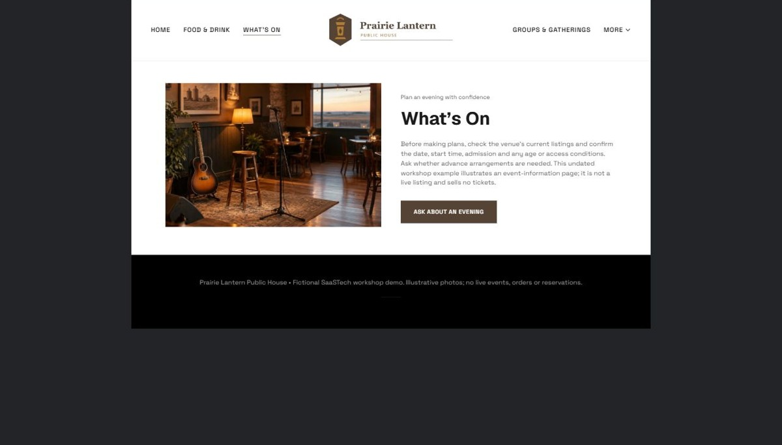
Actual desktop preview - unpublished fictional demonstration

Demo wording excerpt to adapt and verify
Plan an evening with confidence
Before making plans, check the venue’s current listings and confirm the date, start time, admission and any age or access conditions. Ask whether advance arrangements are needed. This undated workshop example illustrates an event-information page; it is not a live listing and sells no tickets.
Suggested button: Ask about an evening

Website advice
Show dated events with practical arrival details and genuine booking links. Assign someone to remove expired listings.

Your draft: What’s On
Write in the voice of your own business. Use facts you can verify, not promises copied from the example.

Headline and short introduction

Main content and details visitors need

Button wording and destination

Photo choice, permission and facts still to confirm
Partner check: can someone unfamiliar with the business find a useful next step?

04 Groups & Private Gatherings
Give this page one clear job in the customer journey.
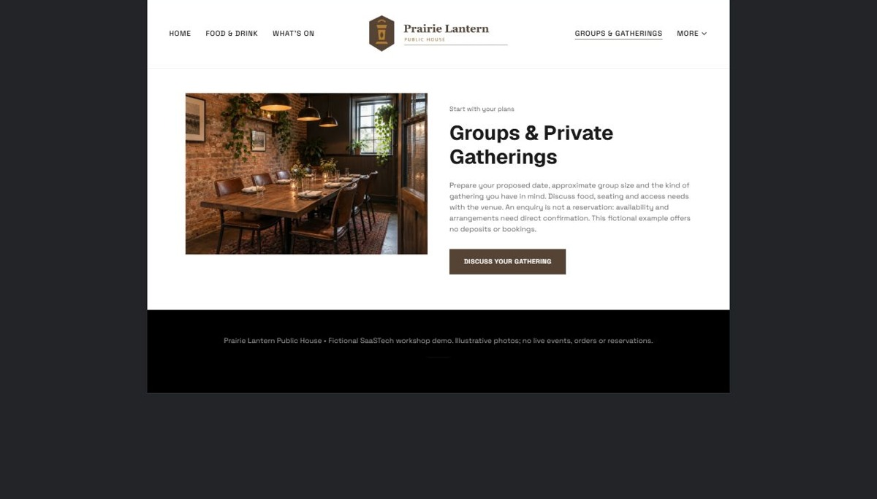
Actual desktop preview - unpublished fictional demonstration

Demo wording excerpt to adapt and verify
Start with your plans
Prepare your proposed date, approximate group size and the kind of gathering you have in mind. Discuss food, seating and access needs with the venue. An enquiry is not a reservation: availability and arrangements need direct confirmation. This fictional example offers no deposits or bookings.
Suggested button: Discuss your gathering

Website advice
Explain group sizes and gathering options only where verified. Separate an enquiry from an accepted reservation or exclusive hire.

Your draft: Groups & Private Gatherings
Write in the voice of your own business. Use facts you can verify, not promises copied from the example.

Headline and short introduction

Main content and details visitors need

Button wording and destination

Photo choice, permission and facts still to confirm
Partner check: can someone unfamiliar with the business find a useful next step?

05 About the Pub
Give this page one clear job in the customer journey.
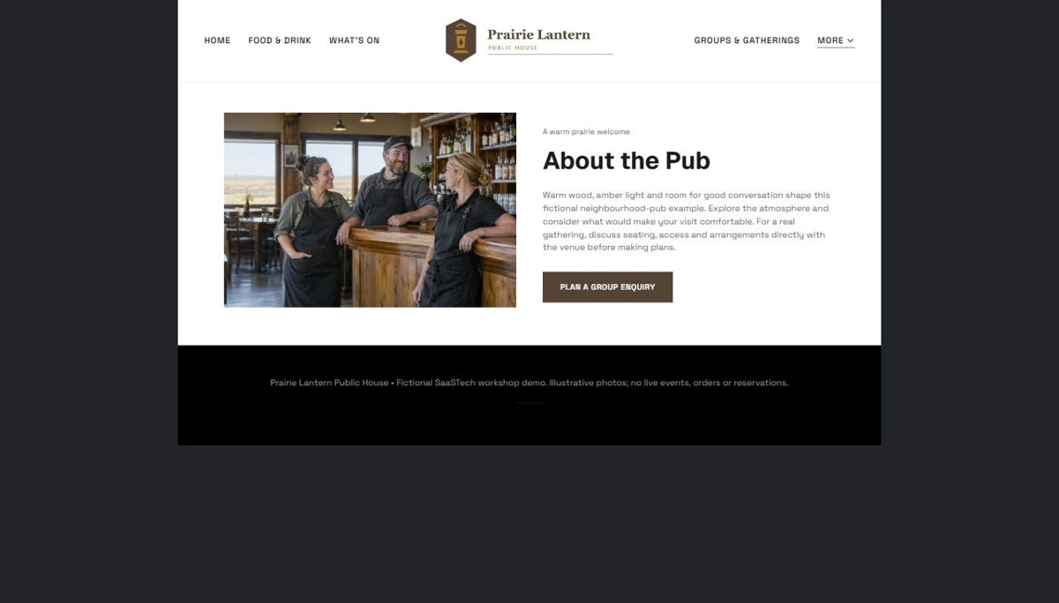
Actual desktop preview - unpublished fictional demonstration

Demo wording excerpt to adapt and verify
A warm prairie welcome
Warm wood, amber light and room for good conversation shape this fictional neighbourhood-pub example. Explore the atmosphere and consider what would make your visit comfortable. For a real gathering, discuss seating, access and arrangements directly with the venue before making plans.
Suggested button: Plan a group enquiry

Website advice
Use distinct atmosphere and team photos that reflect the real venue. Only publish genuine testimonials with permission.

Your draft: About the Pub
Write in the voice of your own business. Use facts you can verify, not promises copied from the example.

Headline and short introduction

Main content and details visitors need

Button wording and destination

Photo choice, permission and facts still to confirm
Partner check: can someone unfamiliar with the business find a useful next step?

06 Contact & Enquiries
Give this page one clear job in the customer journey.
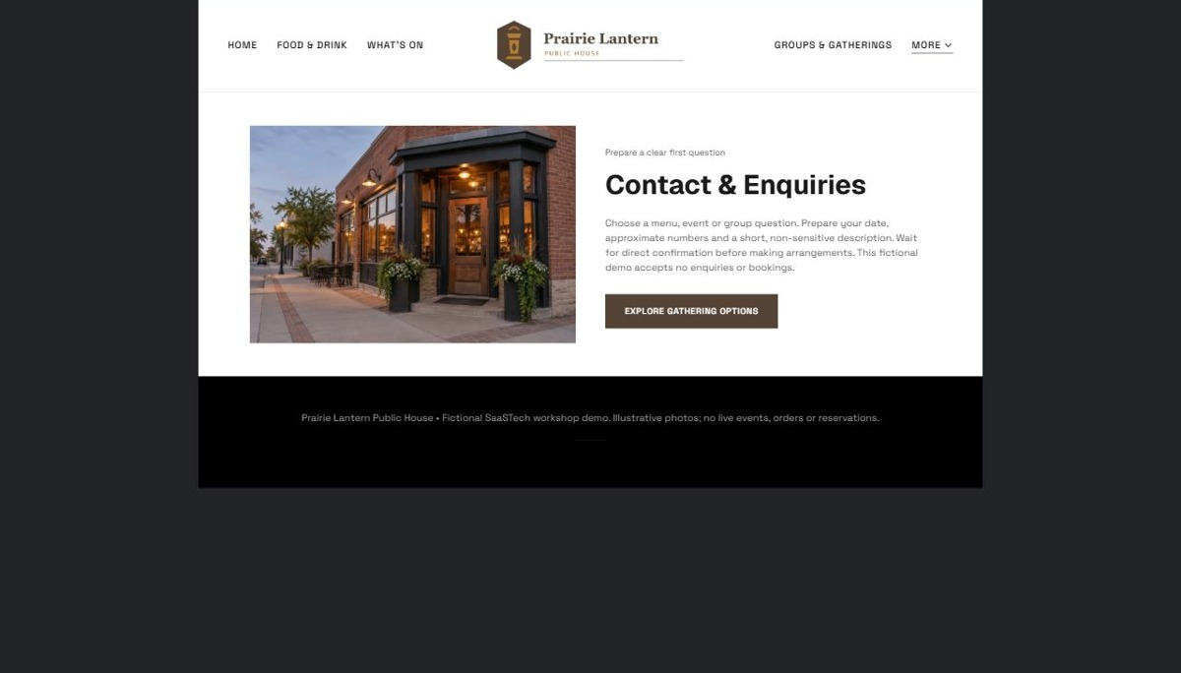
Actual desktop preview - unpublished fictional demonstration

Demo wording excerpt to adapt and verify
Prepare a clear first question
Choose a menu, event or group question. Prepare your date, approximate numbers and a short, non-sensitive description. Wait for direct confirmation before making arrangements. This fictional demo accepts no enquiries or bookings.
Suggested button: Explore gathering options

Website advice
Give the verified address, hours and correct contact path. Collect only the minimum information needed for a first response; make confirmation requirements clear.

Your draft: Contact & Enquiries
Write in the voice of your own business. Use facts you can verify, not promises copied from the example.

Headline and short introduction

Main content and details visitors need

Button wording and destination

Photo choice, permission and facts still to confirm
Partner check: can someone unfamiliar with the business find a useful next step?

Test before publishing
Review the whole journey on a desktop and phone. The industry page pairs each desktop capture with its mobile preview and provides the complete sample page copy.
□ Verify applicable age, service and advertising requirements with the operator before launch. No live event, reservation or alcohol sale is offered by this fictional example.
□ Verify contact routes, hours, location and every offered service.
□ Remove invented prices, claims, testimonials and availability.
□ Keep sensitive records and payment details out of ordinary public forms.
□ Check all image permissions, downloads and page links on a phone.
□ Check every link, form destination, download and confirmation message.
□ Check logo contrast, hero framing, text sizes and image loading.
□ Save a named backup and assign a content-review date.

Changes to finish and person responsible

Approval and next review date
Website Builder plans and signup

