
WEBSITE PLANNING WORKSHOP

Bakeries & Custom Cakes
Website workbook
Plan a clear website for bakeries & custom cakes. Explore a worked example, shape your own message and prepare to build with SaaSTech Servers.
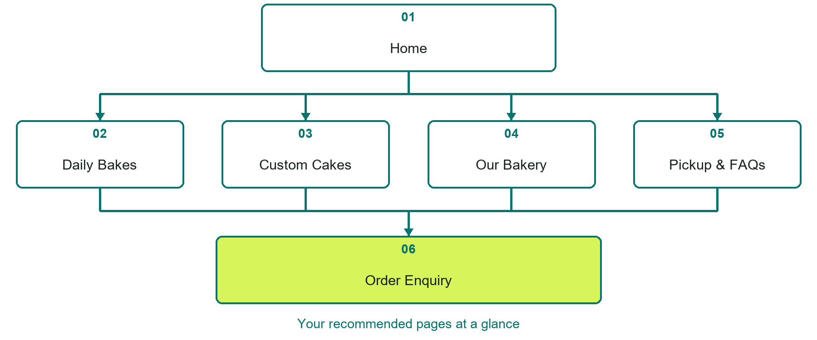

Inside this workbook
Six page examples • Practical writing exercises • A launch review
Use it in a workshop or at your own pace. Write by hand or complete the response fields in Word. The final page links to Website Builder, plans and account signup.
Example business Prairie Crumb Bakery

BAKERIES & CUSTOM CAKES

Your website brief
A SaaSTech Servers workshop for bakeries & custom cakes. Plan your website, learn from the Prairie Crumb Bakery example and draft content for your own business.
Each page has a reference sheet followed by a writing sheet. Demo excerpts are labelled separately from new sample wording, which may differ from the screenshot. Click a blank response line to type; longer answers may add pages. Replace fictional details and verify every claim before publishing.
Your business or organization and workshop date

Who should visit your site and what do they need

The main action you want a visitor to take

What you offer and where or how you provide it

Facts photos and permissions to gather before publishing

Workshop rhythm: review the example, write your draft and exchange feedback. Use the final review to choose your next changes. Website Builder and account links are on the last page.

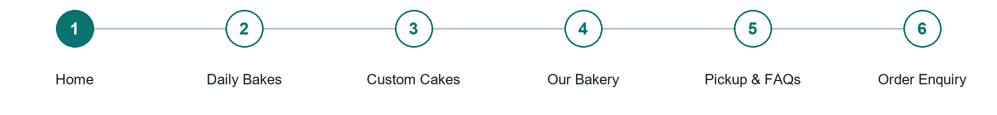
LOOK AND LEARN

Home

The job of this page
Introduce the bakery with a baker-led hero, a short description of the baking and one order-enquiry action.
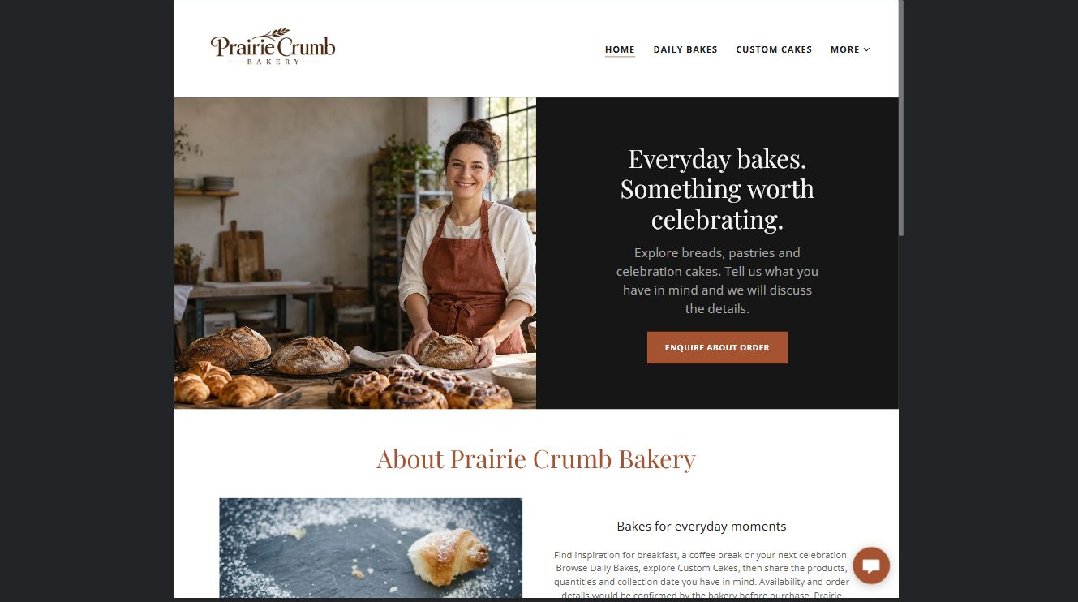
Prairie Crumb Bakery example | Explore SaaSTech Website Builder

Demo text example
Everyday bakes. Something worth celebrating.
Explore breads, pastries and celebration cakes. Tell us what you have in mind and we will discuss the details.

Pause and plan
Could a first-time visitor explain what you do and who it is for after one glance? Choose one main action and the strongest truthful detail that gives them confidence to continue.

WRITE YOUR PAGE

Home
Write for your visitor. Be specific about what they need to know and what happens next. You can revise the wording after the workshop.
Your page headline

Your opening paragraph

Your offer audience location and most useful supporting details

Button or link wording and where it should lead

Photo idea caption and permission or credit needed

Facts to verify or questions to resolve

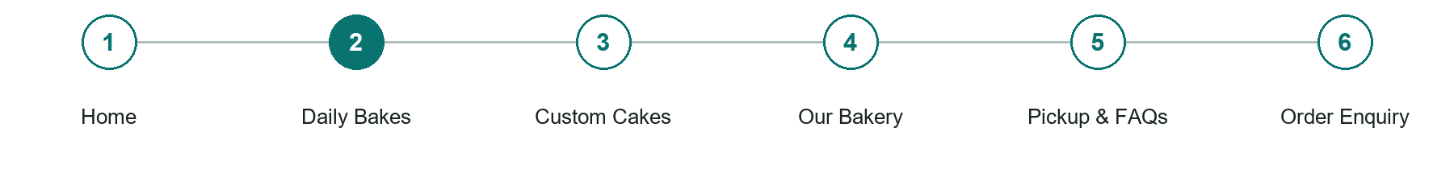
LOOK AND LEARN

Daily Bakes

The job of this page
Group breads, pastries and small treats. Explain sample selection, changing availability, portion sizes and where confirmed prices are shown.
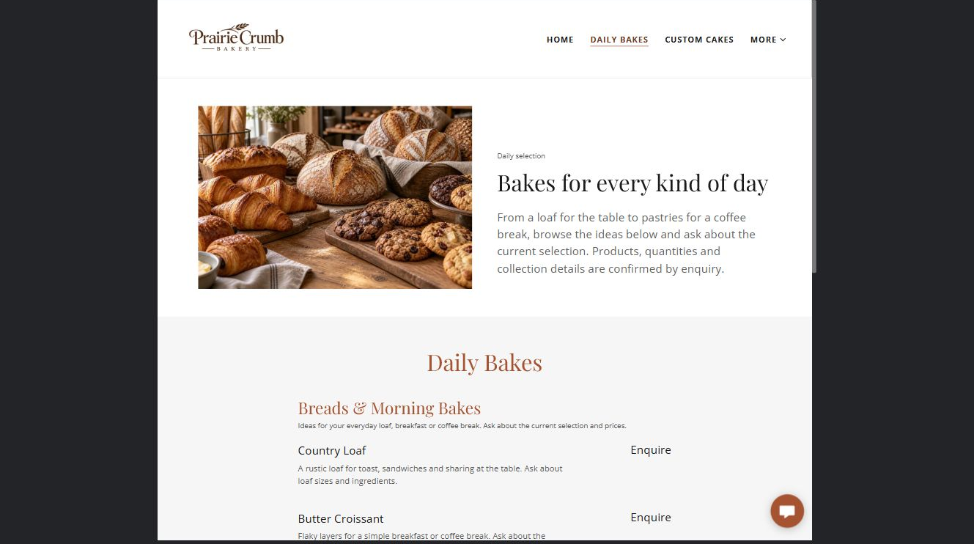
Prairie Crumb Bakery example | Explore SaaSTech Website Builder

Demo text example
Bakes for every kind of day
From a loaf for the table to pastries for a coffee break, browse the ideas below and ask about the current selection. Products, quantities and collection details are confirmed by enquiry.

Pause and plan
What is included and what needs separate confirmation? Make quantities, timing, exclusions and price conditions understandable. Avoid implying that an example price or image guarantees availability.

WRITE YOUR PAGE

Daily Bakes
Write for your visitor. Be specific about what they need to know and what happens next. You can revise the wording after the workshop.
Your page headline

Your opening paragraph

Options inclusions price conditions and availability details

Button or link wording and where it should lead

Photo idea caption and permission or credit needed

Facts to verify or questions to resolve

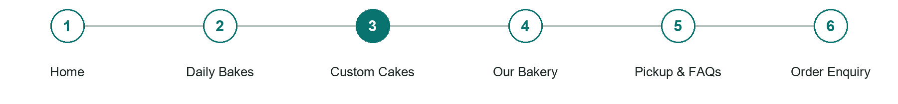
LOOK AND LEARN

Custom Cakes

The job of this page
Explain cake styles, servings, flavour choices and the consultation process. Ask customers to enquire about their date rather than promising capacity.
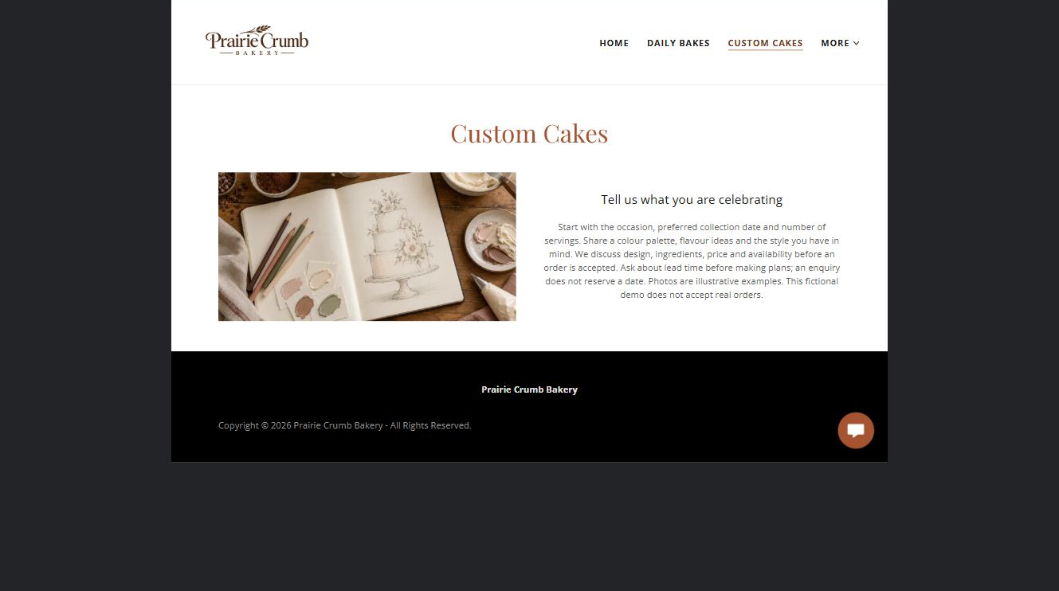
Prairie Crumb Bakery example | Explore SaaSTech Website Builder

Sample wording to adapt
Tell us what you are celebrating
Share your occasion, preferred collection date, serving count and design ideas. We will discuss flavours, ingredients, price and availability before an order is accepted. An enquiry does not reserve a date.

Pause and plan
What question brings a visitor to this page? List the details they need, the evidence you can provide and the next useful action. Remove content that does not help them decide or proceed.

WRITE YOUR PAGE

Custom Cakes
Write for your visitor. Be specific about what they need to know and what happens next. You can revise the wording after the workshop.
Your page headline

Your opening paragraph

Key sections visitor questions and supporting details

Button or link wording and where it should lead

Photo idea caption and permission or credit needed

Facts to verify or questions to resolve

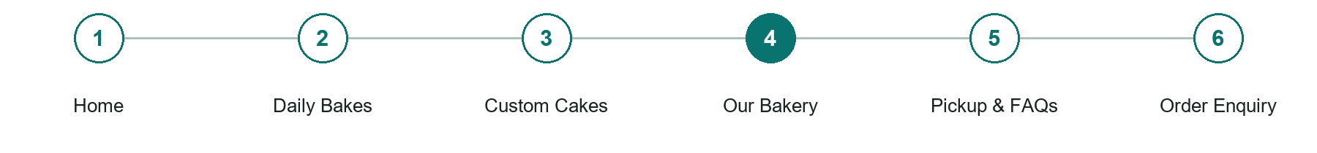
LOOK AND LEARN

Our Bakery

The job of this page
Introduce the people and approach with distinct portraits or working photographs. Publish only genuine background, sourcing and business claims.
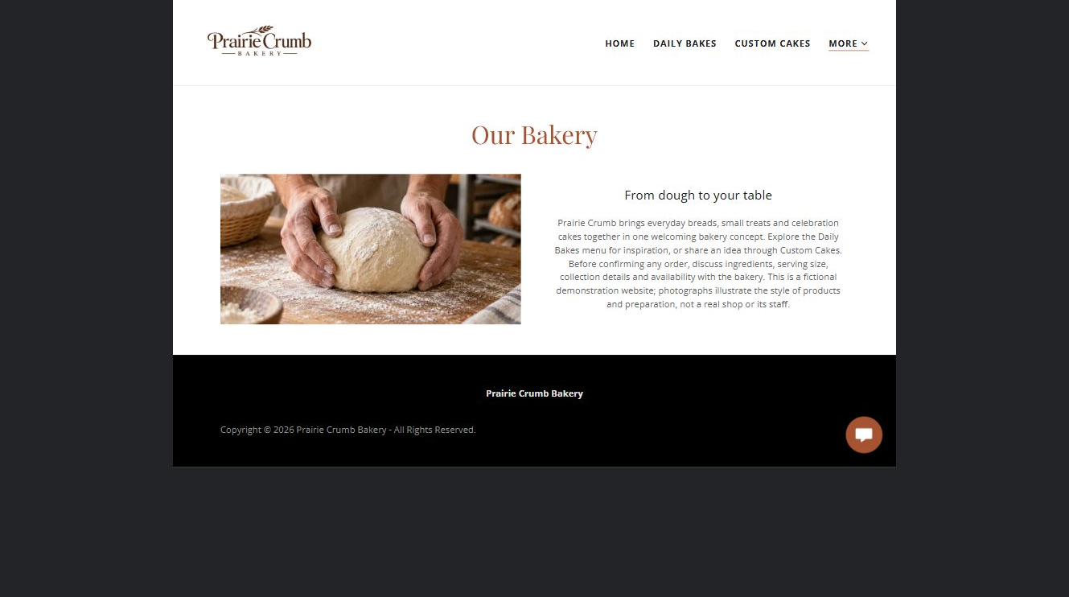
Prairie Crumb Bakery example | Explore SaaSTech Website Builder

Sample wording to adapt
From dough to your table
Explore our everyday breads and celebration-cake ideas. Ask about ingredients, serving sizes and collection arrangements before confirming an order. The photographs in this example illustrate the bakery concept.

Pause and plan
What question brings a visitor to this page? List the details they need, the evidence you can provide and the next useful action. Remove content that does not help them decide or proceed.

WRITE YOUR PAGE

Our Bakery
Write for your visitor. Be specific about what they need to know and what happens next. You can revise the wording after the workshop.
Your page headline

Your opening paragraph

Key sections visitor questions and supporting details

Button or link wording and where it should lead

Photo idea caption and permission or credit needed

Facts to verify or questions to resolve

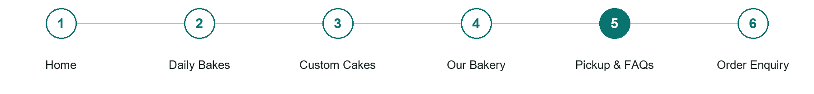
LOOK AND LEARN

Pickup FAQs

The job of this page
Explain ordering deadlines, collection arrangements, storage guidance and the actual cancellation process. Direct ingredient and allergen questions to the bakery; do not promise an allergen-free kitchen.
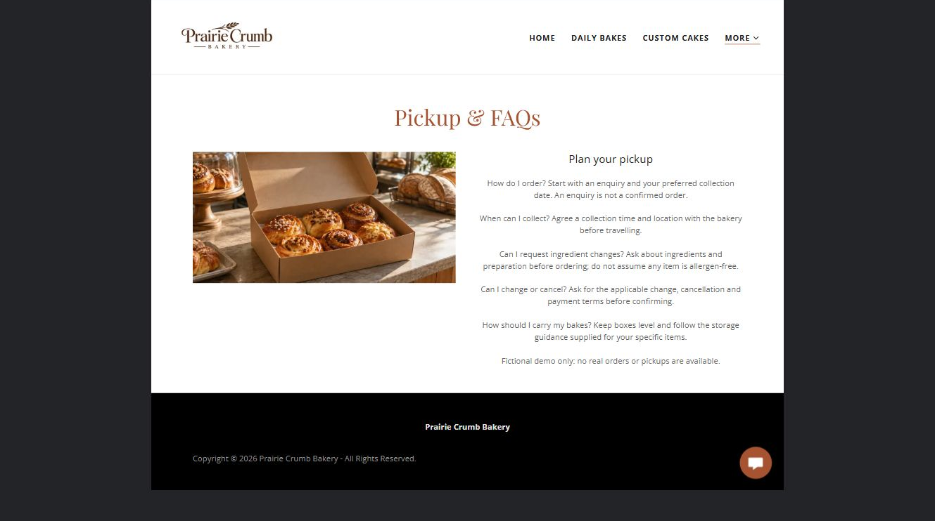
Prairie Crumb Bakery example | Explore SaaSTech Website Builder

Sample wording to adapt
Plan your pickup
Agree a collection time before travelling. Ask about ingredients and any change or cancellation terms before confirming. Follow the bakery's guidance for carrying and storing your particular order.

Pause and plan
What should someone know before arriving or proceeding? Clarify preparation, access and the right contact route. Verify policies and avoid promising urgent help or specialist advice the website cannot provide.

WRITE YOUR PAGE

Pickup FAQs
Write for your visitor. Be specific about what they need to know and what happens next. You can revise the wording after the workshop.
Your page headline

Your opening paragraph

Preparation access policies and practical questions to answer

Button or link wording and where it should lead

Photo idea caption and permission or credit needed

Facts to verify or questions to resolve

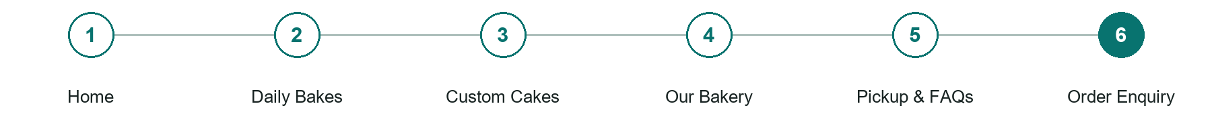
LOOK AND LEARN

Order Enquiry

The job of this page
Ask for contact details, product interest, quantity or servings, preferred collection date and a short brief. Explain that availability, design, price and collection time must be confirmed.
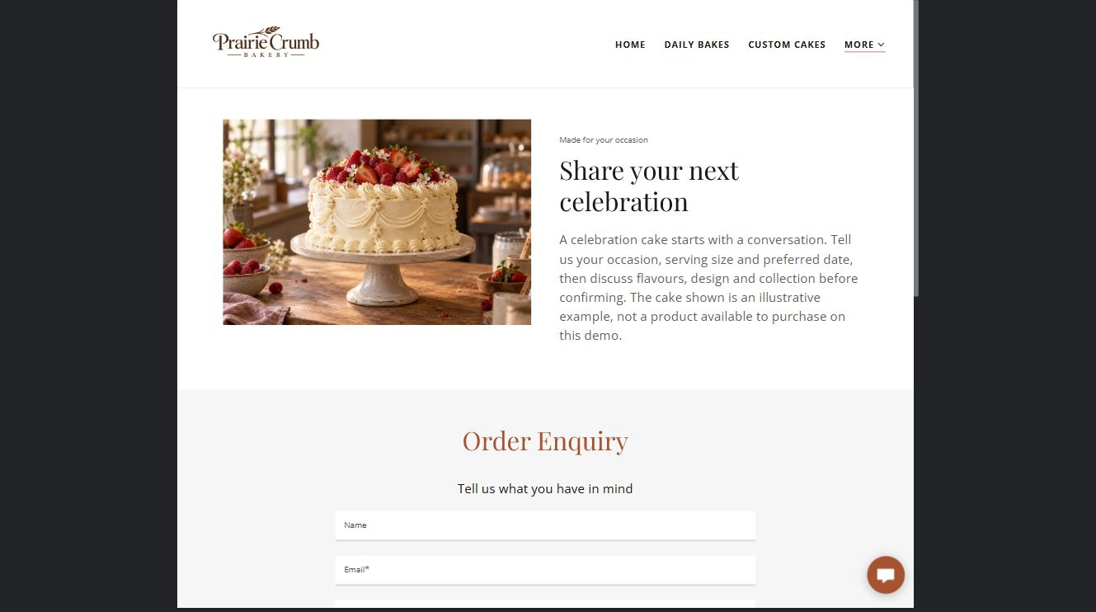
Prairie Crumb Bakery example | Explore SaaSTech Website Builder

Demo text example
Share your next celebration
A celebration cake starts with a conversation. Tell us your occasion, serving size and preferred date, then discuss flavours, design and collection before confirming.

Pause and plan
What must someone provide, and what happens after they send it? Separate a request from a confirmed booking, order or place. Decide what information should stay out of a public form.

WRITE YOUR PAGE

Order Enquiry
Write for your visitor. Be specific about what they need to know and what happens next. You can revise the wording after the workshop.
Your page headline

Your opening paragraph

Information to request and how you will reply or confirm

Button or link wording and where it should lead

Photo idea caption and permission or credit needed

Facts to verify or questions to resolve

WORKSHOP CLOSE

Review and next steps
Ask a partner to read your draft as a first-time visitor. Can they explain what you offer, who it is for and the next step without extra help?

Before you publish
[ ] Every page has a clear purpose and a useful next step.
[ ] Headlines are specific and the wording sounds like your business.
[ ] Names, service areas, prices, dates and policies have been checked.
[ ] Credentials, testimonials and results are genuine and permission-cleared.
[ ] Photos support the text, do not repeat needlessly and have appropriate permissions.
[ ] Forms ask only for necessary information and explain what happens next.
[ ] Links, downloads and the main visitor task work on a phone.
The most useful feedback from your workshop partner

First change to make and who will do it

Information or photographs still needed

Target review date and who will approve the final content

Keep sensitive customer, patient, employee and payment information out of this workbook. Completing it does not publish a website or connect to Website Builder.

BUILD WITH SAASTECH SERVERS

Put your draft into Website Builder
Use the content you have written to build your own site. Keep the bakeries & custom cakes demo as a reference, and replace its company name, images and claims with your verified business information.

Explore the builder
See the editor, compare available plans and decide which features your business needs. Confirm current pricing and terms before purchasing.
Website Builder overview

Create your account
Set up your SaaSTech Servers customer account using your own details. Creating an account is separate from purchasing a Website Builder plan.
Create your SaaSTech account

Choose your plan
Open the secure shop to review the plan, subscription term and final total. Use the account connected to your purchase when you open your service.
View Website Builder plans

Build and check your pages
Add the pages from this workbook. Transfer your approved wording, upload permission-cleared photos and review each page on desktop and mobile before publishing.
Return to the Website Builder guide

Using a printed workbook
Type these short addresses into your browser. The account guide includes the Create My Account button.
www.saastech.net/products/website-builder
www.saastech.net/create-account
This workbook does not create an account, purchase a plan or publish your website. Keep passwords, payment details and confidential customer information out of your draft.

