

Auto Parts Stores website workbook
A print-ready workshop guide to study Prairie Parts, plan six useful pages and draft clear wording for a real parts store.
Prairie Parts & Supply is a fictional workshop example. Replace every sample detail with current, approved business information. Keep customer, vehicle and payment records in approved private systems.
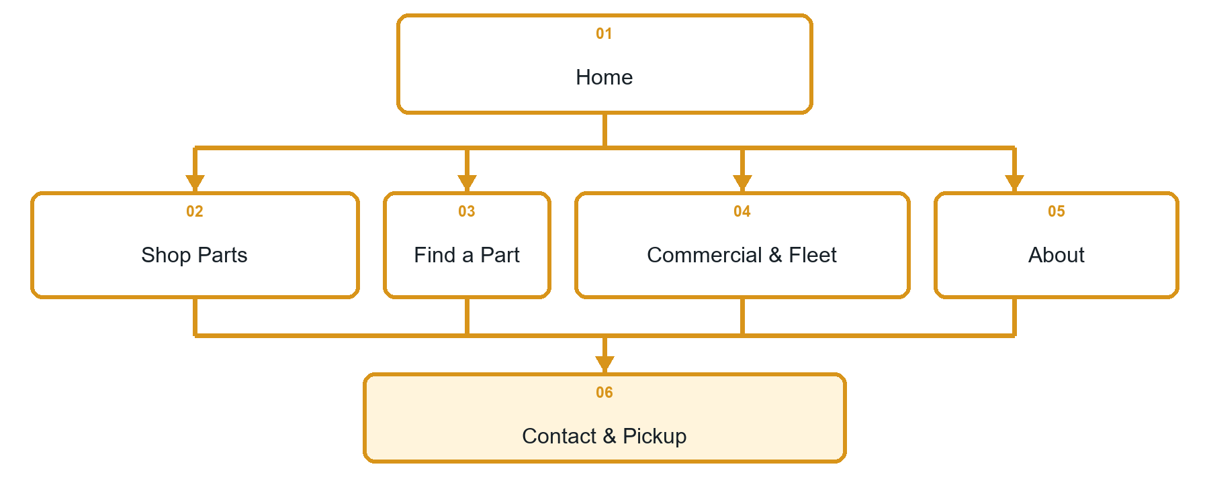

Inside this workbook
Six page examples • Practical writing exercises • Desktop and mobile review
Explore Website Builder and compare plans
Open the Auto Parts Stores industry guide

WORKSHOP PLAN

Before writing pages
Choose one customer task per page, gather permission-cleared images and decide how staff will verify fitment, stock and pickup.
□ Use a parts enquiry as the website action—not an unverified stock promise.
□ Keep VINs, account details and payment information out of public forms.
□ Use distinct images for retail, fitment help, fleet orders, team and pickup.
□ Test every page on desktop and mobile.

The customer journey this website should support

Facts, policies, photos and links to confirm

PAGE 1

Home
Establish the local store, the types of customers served and one clear next step.


Clearly labelled sample wording
Sample wording: The right part starts with the right details. Browse common categories or send the vehicle information our team needs to begin a fitment check.

Draft your own page copy

Photographs, proof and links to prepare

PAGE 2

Shop Parts
Group products by customer need and explain that availability and fitment must be confirmed.
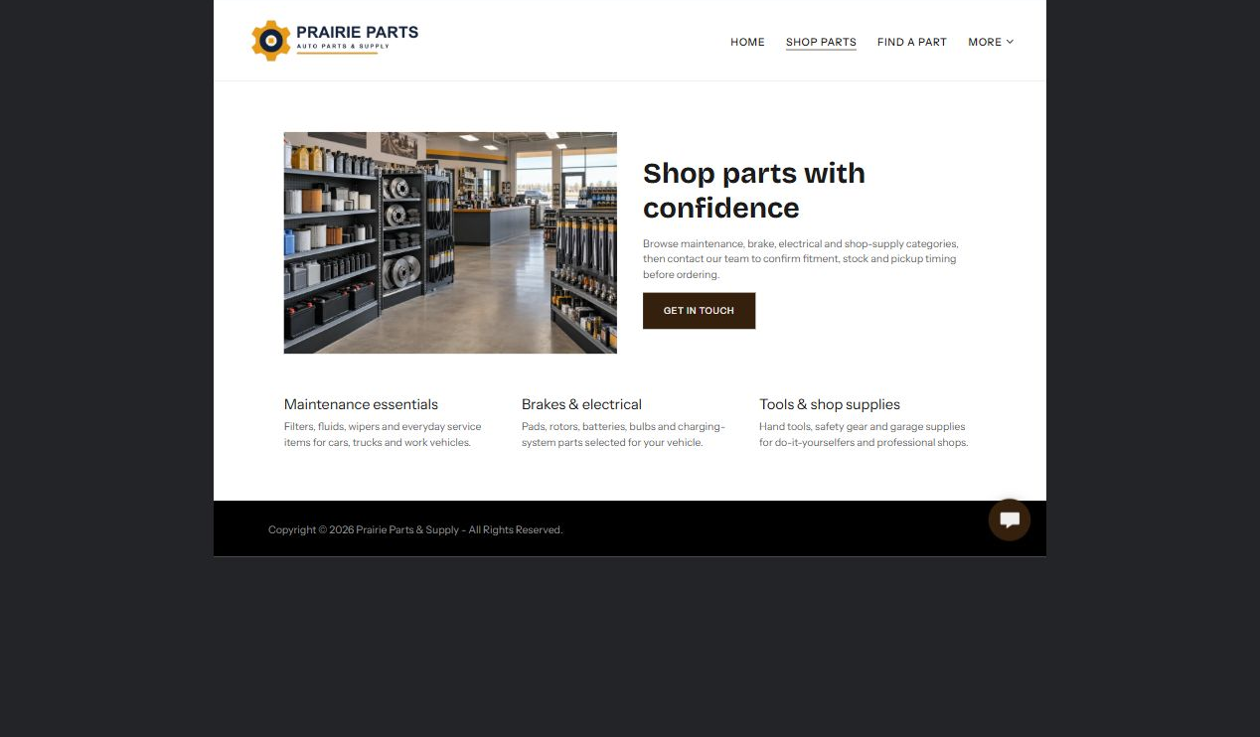

Clearly labelled sample wording
Sample wording: Explore maintenance, repair and seasonal categories, then contact the counter for current stock, alternatives and compatibility.

Draft your own page copy

Photographs, proof and links to prepare

PAGE 3

Find a Part
Tell visitors exactly what details help staff identify the correct part.
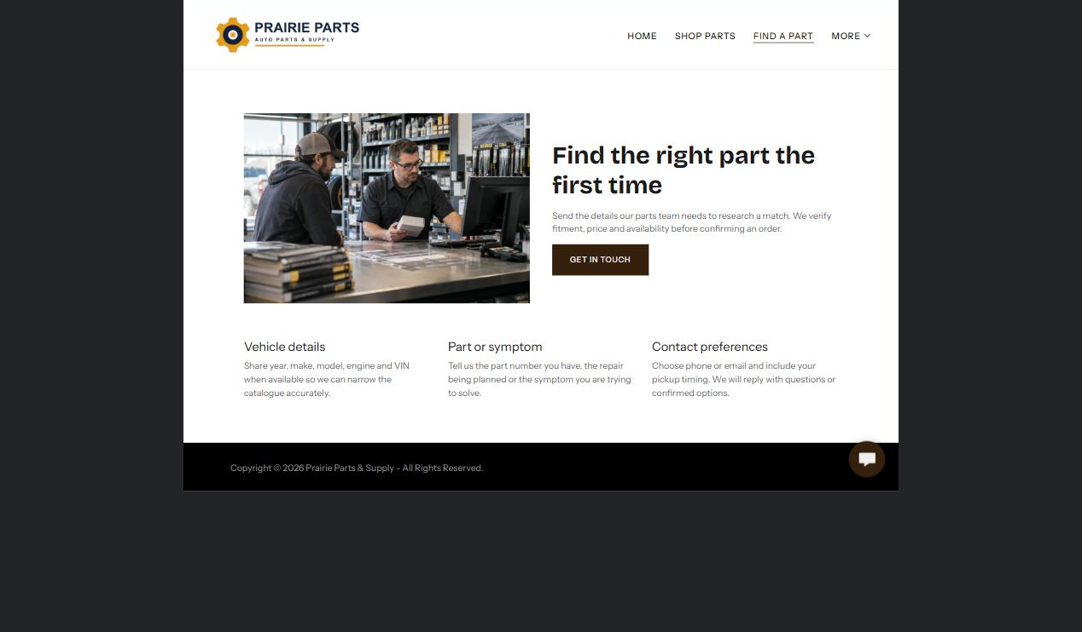

Clearly labelled sample wording
Sample wording: Share the year, make, model, engine and part needed. A parts specialist will confirm fitment, availability and the next step.

Draft your own page copy

Photographs, proof and links to prepare

PAGE 4

Commercial & Fleet
Explain repeat-order and fleet support without promising credit, delivery or emergency stock.
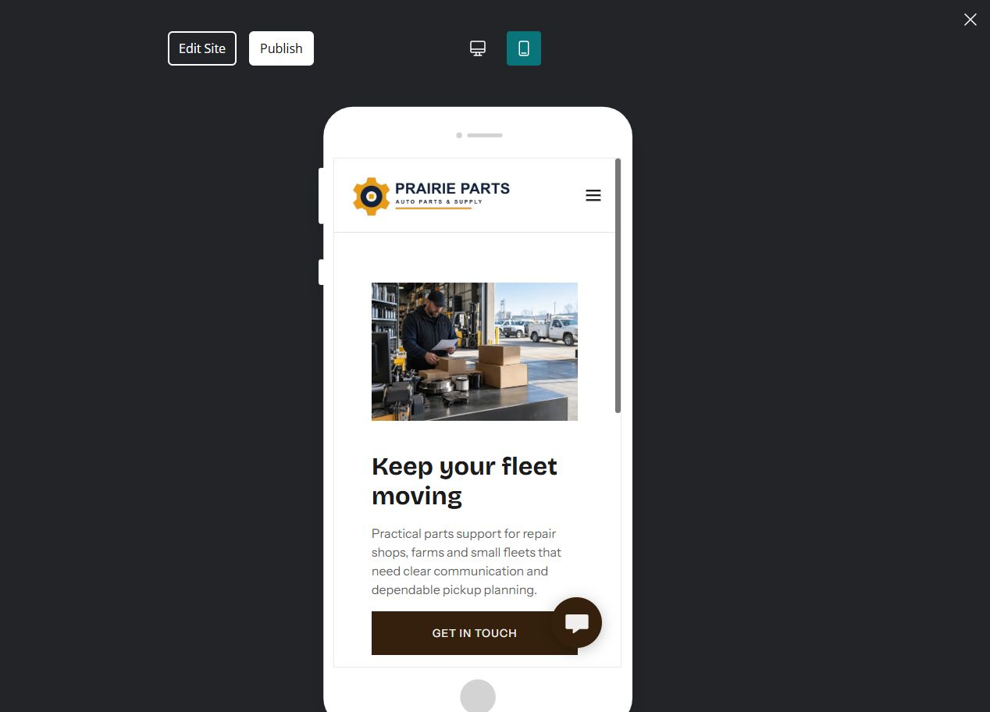

Clearly labelled sample wording
Sample wording: Keep work vehicles moving with an organized contact for common parts, planned orders and supplier follow-up.

Draft your own page copy

Photographs, proof and links to prepare

PAGE 5

About the Store
Build trust with people, process and local knowledge rather than unsupported claims.
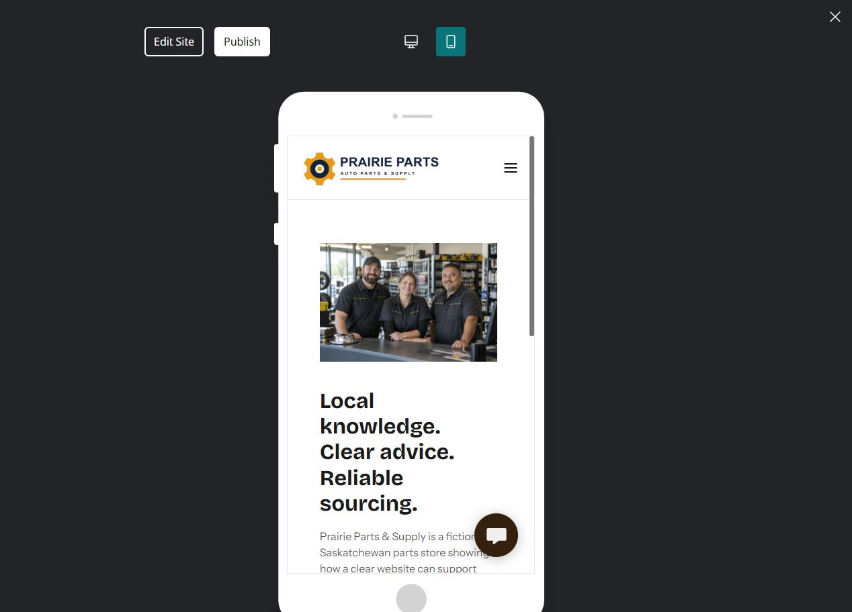

Clearly labelled sample wording
Sample wording: Meet the team that cross-checks catalogue information, supplier options and pickup details before an order is finalized.

Draft your own page copy

Photographs, proof and links to prepare

PAGE 6

Contact & Pickup
Publish current hours, location and pickup expectations with a useful contact path.
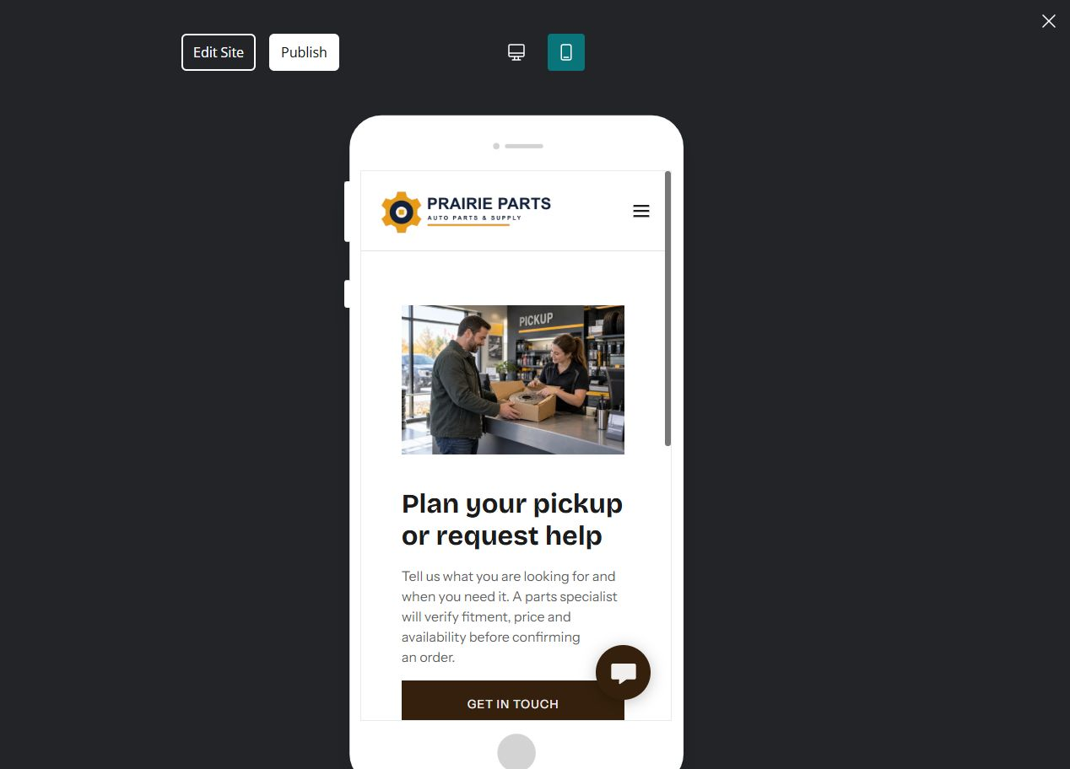

Clearly labelled sample wording
Sample wording: Ask a question or prepare a pickup. We will confirm the part, price, availability and collection details before you travel.

Draft your own page copy

Photographs, proof and links to prepare

FINAL REVIEW

Test the whole customer journey
Ask someone unfamiliar with the business to find a part, understand the verification step and plan a pickup using only the website.
□ Each page has one clear purpose and next action.
□ Every desktop page is followed by its mobile preview.
□ Logo contrast works on pale and dark themes.
□ All photos are relevant, distinct and permission-cleared.
□ Stock, compatibility, price and pickup are described as confirmed steps.
□ Hours, location, policies and contact details are verified.
□ A named backup and future review owner are recorded.

Changes found during review

Content owner and next review date

