

Arcades and pool halls website workbook
Plan a welcoming six-page venue website before entering content in Website Builder. Each working page combines practical advice, a Prairie Break example, and room for your own draft.
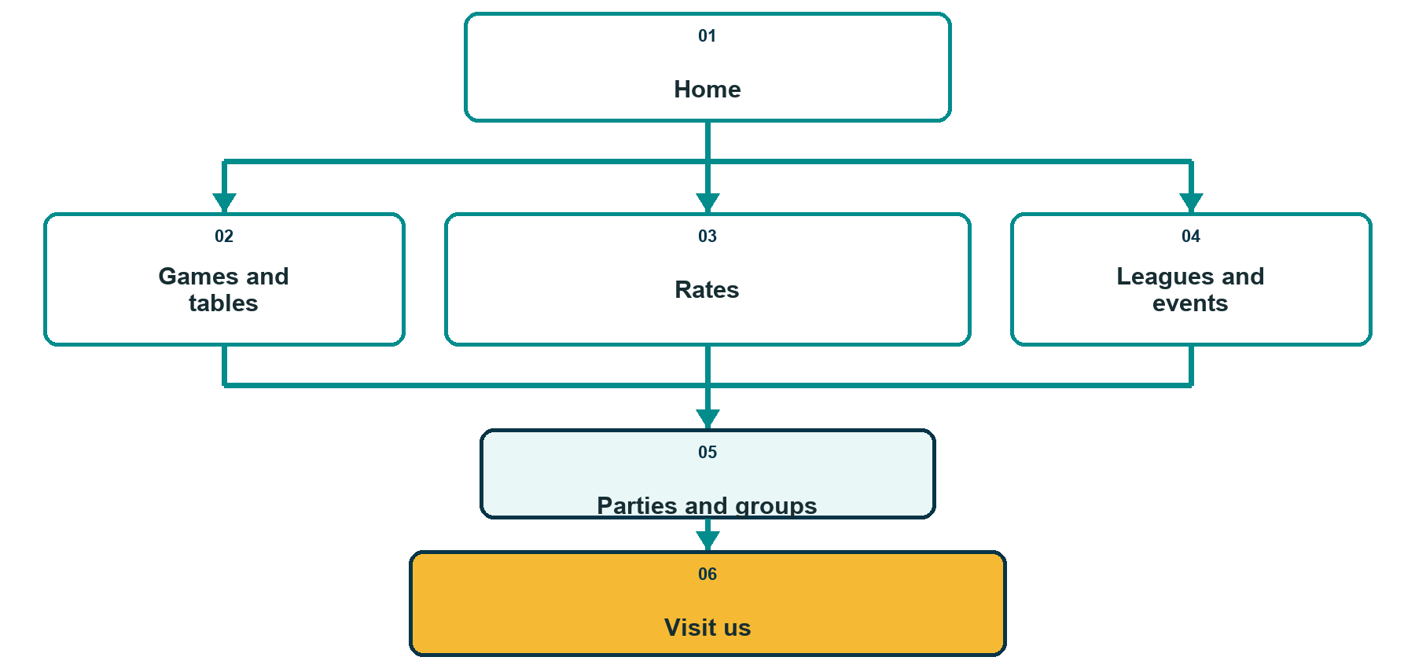
The visitor explores what is available, checks rates and events, plans a group visit, then confirms how to arrive.

Before the workshop
Bring verified hours, rates, capacity limits, booking terms, public contact details, accessibility information, current logo files, and photographs you have permission to publish. Replace every fictional Prairie Break detail with approved business information.
The experience this website should help guests plan
________________________________________________________________________________
________________________________________________________________________________

1 Home
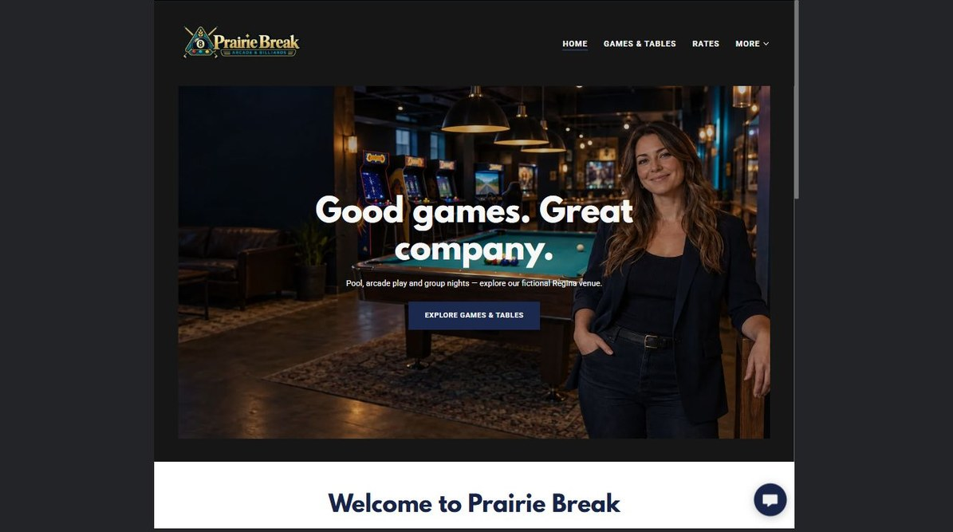
Current Prairie Break Home page
Website advice
Lead with the experience, location, and best next step. Make it immediately clear whether visitors should plan a casual visit, book a group, or check an event.
Prairie Break example
Classic games, modern fun, and room for your whole crew. Visit Prairie Break for arcade favourites, billiards, leagues, and group celebrations in Regina.
Your draft
Hero promise and atmosphere
________________________________________________________________________________
Primary call to action
________________________________________________________________________________
Today’s hours or event highlight
________________________________________________________________________________

2 Games and tables
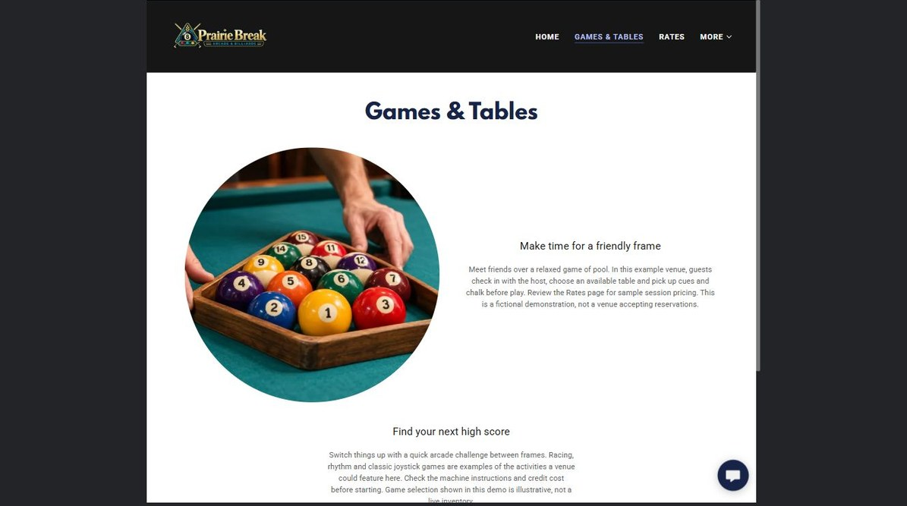
Current Prairie Break Games and tables page
Website advice
Organize attractions by what guests can play. Include enough detail to set expectations, while keeping the page easy to scan on a phone.
Prairie Break example
Choose from pinball, cabinet games, pool tables, and social games for beginners and regular players. Ask our team what is available today.
Your draft
Featured games and tables
________________________________________________________________________________
Skill level or age guidance
________________________________________________________________________________
Availability note
________________________________________________________________________________

3 Rates
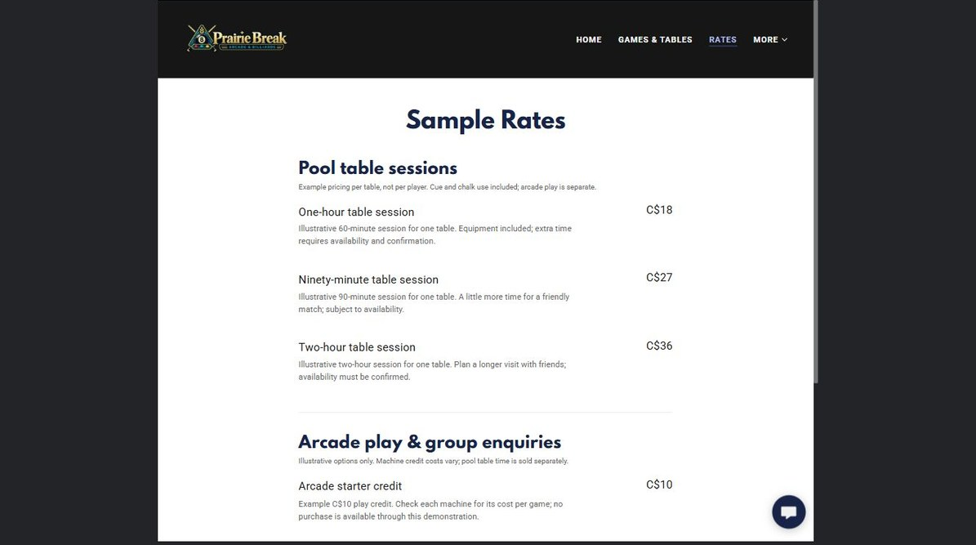
Current Prairie Break Rates page
Website advice
Show the common pricing choices in plain language. State what is included, how long a session lasts, and which prices require confirmation.
Prairie Break example
Drop in for a quick round or plan a longer night. List current game, table, and group rates with taxes, time limits, and booking conditions clearly identified.
Your draft
Core rates
________________________________________________________________________________
What each rate includes
________________________________________________________________________________
Terms that need confirmation
________________________________________________________________________________

4 Leagues and events

Current Prairie Break Leagues and events page
Website advice
Give regulars a reason to return. Explain the schedule, who can join, how registration works, and where last-minute changes will be posted.
Prairie Break example
Join a welcoming weekly league, tournament, or themed game night. New players can review the format, dates, entry details, and registration steps before attending.
Your draft
Event or league name
________________________________________________________________________________
Dates and audience
________________________________________________________________________________
Registration action
________________________________________________________________________________

5 Parties and groups
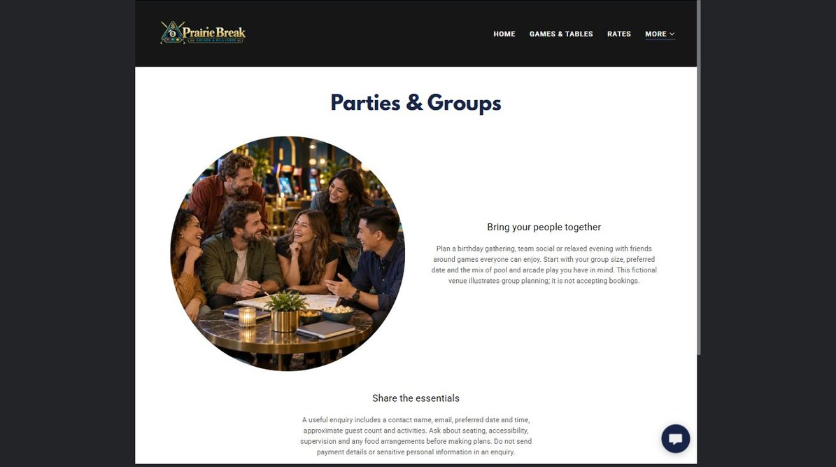
Current Prairie Break Parties and groups page
Website advice
Turn group interest into a qualified inquiry. Describe suitable occasions, capacity, included features, optional extras, and the information needed for a quote.
Prairie Break example
Plan a birthday, staff social, fundraiser, or private game night. Tell Prairie Break your date, group size, preferred activities, and accessibility needs to begin planning.
Your draft
Group types and capacity
________________________________________________________________________________
Package inclusions
________________________________________________________________________________
Inquiry details to collect
________________________________________________________________________________

6 Visit us
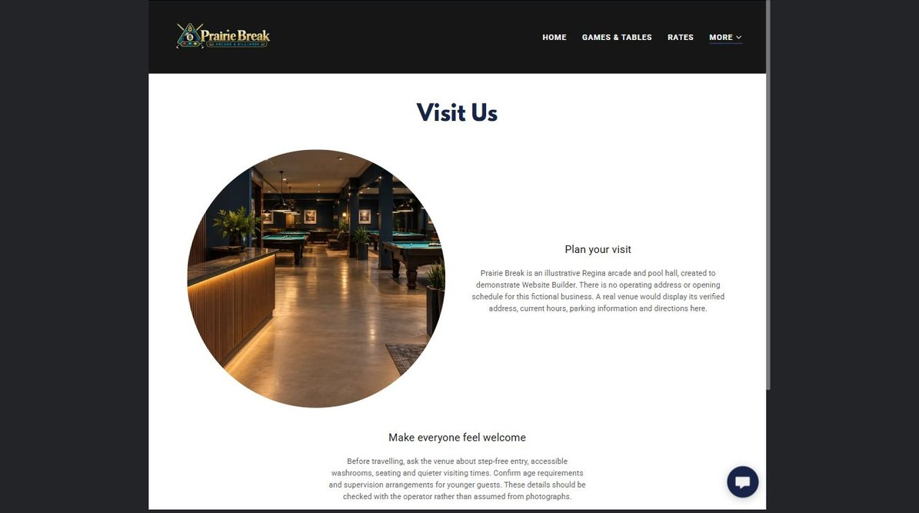
Current Prairie Break Visit us page
Website advice
Make the final trip easy. Keep address, hours, parking, accessibility, age policies, public contact details, and map directions consistent everywhere.
Prairie Break example
Find Prairie Break, check today’s hours, and review arrival details before leaving home. Contact the venue directly to confirm holiday hours or special-event access.
Your draft
Verified address and hours
________________________________________________________________________________
Parking and accessibility
________________________________________________________________________________
Public contact method
________________________________________________________________________________

Review and launch
Read the draft as a first-time visitor, then verify every operational detail with the person responsible for the venue.
☐ Every page answers a different visitor question and has one clear next action.
☐ Hours, rates, event dates, capacity, age guidance, accessibility, and booking terms are current.
☐ Each photograph is relevant, distinct, licensed, and readable on desktop and mobile.
☐ The address, map, parking notes, public email, and public phone number agree everywhere.
☐ Group inquiries collect only the information needed to plan or quote the event.
☐ All buttons, forms, galleries, and lightbox images have been tested on desktop and mobile.
☐ A clearly named backup is saved before publishing or making the next major revision.

Next actions
Corrections to make before publishing
________________________________________________________________________________
________________________________________________________________________________
________________________________________________________________________________
Who will approve the final wording and operational details
________________________________________________________________________________
Continue with SaaSTech Servers
Return to the Arcades and Pool Halls industry guide, review Website Builder, or choose a plan when the content is approved.
Arcades and Pool Halls industry guide | Website Builder | Choose a Website Builder plan

